# Exp No: 2 Date: 28/07/24

VIRTUALIZATION

**CONFIGURATION AND CREATION OF VIRTUAL MACHINE**

# AIM:

To configure a Virtual Machine using VM ware and Launch the VM and execute a simple program using C/PYTHON/JAVA.

# PROCEDURE:

1. Launch a VM ware
2. Create new virtual machine
3. Customize the set-up
4. Set username and password
5. Browse for .iso file of an operating system
6. Configure the hardware capacity
7. Finish and power on the VM
8. Install C / PYTHON /JAVA Compiler and execute simple program

# OUTPUT:

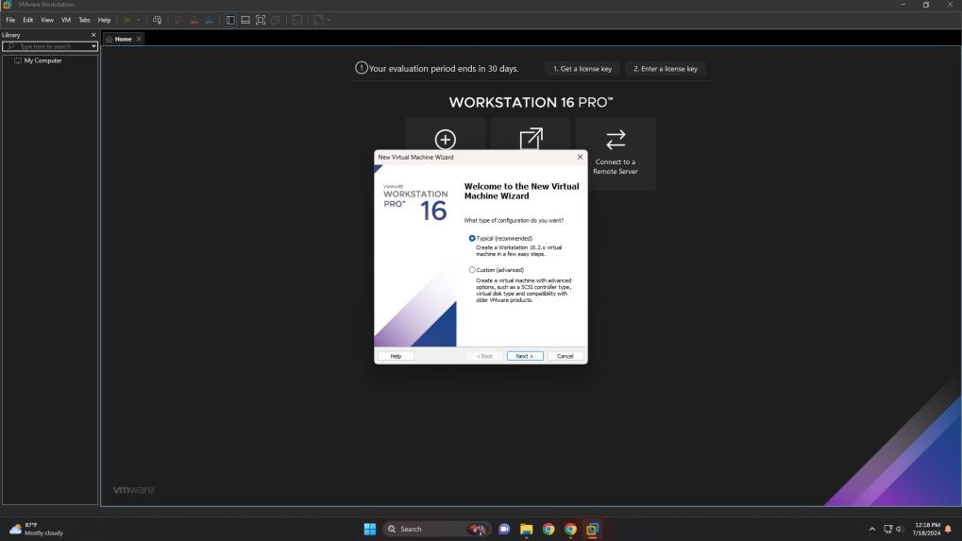

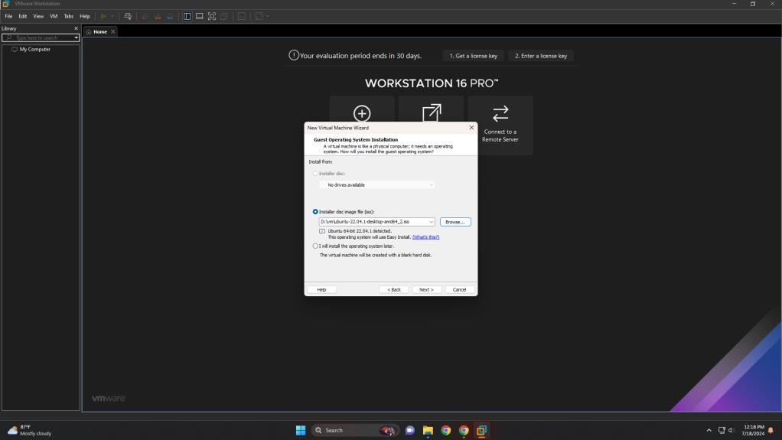

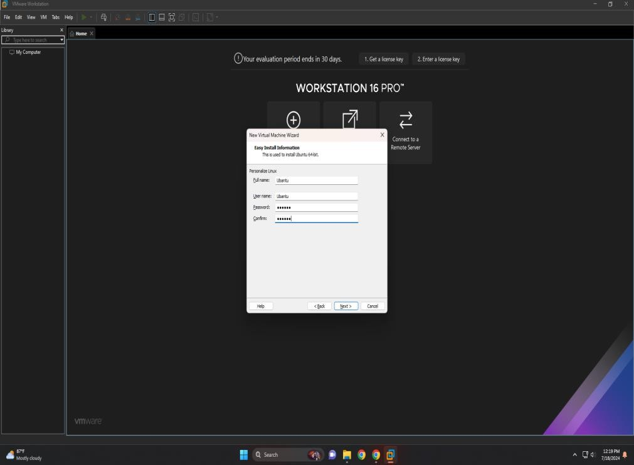

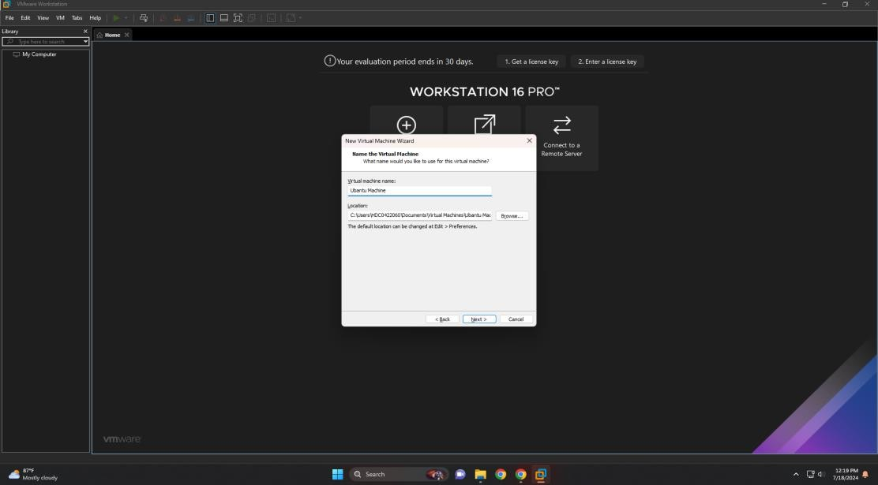

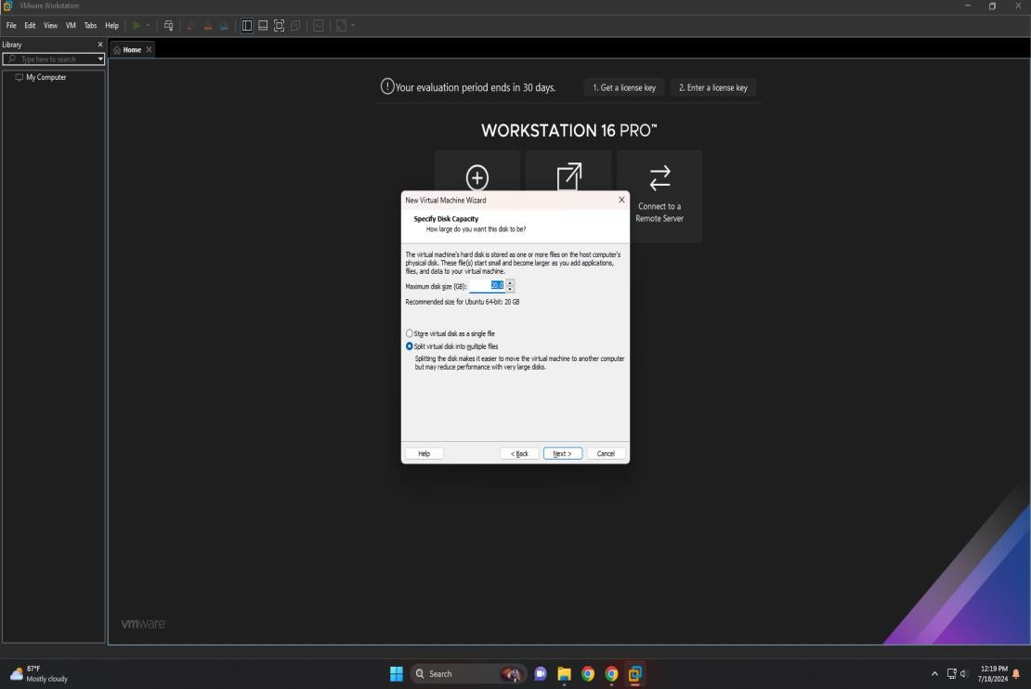

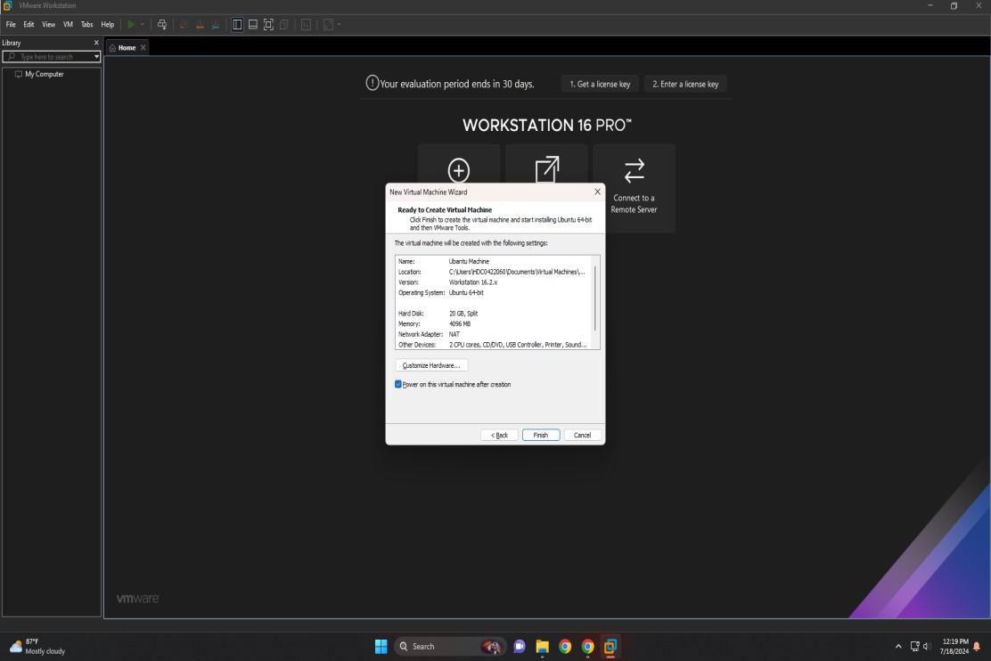

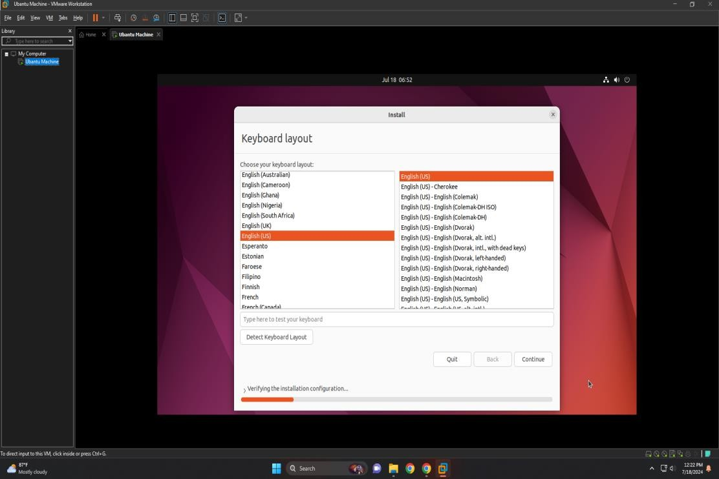

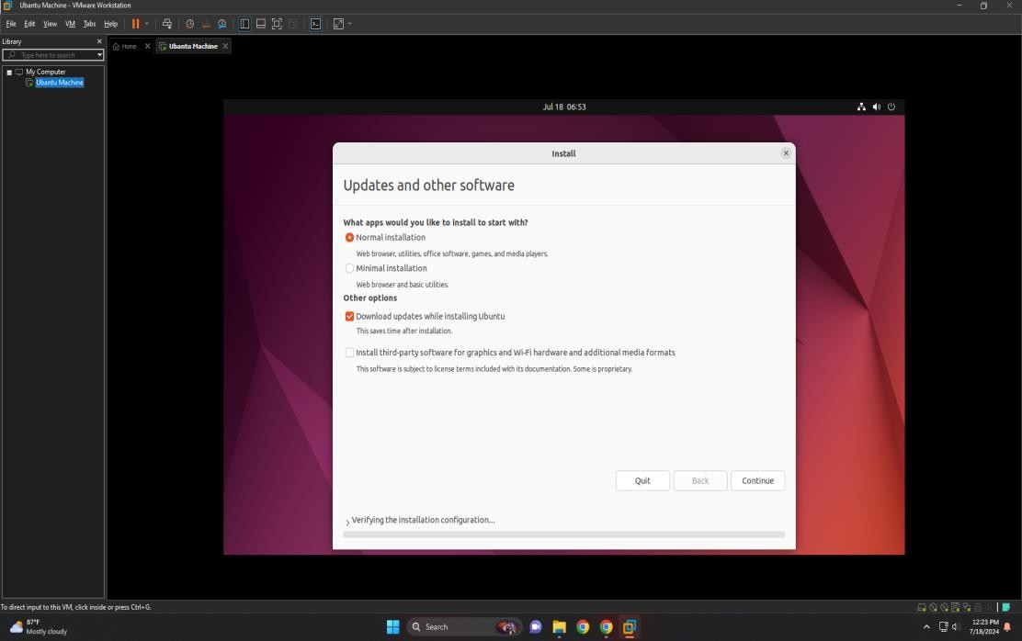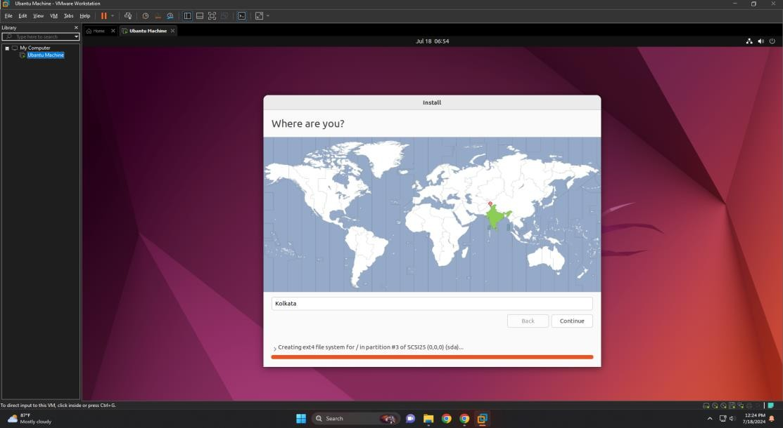

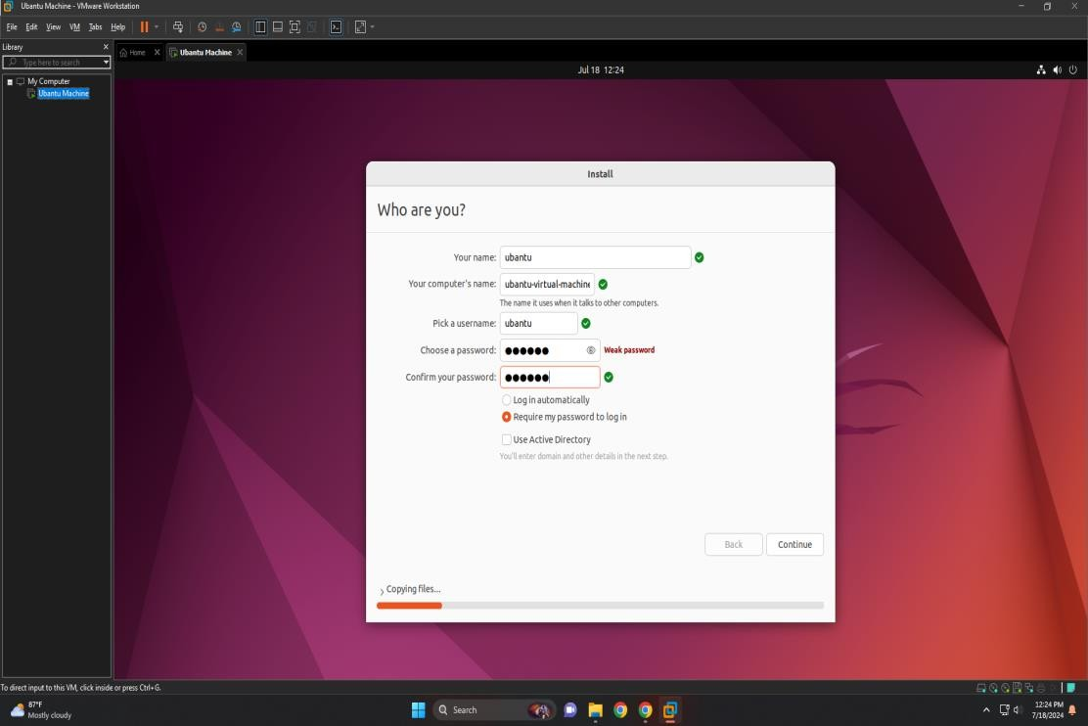

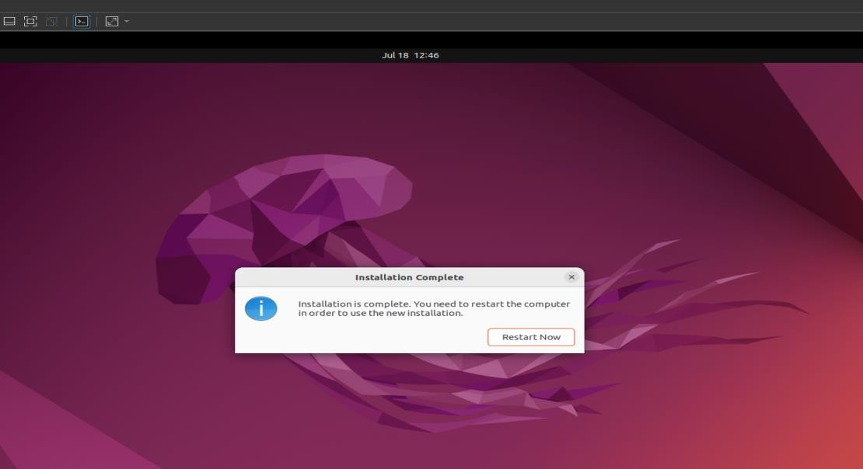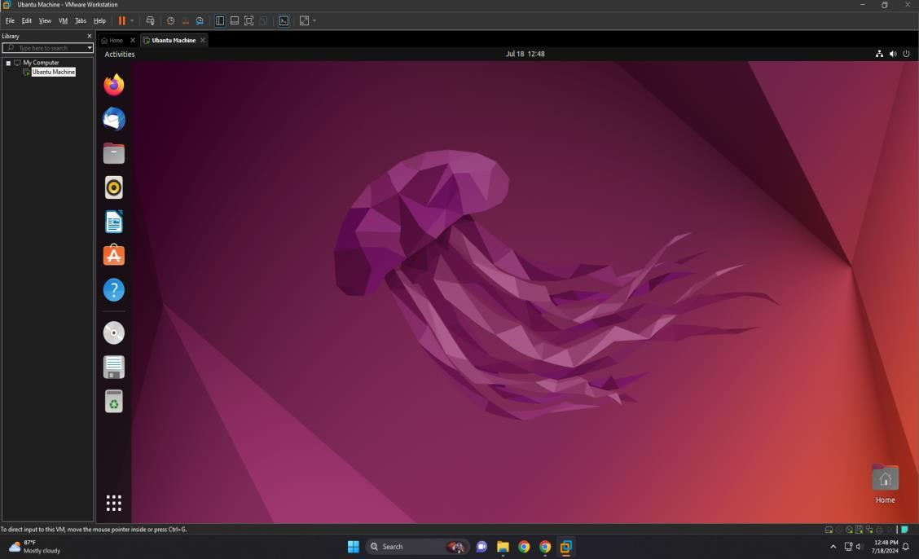

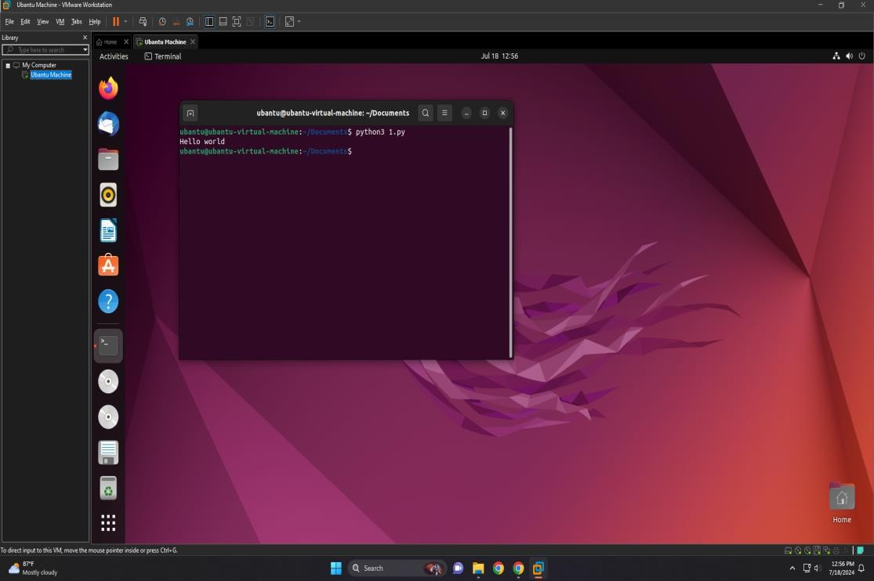

**RESULT:**

Thus the configuring a Virtual Machine using VM ware and launched the VM and executed a simple program using C/PYTHON/JAVA.