**Code Test –** User need to run the console application and input two positive integers for processing, please see the below screenshots.

Code folder : Multiplication_Test

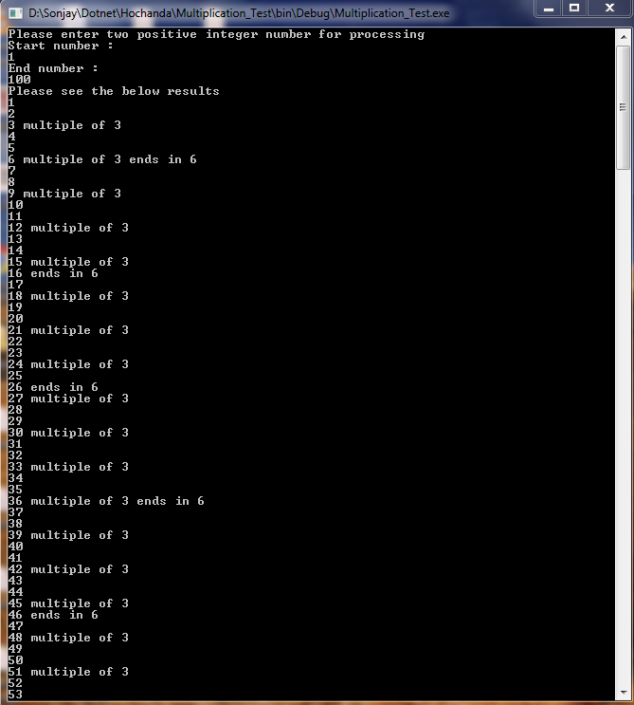

The logic can configurable using the config xml file as below. User can change the logic without making any changes into existing code

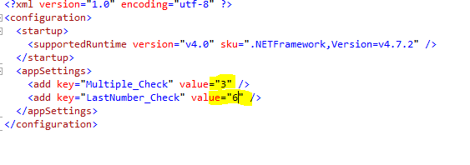

Updated config file and output.

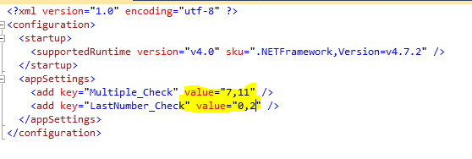

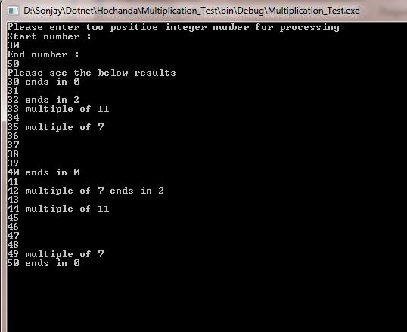

**JavaScript Test**

Please see the output as requested

Code folder : GridView_Test

