**Construction**

Very fortunately, I was able to acquire a TV for a mere £20 from a friend of mine. The TV model is a **Technika 19-248**. These were the results of the teardown.

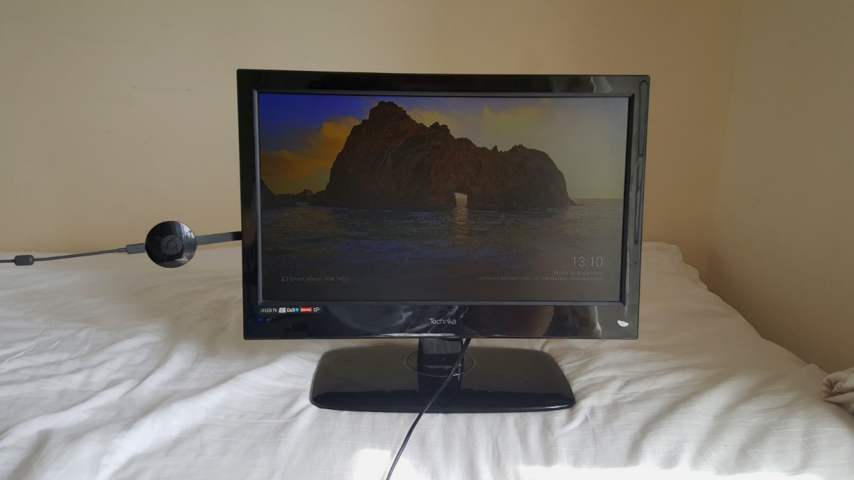

Chromecast (2nd Generation)

TV (Technika 19-248**)**

Fig 8.1 – The TV I will be using to power the display

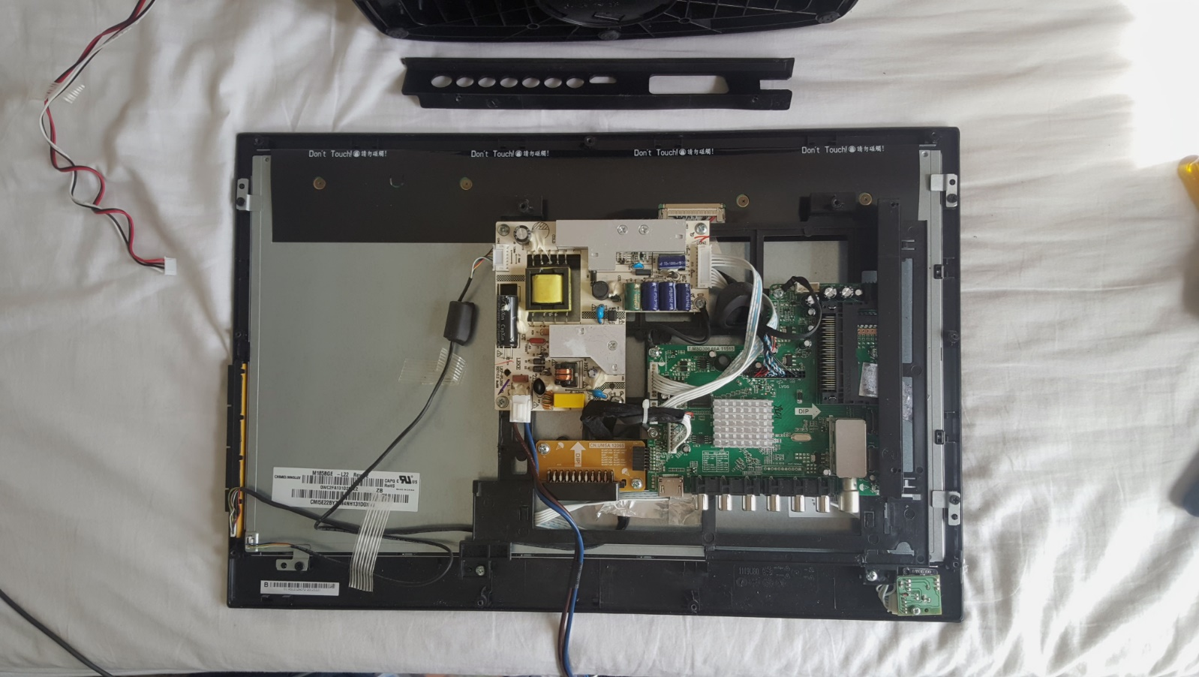

Fig 8.2 – The display controller on the back of the TV exposed

Display Controller

The next course of action is to acquire a one-way mirror (also sometimes confusingly called a two-way mirror) that will create the desired futuristic mirror-display effect. For this I investigated three methods of achieving this: glass, acrylic and film.

I concluded that acrylic one-way mirrors provide an optimal compromise between cost and quality.

Upon acquiring the mirror I made the unfortunate discovery that it was a few millimetres too big for my LCD.

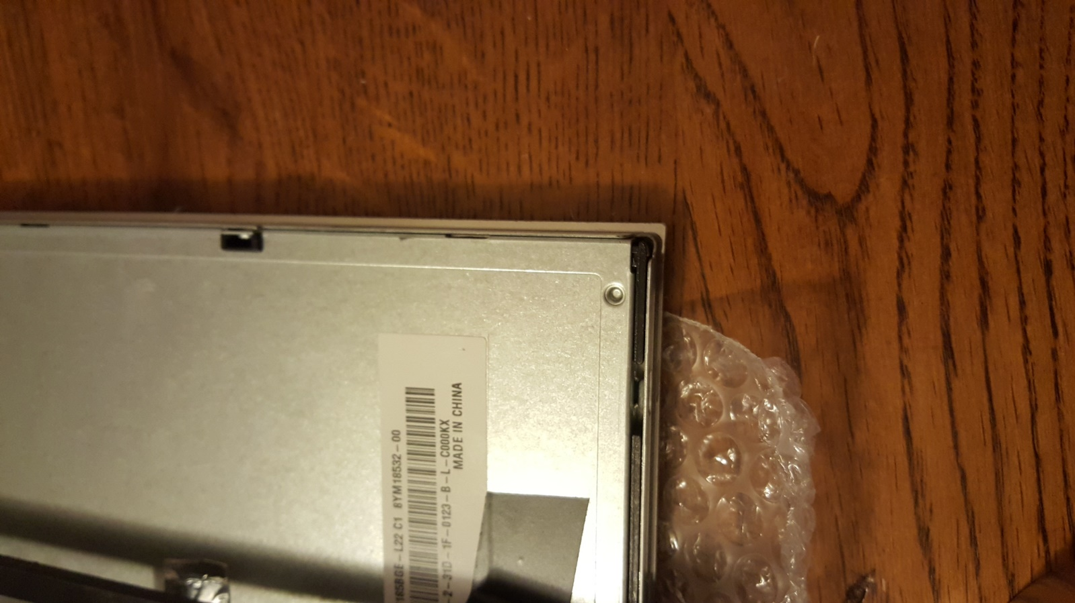

Fig 8.3 – This is the LCD on top of the mirror. The overhang is shown in the red box

To fit a frame around the device I needed a precise fit, without any overhang. I considered my options:

* Attempt to cut the few millimetres very precisely
* Try and sand the edges down

It did not take much thought before I decided that neither of these ideas would be very suitable. It would be an impossible task to cut with such precision and without causing damage to the mirror with the tools I have on hand. Sanding was likely to create an uneven edge, somewhat ruining the clean and minimalistic aesthetic of the mirror. Instead, I went into college to meet with an electronics teacher (and enthusiastic home-engineer) who had extensive experience in his own personal projects. He suggested using thin wooden splints to fill out the overhang. This would be many times safer than cutting the mirror and required minimal cost.

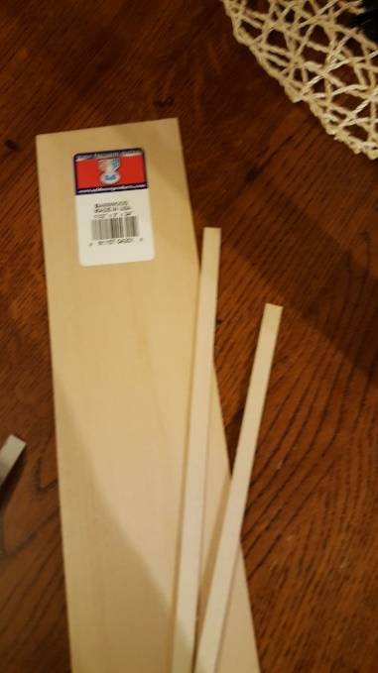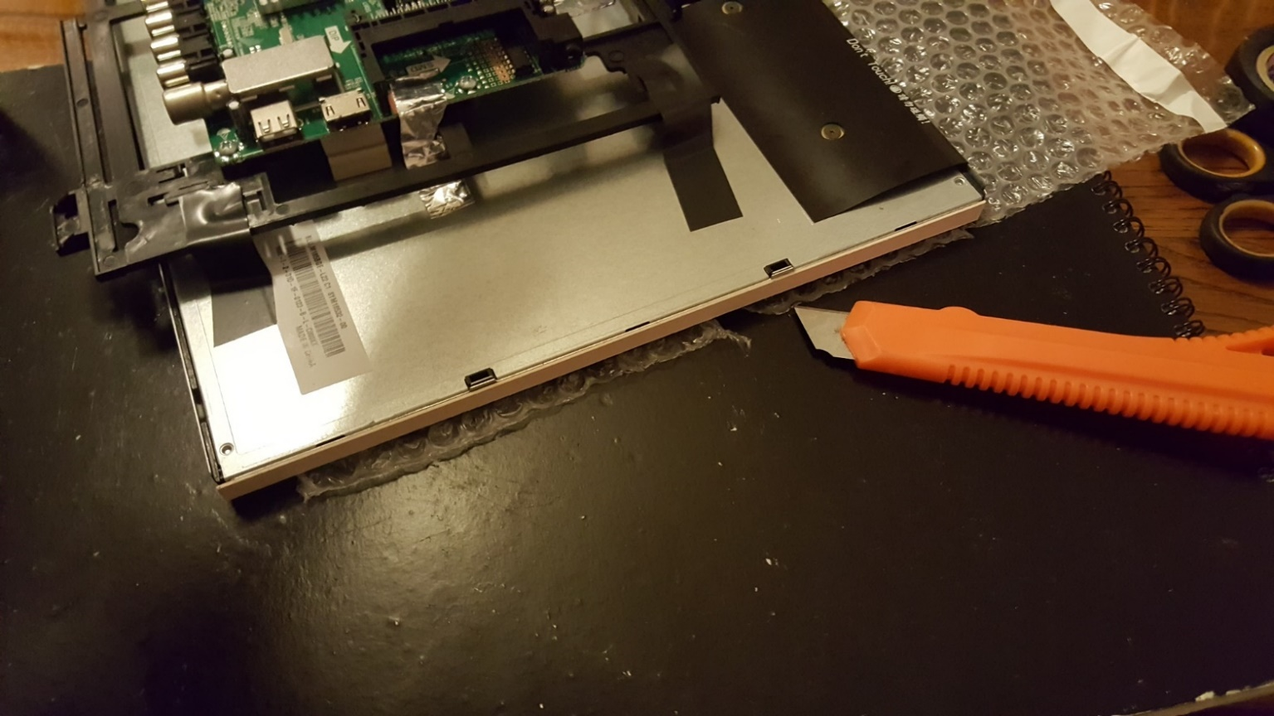I bought some thin pieces of basswood and cut them to size with a box cutter.

Fig 8.5 – Wooden strips glued to the edges to fill out the space

Fig 8.4 – Wooden strips of basswood

Before sticking the mirror to the bezel I had to remove some excess plastic on the display controller board that was bigger than the LCD, meaning it could not stand up properly.

After solving this problem, I was next faced with the task of sticking the mirror to the LCD itself. I had previously decided to glue the mirror to the bezel (metal part surrounding the screen) with a type of superglue. However, I decided to get a second opinion from a friend of mine who is an engineer. He agreed on my decision to use glue, and recommended a brand called Loctite.

Before sticking the two together, it was imperative to clean and polish the surface of the mirror as much as possible, as any imperfections will be permanent. I wore gloves to prevent fingerprints and used a microfiber cloth clean it.

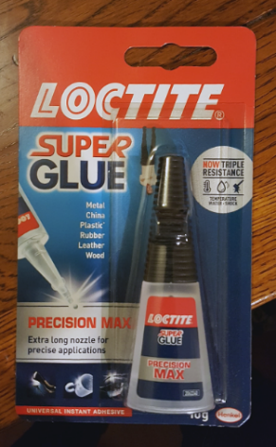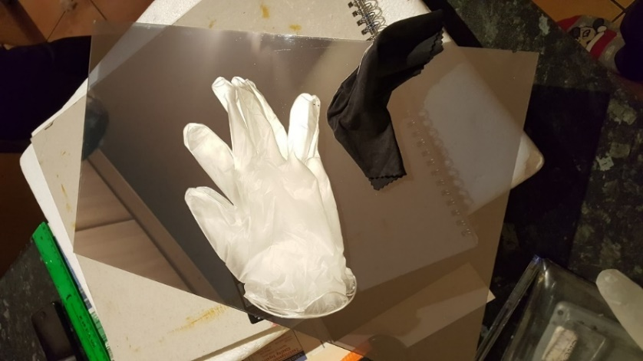

Fig 8.6 – Loctite super glue

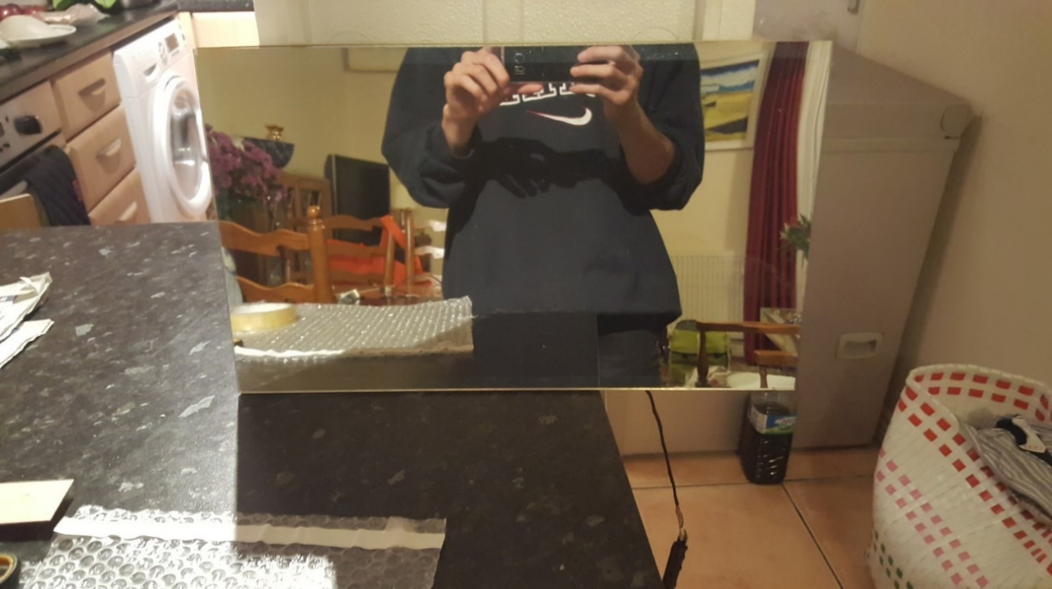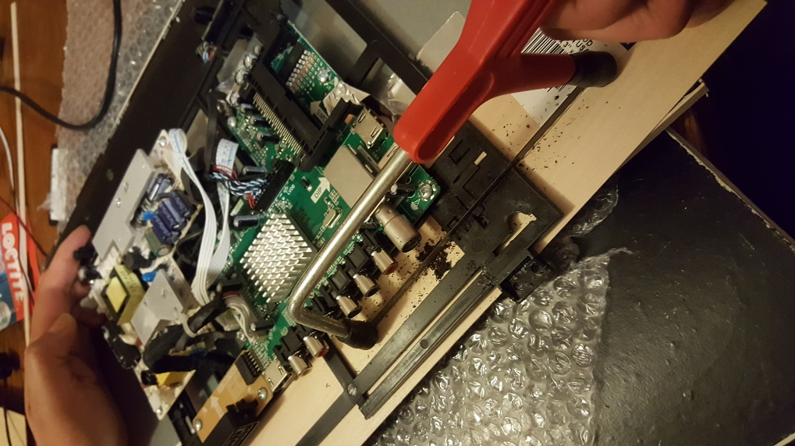

Fig 8.7 – Cleaning the surface of the mirror

Fig 8.9 – The mirror glued to the bezel

Fig 8.8 – Sawing through the extra plastic