**Evaluation**

**Marketplace Review**

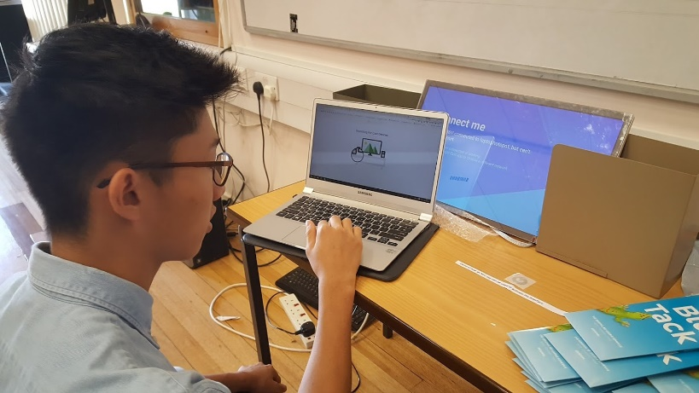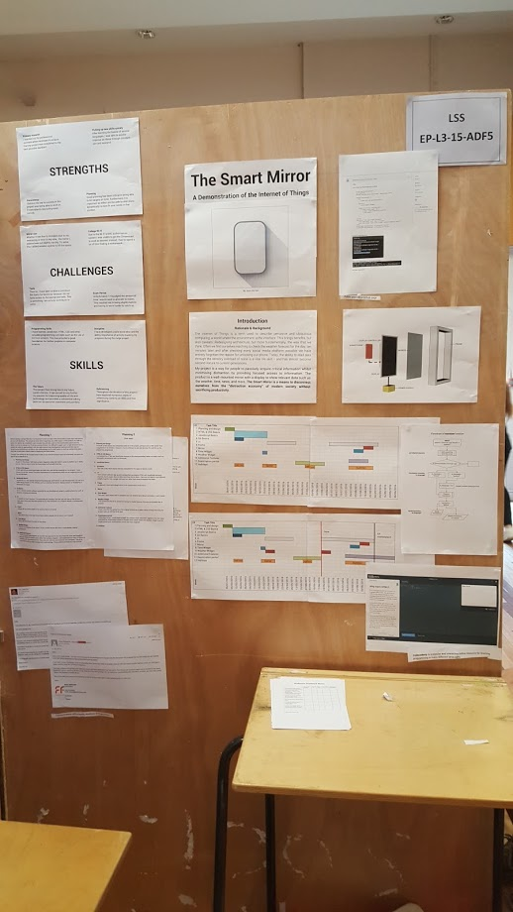

NFC tag demo

Fig 9.1

Mirror Display

Overall, I would say my marketplace was a success. It was not without its challenges, however. I faced some major technical issues while I was setting up my mirror. The problem was due to the fact that my Chromecast could not connect properly to the school’s Wi-Fi. I go into further detail about this in the *“Challenges”* section later on.

Planning

Introduction

In spite of this, I eventually managed to get a basic demo of the interface working, albeit with many of the major features not available. Unfortunately, as a result of this I was not able to show off the speech recognition features which is perhaps one of the more desirable or more impressive aspects of the mirror.

Examples of Primary Research

Timelines

Apart from the main mirror, I also had an NFC tag demo working which was a small victory in a day plagued by unexpected difficulties.

Fig 9.2

However, as eye catching as it was, I felt that the mirror was not necessarily the most important part of the project but instead the process I went through to get there and the lessons I had learned as a result. I prepared various materials to showcase these achievements. These materials were taken from my final write-up which was largely complete by the time of the marketplace, but with some text had to be cut as to reach a reasonable compromise between readability (font-size) and quantity. Despite this I tried to be selective with what material I included by attempting to cover as many of the marking points as possible as comprehensively as possible.

I feel that I was able to effectively deliver a clear presentation on every aspect of my project and answer any questions that visitors to my stall had. Moreover I got the impression that people were drawn to the stall because of the unique artefact I had on display which satisfying to see after many months of hard work.

Despite the technical nature of my project, my presentation demographic was a largely non-technical audience. Therefore I had to apply a degree of abstraction when putting together my presentation materials. A prime example of this was a flowchart I created of a sample function in my code. This flowchart is pictured on below, with the original code. Code is close to meaningless to non-programmers – even with comments. The aim of the flowchart was to provide a visual and easy-to-digest medium to show what the code is doing.

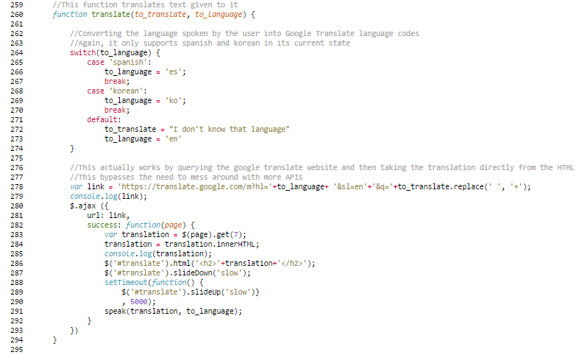

Fig 9.3 – Code snippet depicting *translate* function

C:\Users\Joonho\Google Drive\College\EP\Images\Development\Flowchart.png

Fig 9.4 – Flowchart of above code

**Strengths**

In my opinion, one of my greatest strengths during this project was the ability to pick up new skills quickly. Before beginning the project I had little to no experience in any of the programming languages or techniques used. This skill enabled me to get started on the actual development quickly, so I could hit deadlines and targets punctually.

Furthermore, in order to meet these targets I was required to work consistently. I would not have been able to accomplish what I did by cramming it just before the deadline. The task simply demanded a level of complexity and organisation that could only be achieved by constant and steady progress. Of course, this excluded the exam period where revision took precedence.

Of course, consistency is one thing, but having set targets to work towards is as, if not more, important. Good planning has been critical, allowing me to track my progress and prioritise the most important tasks. Not only is setting deadlines in advance important, but also being able to reflect and alter your plans dynamically to best fit your needs in that context. It is inevitable that your current conditions and ideas will change so a degree of adaptability is needed.

The project would be vastly different if it were not the help and expertise of professionals I asked for assistance. I reached out for opinions when I needed them to ensure that I could complete whatever task I was working on within the allocated time and to the best possible standard.

**Challenges**

One of the few oversights in my initial planning was due to the exam period. Unfortunately I had misjudged the amount of time I would need to dedicate to revision. Exam preparation took a lot longer than I had anticipated, resulting me in being slightly behind schedule and having to work harder to catch up.

Whether it was due to mistakes in my measurements or inaccuracy in my ruler, the one-way mirror I ordered was cut to slightly erroneous dimensions – being several millimetres too big in each direction. However, I was able to find a suitable solution to this (as detailed in the construction section) and in the end it had no great detrimental effect on my project.

One major issue I faced was the inability to pair my mirror and phone in college. The school’s MAC authorisation system means that only approved devices have access to the internet. I had to devote a large amount of time to finding a workaround – which I finally did. The solution was to use a phone to create a mobile Wi-Fi hotspot that my Chromecast could connect to. This was less than ideal as the mobile network connection was patchy in that area.

Some way through the summer I decided to add native Chromecast integration to my app. I theorised that this could potentially enable capabilities such as the ability to have the screen casting run in the background so that the user could do other things on the phone while the interface was still running. However, none of the solutions I tried worked, and instead I just wasted a significant amount of time trying to get it to run properly.

Another unexpected challenge I faced was to do with my frame that I had planned to build around my mirror. After gluing the basswood strips to the edges of the LCD I noticed some damage to the backlight circuit. While there was no apparent effect on the actual functioning of the device, I feared that adding a solid wooden frame on top of it could destroy my entire project. As a result I decided to abandon this idea, despite scheduling it in my timeline prior. This ultimately meant that the mirror was not freestanding and I am yet to come up with a suitable solution to this issue.

**Skills**

Foremost, I have learned JavaScript, HTML, CSS and other critical programming concepts such as the use of APIs and Git from scratch. This has provided excellent programming practice, providing good preparation for a Computer Science degree where I will have a head start with my programming skills. Not only this but this project in particular has allowed me to pursue my passion of improving quality of life with technology and forced me to communicate my ideas with clarity. It is a prime example of the type of thing I hope that a Computer Science will lead to. Furthermore, it has provided a significant talking point on my personal statement which I believe will give my application a competitive edge against others.

As a result of being forced to keep a strict diary and extensive planning, I have developed a solid work-ethic and learned the value of tracking your progress and producing detailed documentation as a result of this task. I feel like the final artefact would not even resemble its final form without the prior timescale materials I produced before I even began programming. Being able to set and hit deadlines is a vital skill that will be applicable to projects of any kind in the future, and even in general work and study.

I comprehensively researched different development methodologies and selected the one that resonated with me the most. I then applied this to my own project in a way that I think was very successful. In this way, there has been an element of self-discovery by which I have found how I can optimally approach a project.