**Sentence Contradiction Classification**

**Project Overview**

This project classifies pairs of sentences into three categories: Contradiction, Entailment, or Neutral, based on their semantic relationships. The goal is to build a machine learning model to predict the relationship between two sentences.

**Dataset Description**

**Labeled training data with**

1. id: Unique identifier for each sentence pair.
2. sentence1: The first sentence (Premise).
3. sentence2: The second sentence (Hypothesis).
4. label: Relationship classification:
   * + 0 = Contradiction.
     + 1 = Neutral.
     + 2 = Entailment.

**Random Forest Learning Model Performance evaluation:**

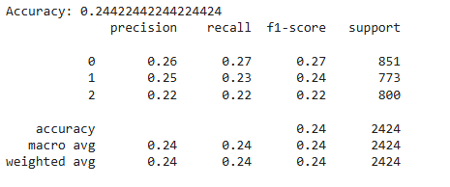

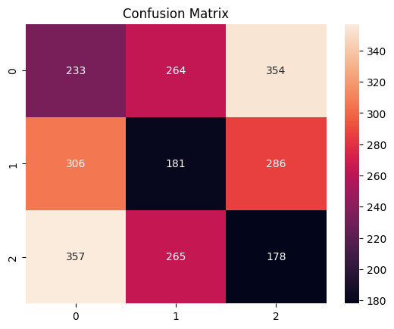

**Decision Tree model Performance evaluation:**

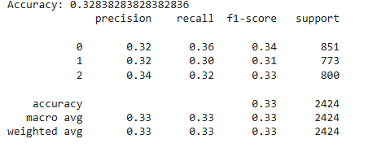

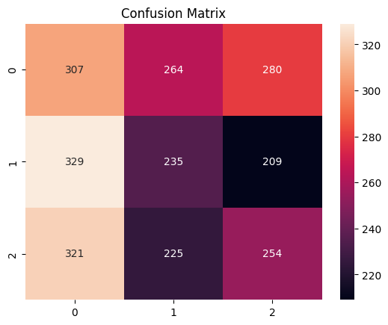

**XGboost model Performance evaluation:**

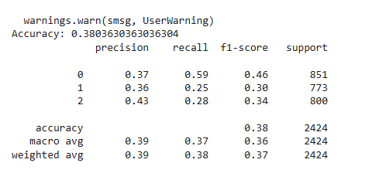

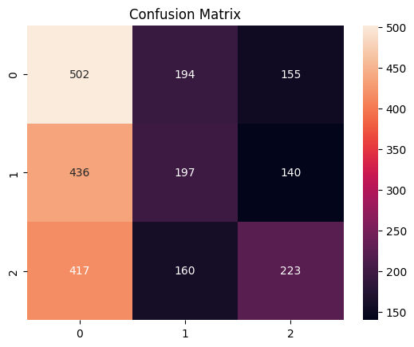

**ANN model Performance evaluation:**

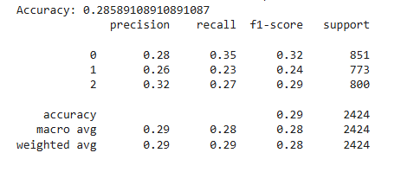

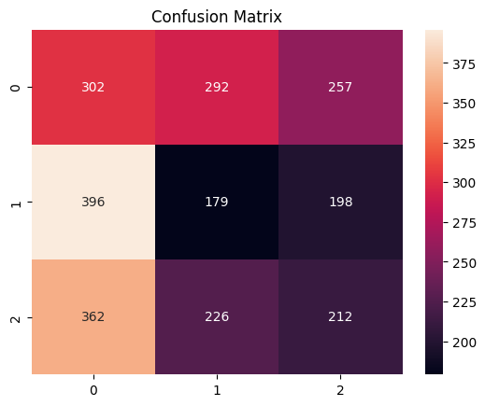

**LSTM Model Performance evaluation**:

