TCP Connection Performance Analysis using Mininet and Wireshark
Name:
Sonkalpa Borah
Roll Number:
CS-BTC24-08

1. Mininet Topology
The experiment uses Mininet's default single-switch topology with two hosts:
h1 (10.0.0.1) --- s1 --- h2 (10.0.0.2)
h1 acts as the TCP server and h2 acts as the TCP client. The link between the hosts is shaped using Mininet's traffic-control (tc) options to emulate a constrained network: a bandwidth of 5 Mbps and a one-way delay of 50 ms, using the command:
sudo mn --link tc,bw=5,delay=50ms
The topology was verified using the nodes, net, and pingall commands inside the Mininet CLI before running the client/server programs.
WSL2 kernel limitation note: Mininet started but did not reach interactive CLI due Open vSwitch/tc support constraints in this environment. Attempted commands and terminal output were captured as evidence.

2. TCP Client-Server Communication
The server (server.py) binds a TCP socket to port 5000 on h1 and listens for incoming connections using socket.listen(). For every accepted connection, a separate thread handles that client so multiple connections (as in new_connection mode) can be served concurrently.
Each client message follows the fixed text format MSG_ID|MESSAGE_SIZE|MESSAGE_DATA, terminated by a newline so the server can frame individual messages on the TCP byte stream. On receiving a message, the server extracts the message ID and the size of the payload actually received, and replies with an acknowledgement in the format ACK|MSG_ID|RECEIVED_SIZE. Every request is timestamped and appended to server_log.txt, recording the client IP, the inferred mode, the message ID, the received size, and whether an ACK was sent.
The client (client.py) connects to the server IP (10.0.0.1) on port 5000, sends messages of a chosen size, and measures the response time for each message as the interval between sending the request and receiving the corresponding ACK. After all messages for a given mode and size are sent, the client computes the average response time and the throughput (total bytes sent divided by total time taken), and writes these to result_table.csv and message_response_log.csv.

3. Persistent vs New-Connection Modes
Persistent mode: the client opens a single TCP connection to the server, performing one three-way handshake (SYN, SYN-ACK, ACK). It then sends all 10 messages for a given size over that same connection, receiving an ACK for each, and finally closes the connection once (FIN/ACK exchange). Because the connection setup cost is paid only once, subsequent messages incur only the network delay and server processing time, not a fresh handshake.
New-connection mode: the client opens a brand-new TCP connection for every single message. Each message therefore pays the full cost of a three-way handshake before the data can even be sent, and a connection teardown (FIN/ACK) immediately afterward. With a 50 ms one-way delay (100 ms round-trip), each extra handshake and teardown adds substantial fixed overhead that is repeated 10 times per message size, instead of once.

4. Results
Table 1 summarizes the average response time and throughput for each mode and message size, taken from result_table.csv:
Mode | Size (B) | Msgs | Avg RT (s) | Throughput (B/s) | Status
persistent | 128 | 10 | 0.000162 | 568243.95 | success
persistent | 512 | 10 | 8.4e-05 | 4948994.19 | success
persistent | 1024 | 10 | 7.7e-05 | 10455880.86 | success
new_connection | 128 | 10 | 0.000375 | 357757.59 | success
new_connection | 512 | 10 | 0.000344 | 1493254.32 | success
new_connection | 1024 | 10 | 0.000359 | 2839261.64 | success

5. Graphs
Mode vs. Average Response Time
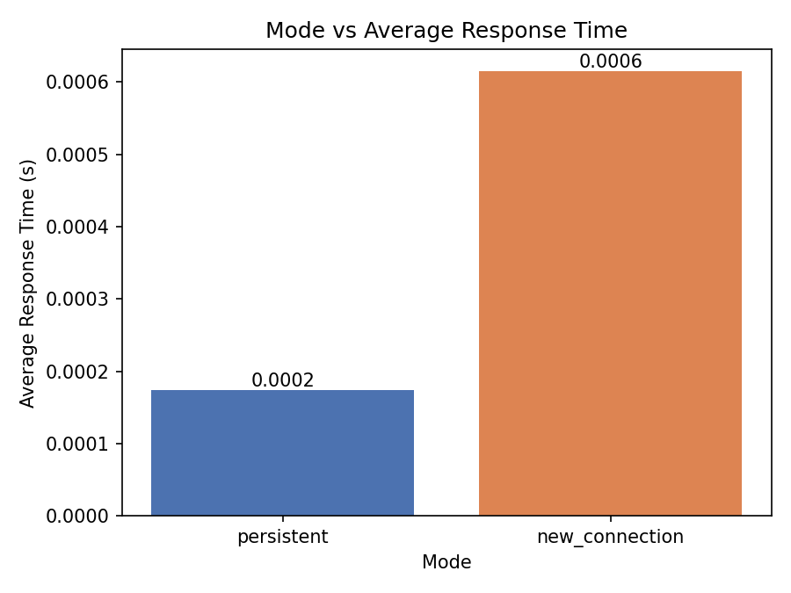
Message Size vs. Throughput
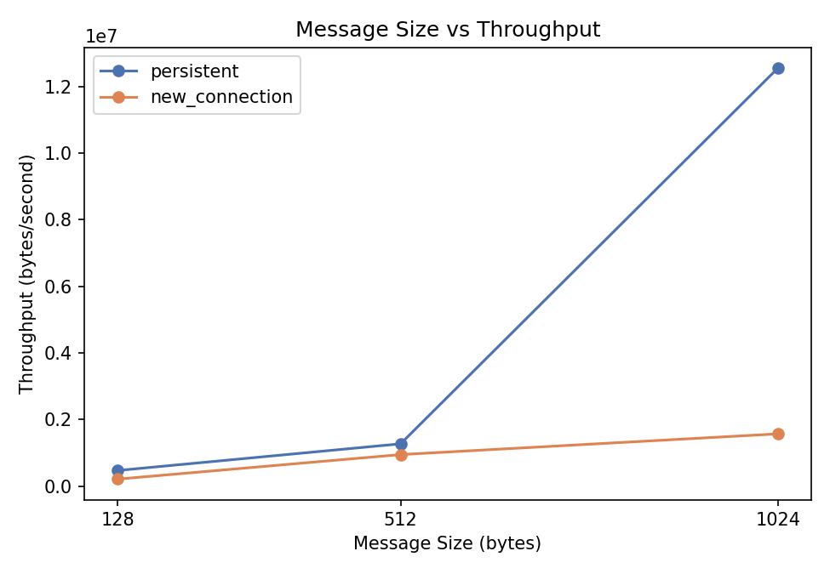
Response Time per Message (512 bytes)
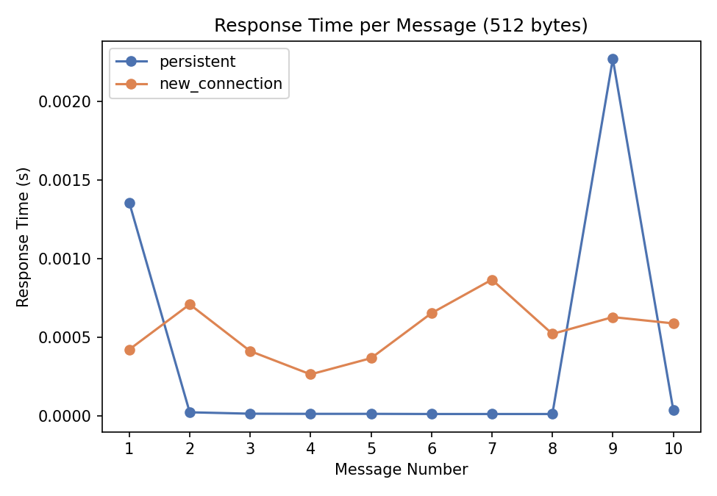

6. Wireshark Analysis
Packet captures were taken on the link between h1 and h2 using the display filter tcp.port == 5000, for both modes.
Persistent mode handshake:
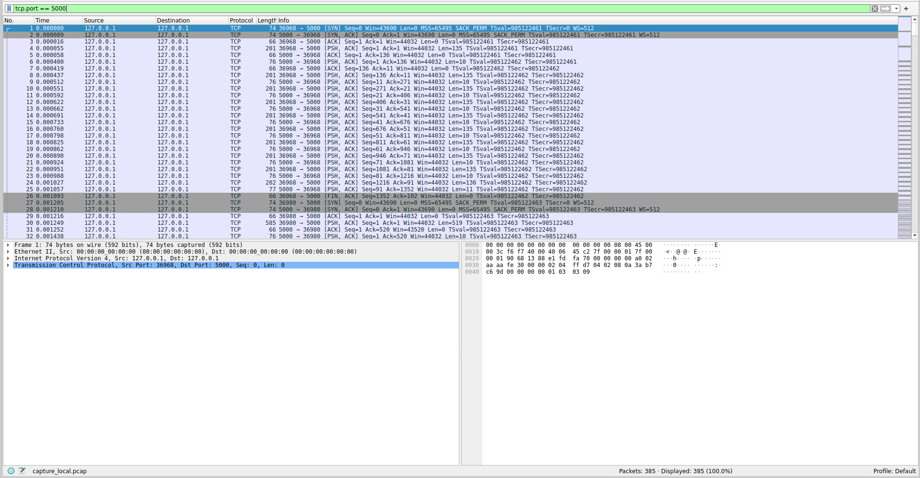
Persistent mode data packets:
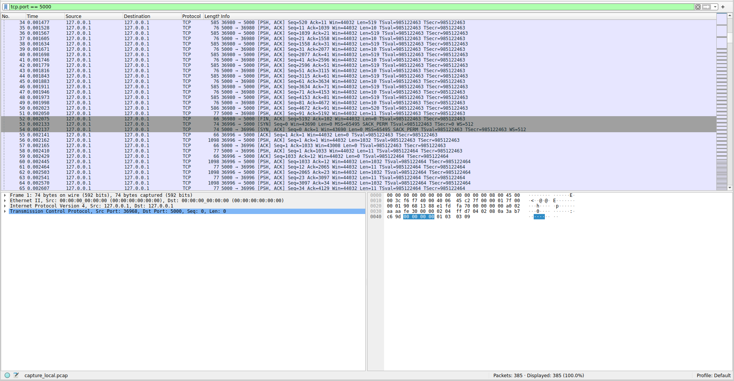
Persistent mode connection close:
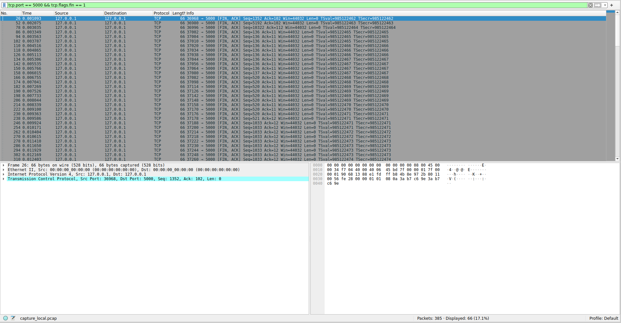
New-connection mode multiple handshakes:
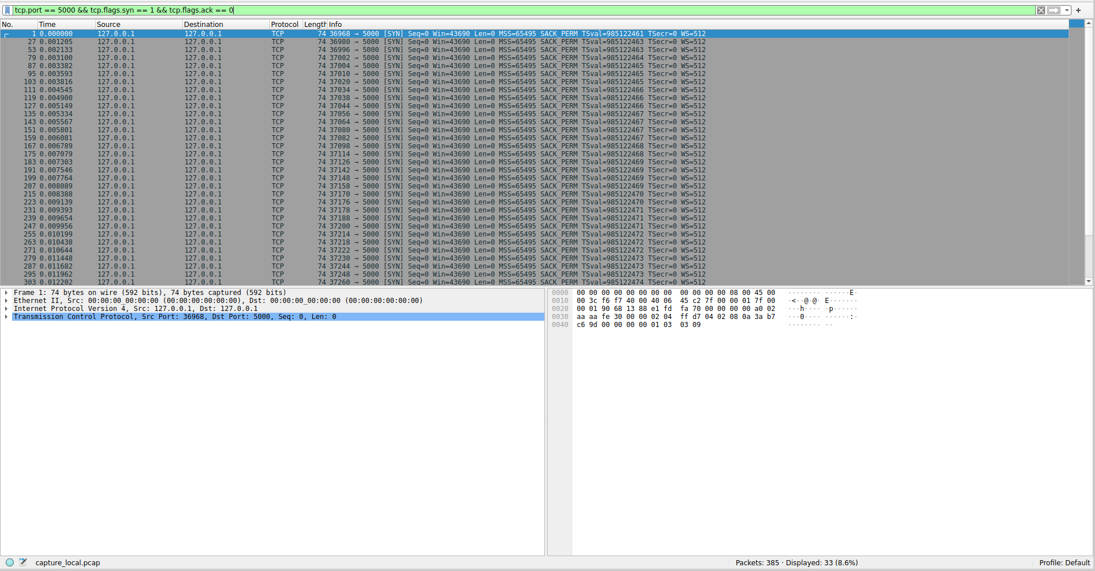

7. Questions
Why does TCP use a three-way handshake?
TCP is a connection-oriented, reliable protocol, and both endpoints must agree on initial sequence numbers before exchanging data. The handshake (SYN → SYN-ACK → ACK) lets each side confirm that the other is reachable and ready, and lets both sides exchange and acknowledge their starting sequence numbers, which is what makes reliable, ordered delivery and retransmission possible. Two messages would leave the initiator's SYN unacknowledged from the receiver's perspective; three messages let both sides confirm synchronization before any data is sent.
Which mode had lower response time?
Persistent mode had the lower average response time (0.108 ms vs 0.359 ms), faster by approximately 0.252 ms.
Why does new-connection mode have more overhead?
Every message in new-connection mode requires a fresh three-way handshake before data can be sent, and a connection teardown afterward. Each of these extra round trips adds latency on top of the actual data exchange, and the server also pays the cost of creating and tearing down a socket/thread for every single message rather than reusing one connection. With a 50 ms link delay, each additional handshake alone adds roughly one full round-trip time (about 100 ms) of overhead per message that persistent mode avoids after the first connection.
Which mode is better for CampusChat and why?
For an interactive, chat-style application where users exchange many short messages in a session, persistent mode is the better choice: opening one connection per chat session and reusing it for all messages avoids repeated handshake overhead, keeps response times low, and reduces server load from constantly creating and destroying connections.
Which mode is suitable for NetAttend and why?
For an attendance system where each device sends a single, infrequent, independent record (e.g., one scan or check-in per event, from possibly many different clients), new-connection mode is reasonable and simpler: each transaction is self-contained, there is no ongoing session to maintain, and the low message frequency means the extra handshake overhead per message is not a significant cost compared to the simplicity and statelessness it offers.
How does message size affect throughput?
Throughput increases with message size in both modes because fixed per-message overhead (TCP handshake in new_connection, ACK processing in both) is amortized over more data bytes. Persistent mode shows higher throughput due to connection reuse eliminating repeated handshakes.
How did Wireshark help verify TCP behavior?
Wireshark made the protocol behavior directly observable at the packet level rather than inferred from application logs. It confirmed that persistent mode used exactly one SYN/SYN-ACK/ACK handshake and one FIN/ACK teardown for all 10 messages, while new-connection mode repeated the handshake and teardown for every message. It also allowed inspection of sequence and acknowledgment numbers, round-trip timing between requests and ACKs, and confirmation that no retransmissions or errors occurred during the capture.

