**Preparation**

1. What will happen if you type man man in Linux?

- It displays the manual page for the 'man' program

2. How can you use the command ls to find out about the size of the file */etc/lilo.con*?

- The command `ls -l /etc/lilo.conn` will list in long format, giving mode, ACL indication, number of links, owner, group, size in bytes, and time of last modification for the file.

3. What happens to the files in the command mv *file1 file2* ? Which option of mv issues a warning?

- If both files are in the current directory and type “mv file1 file2”; file1 will write over file2.

After this operation, there will be only one file left, which contains the contents of the previous file1 and is named as file2. The command `mv -i file1 file2` will prompt for confirmation whenever the move would overwrite an existing target.  It looks like "mv: overwrite file2 (yes/no)?".  An affirmative answer means that the move should proceed.  Any other answer prevents mv from overwriting the target.

4. What is the command that you issue if you are in directory / and want to copy the file /mydata to directory /labdata?

- The command `cp mydata labdata`.

5. What is the command that you issue if you are in directory / and want to copy all files and directories under /mydirectory to directory /newdirectory?

- The command `cp -r mydirectory newdirectory` or command `cp -R /mydirectory newdirectory` will do the job. The option "cp -r" recursively copies the directory and all its files, including any subdirectories and their files, to the target.  The option "cp -R" is the same as "cp -r", except pipes are replicated, not read from

6. What happens when you type rm * in a directory?

- The command `rm *` will remove all the files in the current directory and will display the subdirectories that are in the current directory.  It looks like "rm: subdirectory is a directory".  The subdirectories won't be removed.

7. What is the command used to delete all files and directories under the directory */mydirectory*?

+ rm -Rf /mydirectory/

+ rm -rf /mydirectory/

This question covers basic file manipulation. To begin this question use the first button to set up a small file and directory tree in /home/caine. The resulting tree looks like:

/

+--- home

|

+--- caine

|

+--- test1

| +--- file1

| +--- file2

| +--- file3

| +--- file4

|

+--- mydir1

| +--- info1

| +--- info2

|

+--- data

| +--- data1

| +--- data2

|

+--- lines

+--- words

+--- info

8. Bottom of Form

9. COPY file1 from test1 to data. Keep the name as file1.

10. COPY file2 from test1 to data. Change the name as you copy the file to the new name of filecopy1

11. Rename info1 to newinfo1. Do not move it out of mydir1 ?

12. Change directory into mydir1, and then copy "lines" into the current directory.

13. Still in mydir1, concatinate info2 and lines, saving the output as "joined".?

14. Still in mydir1, concatinate info2 and lines and file1 from test1, saving the output as "joined2".?

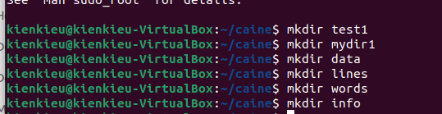







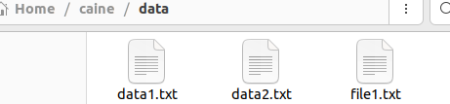



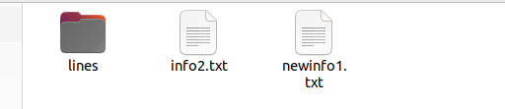

d

**Classwork**

**Exercise 1:**

In the console or terminal window, type the following LINUX commands on the command line.

Note and write down the results

$ ls



$ pwd and $ps

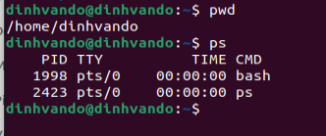

$ cd .. and $ pwd

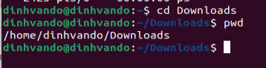

$ cd /usr/local

ls

$ ls



**Exercise 2:**

Execute the following command and explain the meaning of each of them.

• ifconfig: "ifconfig" command is used for displaying current network configuration information, setting up an ip address, netmask or broadcast address to a network interface

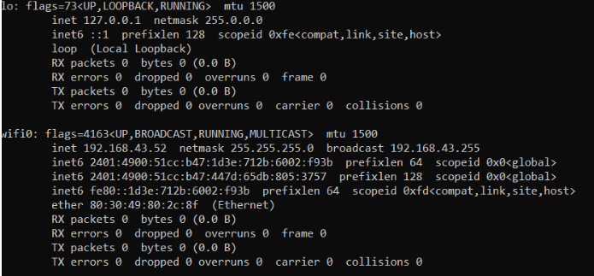

• route –n:  The route command is the interface used to access the linux kernel's routing tables

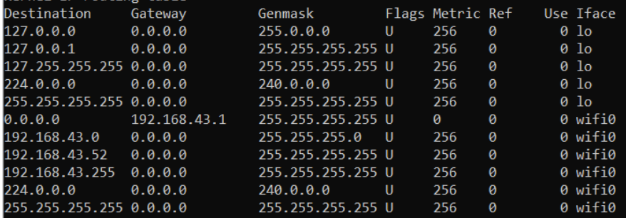

• hostname: It is used to obtain the Domain Name System and set the system's hostname or Network Information System domain name



• cat /proc/cpuinfo:  It displays what type of processor your system is running including the number of CPUs present



• free –m or top: The top command is used to **show the active Linux processes**. It provides a dynamic real-time view of the running system. Usually, this command shows the summary information of the system and the list of processes or threads which are currently managed by the Linux kernel.



• dpkg ‐l: dpkg is the software that forms the low-level base of the Debian package management system. It is the **default package manager on** Ubuntu.

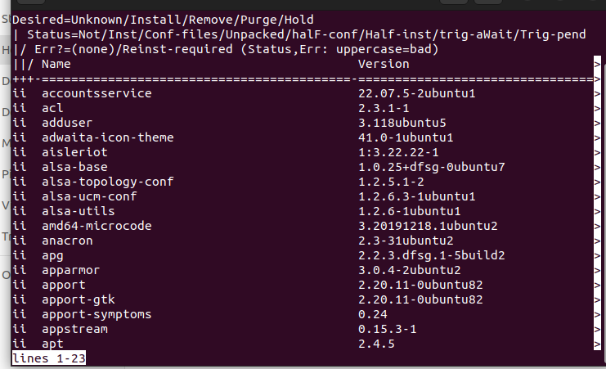

• uname –r: The uname command is **used to print basic system information**. **-r option** prints the kernel release date.

**Exercise 3:**

In your home folder, create a folder tree as following. Note that, the rectangular describes a folder and the circle represent for a file. You can add any information into your created files.

 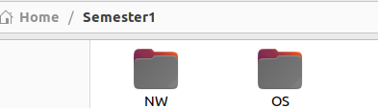 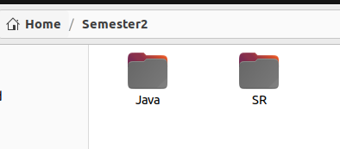

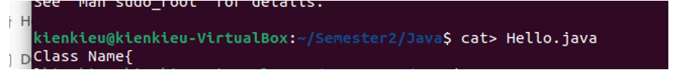

|  |  |
| --- | --- |
|  |  |
|  | **Exercise 4:**  - Create a file named user.txt. Then, you add n usernames (each in one line, n>=5). (cat >)  - Display the content of file user.txt (cat )  - Display list of n sorted usernames in your file and store that sorted list into a new file named suser.txt (sort)  - Count the number of users in your file and display it. |