1. Assume that jobs A-D arrive in the ready queue in quick succession and have the CPU cycle requirements listed below. Using the Shortest Remaining Time Next algorithm

a) The average waiting time is 2.75

b) The Turnaround time of job D is 6

c) The Waiting time of job A is 8

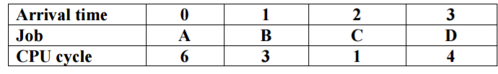

2. A ssume that four jobs A-D require the CPU cycles listed below. Using the Shortest Job First algorithm, the C job is run first.

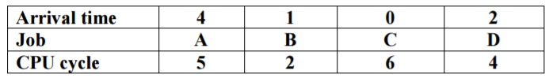

3) A ssume that four jobs A-D require the CPU cycles listed below. Using the Round-Robin algorithm with time slide equaling 4, the average of turnaround time of one process is 10.5 .

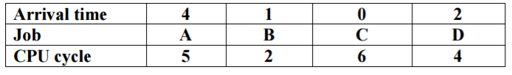

4) Assume that four jobs A-D require the CPU cycles listed below. Using the Shortest Job First algorithm, the average waiting time is 4.75.



5) A ssume that four jobs A-D require the CPU cycles listed below. Using the Round-Robin algorithm with time slide equaling 4, the waiting time of all process is 6.25.

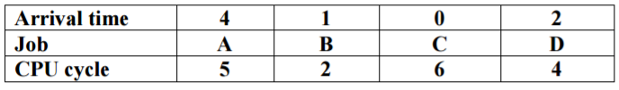

6) Assume jobs A-D arrive in quick succession in the READY queue. Using round robin scheduling with time slice equaling 4, the turnaround time for job D is 22.

|  |  |  |  |  |
| --- | --- | --- | --- | --- |
| **Arrival time** | **0** | **1** | **2** | **3** |
| **Job** | **A** | **B** | **C** | **D** |
| **CPU cycle** | **8** | **4** | **9** | **5** |

7) Assume jobs A-D arrive in quick succession in the READY queue. Using shortest job first scheduling, the average turnaround time for each process is 14.25

|  |  |  |  |  |
| --- | --- | --- | --- | --- |
| **Arrival time** | **0** | **1** | **2** | **3** |
| **Job** | **A** | **B** | **C** | **D** |
| **CPU cycle** | **8** | **4** | **9** | **5** |

8) Assume jobs A-D arrive in quick succession in the READY queue. Using shortest remaining time next scheduling, the average waiting time for each process is 6.5

|  |  |  |  |  |
| --- | --- | --- | --- | --- |
| **Arrival time** | **0** | **1** | **2** | **3** |
| **Job** | **A** | **B** | **C** | **D** |
| **CPU cycle** | **8** | **4** | **9** | **5** |

9) A ssume that four jobs A-D require the CPU cycles listed below. Using the Shortest Job First algorithm, the B job is run first.

|  |  |  |  |  |
| --- | --- | --- | --- | --- |
| **Job** | **A** | **B** | **C** | **D** |
| **CPU cycle** | **5** | **2** | **6** | **4** |

10) Assume jobs A-D arrive in quick succession in the READY queue. Using round robin scheduling with time slice equaling 4, the turnaround time for job C is 16

|  |  |  |  |  |
| --- | --- | --- | --- | --- |
| **Arrival time** | **0** | **1** | **2** | **3** |
| **Job** | **A** | **B** | **C** | **D** |
| **CPU cycle** | **4** | **5** | **5** | **4** |

11) Assume jobs A-D arrive in quick succession in the READY queue. Using shortest job first scheduling, the average turnaround time for each process is 9.25 .

|  |  |  |  |  |
| --- | --- | --- | --- | --- |
| **Arrival time** | **0** | **1** | **2** | **3** |
| **Job** | **A** | **B** | **C** | **D** |
| **CPU cycle** | **4** | **5** | **5** | **4** |

12) Assume jobs A-D arrive in quick succession in the READY queue. Using shortest remaining time next scheduling, the average waiting time for each process is 4.75.

|  |  |  |  |  |
| --- | --- | --- | --- | --- |
| **Arrival time** | **0** | **1** | **2** | **3** |
| **Job** | **A** | **B** | **C** | **D** |
| **CPU cycle** | **4** | **5** | **5** | **4** |

13) Assume jobs A-D arrive in quick succession in the READY queue. Using round robin scheduling (quantum=4), the average turnaround time for each job is 18.25 .

|  |  |  |  |  |
| --- | --- | --- | --- | --- |
| **Arrival time** | **0** | **1** | **2** | **3** |
| **Job** | **A** | **B** | **C** | **D** |
| **CPU cycle** | **8** | **4** | **9** | **5** |

14) Five batch jobs A through E, arrive at a computer center at almost the same time. They have estimated running times of 8, 6, 2, 10, and 4 minutes. Determine the mean process average turnaround time for SJF (Shortest job first) scheduling. Ignore process switching overhead.

🡪 14 minutes