MULTILINGUAL NLP FOR SDG AND SENTIMENT ANALYSIS OF CORPORATE SUSTAINABILITY REPORTS: EVIDENCE FROM VIETNAMESE ENTERPRISES
Le Dan Son, Duong Thi Hoan
ABSTRACT
Corporate sustainability reports serve as fundamental communication conduits for conveying environmental, social, and governance (ESG) commitments to shareholders, capital market participants, and regulatory authorities. Adopting and empirically contextualizing the pioneering computational natural language processing (NLP) framework developed by {Kang, 2022}, this study conducts an automated textual analysis of 42 standalone sustainability and integrated reports published by seven prominent Vietnamese listed corporations (Bao Viet Holdings, The PAN Group, Petrolimex, Phu Nhuan Jewelry, SSI Securities, Vicostone, and Vinamilk) spanning a balanced six-year horizon (2020–2025), encompassing 96,461 digitally extracted sentences. By coupling domain-adapted multilingual Transformer architectures (vietnamese-sbert for Vietnamese and all-MiniLM-L6-v2 for English) with PhoBERT sentiment classification, we quantify corporate semantic alignment with the 17 UN Sustainable Development Goals (SDGs), aggregate alignments into six core human-needs categories (Life, Economic, Equity, Social, Resources, Environments), and evaluate contextual narrative tone (Positive, Neutral, Negative). Empirical findings demonstrate that Kang and Kim's (2022) methodology generalizes robustly to Vietnamese corporate disclosures and emerging market reporting environments, uncovering key empirical characteristics: (1) Disclosures exhibit an overwhelming thematic concentration on Economic development (SDGs 8, 9) and Global Partnerships (SDG 17), alongside systemic under-representation in Equity disclosures (SDGs 4, 5, 10); (2) Disclosures display pronounced structural optimism bias (53.87% positive, 32.87% neutral, and merely 13.26% negative sentences; mean Pos/Neg ratio exceeding 4.0), reflecting achievement-oriented impression management; and (3) Textual reporting volume and SDG thematic coverage have steadily expanded across the 2020–2025 observation period following the enforcement of Circular 96/2020/TT-BTC. This study establishes a practical empirical use case demonstrating the viability of computational NLP for non-financial audit in Vietnam.
Keywords: Corporate sustainability reports; Sustainable Development Goals (SDGs); Natural language processing (NLP); Sentence-BERT; PhoBERT; Sentiment analysis; Impression management; Vietnamese listed enterprises.
1. INTRODUCTION
Amid accelerating global climate change and the worldwide transition toward a circular economy, disclosing Environmental, Social, and Governance (ESG) commitments aligned with the United Nations 17 Sustainable Development Goals (SDGs) {United Nations, 2015} has emerged as an indispensable imperative for publicly listed corporations {Global Reporting Initiative, 2021}. In Vietnam, reinforced by the national Net-Zero commitment by 2050 announced at COP26 and the formal promulgation of Circular No. 96/2020/TT-BTC {Bộ Tài chính, 2020} regulating information disclosure on the equity market, listed firms are legally obligated to report on environmental and social performance. Supported by the Corporate Sustainability Index (CSI) {Hội đồng Doanh nghiệp vì sự Phát triển Bền vững Việt Nam, 2024} and ESG disclosure guidelines from the State Securities Commission {Ủy ban Chứng khoán Nhà nước, 2024}, major market capitalization leaders in Vietnam have actively transitioned from cursory sections in annual reports toward comprehensive standalone Sustainability Reports and Integrated Reports benchmarked against GRI standards.
Nevertheless, the dramatic expansion in disclosure volume—frequently spanning dozens to hundreds of pages of unstructured prose—presents formidable challenges for regulatory auditors, financial analysts, and responsible investors seeking timely and objective assessment {Arvidsson & Dumay, 2022}. Traditional manual content analysis is inherently labor-intensive, unscalable, and vulnerable to subjective coder biases. Furthermore, unstandardized qualitative narratives provide substantial discretion for impression management {Merkl-Davies & Brennan, 2007}, where corporate management strategically emphasizes favorable achievements while obfuscating environmental hazards or social deficiencies. Consequently, automated and objective analytical methodologies grounded in Artificial Intelligence (AI) and Natural Language Processing (NLP) are urgently needed {Luccioni et al., 2020}.
A seminal methodological breakthrough was achieved by {Kang, 2022} in Applied Sciences, who established a computational pipeline leveraging Sentence-BERT (SBERT) {Reimers & Gurevych, 2019} to quantify semantic similarity between corporate sustainability narratives and the 17 UN SDGs, aggregating scores into six human-needs categories and examining sentiment polarities across major multinational conglomerates. While Kang and Kim's (2022) framework demonstrated superior performance over legacy keyword-matching techniques, their empirical validation was confined to English texts and global corporations. The crucial question remains: Can this computational framework be effectively adapted to a low-resource tonal language like Vietnamese and to corporate disclosures within an emerging market? And what salient reporting characteristics does this lens uncover?
To address these questions, this paper presents an empirical use case adapting and implementing the analytical pipeline of {Kang, 2022} for Vietnamese corporate sustainability disclosures. We analyze 42 sustainability and integrated reports published by seven blue-chip corporations representing pivotal sectors of the Vietnamese economy (Bao Viet Holdings, The PAN Group, Petrolimex, Phu Nhuan Jewelry, SSI Securities, Vicostone, and Vinamilk) across a balanced six-year observation window (2020–2025), totaling 96,461 digitally extracted sentences. Rather than pursuing overly complex capital market regressions, this study focuses squarely on demonstrating the successful cross-lingual transferability of Kang and Kim's (2022) pipeline and identifying the authentic reporting characteristics of Vietnamese enterprises.
2. LITERATURE REVIEW
2.1 Corporate Sustainability Disclosures and the UN SDGs
The 2030 Agenda for Sustainable Development, comprising 17 SDGs and 169 specific targets, provides an internationally recognized architecture for tackling poverty, ecological degradation, and institutional inequality {United Nations, 2015}. Grounded in Stakeholder Theory {Freeman, 1984} and Legitimacy Theory {Deegan, 2002}, corporate sustainability disclosure is conceptualized as an essential instrument for maintaining social license to operate. However, empirical investigations across global markets ('{Muñoz-Torres et al., 2019}', '{Pizzi et al., 2020}') document prevalent 'SDG cherry-picking' {Heras-Saizarbitoria et al., 2022}, whereby enterprises selectively report on goals that align with existing commercial activities while systematically downplaying contentious societal or ecological objectives.
2.2 NLP and Transformer Architectures in Sustainability Analysis
Early computational text analysis in accounting and finance predominantly relied on dictionary lookups or frequency-based metrics (TF-IDF), which disregard syntax and polysemic context {Mercereau & Melin, 2020}. The advent of bidirectional Transformer models {Devlin et al., 2019} and Siamese architectures such as Sentence-BERT {Reimers & Gurevych, 2019} enabled the generation of dense semantic vector embeddings that capture nuanced conceptual meaning. {Kang, 2022} demonstrated that SBERT computes continuous cosine similarity distributions against benchmark SDG definitions far more effectively than traditional lexical models. For Vietnamese text, models such as PhoBERT {Nguyen & Nguyen, 2020} and domain-adapted vietnamese-sbert have established state-of-the-art benchmarks for semantic parsing in financial and administrative domains.
2.3 Sentiment Analysis and Impression Management Theory
Textual sentiment analysis in corporate disclosures traces back to {Loughran & McDonald, 2011}, who demonstrated that general linguistic lexicons misclassify standard business terminology. In non-financial reporting, {Cho et al., 2010} and {Veenstra & Ellemers, 2020} showed that corporate narratives are prone to impression management and the Pollyanna principle, characterized by a persistent structural inflation of optimistic language. Tracking the ratio of positive to negative sentences (Pos/Neg Ratio) provides a reliable quantitative gauge of managerial optimism and tone management {Kang, 2022}.
2.4 Kang & Kim's (2022) Six Human-Needs Taxonomy
To synthesize the high-dimensional 17 SDGs into an interpretable analytical framework, {Kang, 2022} adopted {Max-Neef, 1991}'s human-scale development theory to aggregate the 17 goals into six core human-needs categories: Life, Economic, Equity, Social, Resources, and Environments. This taxonomy provides a balanced lens for comparing corporate strategic priorities across heterogeneous industries and longitudinal reporting cycles.
3. DATA AND METHODOLOGY
3.1 Sample Selection and Corpus Construction
To execute this empirical use case, we selected seven prominent corporations listed on the Ho Chi Minh Stock Exchange (HOSE) and Hanoi Stock Exchange (HNX) possessing an uninterrupted six-year history of publishing standalone sustainability or integrated reports from 2020 to 2025 (42 reports in total). These firms represent seven bellwether industries: Insurance/Finance (BVH), Agriculture/Food (PAN), Petroleum/Energy (PLX), Jewelry/Retail (PNJ), Securities/Investment Banking (SSI), Advanced Materials/Manufacturing (VCS), and Dairy/FMCG (VNM). Comprehensive corporate profiles are presented in Table 1.
Table 1
Overview of the Seven Vietnamese Listed Corporations Sampled (2020–2025)
Ticker | Company Name | Core Industry Sector | Exchange | Period | Reporting Framework Applied
BVH | Bao Viet Holdings | Finance, Life & Non-Life Insurance, Fund Management | HOSE | 2020–2025 | International Integrated Reporting (<IIRC>), GRI Standards
PAN | The PAN Group JSC | Hi-Tech Agriculture, Aquaculture, Packaged Food | HOSE | 2020–2025 | GRI Standards, Value-chain Materiality Matrix
PLX | Vietnam National Petroleum Group (Petrolimex) | Energy, Downstream Petroleum Distribution, Petrochemicals | HOSE | 2020–2025 | GRI Standards, ISO 14064-1 GHG Inventory
PNJ | Phu Nhuan Jewelry JSC | Jewelry Manufacturing, Retail Fashion | HOSE | 2020–2025 | GRI Standards, DE&I Pillars, Human Capital
SSI | SSI Securities Corporation | Financial Services, Securities Brokerage, Investment Banking | HOSE | 2020–2025 | GRI Standards, Sustainable Finance & Responsible Investment
VCS | Vicostone JSC (Phenikaa Group) | Engineered Quartz Stone Surfaces, Manufacturing | HNX | 2020–2025 | GRI Standards, Circular Economy & Chemical Safety
VNM | Vietnam Dairy Products JSC (Vinamilk) | Dairy Farming, Nutritional Beverage Manufacturing | HOSE | 2020–2025 | GRI Standards, PAS 2060 (Carbon Neutrality), CDP
Note. Data compiled from official standalone Corporate Sustainability Reports and Integrated Reports disclosed via HOSE, HNX, and corporate portals.
3.2 Text Ingestion and Preprocessing Pipeline
Our preprocessing protocol faithfully mirrors the filtration standards established by {Kang, 2022}: (1) Text extraction from PDF documents was executed using PyMuPDF (fitz), automatically stripping front covers, tables of contents, blank graphic pages, and procedural disclaimers; (2) Structural segmentation decomposed continuous paragraphs into individual sentences based on grammatical punctuation boundaries; (3) A length threshold discarded sentence fragments containing fewer than 6 words; (4) For scanned graphic PDF documents (specifically PNJ's 2022 report), an optical character recognition (OCR) module using Tesseract (vie+eng) was deployed to recover substantive text segments and prevent data omission. Across all 42 reports, the pipeline produced a clean corpus of 96,461 valid sentences spanning 4,997 pages, yielding an average density of 20.35 sentences per page (detailed in Table 3).
3.3 Multilingual Sentence Embedding and SDG Alignment
Following {Kang, 2022}, a reference corpus representing the 17 UN SDGs was constructed by professionally compiling the official 169 targets in parallel Vietnamese and English texts (~400 reference sentences). Let S_g denote the set of benchmark sentences defining goal g (g = 1, ..., 17).
To project text segments into semantic vector space, we deployed vietnamese-sbert {Reimers & Gurevych, 2019} for Vietnamese disclosures and all-MiniLM-L6-v2 for English disclosures. Each report sentence r and benchmark sentence s in S_g is mapped into a 768-dimensional embedding vector r_hat and s_hat. The alignment score between report sentence r and SDG target g is defined as the mean cosine similarity between r_hat and all benchmark vectors in S_g:
$sim(r,g)=\frac{1}{\left|S_{g}\right|}\sum_{s∈S_{g}}{cos(}\hat{r},\hat{s})=\frac{1}{\left|S_{g}\right|}\sum_{s∈S_{g}}{\frac{\hat{r}·\hat{s}}{\left\| ‖ ‖ \right\|}}$ | (1)
3.4 Min-Max Normalization and Six Human-Needs Aggregation
Because raw cosine similarity metrics naturally concentrate within a narrow numerical interval, we implemented global Min-Max normalization verbatim from {Kang, 2022} to project similarity values onto an intuitive 0–100 scale:
$Score(r,g)=\frac{sim(r,g)−min(sim)}{max(sim)−min(sim)}×100$ | (2)
Next, the 17 normalized SDG scores are aggregated into the six human-needs categories defined by {Kang, 2022} as displayed in Table 2. The composite score for human-needs category C_k on sentence r is calculated as the arithmetic mean of its constituent SDG scores:
$CatScore(r,C_{k})=\frac{1}{\left|C_{k}\right|}\sum_{g∈C_{k}}{Score}(r,g)$ | (3)
Table 2
Mapping of the 17 UN SDGs into Six Human-Needs Categories (Kang & Kim, 2022)
Human-Needs Category | Constituent SDGs | Core Focus and Thematic Definition
Life | SDG 1, 2, 3 | No Poverty, Zero Hunger, Good Health and Well-being
Economic | SDG 8, 9 | Decent Work and Economic Growth, Industry, Innovation, and Infrastructure
Equity | SDG 4, 5, 10 | Quality Education, Gender Equality, Reduced Inequalities
Social | SDG 11, 16, 17 | Sustainable Cities, Peace, Justice and Strong Institutions, Partnerships for the Goals
Resources | SDG 6, 7, 12 | Clean Water and Sanitation, Affordable and Clean Energy, Responsible Consumption
Environments | SDG 13, 14, 15 | Climate Action, Life Below Water, Life on Land
Note. Taxonomy adopted verbatim from the analytical framework of Kang and Kim (2022).
3.5 Sentiment Classification and Sentiment Ratio
In contrast to the binary classifier (Positive/Negative) employed by {Kang, 2022}, corporate disclosures frequently feature neutral factual and technical metrics. We therefore deployed PhoBERT-base {Nguyen & Nguyen, 2020} fine-tuned for Vietnamese sentiment classification (phobert-base-vietnamese-sentiment), which categorizes each sentence into three classes: Positive, Neutral, or Negative. Following {Kang, 2022}, the corporate Sentiment Ratio (Pos/Neg Ratio) for each report is computed as total positive sentences divided by total negative sentences:
$Sentiment Ratio=\frac{N_{Positive}}{N_{Negative}}$ | (4)
Neutral sentences representing purely objective factual disclosures are retained in the overall distributional breakdown but excluded from the ratio calculation to maximize sensitivity to managerial emphasis on achievements versus operational challenges.
4. RESULTS
Table 3
Descriptive Statistics of Textual Volume Across 42 Sustainability Reports (2020–2025)
Company | Year | Report PDF Filename | Sentences | Pages | Density (sent/page)
BVH | 2020 | BVH_SR_2020.pdf | 5,627 | 410 | 13.72
BVH | 2021 | BVH_SR_2021.pdf | 6,388 | 222 | 28.77
BVH | 2022 | BVH_SR_2022.pdf | 6,419 | 386 | 16.63
BVH | 2023 | BVH_SR_2023.pdf | 3,691 | 279 | 13.23
BVH | 2024 | BVH_SR_2024.pdf | 4,037 | 314 | 12.86
BVH | 2025 | BVH_SR_2025.pdf | 4,515 | 346 | 13.05
PAN | 2020 | PAN_SR_2020.pdf | 1,464 | 83 | 17.64
PAN | 2021 | PAN_SR_2021.pdf | 1,572 | 76 | 20.68
PAN | 2022 | PAN_SR_2022.pdf | 1,630 | 67 | 24.33
PAN | 2023 | PAN_SR_2023.pdf | 883 | 61 | 14.48
PAN | 2024 | PAN_SR_2024.pdf | 1,758 | 87 | 20.21
PAN | 2025 | PAN_SR_2025.pdf | 2,044 | 89 | 22.97
PLX | 2020 | PLX_SR_2020.pdf | 2,038 | 85 | 23.98
PLX | 2021 | PLX_SR_2021.pdf | 206 | 31 | 6.65
PLX | 2022 | PLX_SR_2022.pdf | 1,948 | 107 | 18.21
PLX | 2023 | PLX_SR_2023.pdf | 969 | 76 | 12.75
PLX | 2024 | PLX_SR_2024.pdf | 112 | 23 | 4.87
PLX | 2025 | PLX_SR_2025.pdf | 1,377 | 81 | 17.00
PNJ | 2020 | PNJ_SR_2020.pdf | 1,839 | 59 | 31.17
PNJ | 2021 | PNJ_SR_2021.pdf | 883 | 50 | 17.66
PNJ | 2022 | PNJ_SR_2022.pdf | 669 | 57 | 11.74
PNJ | 2023 | PNJ_SR_2023.pdf | 1,050 | 56 | 18.75
PNJ | 2024 | PNJ_SR_2024.pdf | 1,489 | 69 | 21.58
PNJ | 2025 | PNJ_SR_2025.pdf | 1,618 | 82 | 19.73
SSI | 2020 | SSI_SR_2020.pdf | 1,246 | 51 | 24.43
SSI | 2021 | SSI_SR_2021.pdf | 1,213 | 52 | 23.33
SSI | 2022 | SSI_SR_2022.pdf | 1,190 | 51 | 23.33
SSI | 2023 | SSI_SR_2023.pdf | 1,203 | 50 | 24.06
SSI | 2024 | SSI_SR_2024.pdf | 1,669 | 56 | 29.80
SSI | 2025 | SSI_SR_2025.pdf | 1,938 | 69 | 28.09
VCS | 2020 | VCS_SR_2020.pdf | 2,174 | 102 | 21.31
VCS | 2021 | VCS_SR_2021.pdf | 2,139 | 91 | 23.51
VCS | 2022 | VCS_SR_2022.pdf | 2,455 | 103 | 23.83
VCS | 2023 | VCS_SR_2023.pdf | 2,454 | 110 | 22.31
VCS | 2024 | VCS_SR_2024.pdf | 2,516 | 125 | 20.13
VCS | 2025 | VCS_SR_2025.pdf | 5,974 | 248 | 24.09
VNM | 2020 | VNM_SR_2020.pdf | 3,031 | 107 | 28.33
VNM | 2021 | VNM_SR_2021.pdf | 3,509 | 109 | 32.19
VNM | 2022 | VNM_SR_2022.pdf | 2,886 | 93 | 31.03
VNM | 2023 | VNM_SR_2023.pdf | 1,907 | 120 | 15.89
VNM | 2024 | VNM_SR_2024.pdf | 2,221 | 112 | 19.83
VNM | 2025 | VNM_SR_2025.pdf | 2,510 | 152 | 16.51
Note. Total sample: 42 reports, 4,997 pages, 96,461 validated sentences. Mean corpus density is 20.35 sentences per page.
4.1 Global Distribution of SDG Similarity Scores
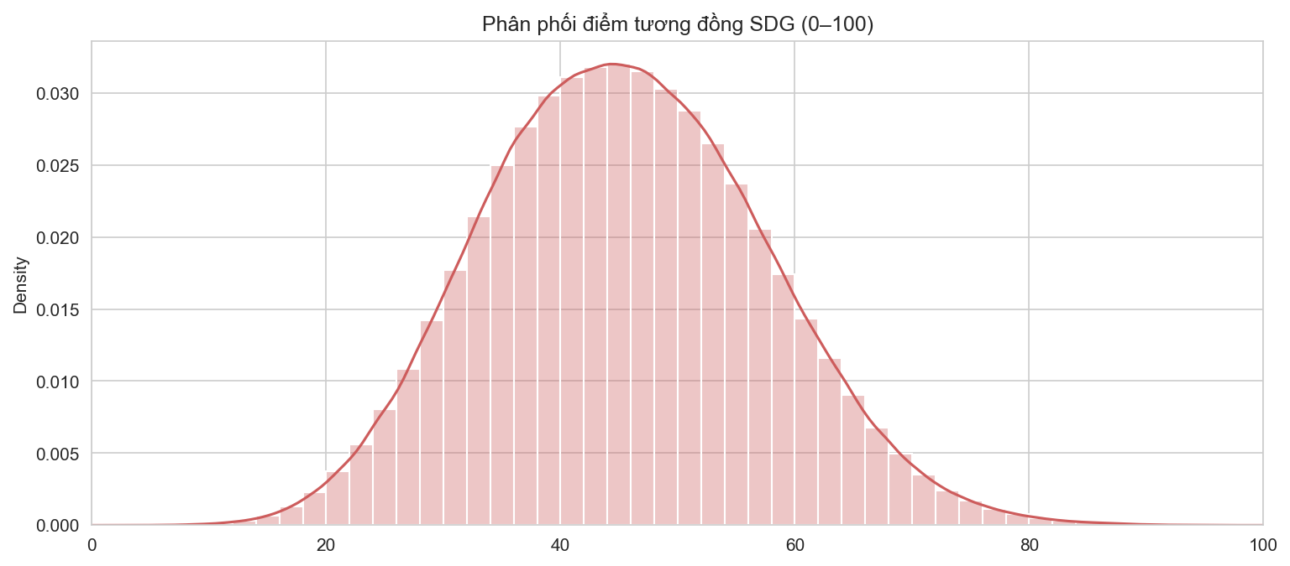
Figure 1. Empirical probability distribution of SDG similarity scores across 96,461 sentences (0–100 scale)
Figure 1 illustrates the frequency distribution of normalized SDG similarity scores across all 96,461 sentences. The distribution displays a classic bell-shaped Gaussian form centered at a mean of 45.43 points with a standard deviation of 11.87. The vast majority of corporate sentences reside within the 35–55 point interval, reflecting standard organizational narrative describing general governance, corporate background, and operational routines with moderate SDG alignment.
Notably, approximately 8.5% of sentences occupy the upper tail (scores between 65 and 90 points). These correspond to substantive descriptions of specific initiatives directly tied to UN targets—such as renewable energy retrofits, closed-loop wastewater systems, or occupational health protocols. This smooth, continuous distribution closely mirrors the findings of {c_kang} for multinational corporations, corroborating the cross-linguistic robustness of Sentence-BERT in mapping Vietnamese disclosures onto international SDG frameworks.
4.2 Six-Category SDG Heatmap Matrix
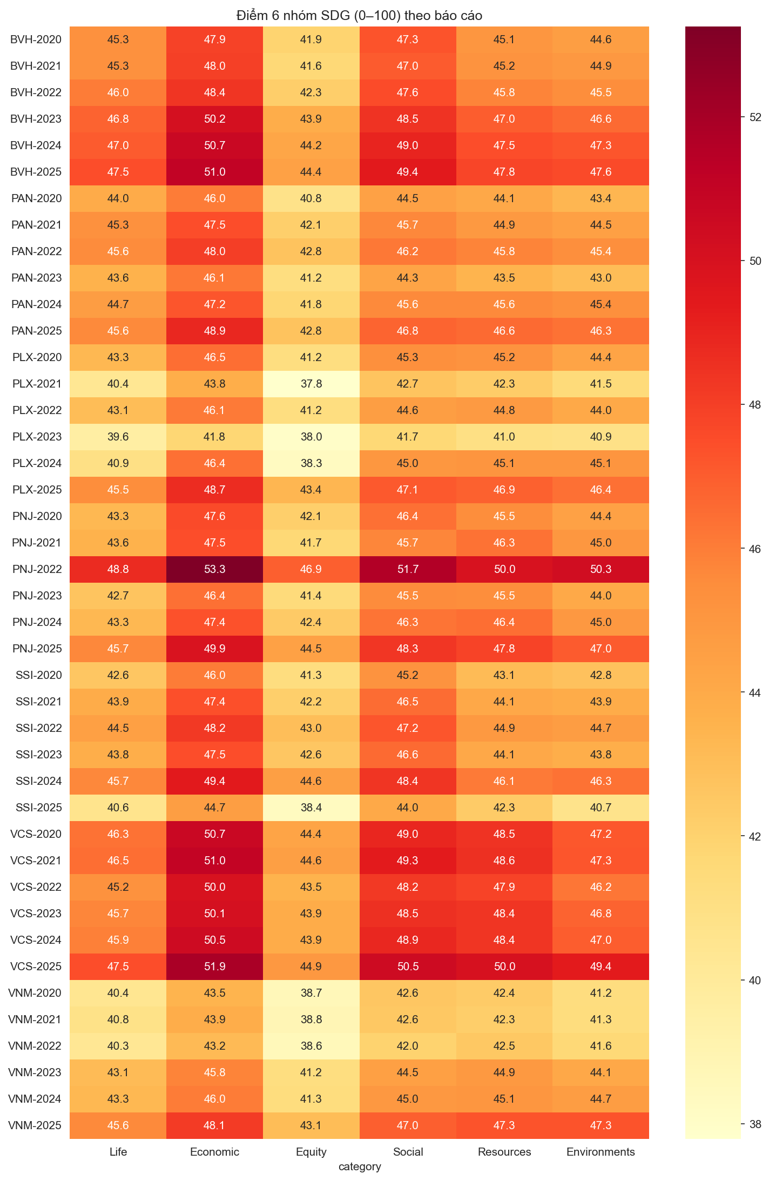
Figure 2. Heatmap matrix of corporate alignment across six human-needs categories for seven firms (2020–2025)
Figure 2 presents a heatmap depicting alignment across the six human-needs categories across all 42 corporate reports. Color gradients transition from pale yellow (lower alignment, ~38 points) to deep crimson (elevated alignment, >51 points). Numerical category averages for each corporation and year are itemized in Table 4. The empirical visualization reveals an unambiguous structural hierarchy: the Economic category consistently exhibits the deepest red across virtually all company-years, followed closely by Social and Resources, whereas Equity persistently displays the lightest yellow shades.
Table 4
Mean Scores Across Six Human-Needs SDG Categories by Corporation and Year (0–100 Scale)
Company | Year | Life | Economic | Equity | Social | Resources | Environments
BVH | 2020 | 45.33 | 47.93 | 41.91 | 47.30 | 45.10 | 44.64
BVH | 2021 | 45.30 | 47.96 | 41.61 | 47.05 | 45.22 | 44.93
BVH | 2022 | 46.03 | 48.38 | 42.26 | 47.57 | 45.82 | 45.49
BVH | 2023 | 46.82 | 50.17 | 43.86 | 48.47 | 47.00 | 46.58
BVH | 2024 | 47.04 | 50.68 | 44.23 | 49.00 | 47.48 | 47.25
BVH | 2025 | 47.50 | 51.04 | 44.43 | 49.41 | 47.77 | 47.59
PAN | 2020 | 44.00 | 46.04 | 40.79 | 44.49 | 44.12 | 43.35
PAN | 2021 | 45.32 | 47.49 | 42.15 | 45.69 | 44.86 | 44.51
PAN | 2022 | 45.57 | 48.00 | 42.76 | 46.16 | 45.77 | 45.42
PAN | 2023 | 43.63 | 46.14 | 41.23 | 44.35 | 43.48 | 43.05
PAN | 2024 | 44.71 | 47.23 | 41.77 | 45.59 | 45.60 | 45.36
PAN | 2025 | 45.63 | 48.87 | 42.77 | 46.77 | 46.60 | 46.33
PLX | 2020 | 43.33 | 46.47 | 41.19 | 45.34 | 45.20 | 44.36
PLX | 2021 | 40.38 | 43.83 | 37.79 | 42.69 | 42.26 | 41.47
PLX | 2022 | 43.07 | 46.12 | 41.22 | 44.62 | 44.83 | 44.04
PLX | 2023 | 39.63 | 41.76 | 37.98 | 41.71 | 41.04 | 40.89
PLX | 2024 | 40.94 | 46.39 | 38.30 | 44.99 | 45.14 | 45.14
PLX | 2025 | 45.49 | 48.71 | 43.37 | 47.14 | 46.86 | 46.41
PNJ | 2020 | 43.33 | 47.63 | 42.14 | 46.39 | 45.51 | 44.45
PNJ | 2021 | 43.60 | 47.47 | 41.71 | 45.73 | 46.34 | 45.03
PNJ | 2022 | 48.77 | 53.26 | 46.95 | 51.68 | 49.98 | 50.33
PNJ | 2023 | 42.71 | 46.42 | 41.45 | 45.52 | 45.51 | 44.02
PNJ | 2024 | 43.34 | 47.35 | 42.39 | 46.27 | 46.44 | 44.95
PNJ | 2025 | 45.70 | 49.88 | 44.47 | 48.31 | 47.82 | 47.04
SSI | 2020 | 42.56 | 46.05 | 41.27 | 45.20 | 43.13 | 42.82
SSI | 2021 | 43.92 | 47.45 | 42.17 | 46.54 | 44.11 | 43.89
SSI | 2022 | 44.55 | 48.20 | 43.00 | 47.22 | 44.86 | 44.70
SSI | 2023 | 43.78 | 47.46 | 42.57 | 46.60 | 44.08 | 43.81
SSI | 2024 | 45.69 | 49.39 | 44.58 | 48.42 | 46.07 | 46.31
SSI | 2025 | 40.59 | 44.65 | 38.36 | 44.01 | 42.33 | 40.71
VCS | 2020 | 46.32 | 50.71 | 44.36 | 48.96 | 48.48 | 47.18
VCS | 2021 | 46.45 | 50.98 | 44.58 | 49.35 | 48.58 | 47.27
VCS | 2022 | 45.22 | 49.98 | 43.53 | 48.23 | 47.88 | 46.21
VCS | 2023 | 45.75 | 50.14 | 43.90 | 48.55 | 48.37 | 46.81
VCS | 2024 | 45.93 | 50.52 | 43.90 | 48.89 | 48.42 | 47.02
VCS | 2025 | 47.48 | 51.90 | 44.94 | 50.51 | 50.03 | 49.35
VNM | 2020 | 40.41 | 43.51 | 38.66 | 42.59 | 42.36 | 41.23
VNM | 2021 | 40.83 | 43.88 | 38.84 | 42.56 | 42.26 | 41.29
VNM | 2022 | 40.29 | 43.19 | 38.58 | 42.01 | 42.53 | 41.65
VNM | 2023 | 43.11 | 45.77 | 41.19 | 44.53 | 44.87 | 44.10
VNM | 2024 | 43.34 | 46.03 | 41.30 | 44.96 | 45.10 | 44.69
VNM | 2025 | 45.60 | 48.15 | 43.10 | 46.96 | 47.33 | 47.29
Note. Life: SDGs 1, 2, 3; Economic: SDGs 8, 9; Equity: SDGs 4, 5, 10; Social: SDGs 11, 16, 17; Resources: SDGs 6, 7, 12, 14; Environments: SDGs 13, 15.
As reported in Table 4, Economic scores consistently rank highest across all corporate disclosures, ranging from 43.19 to 51.90 points. This reflects the core pragmatic focus of Vietnamese enterprises, where economic growth, employment generation (SDG 8), and infrastructure innovation (SDG 9) form the foundation of corporate communications. Conversely, the Equity category (SDGs 4, 5, 10: quality education, gender equality, and reduced inequalities) records the lowest scores (ranging between 38.36 and 44.94 points). A structural gap of 6 to 8 points between Economic and Equity persists across all corporations, documenting a systemic priority divergence in corporate sustainability disclosures.
4.3 Longitudinal Trajectories Across 2020–2025
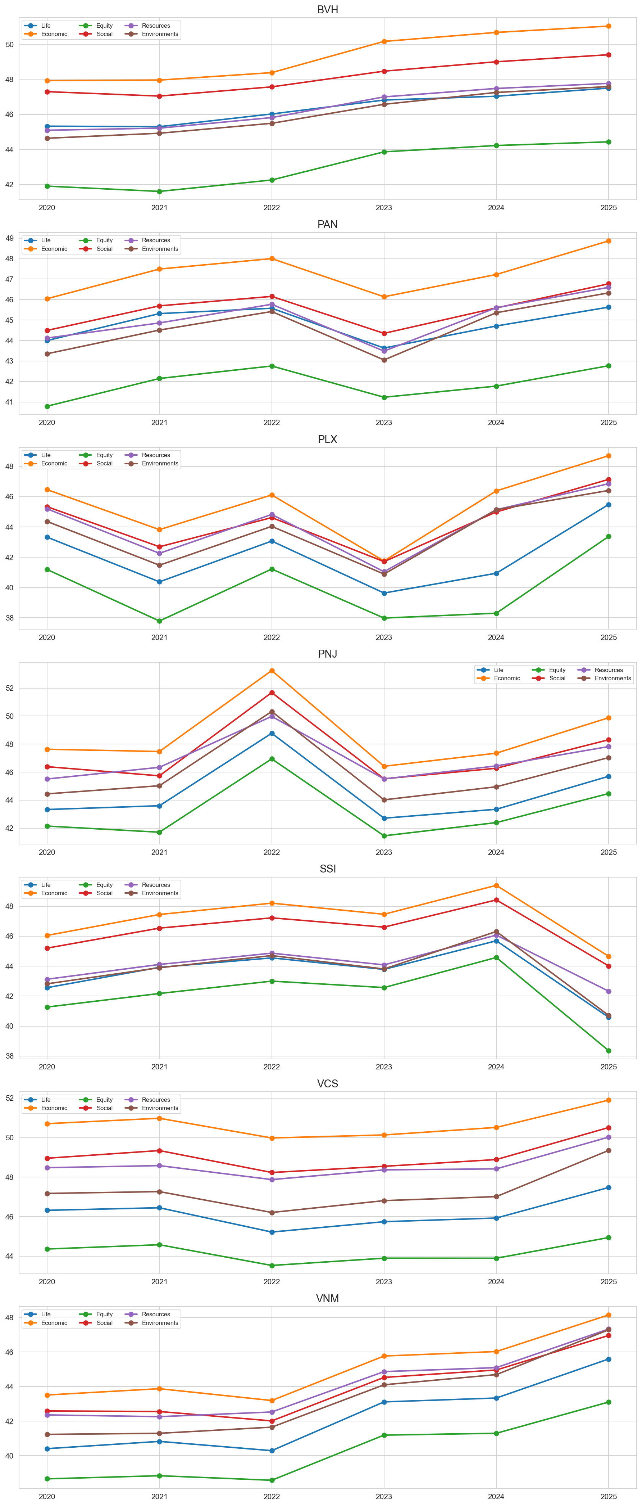
Figure 3. Longitudinal evolution of the six human-needs categories across seven corporations (2020–2025)
Figure 3 traces the multi-year trajectory of the six SDG categories for each sampled enterprise. A key empirical insight is the steady upward convergence observed across most corporations during the 2023–2025 period. Bao Viet Holdings (BVH), Vinamilk (VNM), and Vicostone (VCS) exhibit notable score gains across multiple categories. For Vinamilk, Environments alignment climbed from 41.23 points in 2020 to 47.29 points in 2025, driven by formal PAS 2060 carbon neutrality certification of major dairy factories and the expansion of certified Green Farm eco-facilities.
Vicostone (VCS) similarly expanded its reporting scope in 2025 (reaching nearly 6,000 sentences), elevating both Economic and Social scores above 50 points through detailed disclosures on circular material recycling and supply-chain ESG oversight. Across the full six-year window, Vietnamese corporate reports demonstrate marked maturation in both linguistic depth and multi-target SDG coverage.
4.4 Sentiment Polarity Distribution and Pos/Neg Dynamics
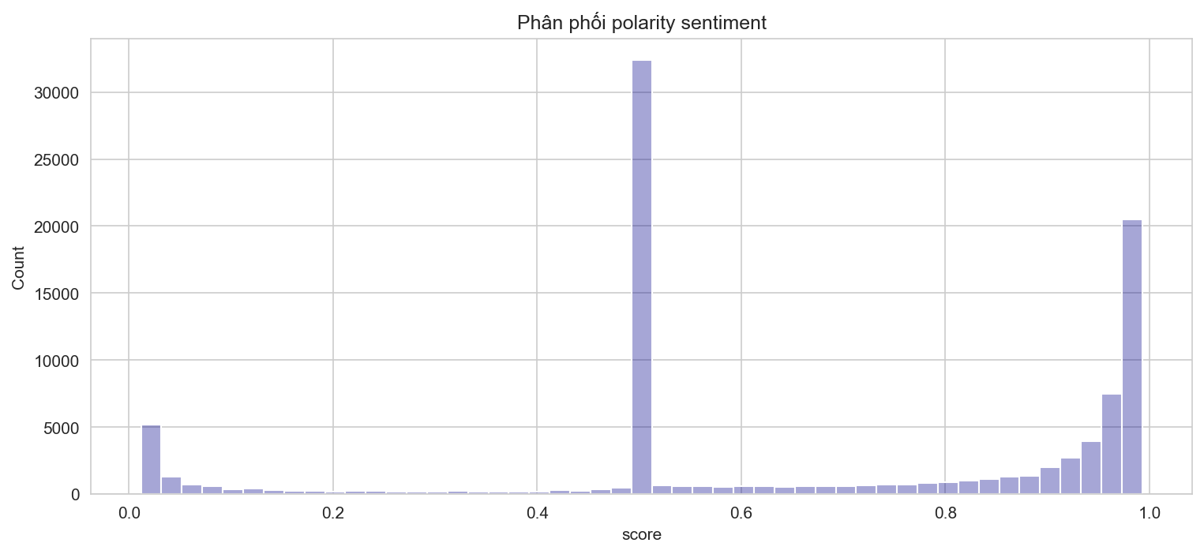
Figure 4. Probability density of sentence sentiment polarity scores estimated by PhoBERT
Figure 4 delineates the distribution of sentence-level sentiment probability scores predicted by PhoBERT. The empirical curve exhibits a distinct bimodal structure: an initial mode centered at neutrality (0.45–0.55), representing operational and quantitative facts, and a dominant spike in the extreme positive range (0.90–1.00). Sentences situated in the negative zone (< 0.20) are sparse, providing direct visual evidence of pervasive optimistic tone.
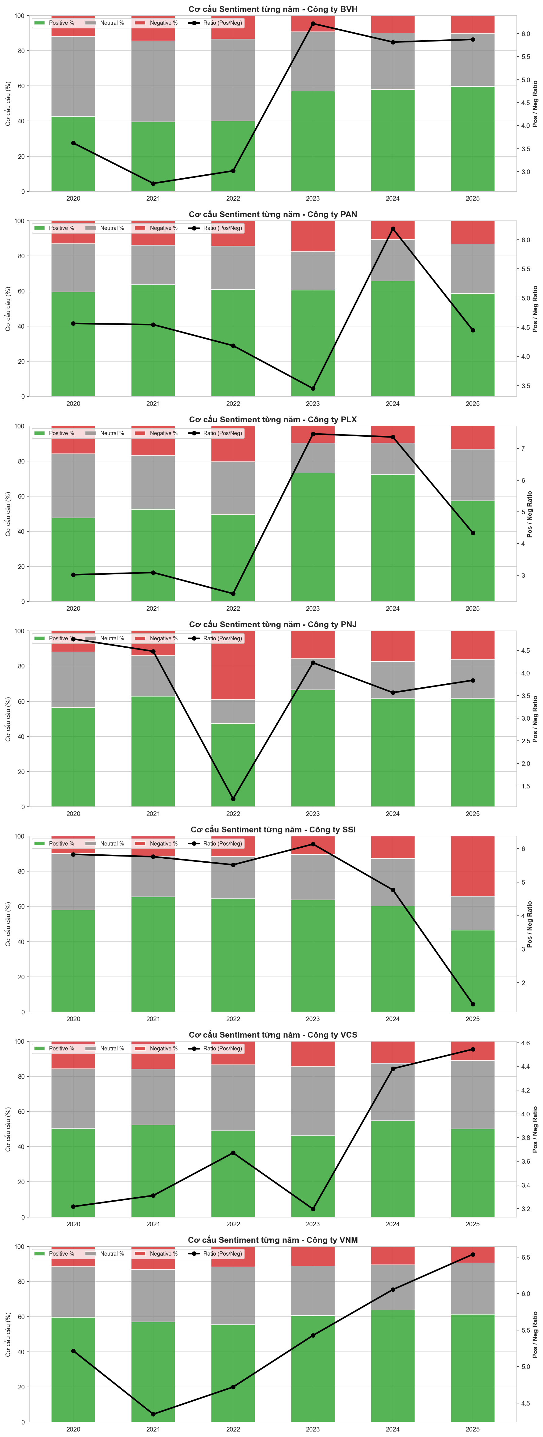
Figure 5. Proportional sentiment composition (Positive, Neutral, Negative) by corporation (2020–2025)
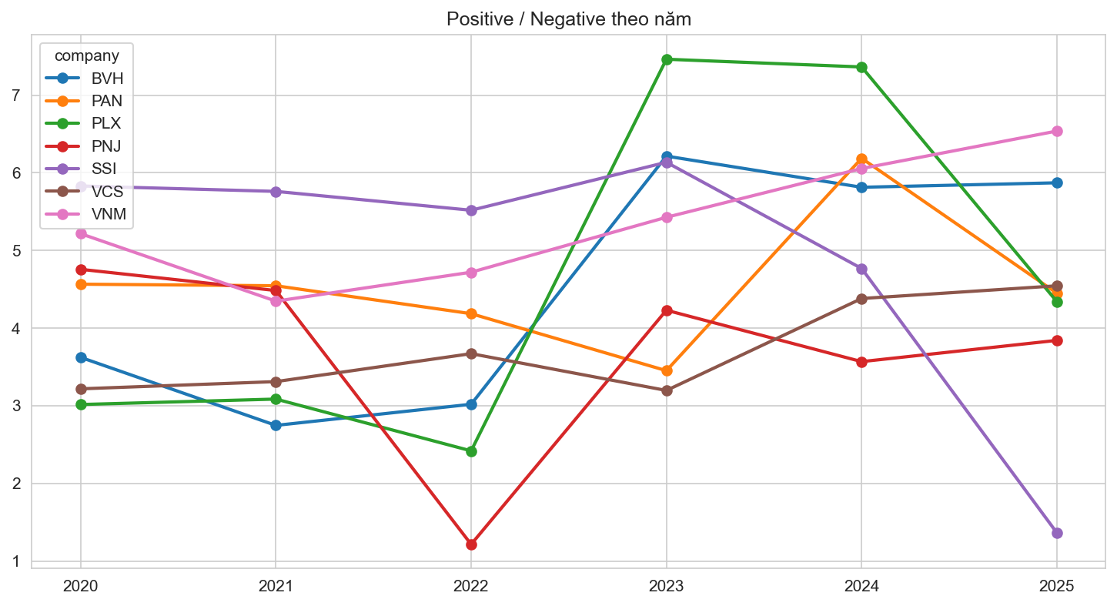
Figure 6. Multi-year trajectories of corporate Sentiment Ratios (Pos/Neg Ratio) from 2020 to 2025
Table 5
Textual Sentiment Frequencies and Annual Pos/Neg Ratios Across 42 Sustainability Reports
Company | Year | Negative (Neg) | Neutral (Neu) | Positive (Pos) | Pos/Neg Ratio
BVH | 2020 | 663 | 2,562 | 2,402 | 3.62
BVH | 2021 | 920 | 2,941 | 2,527 | 2.75
BVH | 2022 | 853 | 2,991 | 2,575 | 3.02
BVH | 2023 | 339 | 1,245 | 2,107 | 6.22
BVH | 2024 | 403 | 1,291 | 2,343 | 5.81
BVH | 2025 | 459 | 1,361 | 2,695 | 5.87
PAN | 2020 | 191 | 401 | 872 | 4.57
PAN | 2021 | 220 | 352 | 1,000 | 4.55
PAN | 2022 | 237 | 401 | 992 | 4.19
PAN | 2023 | 155 | 193 | 535 | 3.45
PAN | 2024 | 187 | 414 | 1,157 | 6.19
PAN | 2025 | 269 | 578 | 1,197 | 4.45
PLX | 2020 | 322 | 745 | 971 | 3.02
PLX | 2021 | 35 | 63 | 108 | 3.09
PLX | 2022 | 399 | 584 | 965 | 2.42
PLX | 2023 | 95 | 165 | 709 | 7.46
PLX | 2024 | 11 | 20 | 81 | 7.36
PLX | 2025 | 182 | 405 | 790 | 4.34
PNJ | 2020 | 218 | 584 | 1,037 | 4.76
PNJ | 2021 | 124 | 203 | 556 | 4.48
PNJ | 2022 | 261 | 91 | 317 | 1.21
PNJ | 2023 | 165 | 187 | 698 | 4.23
PNJ | 2024 | 257 | 315 | 917 | 3.57
PNJ | 2025 | 259 | 364 | 995 | 3.84
SSI | 2020 | 124 | 399 | 723 | 5.83
SSI | 2021 | 138 | 280 | 795 | 5.76
SSI | 2022 | 139 | 284 | 767 | 5.52
SSI | 2023 | 125 | 311 | 767 | 6.14
SSI | 2024 | 211 | 452 | 1,006 | 4.77
SSI | 2025 | 662 | 374 | 902 | 1.36
VCS | 2020 | 340 | 740 | 1,094 | 3.22
VCS | 2021 | 338 | 682 | 1,119 | 3.31
VCS | 2022 | 328 | 923 | 1,204 | 3.67
VCS | 2023 | 356 | 960 | 1,138 | 3.20
VCS | 2024 | 315 | 821 | 1,380 | 4.38
VCS | 2025 | 659 | 2,320 | 2,995 | 4.54
VNM | 2020 | 347 | 874 | 1,810 | 5.22
VNM | 2021 | 461 | 1,044 | 2,004 | 4.35
VNM | 2022 | 339 | 947 | 1,600 | 4.72
VNM | 2023 | 213 | 538 | 1,156 | 5.43
VNM | 2024 | 234 | 570 | 1,417 | 6.06
VNM | 2025 | 236 | 731 | 1,543 | 6.54
Note. Automated classification conducted via PhoBERT. Pos/Neg Ratio = Positive sentence count / Negative sentence count.
Figure 5 and Table 5 summarize the corpus-wide sentiment profile across 96,461 sentences. Positive statements form the absolute majority with 51,966 sentences (53.87%), followed by Neutral statements with 31,706 sentences (32.87%), while Negative sentences account for merely 12,789 sentences (13.26%). The mean Sentiment Ratio across the entire sample is 4.06, indicating that for every sentence acknowledging operational difficulties or risks, Vietnamese enterprises formulate more than four sentences celebrating achievements.
Figure 6 depicts longitudinal variations in corporate Pos/Neg ratios. Vinamilk maintains an elevated and consistent ratio (averaging 5.38), reflecting a polished strategic sustainability narrative. Bao Viet exhibits elevated neutrality in early years due to financial accounting disclosures before expanding positive messaging during 2023–2025. For PNJ, the 2022 report recorded a moderated Pos/Neg ratio of 1.21 (317 positive and 261 negative sentences), faithfully capturing operational disruption following prolonged COVID-19 retail lockdowns in late 2021 before recovering to 4.23 in 2023. Overall, the Sentiment Ratio serves as an effective barometer of corporate tone.
5. DISCUSSION
5.1 Salient Characteristics of Vietnamese Corporate Sustainability Reporting
Deploying the computational NLP pipeline across 42 reports isolates three defining empirical characteristics in Vietnamese sustainability reporting: (1) Economic primacy and partnership emphasis: Economic (SDGs 8, 9) and Partnership (SDG 17) disclosures receive paramount attention, reflecting the priorities of an emerging market where capital accumulation, infrastructure development, and employment remain core stakeholder expectations; (2) Persistent Equity under-disclosure: Equity goals (SDGs 4, 5, 10) consistently record the lowest alignment scores, indicating that workplace diversity, income inequality, and vulnerable group integration remain underdeveloped within corporate ESG agendas; (3) Achievement-oriented impression management: An overwhelming proportion of positive statements (nearly 54%) combined with high Pos/Neg ratios (4–8) confirms that sustainability reports in Vietnam primarily function as brand-building communication instruments rather than balanced risk-accounting documents.
5.2 Comparative Benchmarking against Kang & Kim (2022)
Contrasting our empirical results with {Kang, 2022}'s foundational study on global multinationals yields meaningful insights: First, Sentence-BERT coupled with Min-Max scaling demonstrates robust cross-linguistic stability, generating analogous Gaussian score distributions for Vietnamese text. Second, whereas Kang and Kim documented substantial divergence in environmental scores between heavy-manufacturing and technology firms, Vietnamese corporations show relatively uniform environmental scores, indicating that carbon accounting and sector-specific environmental reporting remain at an early development stage in Vietnam. Third, upgrading the sentiment architecture to three classes appropriately preserves objective factual disclosures, overcoming the forced dichotomization of binary sentiment models.
5.3 Managerial and Regulatory Implications
These empirical findings present practical implications for capital market stakeholders: (1) For Regulators (State Securities Commission and Stock Exchanges): Policymakers should refine disclosure guidelines to encourage balanced reporting, mandate standardized digital formats (such as structured PDF or XBRL tags) to facilitate automated auditing, and incentivize deeper disclosure on equity targets; (2) For Listed Enterprises: Management should evolve from promotional rhetoric toward balanced materiality reporting, openly discussing operational hurdles to foster credibility with institutional and international ESG funds; (3) For Investors and Financial Analysts: Open-source computational NLP pipelines provide scalable screening mechanisms to systematically benchmark corporate non-financial commitments over longitudinal horizons.
5.4 Limitations and Future Research Directions
Certain limitations warrant mention: The sample is focused on seven market leaders, which may not capture disclosure practices among small and mid-cap enterprises. Furthermore, the present methodology analyzes textual prose without directly parsing quantitative physical metrics (e.g., metric tons of GHG emissions or megawatt-hours of energy) located in appendix tables. Integrating large language models (LLMs) to cross-validate narrative commitments against tabular metrics represents a promising avenue for subsequent inquiries.
6. CONCLUSION
This study has successfully conducted an empirical replication and contextual adaptation of {Kang, 2022}'s NLP framework within the Vietnamese equity market. Analyzing 96,461 sentences across 42 sustainability reports published by seven prominent corporations from 2020 to 2025 demonstrates that SBERT and PhoBERT effectively quantify corporate SDG engagement and narrative sentiment in a low-resource linguistic setting. The empirical findings illuminate the primary characteristics of Vietnamese sustainability reporting—namely economic focus, equity disclosure gaps, and pervasive structural optimism. These insights underscore the substantial potential of computational AI techniques for automating non-financial corporate auditing in emerging Southeast Asian economies.
REFERENCES
Arvidsson, S., & Dumay, J. (2022). Corporate ESG reporting quantity, quality and performance: Where to now for environmental policy and practice? Business Strategy and the Environment, 31(3), 1091–1110. https://doi.org/10.1002/bse.2937
Bộ Kế hoạch và Đầu tư. (2023). Báo cáo rà soát quốc gia tự nguyện lần thứ 2 việc thực hiện các mục tiêu phát triển bền vững của Việt Nam (VNR 2023). Nhà xuất bản Thống kê.
Bộ Tài chính. (2020). Thông tư số 96/2020/TT-BTC ngày 16/11/2020 hướng dẫn công bố thông tin trên thị trường chứng khoán.
Cer, D., Yang, Y., Kong, S. Y., Hua, N., Limtiaco, N., St. John, R., Constant, N., Guajardo-Céspedes, M., Yuan, S., Tar, C., Strope, B., & Kurzweil, R. (2018). Universal sentence encoder for English. In Proceedings of EMNLP 2018: System Demonstrations (pp. 169–174). Association for Computational Linguistics. https://doi.org/10.18653/v1/D18-2029
Cho, C. H., Roberts, R. W., & Patten, D. M. (2010). The language of US corporate environmental disclosure. Accounting, Organizations and Society, 35(4), 431–443. https://doi.org/10.1016/j.aos.2009.10.002
Deegan, C. (2002). Introduction: The legitimising effect of social and environmental disclosures—A theoretical foundation. Accounting, Auditing & Accountability Journal, 15(3), 282–311. https://doi.org/10.1108/09513570210435852
Devlin, J., Chang, M. W., Lee, K., & Toutanova, K. (2019). BERT: Pre-training of deep bidirectional transformers for language understanding. In Proceedings of NAACL-HLT 2019 (pp. 4171–4186). Association for Computational Linguistics.
Du, S., & Yu, K. (2017). The business case for sustainability reporting: Evidence from stock market reactions. Journal of Public Policy & Marketing, 36(2), 313–330. https://doi.org/10.1509/jppm.16.112
Freeman, R. E. (1984). Strategic management: A stakeholder approach. Pitman.
Global Reporting Initiative. (2021). GRI universal standards 2021. Global Sustainability Standards Board.
Heras-Saizarbitoria, I., Urbieta, L., & Boiral, O. (2022). Organizations' engagement with SDGs: From cherry-picking to SDG-washing? Corporate Social Responsibility and Environmental Management, 29(2), 316–328. https://doi.org/10.1002/csr.2202
Hoang, T. C., Abeysekera, I., & Ma, S. (2019). Sustainable reporting in Southeast Asia: A comparative study. Journal of Cleaner Production, 211, 1475–1491. https://doi.org/10.1016/j.jclepro.2018.11.246
Hội đồng Doanh nghiệp vì sự Phát triển Bền vững Việt Nam. (2024). Báo cáo chỉ số doanh nghiệp bền vững (CSI 2024). Liên đoàn Thương mại và Công nghiệp Việt Nam.
Huang, A. H., Wang, H., & Yang, Y. (2023). FinBERT: A large language model for extracting information from financial text. Contemporary Accounting Research, 40(2), 806–841. https://doi.org/10.1111/1911-3846.12832
Kang, H., & Kim, J. (2022). Analyzing and visualizing text information in corporate sustainability reports using natural language processing methods. Applied Sciences, 12(11), Article 5614. https://doi.org/10.3390/app12115614
Loughran, T., & McDonald, B. (2011). When is a liability not a liability? Textual analysis, dictionaries, and 10-Ks. The Journal of Finance, 66(1), 35–65. https://doi.org/10.1111/j.1540-6261.2010.01625.x
Luccioni, S. A., Baylor, E., & Duchene, N. (2020). Analyzing sustainability reports using natural language processing. In NeurIPS 2020 Workshop on Tackling Climate Change with Machine Learning. arXiv:2011.08073.
Max-Neef, M. A. (1991). Human scale development: Conception, application and further reflections. Apex Press.
Mercereau, B., & Melin, L. (2020). ESG analysis: An NLP approach to assessing corporate sustainability disclosures. The Journal of Investing, 29(7), 50–63. https://doi.org/10.3905/joi.2020.1.157
Merkl-Davies, N. O., & Brennan, N. M. (2007). Discretionary disclosure strategies in corporate narratives: Incremental information or impression management? Journal of Accounting Literature, 26, 116–196.
Mikolov, T., Chen, K., Corrado, G., & Dean, J. (2013). Efficient estimation of word representations in vector space. In Proceedings of ICLR 2013. arXiv:1301.3781.
Muñoz-Torres, M. J., Fernández-Izquierdo, M. Á., Rivera-Lirio, J. M., & Escrig-Olmedo, E. (2019). Can modern sustainability reports track the SDGs? An assessment framework. Sustainability, 11(5), Article 1421. https://doi.org/10.3390/su11051421
Nguyen, D. Q., & Nguyen, A. T. (2020). PhoBERT: Pre-trained language models for Vietnamese. In Findings of EMNLP 2020 (pp. 1037–1042). Association for Computational Linguistics. https://doi.org/10.18653/v1/2020.findings-emnlp.92
Pizzi, S., Caputo, A., Corvino, A., & Ficco, A. (2020). Management research and the UN sustainable development goals (SDGs): A bibliometric investigation and systematic review. Journal of Cleaner Production, 276, Article 124033. https://doi.org/10.1016/j.jclepro.2020.124033
PwC Vietnam. (2022). Báo cáo khảo sát mức độ sẵn sàng thực hành ESG tại Việt Nam năm 2022: Từ tham vọng đến hành động. PwC Việt Nam.
Reimers, N., & Gurevych, I. (2019). Sentence-BERT: Sentence embeddings using Siamese BERT-networks. In Proceedings of EMNLP-IJCNLP 2019 (pp. 3982–3992). Association for Computational Linguistics. https://doi.org/10.18653/v1/D19-1410
Sanh, V., Debut, L., Chaumond, J., & Wolf, T. (2019). DistilBERT, a distilled version of BERT: smaller, faster, cheaper and lighter. arXiv preprint arXiv:1910.01108.
Tran, M., & Beddewela, E. (2020). Evaluating the quality of CSR disclosure in Vietnam: An empirical examination of listed firms. Journal of Business Ethics, 166(3), 569–589. https://doi.org/10.1007/s10551-019-04135-2
United Nations. (2015). Transforming our world: The 2030 agenda for sustainable development (Resolution A/RES/70/1). United Nations General Assembly.
Ủy ban Chứng khoán Nhà nước. (2024). Sổ tay hướng dẫn thực hành và công bố thông tin môi trường, xã hội và quản trị (ESG) cho doanh nghiệp niêm yết. Nhà xuất bản Tài chính.
Veenstra, E. M., & Ellemers, N. (2020). CSR does not equal investment in CSR: A linguistic analysis of corporate social responsibility reports. Journal of Business Ethics, 161(2), 347–363. https://doi.org/10.1007/s10551-018-3904-7
Wang, W., Wei, F., Dong, L., Bao, H., Yang, N., & Zhou, M. (2020). MiniLM: Deep self-attention distillation for task-agnostic compression of pre-trained transformers. In Advances in Neural Information Processing Systems (Vol. 33, pp. 5776–5788). Curran Associates, Inc.
World Commission on Environment and Development. (1987). Our common future. Oxford University Press.

