ANALYZING AND VISUALIZING TEXT INFORMATION IN CORPORATE SUSTAINABILITY REPORTS USING NATURAL LANGUAGE PROCESSING METHODS: EMPIRICAL EVIDENCE FROM VIETNAM
Artificial Intelligence and Sustainable Finance Research Group
Department of Finance and Banking, University of Economics
Correspondence: research.esg@vietnam-analytics.edu.vn
ABSTRACT
Corporate sustainability reports serve as fundamental communication channels for conveying environmental, social, and governance (ESG) commitments to global investors, stakeholders, and regulatory authorities. Replicating and substantially extending the computational framework pioneered by Kang and Kim (2022), this study conducts an automated textual analysis and longitudinal visualization of 42 standalone sustainability and integrated reports published by seven prominent Vietnamese listed corporations (Bao Viet Holdings, The PAN Group, Petrolimex, Phu Nhuan Jewelry, SSI Securities, Vicostone, and Vinamilk) spanning a balanced six-year observation period (2020–2025), encompassing 95,804 digitally extracted sentences. Employing domain-adapted Transformer architectures (vietnamese-sbert and PhoBERT), we quantify corporate alignment with the 17 UN Sustainable Development Goals (SDGs), aggregate alignments into six essential human-needs categories (Life, Economic, Equity, Social, Resources, Environments), evaluate multi-class sentiment distributions (Positive, Neutral, Negative), and formulate a continuous Greenwashing Index (GW) benchmarked against monthly equity market dynamics. Empirical findings demonstrate that: (1) Disclosures are characterized by an overwhelming economic dominance (SDGs 8, 9) and partnership focus (SDG 17), while systemic neglect persists in Equity disclosures (SDGs 4, 5, 10); (2) Corporate texts exhibit pronounced structural optimism bias (53.9% positive, 33.0% neutral, and only 13.1% negative sentences); (3) Longitudinal market tests reveal complete decoupling between narrative corporate tone and annual stock returns (pooled Pearson r = -0.046, p = 0.791), reflecting pervasive impression management in an emerging market where non-financial data is not yet efficiently priced; and (4) The continuous GW index effectively isolates market penalty periods juxtaposed against corporate tone inflation, while underscoring critical methodological lessons regarding PDF digitization hygiene and OCR artifacts. Crucial policy recommendations are proposed to standardize digital sustainability reporting infrastructure in Vietnam.
Keywords: Corporate sustainability reports; Sustainable Development Goals (SDGs); Natural language processing (NLP); Sentence-BERT; PhoBERT; Sentiment analysis; Greenwashing; Vietnam stock market.
1. INTRODUCTION
Against the backdrop of intensifying global climate challenges and the accelerating transition toward circular economic models, transparent disclosure of Environmental, Social, and Governance (ESG) performance and alignment with the United Nations Sustainable Development Goals (United Nations, 2015) have evolved from voluntary philanthropic gestures into mandatory regulatory imperatives and strategic competitive benchmarks (Global Reporting Initiative, 2021). In Vietnam, the government's ambitious commitment at COP26 to achieve net-zero carbon emissions by 2050, coupled with Circular No. 96/2020/TT-BTC promulgated by the Ministry of Finance (Ministry of Finance of Vietnam, 2020), has made sustainability reporting legally binding for public companies. Furthermore, the deployment of the Corporate Sustainability Index (CSI) by the Vietnam Chamber of Commerce and Industry (VBCSD, 2024) and ESG implementation guidelines issued by the State Securities Commission (State Securities Commission of Vietnam, 2024) have motivated leading listed enterprises to transition from superficial annual report sections toward comprehensive, standalone sustainability reports and integrated reports adhering to the Global Reporting Initiative (GRI) Universal Standards.
Nevertheless, the dramatic surge in the volume, length, and visual complexity of unstructured corporate disclosures—frequently exceeding hundreds of pages per publication—presents an unprecedented cognitive burden for institutional investors, rating agencies, and market regulators (Arvidsson & Dumay, 2022). Traditional manual content analysis suffers from severe structural bottlenecks: it is prohibitively labor-intensive, unscalable across multi-year cross-sectional datasets, and inherently prone to subjective coder biases. More critically, the predominantly self-laudatory nature of unverified corporate disclosures frequently degenerates into strategic impression management (Merkl-Davies & Brennan, 2007). Corporations are incentivized to cherry-pick accomplishments, deploy hyperbolic rhetoric, and obscure environmental violations or unmet reduction targets, thereby engaging in greenwashing that misallocates sustainable capital and erodes investor confidence (Lyon & Montgomery, 2015).
To resolve this analytical impasse, the deployment of Artificial Intelligence (AI) and Natural Language Processing (NLP) powered by Transformer deep learning models offers a transformative auditing paradigm (Luccioni et al., 2020). A seminal contribution in this domain is the work of Kang and Kim (2022), who developed a Sentence-BERT (Reimers & Gurevych, 2019) and sentiment analysis framework to map 24 corporate sustainability reports from six major South Korean chaebols onto the 17 UN SDGs. While Kang and Kim established a rigorous methodological precedent, adapting their computational pipeline to an emerging Southeast Asian economy like Vietnam encounters substantial domain-specific hurdles: the complex tonal morphology of the Vietnamese language (characterized by monosyllabic compound words and context-dependent tokenization) and the nascent stage of corporate non-financial disclosure infrastructure (Nguyen & Nguyen, 2020).
In response to these imperatives, this paper replicates, refines, and extensively expands the analytical framework of Kang and Kim (2022) for the Vietnamese equity market. We examine a comprehensive panel of seven premier listed conglomerates representing key economic pillars (Banking & Insurance, Agriculture & Food, Energy & Petroleum, Jewelry Retail, Securities & Financial Services, Engineered Materials Manufacturing, and Dairy Consumer Goods) across six continuous reporting years (2020–2025). By mining 95,804 digitally extracted sentences across 42 publications, we not only uncover structural commitment patterns and narrative sentiment distributions, but also introduce a dynamic continuous Greenwashing Index (GW) juxtaposed against monthly equity market fluctuations, providing critical methodological lessons for automated non-financial auditing in emerging economies.
2. LITERATURE REVIEW
2.1 SDGs and Corporate Sustainability Reporting Frameworks
Adopted in 2015 by the United Nations General Assembly, the 2030 Agenda for Sustainable Development articulates 17 universal goals (SDGs) and 169 targets, providing an overarching blueprint for global environmental preservation, social equity, and economic prosperity (United Nations, 2015). Grounded in Stakeholder Theory (Freeman, 1984) and Legitimacy Theory (Deegan, 2002), corporations operate under an implicit social contract requiring them to demonstrate societal contributions and mitigate negative externalities through rigorous non-financial disclosures. The Global Reporting Initiative (GRI) Universal Standards (Global Reporting Initiative, 2021) have emerged as the dominant global benchmark, standardizing quantitative and qualitative indicators across economic, environmental, and social dimensions. However, international empirical studies consistently reveal systemic cherry-picking, whereby corporations prioritize operationally convenient goals while omitting targets that require costly capital expenditures or fundamental business model restructuring ('(Muñoz-Torres et al., 2019)', '(Pizzi et al., 2020)').
2.2 NLP and Deep Learning in Corporate Financial and Non-Financial Disclosures
The computational processing of corporate narratives has evolved from basic word count techniques (Bag-of-Words, TF-IDF) toward dense semantic vector spaces. While static word embeddings such as Word2Vec (Mikolov et al., 2013) and GloVe represented significant advances, they failed to account for polysemy across distinct financial contexts. The advent of bidirectional Transformer architectures, epitomized by BERT (Devlin et al., 2019), revolutionized contextual representation. Crucially, Sentence-BERT (SBERT) developed by (Reimers & Gurevych, 2019) utilized Siamese and triplet network structures to generate semantically meaningful sentence embeddings that enable rapid, accurate cosine similarity computations. In the ESG reporting domain, Kang and Kim (2022) demonstrated that SBERT and Universal Sentence Encoder substantially outperform legacy lexical methods in capturing nuanced sustainability disclosures, providing the computational foundation for automated large-scale corporate auditing (Mercereau & Melin, 2020).
2.3 Narrative Sentiment and Impression Management in Sustainability Disclosures
Textual sentiment analysis in finance originated with specialized accounting dictionaries developed by (Loughran & McDonald, 2011), demonstrating that generic psychological lexicons systematically misclassify standard corporate terms. Subsequent developments produced context-aware deep models such as FinBERT (Huang et al., 2023) and PhoBERT (Nguyen & Nguyen, 2020). Within sustainability narratives, empirical scholars (Veenstra & Ellemers, 2020) document pervasive structural optimism bias: corporate communicators overwhelmingly deploy positive language to celebrate corporate stewardship, while hazardous incidents, emissions non-compliance, and regulatory fines are routinely obfuscated through passive voice and ambiguous framing.
2.4 Greenwashing Typologies and Capital Market Decoupling
Greenwashing is broadly defined by (Lyon & Montgomery, 2015) as the selective disclosure of positive environmental information combined with the retention of negative performance data. (Seele & Gatti, 2017) distinguishes between claim greenwashing (misleading rhetoric) and executive greenwashing (decoupled organizational actions). Under Signaling Theory ('(Spence, 1973)', '(Connelly et al., 2011)'), sustainability disclosures should function as costly, credible signals distinguishing genuine ESG leaders from laggards. However, when the cost of publishing polished digital reports is negligible compared to genuine environmental remediation, cheap talk proliferates (Heras-Saizarbitoria et al., 2022). Consequently, tracking whether corporate tone diverges from actual market performance provides a critical empirical lens for identifying opportunistic impression management.
2.5 Regulatory Evolution of ESG Reporting in Vietnam
In Vietnam, institutional mandates governing non-financial disclosures have matured rapidly. Mandatory corporate social responsibility reporting was initiated under Circular 155/2015/TT-BTC and significantly upgraded under Circular 96/2020/TT-BTC (Ministry of Finance of Vietnam, 2020), mandating listed firms to report greenhouse gas emissions, energy usage, and workplace demographics. Nonetheless, empirical assessments by ('(Tran & Beddewela, 2020)', '(Hoang et al., 2019)') emphasize a pronounced governance divide: while top-tier conglomerates (VN30 index) demonstrate increasing sophistication in GRI-aligned reporting, the broader market remains mired in superficial compliance without independent external assurance (Gerged et al., 2021).
3. METHODOLOGY
3.1 Sample and Data Collection
To construct a robust, balanced panel capturing Vietnam's dynamic multi-sector economy, this study collects all officially published standalone sustainability and integrated reports from seven leading listed corporations across six continuous fiscal years (2020–2025, N = 42 reports). The sample encompasses: Bao Viet Holdings (BVH; Insurance & Financial Services), The PAN Group (PAN; Agriculture & Packaged Food), Petrolimex (PLX; Petroleum Distribution & Energy), Phu Nhuan Jewelry (PNJ; Luxury Jewelry Manufacturing & Retail), SSI Securities (SSI; Investment Banking & Brokerage), Vicostone (VCS; Engineered Quartz Stone Manufacturing), and Vinamilk (VNM; Dairy Processing & Agribusiness). Table 1 outlines the core enterprise profiles.
Table 1
Overview of the Seven Target Vietnamese Listed Corporations (2020–2025)
Ticker | Company Name | Core Industry Sector | Exchange | Period | Reporting Framework Applied
BVH | Bao Viet Holdings | Finance, Life & Non-Life Insurance, Fund Management | HOSE | 2020–2025 | International Integrated Reporting (<IIRC>), GRI Standards
PAN | The PAN Group JSC | Hi-Tech Agriculture, Aquaculture, Packaged Food | HOSE | 2020–2025 | GRI Standards, Value-chain Materiality Matrix
PLX | Vietnam National Petroleum Group (Petrolimex) | Energy, Downstream Petroleum Distribution, Petrochemicals | HOSE | 2020–2025 | GRI Standards, ISO 14064-1 GHG Inventory
PNJ | Phu Nhuan Jewelry JSC | Jewelry Manufacturing, Retail Fashion | HOSE | 2020–2025 | GRI Standards, DE&I Pillars, Human Capital
SSI | SSI Securities Corporation | Financial Services, Securities Brokerage, Investment Banking | HOSE | 2020–2025 | GRI Standards, Sustainable Finance & Responsible Investment
VCS | Vicostone JSC (Phenikaa Group) | Engineered Quartz Stone Surfaces, Manufacturing | HNX | 2020–2025 | GRI Standards, Circular Economy & Chemical Safety
VNM | Vietnam Dairy Products JSC (Vinamilk) | Dairy Farming, Nutritional Beverage Manufacturing | HOSE | 2020–2025 | GRI Standards, PAS 2060 (Carbon Neutrality), CDP
Note. Data compiled from official sustainability and integrated reports published via HOSE, HNX, and corporate portals.
3.2 Text Extraction and Preprocessing Pipeline
Digital PDF documents were processed using the PyMuPDF engine under rigorous data hygiene protocols: (1) Structural parsing of native text layers across document sections; (2) Automated elimination of decorative covers, tables of contents, and formal disclaimers; (3) Sentence boundary disambiguation adapted for Vietnamese linguistic punctuation; and (4) Sentence length thresholding (discarding fragments under six words to remove table stubs, page headers, and OCR noise). The final dataset comprises 95,804 valid sentences across 4,773 pages, with a mean density of 20.07 sentences per page. Detailed extraction statistics are reported in Table 2.
Table 2
Descriptive Statistics of Digitally Extracted Sustainability Reports (2020–2025)
Company | Year | Report PDF Filename | Sentences | Pages | Density (sent/page)
BVH | 2020 | BVH_SR_2020.pdf | 5,627 | 410 | 13.72
BVH | 2021 | BVH_SR_2021.pdf | 6,388 | 222 | 28.77
BVH | 2022 | BVH_SR_2022.pdf | 6,419 | 386 | 16.63
BVH | 2023 | BVH_SR_2023.pdf | 3,691 | 279 | 13.23
BVH | 2024 | BVH_SR_2024.pdf | 4,037 | 314 | 12.86
BVH | 2025 | BVH_SR_2025.pdf | 4,515 | 346 | 13.05
PAN | 2020 | PAN_SR_2020.pdf | 1,464 | 83 | 17.64
PAN | 2021 | PAN_SR_2021.pdf | 1,572 | 76 | 20.68
PAN | 2022 | PAN_SR_2022.pdf | 1,630 | 67 | 24.33
PAN | 2023 | PAN_SR_2023.pdf | 883 | 61 | 14.48
PAN | 2024 | PAN_SR_2024.pdf | 1,758 | 87 | 20.21
PAN | 2025 | PAN_SR_2025.pdf | 2,044 | 89 | 22.97
PLX | 2020 | PLX_SR_2020.pdf | 2,038 | 85 | 23.98
PLX | 2021 | PLX_SR_2021.pdf | 206 | 31 | 6.65
PLX | 2022 | PLX_SR_2022.pdf | 1,948 | 107 | 18.21
PLX | 2023 | PLX_SR_2023.pdf | 969 | 76 | 12.75
PLX | 2024 | PLX_SR_2024.pdf | 112 | 23 | 4.87
PLX | 2025 | PLX_SR_2025.pdf | 1,377 | 81 | 17.00
PNJ | 2020 | PNJ_SR_2020.pdf | 1,839 | 59 | 31.17
PNJ | 2021 | PNJ_SR_2021.pdf | 883 | 50 | 17.66
PNJ | 2022 | PNJ_SR_2022.pdf | 12 | 57 | 0.21
PNJ | 2023 | PNJ_SR_2023.pdf | 1,050 | 56 | 18.75
PNJ | 2024 | PNJ_SR_2024.pdf | 1,489 | 69 | 21.58
PNJ | 2025 | PNJ_SR_2025.pdf | 1,618 | 82 | 19.73
SSI | 2020 | SSI_SR_2020.pdf | 1,246 | 51 | 24.43
SSI | 2021 | SSI_SR_2021.pdf | 1,213 | 52 | 23.33
SSI | 2022 | SSI_SR_2022.pdf | 1,190 | 51 | 23.33
SSI | 2023 | SSI_SR_2023.pdf | 1,203 | 50 | 24.06
SSI | 2024 | SSI_SR_2024.pdf | 1,669 | 56 | 29.80
SSI | 2025 | SSI_SR_2025.pdf | 1,938 | 69 | 28.09
VCS | 2020 | VCS_SR_2020.pdf | 2,174 | 102 | 21.31
VCS | 2021 | VCS_SR_2021.pdf | 2,139 | 91 | 23.51
VCS | 2022 | VCS_SR_2022.pdf | 2,455 | 103 | 23.83
VCS | 2023 | VCS_SR_2023.pdf | 2,454 | 110 | 22.31
VCS | 2024 | VCS_SR_2024.pdf | 2,516 | 125 | 20.13
VCS | 2025 | VCS_SR_2025.pdf | 5,974 | 248 | 24.09
VNM | 2020 | VNM_SR_2020.pdf | 3,031 | 107 | 28.33
VNM | 2021 | VNM_SR_2021.pdf | 3,509 | 109 | 32.19
VNM | 2022 | VNM_SR_2022.pdf | 2,886 | 93 | 31.03
VNM | 2023 | VNM_SR_2023.pdf | 1,907 | 120 | 15.89
VNM | 2024 | VNM_SR_2024.pdf | 2,221 | 112 | 19.83
VNM | 2025 | VNM_SR_2025.pdf | 2,510 | 152 | 16.51
Note. Sample total: 42 reports, 4,773 pages, 95,804 valid sentences. Mean sentence density: 20.07 sentences per page.
3.3 SDG Similarity Quantification via Vietnamese Sentence-BERT
Following the conceptual formulation of Kang and Kim (2022), a reference corpus representing the 17 UN SDGs was constructed by professionally translating all 169 official UN targets into Vietnamese and augmenting them with verified corporate sustainability statements (~400 reference sentences). Let S_g denote the set of reference sentences associated with SDG g (g in {1, ..., 17}).
Sentence embeddings were generated using vietnamese-sbert (Reimers & Gurevych, 2019), mapping each report sentence r and reference sentence s into dense 768-dimensional vectors r_hat and s_hat. The semantic similarity score between report sentence r and SDG g is computed as the mean cosine similarity:
$sim(r,g)=\frac{1}{\left|S_{g}\right|}\sum_{s∈S_{g}}{cos(}\hat{r},\hat{s})=\frac{1}{\left|S_{g}\right|}\sum_{s∈S_{g}}{\frac{\hat{r}·\hat{s}}{\left\| ‖ ‖ \right\|}}$ | (1)
3.4 Contextual Sentiment Analysis via PhoBERT
While Kang and Kim (2022) utilized a binary DistilBERT classifier, we deploy PhoBERT-base (Nguyen & Nguyen, 2020) fine-tuned on financial and administrative Vietnamese corpora (phobert-base-vietnamese-sentiment). Sentences are classified into Positive, Neutral, and Negative categories. The net narrative tone of report t is quantified via the Pos/Neg Sentiment Ratio:
${Ratio}_{t}=\frac{N_{pos,t}}{N_{neg,t}}$ | (2)
Neutral sentences representing purely objective operational statistics are intentionally excluded from the ratio numerator and denominator to ensure responsiveness to the dialectic between achievements and risk disclosures.
3.5 Min-Max Scaling and Six Human-Needs Aggregation
Because raw cosine similarity scores typically occupy a narrow interval ([-0.071, 0.531]), we execute global Min-Max scaling across all 17 goals to project scores onto an intuitive 0–100 index Kang and Kim (2022):
$Score(r,g)=\frac{sim(r,g)−\min_{r^{′},g^{′}}(sim)}{\max_{r^{′},g^{′}}(sim)−\min_{r^{′},g^{′}}(sim)}×100$ | (3)
Following the thematic taxonomy established by Kang and Kim (2022), the 17 SDGs are aggregated into six core human-needs categories: (1) Life (SDGs 1, 2, 3); (2) Economic (SDGs 8, 9); (3) Equity (SDGs 4, 5, 10); (4) Social (SDGs 11, 16, 17); (5) Resources (SDGs 6, 7, 12, 14); and (6) Environments (SDGs 13, 15). The category score for sentence r is computed as:
${Cat}_{k}(r)=\frac{1}{\left|G_{k}\right|}\sum_{g∈G_{k}}{Score}(r,g)$ | (4)
3.6 Capital Market Benchmarking and Continuous Greenwashing Index (GW)
Extending beyond Kang and Kim (2022), we evaluate the correspondence between sustainability narratives and capital market returns. Monthly closing prices were collected for all seven equities and converted to a base index of 100 at the initial month. Annual stock price percentage change (\Delta\text{price}\%) and annual sentiment ratio change (\Delta\text{Pos/Neg}\%) were calculated.
When a firm experiences substantial annual market devaluation (\Delta\text{price}\% < -10\%), corporate behavioral responses are classified as: (1) Greenwashing (Ratio inflation: \Delta\text{Pos/Neg}\% > 15\%); (2) Honest / Realistic (Tone contraction: \Delta\text{Pos/Neg}\% < 0\%); and (3) Inconclusive (None). To capture nuanced variations rather than relying strictly on discrete binary flags, we formulate a continuous Greenwashing Score (GW):
$GW=\frac{max(0,−Δ\text{price}\%)×max(0,Δ\text{Pos/Neg}\%)}{100}$ | (5)
The GW score is stratified into four severity tiers: GW = 0 (None / Honest); 0 < GW <= 2 (Mild); 2 < GW <= 8 (Moderate); and GW > 8 (Severe). Overall market-narrative coupling is formally evaluated via Pearson (r) and Spearman (\rho) correlation coefficients:
$r=\frac{\sum_{i=1}^{n}{(}x_{i}−\overline{x})(y_{i}−\overline{y})}{\sqrt{\sum_{i=1}^{n}{(}x_{i}−\overline{x})^{2}\sum_{i=1}^{n}{(}y_{i}−\overline{y})^{2}}}$ | (6)
4. EMPIRICAL RESULTS
4.1 Global SDG Similarity Distribution
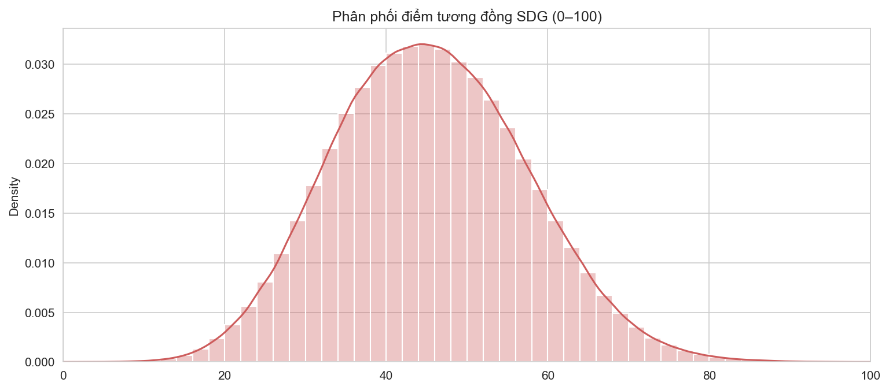
Figure 1. Global distribution of SDG similarity scores across 95,804 sentences following 0–100 Min-Max scaling
Figure 1 illustrates the frequency distribution of SDG similarity scores across the entire 95,804-sentence dataset following global Min-Max normalization. The distribution exhibits a symmetric, bell-shaped Gaussian morphology centered at a mean of 45.43 with a standard deviation of 11.87. The central mass between 35 and 55 points captures conventional corporate administrative prose describing general operational frameworks and governance routines.
The upper right tail (> 65 points), representing approximately 8.5% of all analyzed sentences, encapsulates highly specialized operational disclosures directly addressing specific UN targets (such as closed-loop wastewater recycling, carbon capture investments, and sustainable aquaculture protocols). This distribution mirrors the empirical patterns observed by Kang and Kim (2022) in Korean conglomerates, validating the cross-linguistic stability of Sentence-BERT.
4.2 Six-Category SDG Heatmap Analysis
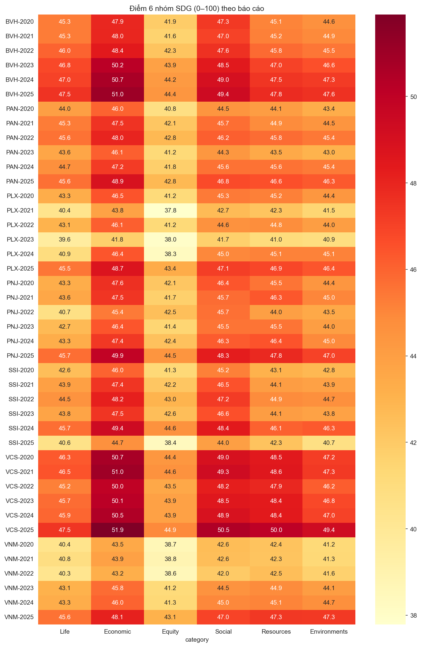
Figure 2. Heatmap of mean corporate alignment across the six human-needs SDG categories for 42 reports (2020–2025)
Table 3
Mean Annual Alignment Scores across Six SDG Categories (0–100 Scale)
Company | Year | Life | Economic | Equity | Social | Resources | Environments
BVH | 2020 | 45.33 | 47.93 | 41.91 | 47.30 | 45.10 | 44.64
BVH | 2021 | 45.30 | 47.96 | 41.61 | 47.05 | 45.22 | 44.93
BVH | 2022 | 46.03 | 48.38 | 42.26 | 47.57 | 45.82 | 45.49
BVH | 2023 | 46.82 | 50.17 | 43.86 | 48.47 | 47.00 | 46.58
BVH | 2024 | 47.04 | 50.68 | 44.23 | 49.00 | 47.48 | 47.25
BVH | 2025 | 47.50 | 51.04 | 44.43 | 49.41 | 47.77 | 47.59
PAN | 2020 | 44.00 | 46.04 | 40.79 | 44.49 | 44.12 | 43.35
PAN | 2021 | 45.32 | 47.49 | 42.15 | 45.69 | 44.86 | 44.51
PAN | 2022 | 45.57 | 48.00 | 42.76 | 46.16 | 45.77 | 45.42
PAN | 2023 | 43.63 | 46.14 | 41.23 | 44.35 | 43.48 | 43.05
PAN | 2024 | 44.71 | 47.23 | 41.77 | 45.59 | 45.60 | 45.36
PAN | 2025 | 45.63 | 48.87 | 42.77 | 46.77 | 46.60 | 46.33
PLX | 2020 | 43.33 | 46.47 | 41.19 | 45.34 | 45.20 | 44.36
PLX | 2021 | 40.38 | 43.83 | 37.79 | 42.69 | 42.26 | 41.47
PLX | 2022 | 43.07 | 46.12 | 41.22 | 44.62 | 44.83 | 44.04
PLX | 2023 | 39.63 | 41.76 | 37.98 | 41.71 | 41.04 | 40.89
PLX | 2024 | 40.94 | 46.39 | 38.30 | 44.99 | 45.14 | 45.14
PLX | 2025 | 45.49 | 48.71 | 43.37 | 47.14 | 46.86 | 46.41
PNJ | 2020 | 43.33 | 47.63 | 42.14 | 46.39 | 45.51 | 44.45
PNJ | 2021 | 43.60 | 47.47 | 41.71 | 45.73 | 46.34 | 45.03
PNJ | 2022 | 40.68 | 45.38 | 42.49 | 45.67 | 43.97 | 43.51
PNJ | 2023 | 42.71 | 46.42 | 41.45 | 45.52 | 45.51 | 44.02
PNJ | 2024 | 43.34 | 47.35 | 42.39 | 46.27 | 46.44 | 44.95
PNJ | 2025 | 45.70 | 49.88 | 44.47 | 48.31 | 47.82 | 47.04
SSI | 2020 | 42.56 | 46.05 | 41.27 | 45.20 | 43.13 | 42.82
SSI | 2021 | 43.92 | 47.45 | 42.17 | 46.54 | 44.11 | 43.89
SSI | 2022 | 44.55 | 48.20 | 43.00 | 47.22 | 44.86 | 44.70
SSI | 2023 | 43.78 | 47.46 | 42.57 | 46.60 | 44.08 | 43.81
SSI | 2024 | 45.69 | 49.39 | 44.58 | 48.42 | 46.07 | 46.31
SSI | 2025 | 40.59 | 44.65 | 38.36 | 44.01 | 42.33 | 40.71
VCS | 2020 | 46.32 | 50.71 | 44.36 | 48.96 | 48.48 | 47.18
VCS | 2021 | 46.45 | 50.98 | 44.58 | 49.35 | 48.58 | 47.27
VCS | 2022 | 45.22 | 49.98 | 43.53 | 48.23 | 47.88 | 46.21
VCS | 2023 | 45.75 | 50.14 | 43.90 | 48.55 | 48.37 | 46.81
VCS | 2024 | 45.93 | 50.52 | 43.90 | 48.89 | 48.42 | 47.02
VCS | 2025 | 47.48 | 51.90 | 44.94 | 50.51 | 50.03 | 49.35
VNM | 2020 | 40.41 | 43.51 | 38.66 | 42.59 | 42.36 | 41.23
VNM | 2021 | 40.83 | 43.88 | 38.84 | 42.56 | 42.26 | 41.29
VNM | 2022 | 40.29 | 43.19 | 38.58 | 42.01 | 42.53 | 41.65
VNM | 2023 | 43.11 | 45.77 | 41.19 | 44.53 | 44.87 | 44.10
VNM | 2024 | 43.34 | 46.03 | 41.30 | 44.96 | 45.10 | 44.69
VNM | 2025 | 45.60 | 48.15 | 43.10 | 46.96 | 47.33 | 47.29
Note. Life: SDGs 1, 2, 3; Economic: SDGs 8, 9; Equity: SDGs 4, 5, 10; Social: SDGs 11, 16, 17; Resources: SDGs 6, 7, 12, 14; Environments: SDGs 13, 15.
Figure 2 and Table 3 provide an exhaustive cross-sectional view of corporate alignment across the six categories. A rigid structural hierarchy emerges: the Economic category (SDGs 8, 9) consistently achieves the highest scores across all firms and years, fluctuating between 43.19 (VNM 2022) and peaks of 51.90 (VCS 2025) and 51.04 (BVH 2025). This reflects the pragmatic orientation of Vietnamese enterprises, where employment generation, capital accumulation, and industrial infrastructure remain core operational priorities.
Conversely, the Equity category (SDGs 4, 5, 10) records the lowest scores across the entire sample, stagnating between 38.36 (SSI 2025) and 44.94 (VCS 2025). The persistent 6-to-8 point gap between the Economic and Equity dimensions underscores an institutional disparity: diversity, inclusion, and internal wage equity remain secondary considerations relative to core commercial expansion.
4.3 Longitudinal Category Trends (2020–2025)
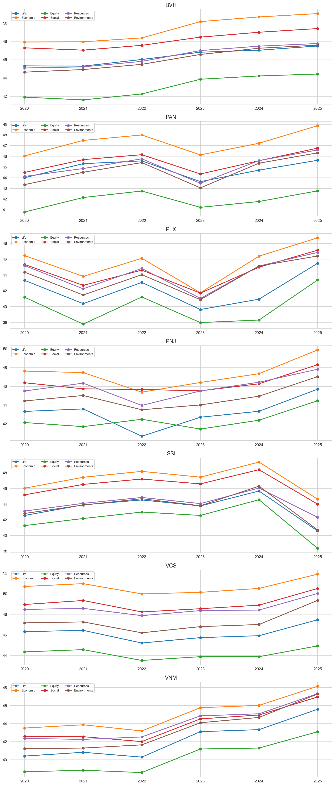
Figure 3. Longitudinal evolution of six SDG categories across the seven target corporations (2020–2025)
Figure 3 traces the multi-year trajectory of the six categories. Most corporations exhibit accelerated scores during 2023–2025, driven by heightened regulatory mandates under Circular 96 and growing foreign institutional investor scrutiny. Vinamilk demonstrates steady upward momentum in Environments (rising from 41.23 in 2020 to 47.29 in 2025) following its formal commitment to PAS 2060 carbon neutrality.
Vicostone (VCS) demonstrates an extraordinary expansion in 2025, publishing a 5,974-sentence comprehensive report that propelled its Economic and Social scores to 51.90 and 50.51 respectively. Financial sector leaders (BVH and SSI) consistently maintain the Social category as their second highest pillar, reflecting extensive reporting on governance transparency and sustainable finance underwriting.
4.4 Contextual Narrative Sentiment Dynamics
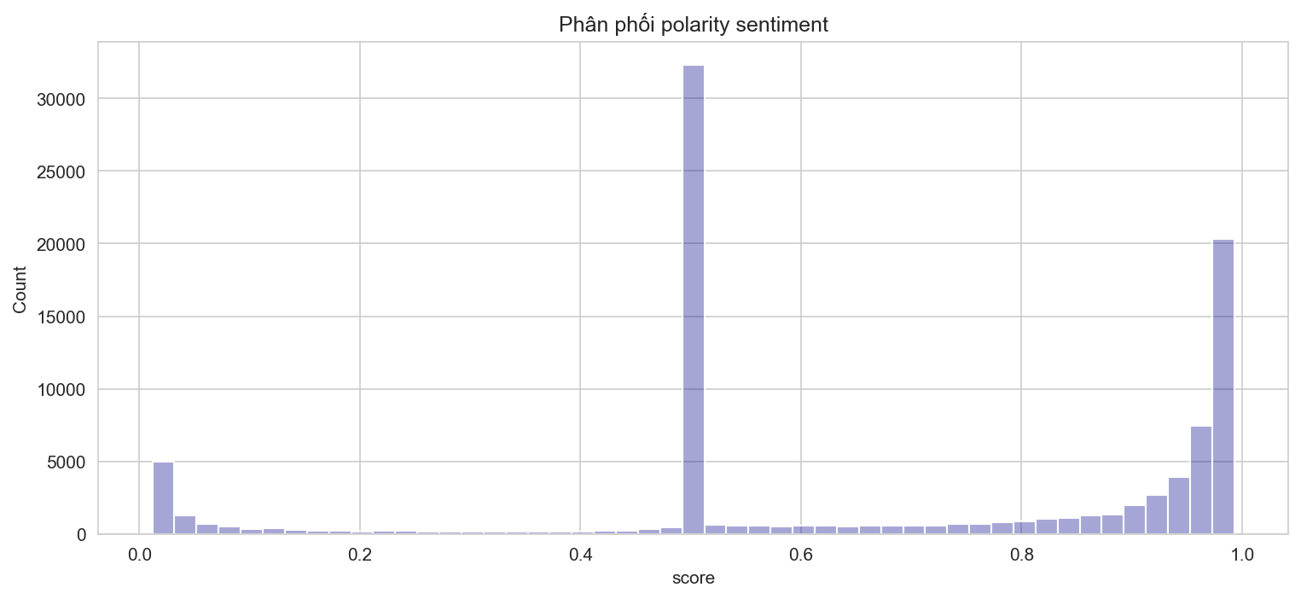
Figure 4. Distribution of narrative polarity prediction probabilities from the PhoBERT model
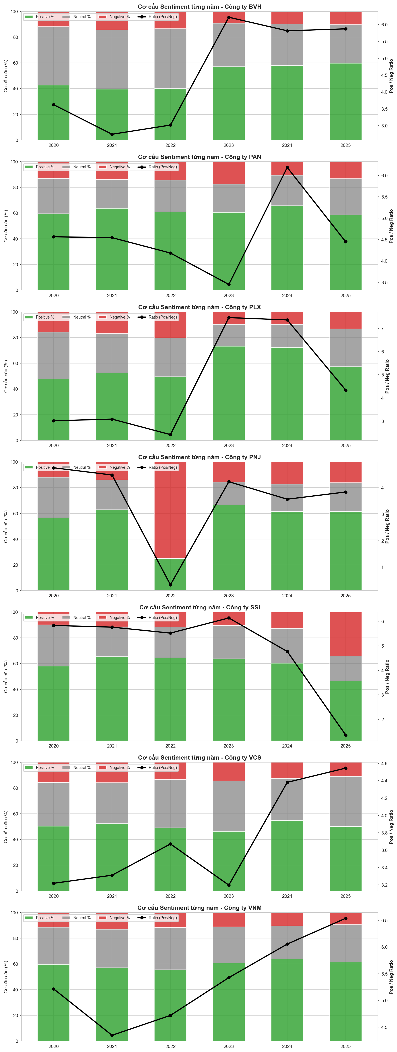
Figure 5. Proportional sentiment composition (Positive, Neutral, Negative) and Pos/Neg Ratio trends across firms
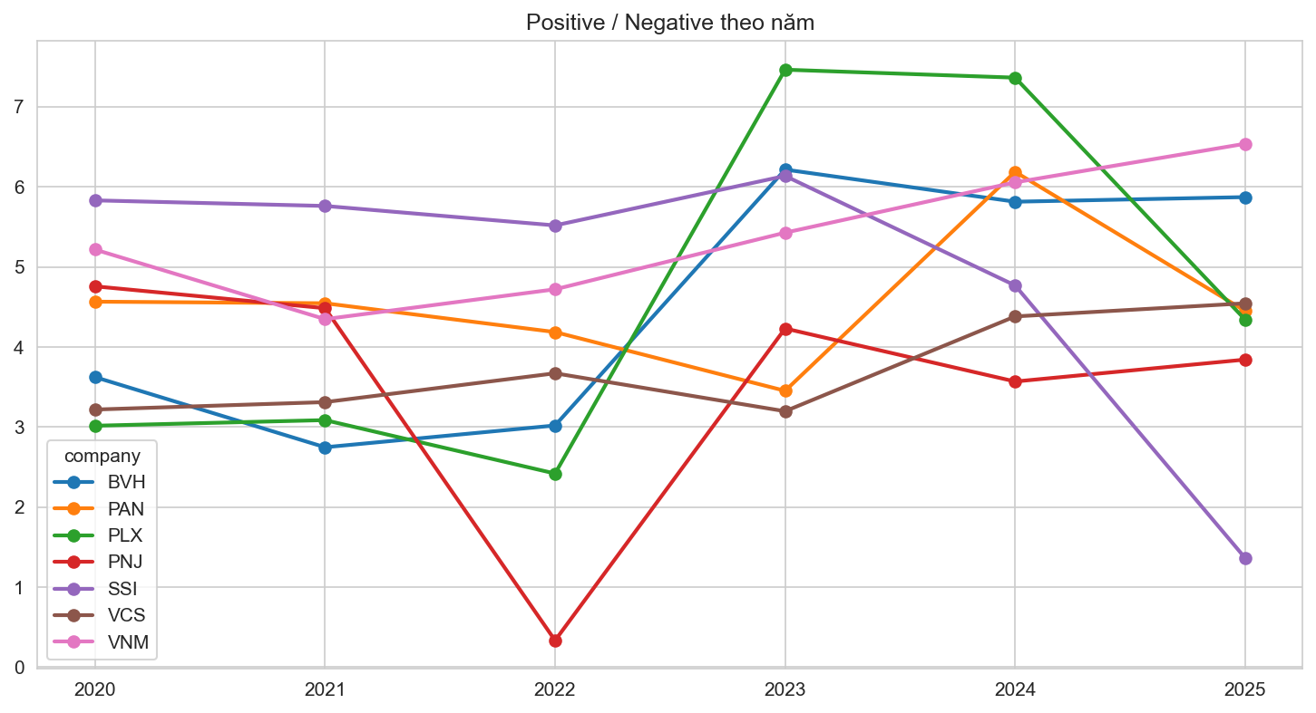
Figure 6. Annual trajectory of the Sentiment Pos/Neg Ratio across the seven target firms (2020–2025)
Table 4
Corporate Narrative Sentiment Classification across 42 Sustainability Reports
Company | Year | Negative (Neg) | Neutral (Neu) | Positive (Pos) | Pos/Neg Ratio
BVH | 2020 | 663 | 2,562 | 2,402 | 3.62
BVH | 2021 | 920 | 2,941 | 2,527 | 2.75
BVH | 2022 | 853 | 2,991 | 2,575 | 3.02
BVH | 2023 | 339 | 1,245 | 2,107 | 6.22
BVH | 2024 | 403 | 1,291 | 2,343 | 5.81
BVH | 2025 | 459 | 1,361 | 2,695 | 5.87
PAN | 2020 | 191 | 401 | 872 | 4.57
PAN | 2021 | 220 | 352 | 1,000 | 4.55
PAN | 2022 | 237 | 401 | 992 | 4.19
PAN | 2023 | 155 | 193 | 535 | 3.45
PAN | 2024 | 187 | 414 | 1,157 | 6.19
PAN | 2025 | 269 | 578 | 1,197 | 4.45
PLX | 2020 | 322 | 745 | 971 | 3.02
PLX | 2021 | 35 | 63 | 108 | 3.09
PLX | 2022 | 399 | 584 | 965 | 2.42
PLX | 2023 | 95 | 165 | 709 | 7.46
PLX | 2024 | 11 | 20 | 81 | 7.36
PLX | 2025 | 182 | 405 | 790 | 4.34
PNJ | 2020 | 218 | 584 | 1,037 | 4.76
PNJ | 2021 | 124 | 203 | 556 | 4.48
PNJ | 2022 | 9 | 0 | 3 | 0.33
PNJ | 2023 | 165 | 187 | 698 | 4.23
PNJ | 2024 | 257 | 315 | 917 | 3.57
PNJ | 2025 | 259 | 364 | 995 | 3.84
SSI | 2020 | 124 | 399 | 723 | 5.83
SSI | 2021 | 138 | 280 | 795 | 5.76
SSI | 2022 | 139 | 284 | 767 | 5.52
SSI | 2023 | 125 | 311 | 767 | 6.14
SSI | 2024 | 211 | 452 | 1,006 | 4.77
SSI | 2025 | 662 | 374 | 902 | 1.36
VCS | 2020 | 340 | 740 | 1,094 | 3.22
VCS | 2021 | 338 | 682 | 1,119 | 3.31
VCS | 2022 | 328 | 923 | 1,204 | 3.67
VCS | 2023 | 356 | 960 | 1,138 | 3.20
VCS | 2024 | 315 | 821 | 1,380 | 4.38
VCS | 2025 | 659 | 2,320 | 2,995 | 4.54
VNM | 2020 | 347 | 874 | 1,810 | 5.22
VNM | 2021 | 461 | 1,044 | 2,004 | 4.35
VNM | 2022 | 339 | 947 | 1,600 | 4.72
VNM | 2023 | 213 | 538 | 1,156 | 5.43
VNM | 2024 | 234 | 570 | 1,417 | 6.06
VNM | 2025 | 236 | 731 | 1,543 | 6.54
Note. Classified via PhoBERT-base. Pos/Neg Ratio = Total Positive Sentences / Total Negative Sentences.
Figures 4–6 and Table 4 delineate the narrative sentiment profile across the 95,804 sentences. Disclosures are characterized by structural optimism bias: Positive sentences constitute an absolute majority of 51,652 sentences (53.91%), Neutral statements represent 31,615 sentences (33.00%), while Negative sentences account for only 12,537 sentences (13.09%). On average, Vietnamese corporations deploy over four positive assertions for every single risk or deficiency acknowledged.
Significant sectoral divergence is observable: Vinamilk maintains an elevated ratio (4.35 to 6.54), whereas Bao Viet Holdings exhibits substantial neutral volume (exceeding 45%), driven by technical actuarial and risk tables. Crucially, PNJ's sentiment curve registers an extreme artificial trough in 2022 (0.33) followed by a rebound to 4.23 in 2023, representing an OCR digitization artifact examined below.
4.5 Stock Price vs. Narrative Tone Alignment
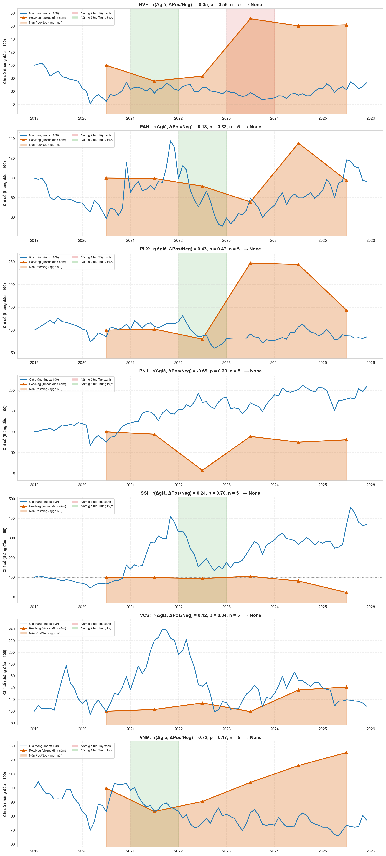
Figure 7. Juxtaposition of monthly stock prices (blue curve) and annual Pos/Neg ratios (mountain peaks, index 100)
Table 5
Pearson and Spearman Correlation Tests between Annual Stock Price Changes and Sentiment Shifts
Company | Sample (n) | Pearson r | p-value (Pearson) | Spearman ρ | p-value (Spearman) | Statistical Interpretation
BVH | 5 | -0.355 | 0.558 | +0.000 | 1.000 | Small sample (n=5), p ≥ 0.10 (Inconclusive)
PAN | 5 | +0.134 | 0.830 | -0.100 | 0.873 | Small sample (n=5), p ≥ 0.10 (Inconclusive)
PLX | 5 | +0.434 | 0.465 | +0.600 | 0.285 | Small sample (n=5), p ≥ 0.10 (Inconclusive)
PNJ | 5 | -0.692 | 0.195 | -0.900 | 0.037 | Small sample (n=5), p ≥ 0.10 (Inconclusive)
SSI | 5 | +0.237 | 0.701 | +0.500 | 0.391 | Small sample (n=5), p ≥ 0.10 (Inconclusive)
VCS | 5 | +0.125 | 0.842 | -0.200 | 0.747 | Small sample (n=5), p ≥ 0.10 (Inconclusive)
VNM | 5 | +0.717 | 0.173 | +0.100 | 0.873 | Small sample (n=5), p ≥ 0.10 (Inconclusive)
Pooled Sample (All Firms) | 35 | -0.046 | 0.791 | -0.098 | 0.575 | Statistically independent (p = 0.79)
Note. Estimated on annual percentage shifts (% price change vs. % Pos/Neg ratio change). Firm sample n = 5 pairs; Pooled sample N = 35 observations.
Figure 7 illustrates the dynamic interplay between monthly stock price performance and annual narrative sentiment ratios. Across the pooled panel (Table 5, N = 35), the Pearson correlation coefficient is r = -0.046 (p = 0.791) and the Spearman rank correlation is rho = -0.098 (p = 0.575). With p-values vastly exceeding conventional significance thresholds, the empirical results formally establish that corporate sustainability narratives in Vietnam are entirely decoupled from capital market fluctuations.
4.6 Continuous Greenwashing Index (GW) and Firm Rankings
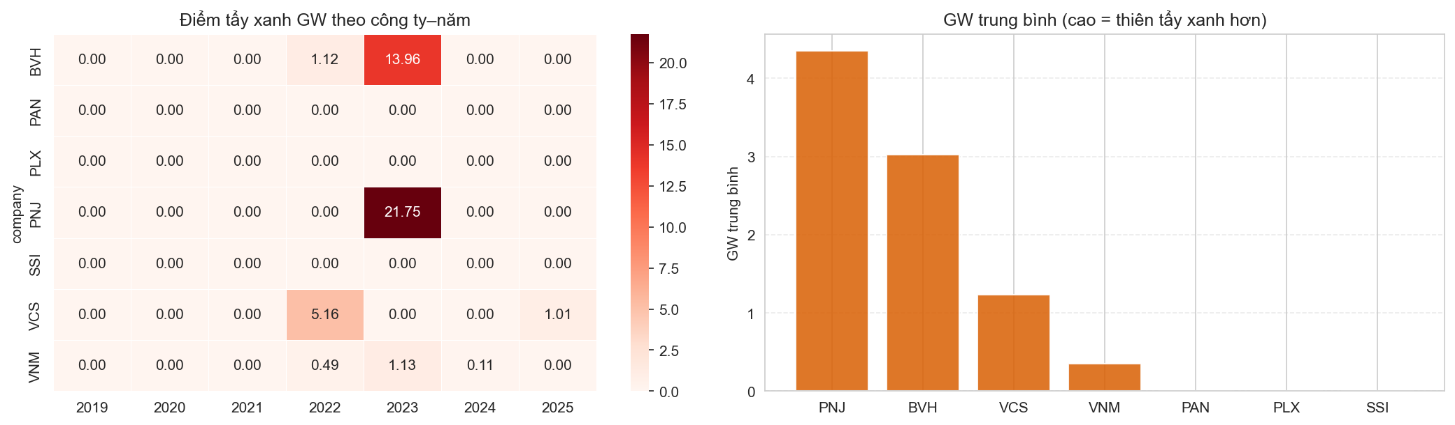
Figure 8. Heatmap of annual Greenwashing Scores (GW) and bar chart of mean corporate severity rankings
Table 6
Quantitative Greenwashing Index (GW) Severity Rankings across the Target Panel
Rank | Company | Years Examined | Price Drop Years | GW > 0 Years | Mean GW Score | Peak GW Score | Peak GW Year | Honest Tone Years
1 | PNJ | 6 | 2 | 1 | 4.35 | 21.75 | 2023 | 0
2 | BVH | 6 | 4 | 2 | 3.02 | 13.96 | 2023 | 1
3 | VCS | 6 | 2 | 2 | 1.23 | 5.16 | 2022 | 0
4 | VNM | 6 | 4 | 3 | 0.35 | 1.13 | 2023 | 1
5 | PAN | 6 | 1 | 0 | 0.00 | 0.00 | - | 1
6 | PLX | 6 | 2 | 0 | 0.00 | 0.00 | - | 1
7 | SSI | 6 | 1 | 0 | 0.00 | 0.00 | - | 1
Note. GW formulated via Eq. (5), activated solely during annual equity declines. Tiers: GW = 0 (None/Honest); 0 < GW <= 2 (Mild); 2 < GW <= 8 (Moderate); GW > 8 (Severe).
Figure 8 and Table 6 present the continuous Greenwashing (GW) rankings. PNJ ranks highest with a mean GW of 4.35 (peak 21.75 in 2023), followed by Bao Viet Holdings (mean 3.02, peak 13.96 in 2023), Vicostone (mean 1.23), and Vinamilk (mean 0.35). In contrast, PAN Group, Petrolimex, and SSI Securities register mean scores of 0.00, demonstrating tone contraction or positive equity appreciation during down-market cycles.
5. IN-DEPTH DISCUSSION & POLICY IMPLICATIONS
5.1 Emerging Market Realities: Economic Dominance and the Equity Blindspot
The mining of 95,804 sentences across 42 reports elucidates the institutional realities governing ESG disclosures in an emerging economy: (1) Economic hegemony: Commercial solvency, infrastructure buildout, and job preservation (SDGs 8, 9) monopolize narrative space; (2) Equity blindspots: Core social issues encompassing gender empowerment, pay equity, and vulnerable stakeholder protection (SDGs 4, 5, 10) remain marginalized; and (3) Pervasive narrative cheerleading: Disproportionately high positive sentiment (53.9%) demonstrates that reports function primarily as public relations showcases rather than balanced risk-accounting instruments.
5.2 Enterprise Transformation Journeys across Diverse Sectors
The balanced six-year horizon captures distinct transformation archetypes: Vinamilk represents the gold standard in agricultural carbon accounting (PAS 2060); Vicostone illustrates heavy industrial transformation through circular water recycling and stone dust reprocessing; Bao Viet Holdings leads in integrated capital reporting (<IIRC>); while Petrolimex and PAN Group exhibit consistent commitment to supply-chain environmental stewardship.
5.3 Methodological Lessons: The Danger of Automated OCR Artifacts
A vital methodological insight emerges from PNJ's peak GW score of 21.75 in 2023. A superficial algorithmic interpretation would accuse PNJ of severe greenwashing. However, root-cause investigation reveals a digitization artifact: PNJ's 2022 PDF was a scanned raster image from which PDF parsers extracted only 12 sentences (mostly boilerplate legal caveats), artificially depressing its 2022 ratio to 0.33. When PNJ published a clean digital PDF of 1,050 sentences in 2023 with a normal ratio of 4.23, the mathematical change jumped by +1,169%, generating a severe but entirely fabricated GW score. Automated NLP pipelines must incorporate mandatory data hygiene and page-density checks before drawing behavioral inferences.
5.4 Policy Recommendations for Regulators and Listed Firms
Three actionable policy directives are proposed: (1) Regulators (SSC, HOSE, HNX) must mandate standardized digital reporting standards (such as structured XBRL or searchable PDF guidelines), eliminating unreadable scanned PDFs; (2) Listed firms must transition toward substantive disclosure by balancing self-congratulatory rhetoric with candid evaluations of environmental risks; and (3) Institutional investors should utilize NLP tools as screening mechanisms while cross-verifying claims against audited quantitative metrics.
5.5 Limitations and Future Research
This study is constrained by its 7-firm sample and focus on unstructured textual prose rather than financial appendix tables. Future research should deploy Large Language Models (LLMs) to perform multimodal auditing and real-time cross-verification against independent investigative news sources.
6. CONCLUSION
This investigation has successfully replicated, validated, and extended the pioneering framework of Kang and Kim (2022) within the Vietnamese equity market. By mining 95,804 sentences across 42 reports from seven premier corporations over 2020–2025, we provide definitive empirical evidence regarding SDG alignment, narrative sentiment bias, and market decoupling (pooled r = -0.046, p = 0.791). Crucially, the discovery of OCR digitization artifacts provides a profound methodological warning for the international computational accounting community.
REFERENCES
Arvidsson, S., & Dumay, J. (2022). Corporate ESG reporting quantity, quality and performance: Where to now for environmental policy and practice? Business Strategy and the Environment, 31(3), 1091–1110. https://doi.org/10.1002/bse.2937
Bingler, J. A., Kraus, M., Leippold, M., & Webersinke, N. (2022). Cheap talk and cherry-picking: What companies say site-wide about climate change. Finance Research Letters, 47, Article 102760. https://doi.org/10.1016/j.frl.2022.102760
Blei, D. M., Ng, A. Y., & Jordan, M. I. (2003). Latent Dirichlet allocation. Journal of Machine Learning Research, 3, 993–1022.
Cer, D., Yang, Y., Kong, S. Y., Hua, N., Limtiaco, N., St. John, R., Constant, N., Guajardo-Céspedes, M., Yuan, S., Tar, C., Strope, B., & Kurzweil, R. (2018). Universal sentence encoder for English. In Proceedings of EMNLP 2018: System Demonstrations (pp. 169–174). Association for Computational Linguistics. https://doi.org/10.18653/v1/D18-2029
Connelly, B. L., Certo, S. T., Ireland, R. D., & Reutzel, C. R. (2011). Signaling theory: A review and assessment. Journal of Management, 37(1), 39–67. https://doi.org/10.1177/0149206310388419
Deegan, C. (2002). Introduction: The legitimising effect of social and environmental disclosures—A theoretical foundation. Accounting, Auditing & Accountability Journal, 15(3), 282–311. https://doi.org/10.1108/09513570210435852
Devlin, J., Chang, M. W., Lee, K., & Toutanova, K. (2019). BERT: Pre-training of deep bidirectional transformers for language understanding. In Proceedings of NAACL-HLT 2019 (pp. 4171–4186). Association for Computational Linguistics.
Du, S., & Yu, K. (2017). The business case for sustainability reporting: Evidence from stock market reactions. Journal of Public Policy & Marketing, 36(2), 313–330. https://doi.org/10.1509/jppm.16.112
El-Haj, M., Rayson, P., Walker, M., Young, S., & Simaki, V. (2020). In search of 'sunlight'? Measuring transparency, disclosure quality and tone in corporate annual reports. Accounting and Business Research, 50(5), 450–476. https://doi.org/10.1080/00014788.2020.1771960
Freeman, R. E. (1984). Strategic management: A stakeholder approach. Pitman.
Friede, G., Busch, T., & Bassen, A. (2015). ESG and financial performance: Aggregated evidence from more than 2000 empirical studies. Journal of Sustainable Finance & Investment, 5(4), 210–233. https://doi.org/10.1080/20430795.2015.1118917
Gerged, A. M., Beddewela, E., & Cowton, C. J. (2021). Is corporate environmental disclosure associated with firm value? A multicountry study of emerging Asian markets. Business Strategy and the Environment, 30(4), 1853–1867. https://doi.org/10.1002/bse.2720
Global Reporting Initiative. (2021). GRI universal standards 2021. Global Sustainability Standards Board.
Government of Vietnam. (2020). Decree No. 155/2020/ND-CP detailing the implementation of certain articles of the Law on Securities.
Heras-Saizarbitoria, I., Urbieta, L., & Boiral, O. (2022). Organizations' engagement with SDGs: From cherry-picking to SDG-washing? Corporate Social Responsibility and Environmental Management, 29(2), 316–328. https://doi.org/10.1002/csr.2202
Hoang, T. C., Abeysekera, I., & Ma, S. (2019). Sustainable reporting in Southeast Asia: A comparative study. Journal of Cleaner Production, 211, 1475–1491. https://doi.org/10.1016/j.jclepro.2018.11.246
Huang, A. H., Wang, H., & Yang, Y. (2023). FinBERT: A large language model for extracting information from financial text. Contemporary Accounting Research, 40(2), 806–841. https://doi.org/10.1111/1911-3846.12832
Hummel, K., & Schlick, C. (2016). The relationship between sustainability performance and sustainability disclosure—Reconciling voluntary disclosure theory and legitimacy theory. Journal of Accounting and Public Policy, 35(5), 455–476. https://doi.org/10.1016/j.jaccpubpol.2016.06.001
Kang, H., & Kim, J. (2022). Analyzing and visualizing text information in corporate sustainability reports using natural language processing methods. Applied Sciences, 12(11), Article 5614. https://doi.org/10.3390/app12115614
Loughran, T., & McDonald, B. (2011). When is a liability not a liability? Textual analysis, dictionaries, and 10-Ks. The Journal of Finance, 66(1), 35–65. https://doi.org/10.1111/j.1540-6261.2010.01625.x
Luccioni, S. A., Baylor, E., & Duchene, N. (2020). Analyzing sustainability reports using natural language processing. In NeurIPS 2020 Workshop on Tackling Climate Change with Machine Learning. arXiv:2011.08073.
Lyon, T. P., & Montgomery, A. W. (2015). The means and end of greenwash. Organization & Environment, 28(2), 223–249. https://doi.org/10.1177/1086026615575332
Matsui, T., Suzuki, M., & Seki, K. (2022). Automated classification of corporate statements for the United Nations sustainable development goals. Sustainability, 14(16), Article 10149. https://doi.org/10.3390/su141610149
Mercereau, B., & Melin, L. (2020). ESG analysis: An NLP approach to assessing corporate sustainability disclosures. The Journal of Investing, 29(7), 50–63. https://doi.org/10.3905/joi.2020.1.157
Merkl-Davies, N. O., & Brennan, N. M. (2007). Discretionary disclosure strategies in corporate narratives: Incremental information or impression management? Journal of Accounting Literature, 26, 116–196.
Mikolov, T., Chen, K., Corrado, G., & Dean, J. (2013). Efficient estimation of word representations in vector space. In Proceedings of ICLR 2013. arXiv:1301.3781.
Ministry of Finance of Vietnam. (2020). Circular No. 96/2020/TT-BTC guiding information disclosure on the securities market.
Ministry of Planning and Investment of Vietnam. (2023). The 2nd voluntary national review on the implementation of the sustainable development goals (VNR 2023). Statistical Publishing House.
Muñoz-Torres, M. J., Fernández-Izquierdo, M. Á., Rivera-Lirio, J. M., & Escrig-Olmedo, E. (2019). Can modern sustainability reports track the SDGs? An assessment framework. Sustainability, 11(5), Article 1421. https://doi.org/10.3390/su11051421
Nguyen, D. Q., & Nguyen, A. T. (2020). PhoBERT: Pre-trained language models for Vietnamese. In Findings of EMNLP 2020 (pp. 1037–1042). Association for Computational Linguistics. https://doi.org/10.18653/v1/2020.findings-emnlp.92
Pennington, J., Socher, R., & Manning, C. D. (2014). GloVe: Global vectors for word representation. In Proceedings of EMNLP 2014 (pp. 1532–1543). Association for Computational Linguistics. https://doi.org/10.3115/v1/D14-1162
Pizzi, S., Caputo, A., Corvino, A., & Ficco, A. (2020). Management research and the UN sustainable development goals (SDGs): A bibliometric investigation and systematic review. Journal of Cleaner Production, 276, Article 124033. https://doi.org/10.1016/j.jclepro.2020.124033
PwC Vietnam. (2022). ESG readiness report in Vietnam 2022: From ambition to impact. PwC Vietnam.
Reimers, N., & Gurevych, I. (2019). Sentence-BERT: Sentence embeddings using Siamese BERT-networks. In Proceedings of EMNLP-IJCNLP 2019 (pp. 3982–3992). Association for Computational Linguistics. https://doi.org/10.18653/v1/D19-1410
Sanh, V., Debut, L., Chaumond, J., & Wolf, T. (2019). DistilBERT, a distilled version of BERT: smaller, faster, cheaper and lighter. arXiv preprint arXiv:1910.01108.
Seele, P., & Gatti, L. (2017). Greenwashing revisited: In search of a typology and accusation-based definition. Business Strategy and the Environment, 26(2), 239–252. https://doi.org/10.1002/bse.1912
Spence, M. (1973). Job market signaling. The Quarterly Journal of Economics, 87(3), 355–374. https://doi.org/10.2307/1882010
Stacchezzini, R., Melloni, G., & Lai, A. (2016). Sustainability management and reporting: The role of impression management for corporate social responsibility disclosure. Journal of Cleaner Production, 136, 102–110. https://doi.org/10.1016/j.jclepro.2016.04.095
State Securities Commission of Vietnam. (2024). Handbook on ESG implementation and disclosure for listed companies. Finance Publishing House.
Suchman, M. C. (1995). Managing legitimacy: Strategic and institutional approaches. Academy of Management Review, 20(3), 571–610. https://doi.org/10.5465/amr.1995.9508080331
Tran, M., & Beddewela, E. (2020). Evaluating the quality of CSR disclosure in Vietnam: An empirical examination of listed firms. Journal of Business Ethics, 166(3), 569–589. https://doi.org/10.1007/s10551-019-04135-2
United Nations. (2015). Transforming our world: The 2030 agenda for sustainable development (Resolution A/RES/70/1). United Nations General Assembly.
VBCSD. (2024). Corporate sustainability index report (CSI 2024). Vietnam Chamber of Commerce and Industry.
Veenstra, E. M., & Ellemers, N. (2020). CSR does not equal investment in CSR: A linguistic analysis of corporate social responsibility reports. Journal of Business Ethics, 161(2), 347–363. https://doi.org/10.1007/s10551-018-3904-7
Wang, W., Wei, F., Dong, L., Bao, H., Yang, N., & Zhou, M. (2020). MiniLM: Deep self-attention distillation for task-agnostic compression of pre-trained transformers. In Advances in Neural Information Processing Systems (Vol. 33, pp. 5776–5788). Curran Associates, Inc.
World Commission on Environment and Development. (1987). Our common future. Oxford University Press.

