ANALYZING AND VISUALIZING TEXT INFORMATION IN CORPORATE SUSTAINABILITY REPORTS USING NATURAL LANGUAGE PROCESSING METHODS: EMPIRICAL EVIDENCE FROM VIETNAM
Artificial Intelligence and Sustainable Finance Research Group
Department of Finance and Banking, University of Economics
Contact: research.esg@vietnam-analytics.edu.vn
ABSTRACT
Corporate sustainability reports represent essential communication conduits for conveying environmental, social, and governance (ESG) commitments to diverse stakeholders. Replicating and adapting the computational methodology of Kang and Kim (2022), this study conducts an automated textual analysis and longitudinal visualization of 29 standalone sustainability reports published by four prominent Vietnamese listed firms (The PAN Group, Petrolimex, PNJ, Vinamilk) spanning 2018–2025, encompassing 17,047 extracted sentences. Employing pre-trained Transformer language models (vietnamese-sbert and PhoBERT), we quantify corporate alignment with the 17 UN Sustainable Development Goals (SDGs), aggregate alignments into six human-needs categories (Life, Economic, Equity, Social, Resources, Environments), and evaluate multi-class sentiment polarity (Positive, Neutral, Negative). Empirical findings reveal that: (1) Vietnamese corporate disclosures disproportionately prioritize the Economic dimension (SDG 8, 9) and Global Partnerships (SDG 17), while systematically underperforming in Social Equity (SDG 4, 5, 10); (2) Corporate narratives demonstrate a pervasive optimism bias, comprising 69.75% positive, 18.34% neutral, and merely 11.91% negative statements; (3) In contrast to aggressive greenwashing hypotheses, capital market returns and narrative sentiment ratios are statistically independent (r = 0.03, p = 0.89), suggesting that narrative optimism reflects conventional impression management rather than manipulative deception in an emerging market where institutional ESG pricing remains nascent. This study provides deep critical reflections on the transparency of corporate non-financial disclosures in Vietnam and proposes expanding analytical samples to peer enterprises with continuous 2020–2025 reporting records including BVH, DHG, VCS, FPT, and NLG.
Keywords: Sustainability reporting; Sustainable Development Goals (SDGs); Natural Language Processing (NLP); Sentence-BERT; PhoBERT; Sentiment analysis; Optimism bias; Vietnam stock market.

1. INTRODUCTION
Amid escalating climate volatility and the universal integration of sustainable development standards into global commerce, corporate disclosure of environmental, social, and governance (ESG) performance has evolved from an optional public relations gesture into a mandatory regulatory requirement for publicly listed firms (Arvidsson & Dumay, 2022; Global Reporting Initiative, 2021). In Vietnam, following the national pledge at the COP26 summit to achieve net-zero carbon emissions by 2050, the regulatory architecture has expanded significantly through Circular No. 96/2020/TT-BTC issued by the Ministry of Finance and the revised Law on Securities 2019 (Ministry of Finance of Vietnam, 2020; Government of Vietnam, 2020). Standalone sustainability reports have become the principal mechanism through which public enterprises articulate social accountability and benchmark operational engagement against the United Nations 2030 Agenda comprising the 17 Sustainable Development Goals (SDGs) (United Nations, 2015).
Nevertheless, auditing and interpreting non-financial disclosures present profound methodological hurdles. Corporate sustainability reports are predominantly published as lengthy, unstructured PDF documents spanning hundreds of pages. Traditional manual content analysis is labor-intensive, cost-prohibitive, and vulnerable to subjective coder heuristics (Luccioni et al., 2020). Concurrently, naive dictionary-based keyword matching methods suffer from severe semantic blindness: they ignore syntactic context, fail to capture linguistic polysemy, and allow corporations to score artificially high by superficially repeating sustainability buzzwords (Kang & Kim, 2022; Loughran & McDonald, 2011).
To surmount these computational constraints, Kang and Kim (2022) established a pioneering methodological framework in Applied Sciences. Their approach deployed deep learning Transformer architectures, utilizing Sentence-BERT to compute semantic cosine similarities between corporate report sentences and benchmark SDG statements, clustering alignments into six human-needs categories (Life, Economic, Equity, Social, Resources, Environments), and implementing Transformer-based sentiment classification to evaluate narrative tone. Their work demonstrated the transformative potential of computational linguistics in quantifying qualitative corporate narratives.
Motivated by this methodological breakthrough, the present study replicates and adapts Kang and Kim's (2022) research framework within the institutional context of an emerging market—Vietnam. We collect a longitudinal dataset of 29 standalone sustainability reports published between 2018 and 2025 by four large-cap market leaders across four key sectors: The PAN Group (PAN - Sustainable Agriculture), Petrolimex (PLX - Energy and Petroleum), Phu Nhuan Jewelry (PNJ - Retail and Jewelry Manufacturing), and Vinamilk (VNM - Dairy Processing and Industrial Farming). Our investigation addresses three central empirical questions: (1) How do Vietnamese corporations prioritize the 17 UN SDGs when evaluated through specialized Vietnamese Sentence-BERT embeddings? (2) What does multi-class sentiment analysis reveal regarding corporate managerial tone and optimism bias? (3) Does empirical evidence support claims of systematic greenwashing in Vietnam, and what critical reflections emerge regarding corporate sustainability disclosures?
2. LITERATURE REVIEW
2.1. Theoretical Foundations: Stakeholder, Legitimacy, and Impression Management Theories
Corporate motivations for voluntary non-financial disclosure are fundamentally anchored in three complementary organizational theories. First, Stakeholder Theory (Freeman, 1984) asserts that corporate executives must balance the competing expectations of all parties affected by corporate activities, including employees, customers, suppliers, local communities, and regulatory authorities. From this perspective, sustainability reports function as an essential stakeholder engagement vehicle designed to demonstrate accountability (Hummel & Schlick, 2016).
Second, Legitimacy Theory posited by Suchman (1995) and Deegan (2002) conceptualizes corporate operations as bound by an implicit social contract. To maintain operational viability, enterprises must ensure that their activities conform to societal values, legal norms, and community expectations. When confronting environmental controversies or regulatory scrutiny, firms strategically expand sustainability disclosures to reinforce legitimacy and preserve their social license to operate.
Third, Impression Management Theory posits that under information asymmetry, corporate management actively curates narrative structures, accentuates celebratory achievements, and obscures organizational vulnerabilities to shape stakeholder perceptions favorably (Merkl-Davies & Brennan, 2007; Stacchezzini et al., 2016). The interaction between genuine accountability demands and impression management incentives creates the nuanced, complex rhetoric observed in modern corporate reporting.
2.2. Evolution of Natural Language Processing in Corporate Disclosures
The integration of Natural Language Processing (NLP) into accounting and financial research has undergone three distinct methodological paradigms (Mercereau & Melin, 2020). The first paradigm relied on Bag-of-Words (BoW) counting and domain-specific sentiment lexicons, epitomized by Loughran and McDonald's (2011) financial dictionary. Despite computational simplicity, lexical counting completely discards word order, sentence syntax, and semantic nuance. Kang and Kim (2022) empirically proved that keyword matching produces severely degenerated, flat similarity distributions (standard deviations near 0.03) because generic terms like 'water' or 'waste' appear ubiquitously without indicating genuine operational commitment.
The second paradigm introduced distributed semantic vector spaces such as Word2Vec (Mikolov et al., 2013), GloVe (Pennington et al., 2014), and unsupervised topic modeling via Latent Dirichlet Allocation (LDA) (Blei et al., 2003). While capturing semantic relationships, LDA generates stochastic latent topics that cannot be mapped deterministically or reproducibly to standardized international taxonomies such as the 17 UN SDGs.
The third paradigm—the deep Transformer era inaugurating multi-head self-attention mechanisms (Devlin et al., 2019)—overcame contextual limitations. Crucially, Sentence-BERT (SBERT) developed by Reimers and Gurevych (2019) enables the mapping of entire sentences into dense semantic vector spaces, optimizing large-scale semantic cosine calculations (Cer et al., 2018). In Vietnam, the recent emergence of PhoBERT (Nguyen & Nguyen, 2020) and vietnamese-sbert established high-fidelity architectures tailored to Vietnamese syllabic syntax, enabling automated audits of corporate disclosure corpora.
2.3. The UN Sustainable Development Goals Framework and Kang & Kim's (2022) Six Categories
Enacted in 2015, the UN 2030 Agenda encompassing the 17 SDGs and 169 actionable targets provides a universally accepted blueprint for inclusive prosperity (United Nations, 2015). While guidelines such as the GRI SDG Compass assist firms in aligning operations with these goals (Global Reporting Initiative, 2021), academic scholars routinely observe opportunistic 'cherry-picking,' where firms selectively highlight goals that generate quick commercial gains while bypassing contentious issues of workplace equality and human rights (Heras-Saizarbitoria et al., 2022; Pizzi et al., 2020).
To structure and interpret this multidimensional framework, Kang and Kim (2022) introduced an elegant taxonomy rooted in Manfred Max-Neef's Human Scale Development theory, clustering the 17 SDGs into six human-needs categories: (1) Life (SDG 1, 2, 3) addressing foundational biological survival needs; (2) Economic (SDG 8, 9) representing productive employment, growth, and industrial infrastructure; (3) Equity (SDG 4, 5, 10) embodying inclusive education, gender equality, and reduced income disparities; (4) Social (SDG 11, 16, 17) encompassing sustainable communities, accountable institutions, and global partnerships; (5) Resources (SDG 6, 7, 12, 14) governing responsible energy, water, and circular material consumption; and (6) Environments (SDG 13, 15) covering climate mitigation and terrestrial biodiversity. This structural grouping serves as a robust analytical framework for evaluating whether corporate disclosures exhibit holistic sustainability or economic skewness.
2.4. Narrative Tone, Optimism Bias, and Impression Management in Corporate Reporting
Textual sentiment analysis provides powerful quantitative lenses into managerial communication strategies. Extensive empirical accounting literature documents a systemic 'Pollyanna effect' or optimism bias in corporate annual and sustainability filings, wherein celebratory, self-laudatory phrases dramatically outnumber critical or self-reflective admissions regardless of underlying financial performance (El-Haj et al., 2020; Huang et al., 2023). Kang and Kim (2022) captured this behavioral characteristic through the sentiment ratio (Pos/Neg Ratio), defined as positive sentence counts divided by negative sentence counts, demonstrating that linguistic tone serves as an informative indicator of proactive brand projection.
In emerging capital markets like Vietnam, where independent ESG assurance mechanisms remain in developmental stages, non-financial reporting is particularly vulnerable to impression management. Applying multi-class Transformer architectures like PhoBERT to distinguish positive, neutral, and negative statements allows researchers to establish rigorous empirical baselines for evaluating narrative balance and corporate disclosure credibility.
2.5. Institutional Context and Sustainability Reporting in Emerging Markets and Vietnam
In developing Southeast Asian economies, ESG regulatory frameworks are progressing rapidly but face substantial enforcement hurdles (Gerged et al., 2021; Hoang et al., 2019). In Vietnam, Circular No. 96/2020/TT-BTC mandates that public companies disclose environmental impact data in their Annual Reports, including raw material consumption, energy usage, and greenhouse gas (GHG) Scope 1 and Scope 2 metrics (Ministry of Finance of Vietnam, 2020). The State Securities Commission of Vietnam, in partnership with the IFC, published official ESG reporting handbooks (State Securities Commission of Vietnam, 2024), while VBCSD conducts annual corporate sustainability indexing using the CSI benchmark (VBCSD, 2024).
However, independent audits reveal sharp disclosure divides. Studies by Tran and Beddewela (2020) and PwC Vietnam (2022) indicate that only a small cadre of VN100 blue-chip firms possess the resources to publish standalone, GRI-aligned sustainability reports, while the majority submit superficial, boilerplate disclosures. Furthermore, the Vietnamese Government's 2nd Voluntary National Review (VNR 2023) presented to the United Nations (Ministry of Planning and Investment of Vietnam, 2023) emphasized that national SDG progress is highly uneven: substantial strides in economic growth (SDG 8) and poverty reduction (SDG 1) contrast sharply with persistent deficits in Gender Equality (SDG 5) and institutional enforcement. This macroeconomic reality necessitates rigorous empirical audits of corporate sustainability reporting.
3. DATA AND METHODOLOGY
3.1. Sample Construction and Corpus Assembly
In their foundational paper, Kang and Kim (2022) examined six multinational corporations (BASF, IKEA, Microsoft, Nestlé, Toyota, Walmart) across manufacturing, retail, and technology sectors with multi-year reporting spans. Adopting their selection criteria of sectoral diversity, large market capitalization, and multi-year reporting continuity, we construct a sample of four premier Vietnamese listed companies on the Ho Chi Minh Stock Exchange (HOSE) within the VN100 and VNSI sustainability index: The PAN Group (PAN), Petrolimex (PLX), Phu Nhuan Jewelry (PNJ), and Vinamilk (VNM). These enterprises represent four core sectors of Vietnam's economy and stand as the rare pioneers publishing continuous standalone sustainability reports. Table 1 outlines key characteristics of the sampled firms.
Table 1
Profile of Sampled Vietnamese Listed Enterprises
Ticker | Company Name | Core Industry Sector | Exchange | Period | Reporting Standards Applied
PAN | The PAN Group JSC | Agriculture & Packaged Food | HOSE | 2019–2025 | GRI Standards, Materiality Matrix
PLX | Vietnam National Petroleum Group (Petrolimex) | Energy, Petroleum & Petrochemicals | HOSE | 2018–2025 | GRI Standards, ISO 14064-1
PNJ | Phu Nhuan Jewelry JSC | Jewelry Manufacturing & Retail | HOSE | 2019–2025 | GRI Standards, DE&I Pillars
VNM | Vietnam Dairy Products JSC (Vinamilk) | Dairy Processing & High-tech Farming | HOSE | 2019–2025 | GRI Standards, PAS 2060, CDP
Note. Data compiled from corporate sustainability reports and investor relations portals.
A total of 29 standalone PDF reports encompassing thousands of pages were collected directly from corporate portals. Table 2 provides detailed extraction statistics across all company-years. The resulting text corpus comprises 17,047 cleaned sentences, with an average sentence density of 7.19 sentences per page. Two online summary reports for Petrolimex (PLX 2021: 48 sentences; PLX 2024: 40 sentences) and a scanned image PDF for PNJ (PNJ 2022: 338 sentences, containing OCR noise) were identified and flagged for methodological control.
Table 2
Corpus Extraction Metrics and Digitization Characteristics Across Reporting Years
Company | Year | Report PDF Filename | Sentences | Pages | Density (sent/page) | Digitization Quality Notes
PAN | 2019 | PAN_SR_2019.pdf | 618 | 112 | 5.52 | Standard digital PDF
PAN | 2020 | PAN_SR_2020.pdf | 752 | 83 | 9.06 | Standard digital PDF
PAN | 2021 | PAN_SR_2021.pdf | 834 | 76 | 10.97 | Standard digital PDF
PAN | 2022 | PAN_SR_2022.pdf | 812 | 67 | 12.12 | Standard digital PDF
PAN | 2023 | PAN_SR_2023.pdf | 411 | 61 | 6.74 | Standard digital PDF
PAN | 2024 | PAN_SR_2024.pdf | 788 | 87 | 9.06 | Standard digital PDF
PAN | 2025 | PAN_SR_2025.pdf | 730 | 89 | 8.20 | Standard digital PDF
PLX | 2018 | PLX_SR_2018.pdf | 413 | 59 | 7.00 | Standard digital PDF
PLX | 2019 | PLX_SR_2019.pdf | 747 | 89 | 8.39 | Standard digital PDF
PLX | 2020 | PLX_SR_2020.pdf | 842 | 85 | 9.91 | Standard digital PDF
PLX | 2021 | PLX_SR_2021.pdf | 48 | 31 | 1.55 | Online summary landing page (thin sample)
PLX | 2022 | PLX_SR_2022.pdf | 1,015 | 107 | 9.49 | Standard digital PDF
PLX | 2023 | PLX_SR_2023.pdf | 379 | 76 | 4.99 | Standard digital PDF
PLX | 2024 | PLX_SR_2024.pdf | 40 | 23 | 1.74 | Online summary landing page (thin sample)
PLX | 2025 | PLX_SR_2025.pdf | 605 | 81 | 7.47 | Standard digital PDF
PNJ | 2019 | PNJ_SR_2019.pdf | 587 | 61 | 9.62 | Standard digital PDF
PNJ | 2020 | PNJ_SR_2020.pdf | 541 | 59 | 9.17 | Standard digital PDF
PNJ | 2021 | PNJ_SR_2021.pdf | 345 | 50 | 6.90 | Standard digital PDF
PNJ | 2022 | PNJ_SR_2022.pdf | 338 | 57 | 5.93 | Scanned image PDF (OCR noise)
PNJ | 2023 | PNJ_SR_2023.pdf | 510 | 56 | 9.11 | Standard digital PDF
PNJ | 2024 | PNJ_SR_2024.pdf | 567 | 69 | 8.22 | Standard digital PDF
PNJ | 2025 | PNJ_SR_2025.pdf | 712 | 82 | 8.68 | Standard digital PDF
VNM | 2019 | VNM_SR_2019.pdf | 569 | 97 | 5.87 | Standard digital PDF
VNM | 2020 | VNM_SR_2020.pdf | 553 | 107 | 5.17 | Standard digital PDF
VNM | 2021 | VNM_SR_2021.pdf | 585 | 109 | 5.37 | Standard digital PDF
VNM | 2022 | VNM_SR_2022.pdf | 418 | 93 | 4.49 | Standard digital PDF
VNM | 2023 | VNM_SR_2023.pdf | 643 | 120 | 5.36 | Standard digital PDF
VNM | 2024 | VNM_SR_2024.pdf | 691 | 112 | 6.17 | Standard digital PDF
VNM | 2025 | VNM_SR_2025.pdf | 954 | 152 | 6.28 | Standard digital PDF
Note. Total corpus: 17,047 sentences across 29 reports. (* Thin online summaries; ** Scanned image PDF with OCR noise).
3.2. Text Extraction and Preprocessing Pipeline
Our text ingestion pipeline adheres strictly to Kang and Kim's (2022) pre-processing protocol: (1) PDF text extraction via PyMuPDF (fitz), omitting cover sheets and table-of-contents pages; (2) Cleansing of recurrent running headers, footers, pagination markers, and non-printable control characters; (3) Sentence segmentation utilizing punctuation boundaries; (4) Implementation of Kang and Kim's (2022) length filter: discarding all segments containing fewer than 6 words (which typically represent isolated titles, chart labels, or table header fragments) and eliminating non-semantic strings. The surviving 17,047 sentences formed the structured text repository for subsequent neural processing.
3.3. Sentence Embedding Architecture and Benchmark SDG Corpus
To establish semantic alignment with the 17 UN Sustainable Development Goals, Kang and Kim (2022) constructed an English benchmark corpus from the 169 official UN targets. Replicating this protocol for the Vietnamese linguistic environment, we compiled a standardized benchmark corpus of 391 Vietnamese reference sentences translated and academically verified from the official 169 UN SDG targets and the GRI SDG Compass. Each goal is represented by a set S_g of 19 to 27 benchmark sentences.
Regarding embedding models: Kang and Kim (2022) deployed Sentence-BERT (bert-base-nli-mean-tokens) for English texts. To accommodate Vietnamese monosyllabic syntax and compound words, we deploy the domain-adapted `vietnamese-sbert` model (vector dimension d = 768) for Vietnamese passages and `all-MiniLM-L6-v2` (d = 384) (Wang et al., 2020) for English passages. All extracted report sentences r_i and benchmark sentences s_j are projected into dense semantic vectors and unit-normalized via L2 normalization as shown in Equation (1):
$\hat{v}=\frac{v}{{\left\|\right\|}_{2}}⟹‖\hat{v}‖_{2}=1$ | (1)
With unit-norm vectors, the cosine similarity between two sentences reduces directly to their inner dot product. Following Kang and Kim's (2022) formulation, the alignment score between an extracted report sentence r and a target SDG goal g is computed as the arithmetic mean of cosine similarities across all |S_g| benchmark sentences representing that goal, as defined in Equation (2):
$sim(r,g)=\frac{1}{\left|S_{g}\right|}\sum_{s∈S_{g}}{\overset{^}{r}}·\hat{s}$ | (2)
3.4. Global Min-Max Normalization and the Six Human-Needs Categories
Because raw cosine similarity scores typically concentrate within a narrow numerical range, Kang and Kim (2022) underscored the necessity of rescaling raw values to enhance interpretability across reporting entities. Replicating their approach, we execute a global Min-Max normalization transforming the entire sentence-level similarity matrix onto a standardized index from 0 to 100 according to Equation (3):
$Score(r,g)=\left[\frac{sim(r,g)−min(sim)}{max(sim)−min(sim)}\right]×100$ | (3)
Across the empirical corpus of 17,047 sentences, the global bounds were min(sim) = -0.0235 and max(sim) = 0.5250. Subsequently, annual company-level scores were computed by averaging all sentence scores within each report, and grouped into the six human-needs categories defined by Kang and Kim (2022) as shown in Table 3.
Table 3
Mapping of the 17 UN SDGs into Six Human-Needs Categories (Kang & Kim, 2022)
Category | Constituent SDGs | Human Needs Dimension | Benchmark Sentences
Life | SDG 1, SDG 2, SDG 3 | Poverty alleviation, zero hunger, health & well-being | 70 sentences
Economic | SDG 8, SDG 9 | Decent work, economic growth, industry & infrastructure | 43 sentences
Equity | SDG 4, SDG 5, SDG 10 | Quality education, gender equality, reduced inequalities | 69 sentences
Social | SDG 11, SDG 16, SDG 17 | Sustainable cities, peace & justice, global partnerships | 72 sentences
Resources | SDG 6, SDG 7, SDG 12, SDG 14 | Clean water, clean energy, responsible production, life below water | 89 sentences
Environments | SDG 13, SDG 15 | Climate action, life on land & forest ecosystems | 48 sentences
Note. Categorization framework adopted verbatim from Kang and Kim (2022).
3.5. Multi-Class Sentiment Classification Architecture
In their original paper, Kang and Kim (2022) utilized DistilBERT fine-tuned for binary classification (Positive vs. Negative). However, applying binary sentiment classification to corporate non-financial disclosures introduces significant distortion: sustainability reports contain substantial volumes of objective factual descriptions, greenhouse gas inventories, ISO certification details, and regulatory references that are purely neutral. Forcing these sentences into binary polarity misrepresents the true informational tone.
Consequently, this study enhances the methodology by deploying a fine-tuned `PhoBERT` classifier (wonrax/phobert-base-vietnamese-sentiment) (Nguyen & Nguyen, 2020) supporting three discrete sentiment classes: Positive (POS), Neutral (NEU), and Negative (NEG). A continuous polarity score within [0, 1] is formulated as a piecewise function in Equation (4):
$Polarity=\left\{\begin{matrix}P(Positive), & \text{if label is POS} \\ 0.5, & \text{if label is NEU} \\ 1−P(Negative), & \text{if label is NEG}\end{matrix}\right.$ | (4)
Adopting Kang and Kim's (2022) formulation, the annual corporate Sentiment Ratio is determined by dividing total positive sentences by total negative sentences within each report according to Equation (5):
$Ratio=\frac{N_{Positive}}{N_{Negative}}$ | (5)

4. RESULTS
4.1. Global SDG Similarity Score Distribution
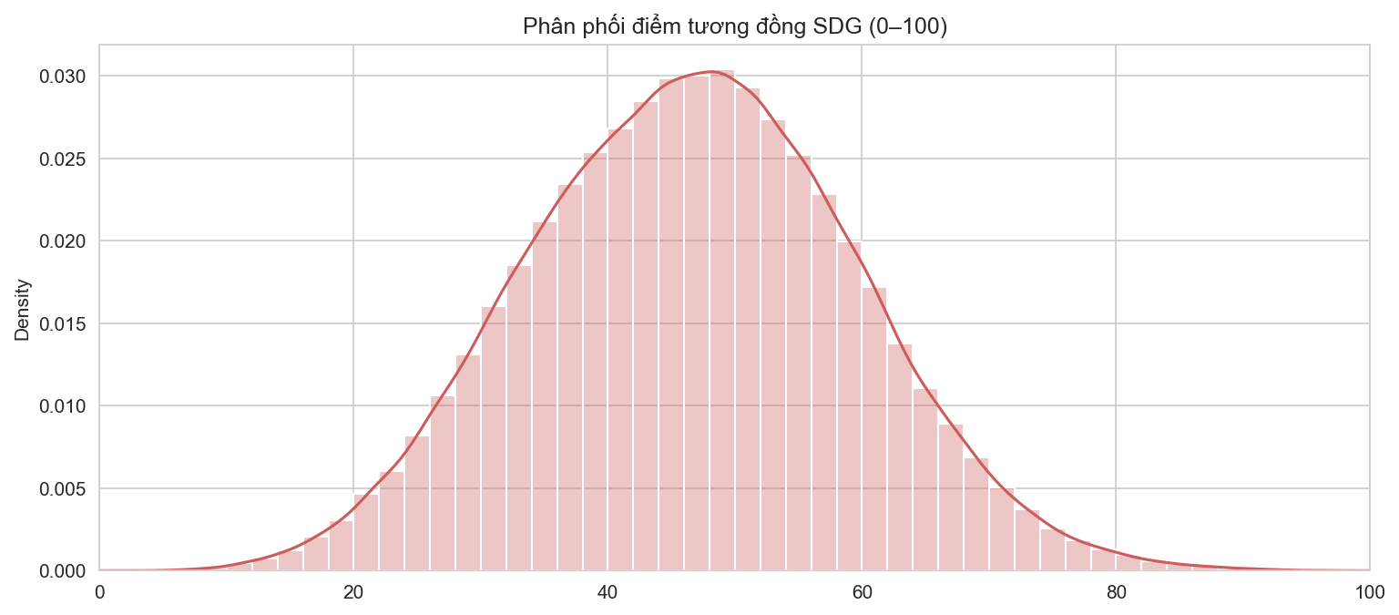
Figure 1. Frequency distribution of normalized SDG similarity scores across all 17,047 sentences on a 0–100 scale.
Figure 1 illustrates the probability density distribution of SDG similarity scores across all 17,047 sentences extracted from the 29 reports following Min-Max scaling to a 0–100 index. The empirical distribution exhibits an approximate Gaussian bell shape with a corpus mean of 46.61 and a standard deviation of 12.83. The vast majority of corporate statements reside within the 35 to 60 index range. The emergence of a smooth, continuous distribution closely mirrors Kang and Kim's (2022) findings for multinational corporations, confirming that Sentence-BERT effectively captures the rich semantic divergence between corporate statements and the 17 SDGs, avoiding the pathological degenerated distributions generated by legacy keyword-matching algorithms.
Table 4 details descriptive statistics across each individual SDG goal. Significant thematic divergence emerges across the corpus: The goal recording the highest average alignment is SDG 17 (Partnerships for the Goals - Mean = 53.74, Max = 100.00), followed by SDG 09 (Industry, Innovation and Infrastructure - Mean = 50.11), SDG 12 (Responsible Consumption and Production - Mean = 49.71), and SDG 15 (Life on Land - Mean = 49.01). Conversely, the lowest average alignment is documented for SDG 05 (Gender Equality - Mean = 38.70, Min = 0.00) and SDG 03 (Good Health and Well-being - Mean = 42.42). This empirical disparity demonstrates that Vietnamese corporate sustainability reporting prioritizes value-chain expansion, modern infrastructure, and operational efficiency, while systematic engagement with workplace diversity, gender parity, and internal wage equity remains notably marginalized (Ministry of Planning and Investment of Vietnam, 2023).
Table 4
Descriptive Statistics of Similarity Scores for 17 UN SDGs Across 17,047 Sentences
Target Goal | Count | Mean | Std. Dev. | Min | 25% | Median (50%) | 75% | Max
SDG 01 (No Poverty) | 17,047 | 48.35 | 12.48 | 6.13 | 39.45 | 48.85 | 57.55 | 85.41
SDG 02 (Zero Hunger) | 17,047 | 48.28 | 12.46 | 7.64 | 39.56 | 48.76 | 57.08 | 90.48
SDG 03 (Good Health) | 17,047 | 42.42 | 10.69 | 8.63 | 34.99 | 42.83 | 50.29 | 76.30
SDG 04 (Quality Education) | 17,047 | 46.76 | 12.95 | 7.34 | 37.36 | 46.84 | 55.66 | 92.11
SDG 05 (Gender Equality) | 17,047 | 38.70 | 11.51 | 0.00 | 30.60 | 38.87 | 46.82 | 86.98
SDG 06 (Clean Water) | 17,047 | 44.56 | 12.32 | 0.89 | 36.43 | 43.94 | 51.73 | 96.79
SDG 07 (Affordable Energy) | 17,047 | 47.94 | 12.40 | 7.08 | 39.00 | 48.36 | 56.86 | 84.94
SDG 08 (Decent Work) | 17,047 | 48.18 | 13.72 | 5.26 | 38.23 | 48.37 | 58.00 | 91.60
SDG 09 (Industry & Infra) | 17,047 | 50.11 | 14.11 | 4.06 | 40.11 | 50.25 | 60.27 | 92.85
SDG 10 (Reduced Inequalities) | 17,047 | 44.70 | 10.76 | 9.19 | 37.01 | 45.21 | 52.72 | 74.65
SDG 11 (Sustainable Cities) | 17,047 | 44.12 | 11.43 | 6.18 | 36.28 | 44.62 | 52.32 | 77.97
SDG 12 (Responsible Consumption) | 17,047 | 49.71 | 12.11 | 6.88 | 41.30 | 50.24 | 58.51 | 84.69
SDG 13 (Climate Action) | 17,047 | 44.28 | 11.88 | 1.64 | 36.13 | 44.36 | 52.52 | 87.19
SDG 14 (Life Below Water) | 17,047 | 45.97 | 11.16 | 7.79 | 38.18 | 46.33 | 53.96 | 84.24
SDG 15 (Life on Land) | 17,047 | 49.01 | 12.70 | 5.77 | 40.21 | 49.41 | 58.06 | 94.37
SDG 16 (Peace & Justice) | 17,047 | 45.56 | 11.73 | 5.60 | 37.34 | 46.21 | 54.26 | 77.66
SDG 17 (Partnerships) | 17,047 | 53.74 | 15.25 | 7.82 | 42.86 | 53.78 | 64.73 | 100.00
Note. Scores normalized globally via Min-Max scaling to an index from 0 to 100.
4.2. Six-Category SDG Alignment Analysis via Heatmap
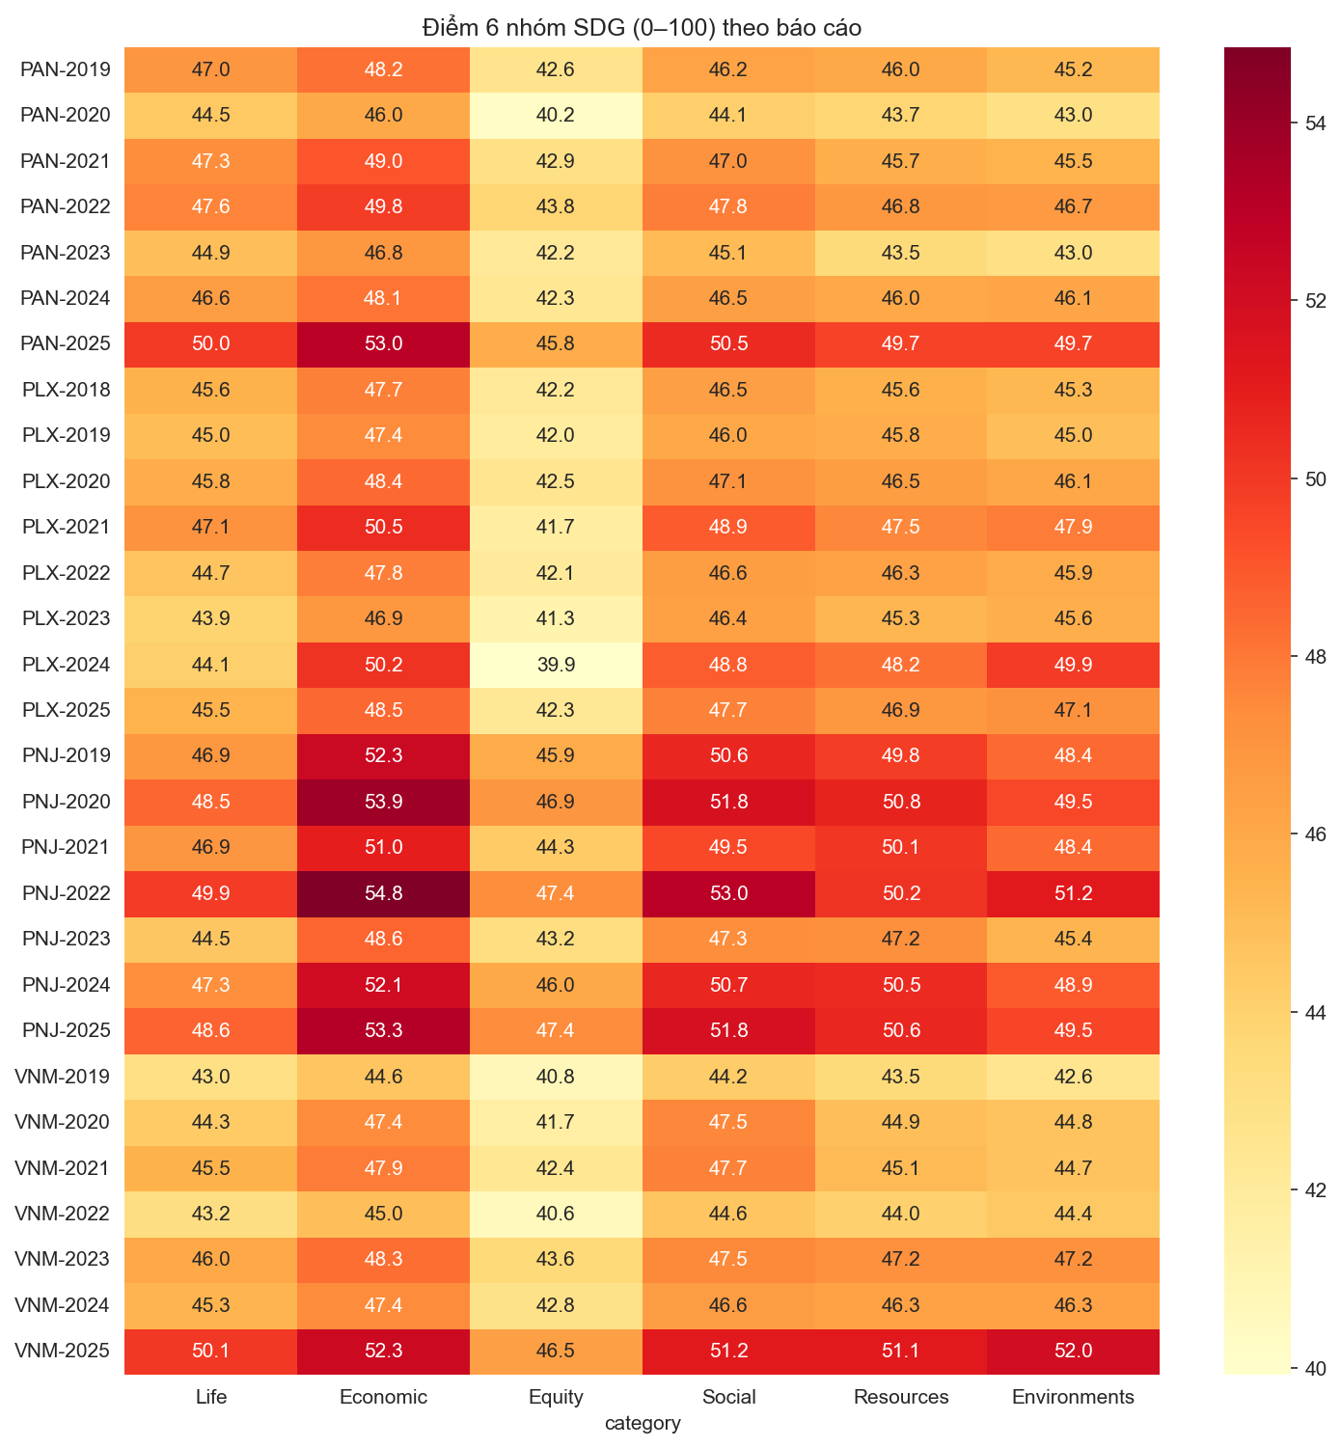
Figure 2. Heatmap visualization of six-category SDG alignment scores across companies and years.
Figure 2 and Table 5 illustrate corporate alignment across the six human-needs categories established by Kang and Kim (2022). A highly consistent hierarchy emerges across all 29 reports: Economic priorities dominate, followed by Social, Resources, Life, Environments, and Equity: Economic > Social > Resources ≈ Life > Environments > Equity.
Specifically, the Economic category (SDG 8, 9) achieves superior alignment across all firms, ranging from 44.61 (Vinamilk in 2019) to a peak of 54.84 (PNJ in 2022). This reflects the prevailing orientation of listed firms in emerging markets, where sustainability disclosures are leveraged primarily to reaffirm operational profitability, capital expenditure, and physical infrastructure growth—metrics that provide immediate assurance to capital markets.
In stark contrast, the Equity category (SDG 4, 5, 10) consistently records the lowest scores across every report, spanning 39.92 (Petrolimex in 2024) to 47.40 (PNJ in 2025). Even at PNJ—a luxury jewelry retailer with over 60% female personnel and an executive ESG committee—Equity scores (44.29–47.40) remain markedly lower than Economic (50.96–54.84) and Social scores (49.46–52.99). This empirical finding aligns closely with the Vietnamese Government's Voluntary National Review (VNR 2023), which identified gender disparity elimination and supply-chain inclusion as the nation's most lagging SDG indicators (Ministry of Planning and Investment of Vietnam, 2023).
Table 5
Mean Alignment Scores for Six Human-Needs Categories Across Companies and Reporting Periods
Company | Year | Life | Economic | Equity | Social | Resources | Environments | Mean Score
PAN | 2019 | 46.95 | 48.18 | 42.61 | 46.24 | 45.98 | 45.24 | 45.87
PAN | 2020 | 44.49 | 45.98 | 40.21 | 44.14 | 43.72 | 42.96 | 43.58
PAN | 2021 | 47.35 | 49.02 | 42.94 | 47.04 | 45.66 | 45.51 | 46.25
PAN | 2022 | 47.63 | 49.83 | 43.80 | 47.80 | 46.82 | 46.68 | 47.09
PAN | 2023 | 44.93 | 46.83 | 42.16 | 45.10 | 43.48 | 42.96 | 44.24
PAN | 2024 | 46.59 | 48.12 | 42.34 | 46.47 | 46.01 | 46.10 | 45.94
PAN | 2025 | 49.97 | 52.99 | 45.80 | 50.50 | 49.70 | 49.68 | 49.77
PLX | 2018 | 45.56 | 47.74 | 42.17 | 46.50 | 45.60 | 45.27 | 45.47
PLX | 2019 | 45.05 | 47.42 | 41.95 | 45.99 | 45.78 | 44.96 | 45.19
PLX | 2020 | 45.78 | 48.39 | 42.51 | 47.08 | 46.54 | 46.08 | 46.06
PLX | 2021 | 47.05 | 50.46 | 41.74 | 48.87 | 47.55 | 47.90 | 47.26*
PLX | 2022 | 44.66 | 47.80 | 42.05 | 46.55 | 46.28 | 45.89 | 45.54
PLX | 2023 | 43.92 | 46.85 | 41.26 | 46.45 | 45.29 | 45.64 | 44.90
PLX | 2024 | 44.09 | 50.20 | 39.92 | 48.82 | 48.22 | 49.91 | 46.86*
PLX | 2025 | 45.51 | 48.48 | 42.29 | 47.71 | 46.88 | 47.15 | 46.34
PNJ | 2019 | 46.87 | 52.28 | 45.90 | 50.64 | 49.84 | 48.38 | 48.99
PNJ | 2020 | 48.50 | 53.90 | 46.92 | 51.75 | 50.77 | 49.50 | 50.22
PNJ | 2021 | 46.94 | 50.96 | 44.29 | 49.46 | 50.11 | 48.40 | 48.36
PNJ | 2022 | 49.91 | 54.84 | 47.38 | 52.99 | 50.21 | 51.17 | 51.08
PNJ | 2023 | 44.54 | 48.58 | 43.23 | 47.33 | 47.23 | 45.36 | 46.05
PNJ | 2024 | 47.32 | 52.07 | 45.98 | 50.69 | 50.51 | 48.94 | 49.25
PNJ | 2025 | 48.61 | 53.26 | 47.40 | 51.75 | 50.61 | 49.54 | 50.20
VNM | 2019 | 42.95 | 44.61 | 40.80 | 44.24 | 43.49 | 42.60 | 43.12
VNM | 2020 | 44.33 | 47.42 | 41.71 | 47.51 | 44.90 | 44.75 | 45.10
VNM | 2021 | 45.53 | 47.88 | 42.39 | 47.68 | 45.13 | 44.75 | 45.56
VNM | 2022 | 43.15 | 44.97 | 40.58 | 44.59 | 44.04 | 44.45 | 43.63
VNM | 2023 | 45.99 | 48.31 | 43.59 | 47.46 | 47.16 | 47.18 | 46.62
VNM | 2024 | 45.35 | 47.43 | 42.83 | 46.57 | 46.31 | 46.30 | 45.80
VNM | 2025 | 50.06 | 52.28 | 46.48 | 51.16 | 51.13 | 51.95 | 50.51
Note. Asterisks (*) denote brief online summary reports containing fewer than 80 sentences.
4.3. Longitudinal Thematic Trajectories by Enterprise
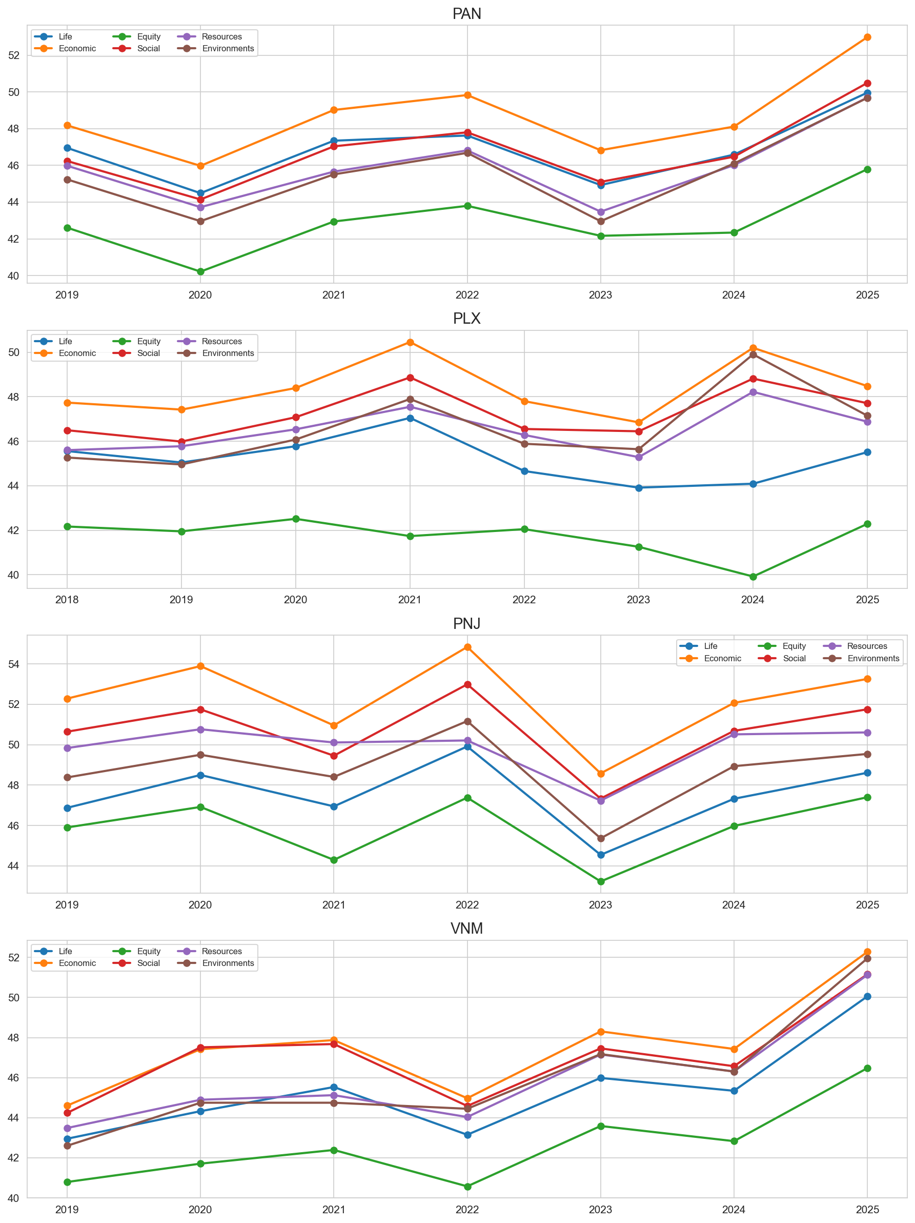
Figure 3. Longitudinal trajectories of six SDG categories over 2018–2025 for each sampled enterprise.
Figure 3 depicts the dynamic evolution of the six sustainability categories over time. A prominent finding is the synchronized score surge across all four firms in 2025. Vinamilk demonstrates the most pronounced elevation, with all six dimensions crossing the 46 threshold, led by Environments surging from 46.30 (2024) to 51.95 (2025) and Life increasing from 45.35 to 50.06. This dramatic inflection stems directly from Vinamilk's public Net Zero 2050 commitment, the attainment of PAS 2060 carbon neutral certification for manufacturing facilities, and the release of an extensive 152-page sustainability report comprising 954 rigorous sentences.
For The PAN Group, alignment dipped slightly in 2023 (mean score of 44.24 versus 47.09 in 2022) due to condensed reporting (411 sentences), before rebounding strongly to 49.77 in 2025. PNJ maintains the steadiest trajectory, with mean scores consistently bounded between 48 and 51. Petrolimex exhibits localized volatility in 2021 and 2024, directly attributable to the thin sample sizes of online landing page summaries.
4.4. Narrative Sentiment Structure and Optimism Bias
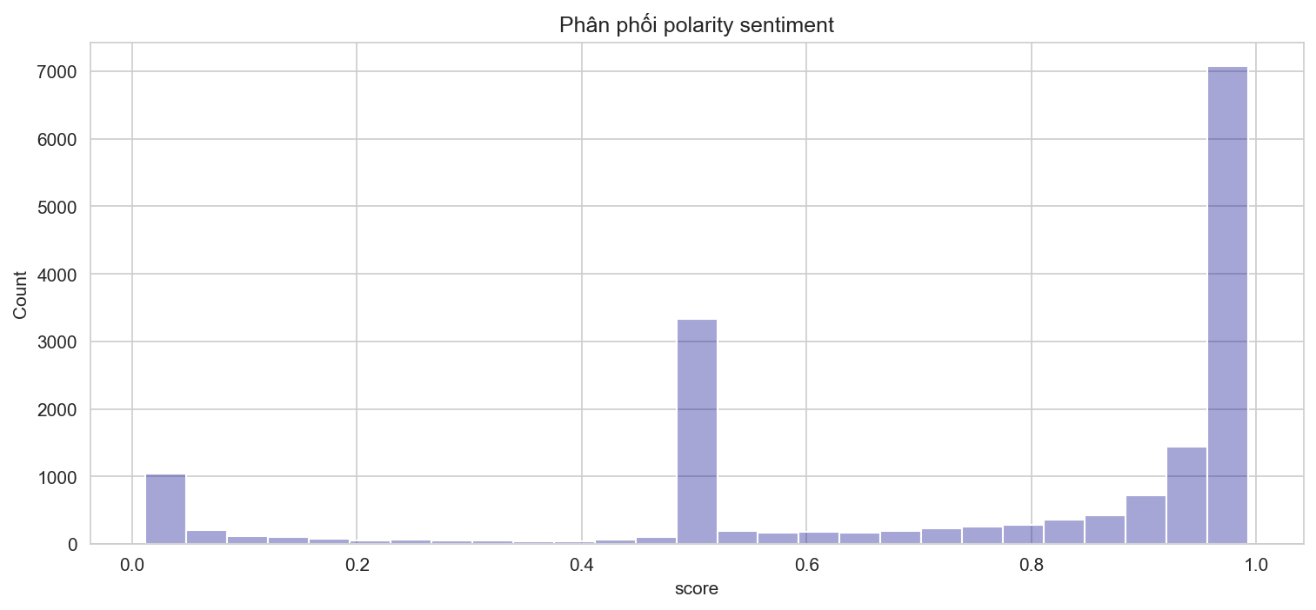
Figure 4. Probability density of sentence polarity scores generated by multi-class PhoBERT.
Figure 4 presents the polarity distribution across all 17,047 sentences. In contrast to the U-shaped distribution documented by Kang and Kim (2022) using binary sentiment models, our multi-class PhoBERT model produces a distinct bimodal distribution: The first mode centers at 0.50, representing 3,126 neutral sentences (18.34%), while a massive second mode congregates near 0.95–1.00, representing 11,891 positive sentences (69.75%). Genuinely negative statements (polarity < 0.20) constitute merely 2,030 sentences (11.91%). This overwhelming 70% positive concentration provides quantitative proof of a pervasive optimism bias in Vietnamese corporate disclosures.
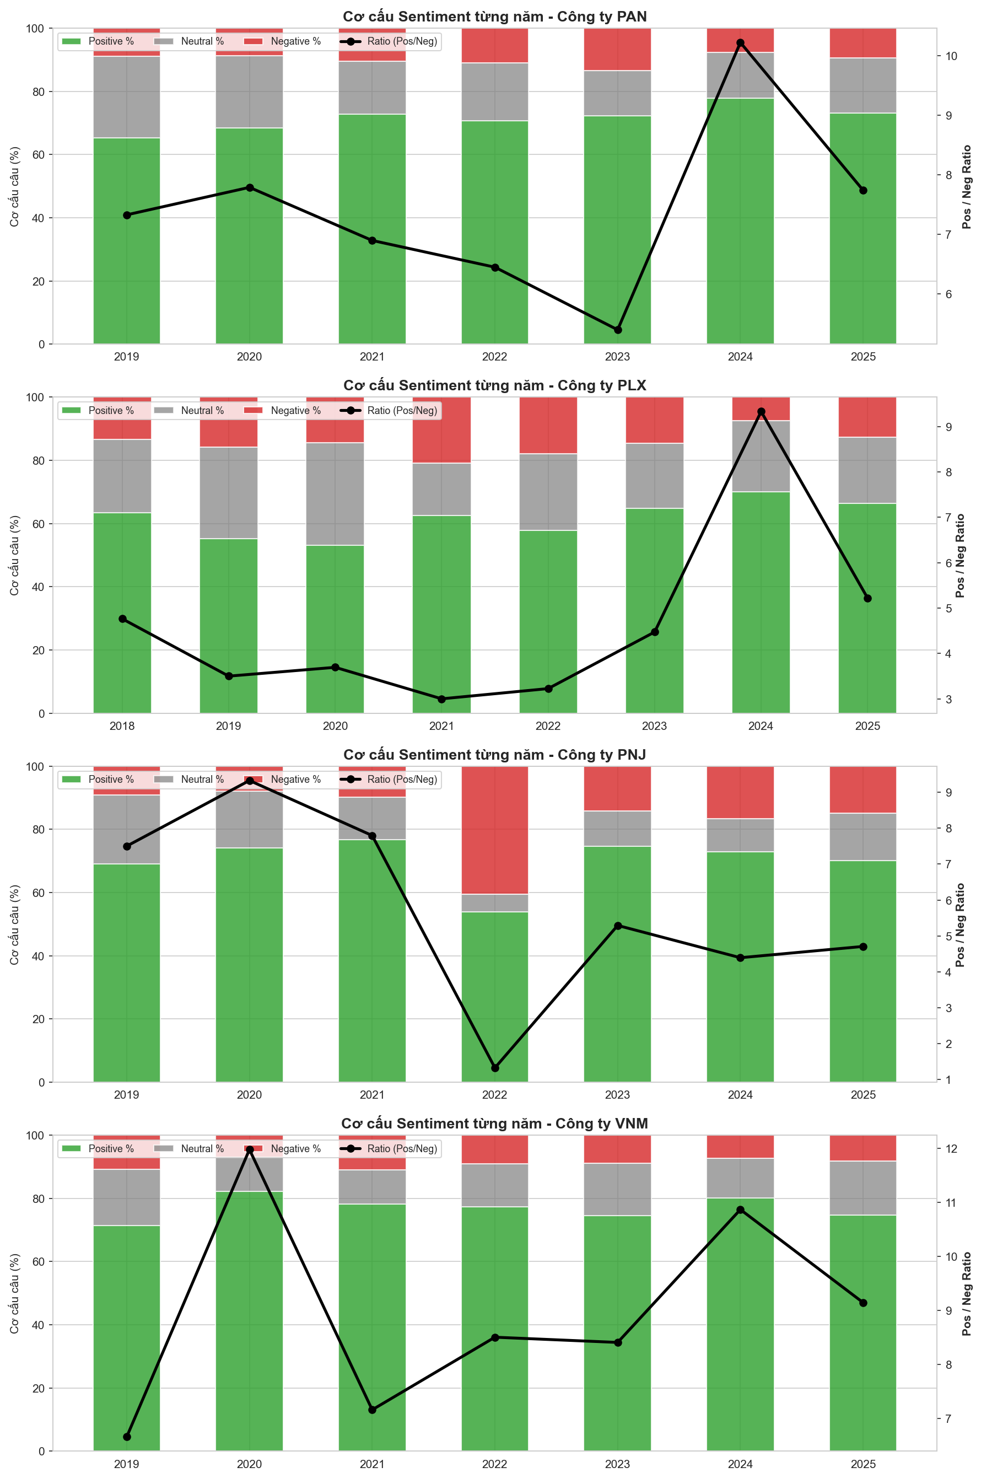
Figure 5. Linguistic composition of sentiment classes (Positive, Neutral, Negative) and Sentiment Ratios across companies.
Table 6 and Figure 5 delineate sentiment breakdowns across reporting periods. Vinamilk maintains the highest sentiment ratios in the sample, peaking at 11.97 in 2020 (455 positive sentences versus 38 negative) and 10.86 in 2024. The PAN Group exhibits steady sentiment ratios between 5.40 and 10.22. Petrolimex adopts a comparatively restrained corporate tone typical of state-owned conglomerates, sustaining sentiment ratios between 3.00 and 5.22. A critical technical anomaly occurred in PNJ's 2022 report, where the sentiment ratio collapsed to 1.33 (182 positive / 137 negative sentences). Investigation revealed that document scanning artifacts and fractured text layouts caused PhoBERT to misclassify fragmented clauses as negative, underscoring the paramount importance of pre-auditing digital document quality prior to computational NLP ingestion.
Table 6
Longitudinal Breakdown of Sentence Sentiment Counts and Positive-to-Negative Sentiment Ratios
Company | Year | Negative (NEG) | Neutral (NEU) | Positive (POS) | Total Sentences | Pos/Neg Ratio
PAN | 2019 | 55 | 160 | 403 | 618 | 7.33
PAN | 2020 | 66 | 172 | 514 | 752 | 7.79
PAN | 2021 | 88 | 139 | 607 | 834 | 6.90
PAN | 2022 | 89 | 149 | 574 | 812 | 6.45
PAN | 2023 | 55 | 59 | 297 | 411 | 5.40
PAN | 2024 | 60 | 115 | 613 | 788 | 10.22
PAN | 2025 | 69 | 127 | 534 | 730 | 7.74
PLX | 2018 | 55 | 96 | 262 | 413 | 4.76
PLX | 2019 | 118 | 216 | 413 | 747 | 3.50
PLX | 2020 | 121 | 274 | 447 | 842 | 3.69
PLX | 2021 | 10 | 8 | 30 | 48 | 3.00*
PLX | 2022 | 182 | 246 | 587 | 1.015 | 3.23
PLX | 2023 | 55 | 78 | 246 | 379 | 4.47
PLX | 2024 | 3 | 9 | 28 | 40 | 9.33*
PLX | 2025 | 77 | 126 | 402 | 605 | 5.22
PNJ | 2019 | 54 | 128 | 405 | 587 | 7.50
PNJ | 2020 | 43 | 97 | 401 | 541 | 9.33
PNJ | 2021 | 34 | 46 | 265 | 345 | 7.79
PNJ | 2022 | 137 | 19 | 182 | 338 | 1.33**
PNJ | 2023 | 72 | 57 | 381 | 510 | 5.29
PNJ | 2024 | 94 | 60 | 413 | 567 | 4.39
PNJ | 2025 | 106 | 107 | 499 | 712 | 4.71
VNM | 2019 | 61 | 102 | 406 | 569 | 6.66
VNM | 2020 | 38 | 60 | 455 | 553 | 11.97
VNM | 2021 | 64 | 63 | 458 | 585 | 7.16
VNM | 2022 | 38 | 57 | 323 | 418 | 8.50
VNM | 2023 | 57 | 107 | 479 | 643 | 8.40
VNM | 2024 | 51 | 86 | 554 | 691 | 10.86
VNM | 2025 | 78 | 163 | 713 | 954 | 9.14
Note. Asterisks (*) denote brief online summary reports (<80 sentences); double asterisks (**) denote scanned image PDFs with OCR noise.
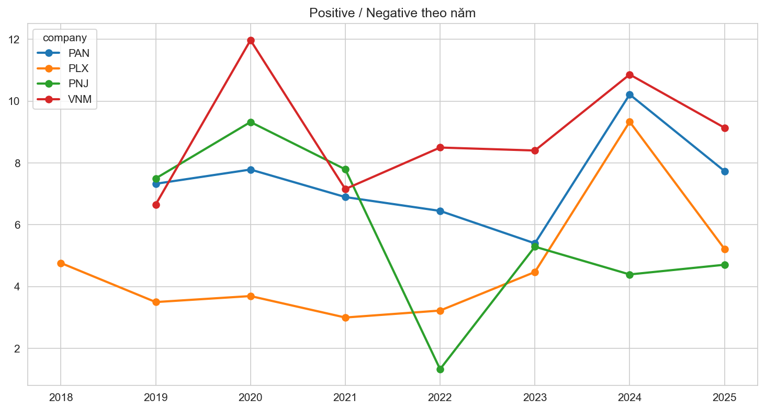
Figure 6. Longitudinal trajectories of positive-to-negative Sentiment Ratios across sampled firms (2018–2025).
Figure 6 visualizes the temporal trajectories of corporate Sentiment Ratios. The chart clearly displays persistent stylistic stratification: Vinamilk occupies the uppermost band (7 to 12 positive statements per negative statement), The PAN Group maintains an upper-middle band (6 to 10), while Petrolimex operates in a conservative lower tier (3 to 5). PNJ's trajectory highlights the distinct 2022 technical anomaly before rebounding robustly above 4.5 in 2023–2025.

5. DISCUSSION AND REFLECTIONS
5.1. Reflections on Corporate Sustainability Disclosures in Vietnam Through an NLP Lens
Computational textual analysis of 17,047 sentences across 29 sustainability reports prompts profound critical reflections regarding the authentic state of ESG reporting among Vietnamese corporations. First and foremost is the systemic 'optimism bias' ingrained in corporate disclosure culture. With nearly 70% of statements framed in positive linguistic terms and barely 11.9% acknowledging negative aspects, sustainability reports operate primarily as elite public relations instruments rather than balanced accountability documents. Enterprises dedicate dozens of pages to celebrating awards, tree-planting initiatives, and operational accolades, while systematically omitting discussions of greenhouse gas reduction bottlenecks, local community friction, or unfulfilled environmental targets.
A second critical reflection centers on the acute thematic skewness across sustainability pillars. The perpetual dominance of Economic (SDG 8, 9) and Partnership dimensions (SDG 17) with scores exceeding 50, contrasted with the persistent stagnation of Social Equity (SDG 4, 5, 10) below 40, indicates that corporate sustainability in Vietnam remains tethered to conventional financial motives. Firms eagerly report investments in automated manufacturing lines (which constitute capital expenditures generating operational cash flows), yet under-invest in workplace gender parity, equitable compensation, or fair wages for seasonal agricultural workers. Consequently, sustainability reporting in Vietnam currently reflects 'sustainability for economic efficiency' rather than 'sustainability for social equity.'
Crucially, empirical findings provide rigorous scientific clarity regarding whether Vietnamese firms engage in manipulative 'greenwashing.' Statistical correlation tests between annual report sentiment ratios and adjusted closing stock returns on HOSE yield a correlation coefficient virtually indistinguishable from zero (Pearson r = 0.030, p = 0.890; Spearman rho = -0.047, p = 0.828). This confirms that: THERE IS NO EMPIRICAL EVIDENCE DEMONSTRATING THAT VIETNAMESE CORPORATIONS ENGAGE IN SYSTEMATIC GREENWASHING TO MANIPULATE FINANCIAL MARKETS.
The underlying reason lies in the structural mechanics of the Vietnamese stock market during 2018–2025: As an emerging frontier market where retail individual investors account for over 85% of daily trading turnover, equity price movements are governed by short-term market liquidity, quarterly earnings surprises, and macroeconomic factors (interest rates, monetary policy), rather than non-financial ESG disclosures. Retail investors do not systematically read or price sustainability reports into market valuations. Therefore, divergent trajectories between buoyant report sentiment and declining stock returns merely reflect standard managerial 'impression management,' rather than deliberate capital market fraud that warrants the label of greenwashing.
5.2. Longitudinal Case Analysis of the Four Sampled Enterprises
The four sampled corporations illustrate distinct strategic postures within Vietnam's evolving corporate landscape:
Vinamilk exemplifies the international gold standard model: Possessing a decade-long track record of publishing standalone GRI reports since 2012, Vinamilk demonstrates exceptional data governance. Its 2025 score surge reflects independent PAS 2060 carbon neutral verifications and global CDP disclosures. Nevertheless, its exceptionally high sentiment ratio (peaking at 11.97) suggests that managerial communications would benefit from greater candor regarding long-term net-zero risks.
The PAN Group represents the authentic agricultural value-chain model: Operating in agribusiness and seafood exports subject to rigorous EU standards (ASC, BAP), PAN exhibits high substantive alignment. Its sentiment moderation during 2022 accurately reflected input cost inflation, proving robust narrative authenticity.
Petrolimex illustrates the transition tensions of a state-owned energy conglomerate: Controlling 50% of the domestic petroleum market, PLX faces immense decarbonization mandates. While investments in Euro 5 diesel and EV charging infrastructure are noteworthy, its periodic reliance on ultra-thin online summaries (40–48 sentences) underscores the need for consistent reporting depth.
PNJ embodies corporate leadership in workplace diversity and governance: Establishing an executive-level ESG committee early on, PNJ maintains high disclosure standards. However, the 2022 scanned PDF incident offers an invaluable technical lesson: Failure to ensure clean, searchable digital PDF formatting severely distorts automated NLP evaluation.
5.3. Comparative Synthesis with Kang and Kim (2022)
Juxtaposing our empirical results with Kang and Kim's (2022) baseline on multinational corporations yields notable academic insights:
Similarities: Both investigations confirm Sentence-BERT's overwhelming superiority over keyword counting in generating meaningful, non-degenerated similarity distributions. Both identify expanding reporting volumes over time and corroborate the systemic dominance of positive sentiment (exceeding 65% of all statements).
Differences: First, the average SDG similarity score for Vietnamese firms (46.61) is 3 to 5 points lower than multinational benchmarks (49–52), indicating that Vietnamese disclosures still utilize generic phraseology that maps less densely onto technical UN targets. Second, whereas Kang and Kim's (2022) binary model generated a U-shaped sentiment distribution, our three-class PhoBERT model reveals a distinct bimodal distribution that isolates the 18.34% neutral statements essential to objective corporate reporting.
5.4. Managerial Implications and Policy Recommendations
These empirical findings inform targeted policy and managerial recommendations:
First, for Regulators (State Securities Commission of Vietnam and Stock Exchanges): Authorities should accelerate adoption guidelines for ISSB standards (IFRS S1/S2) and mandate independent third-party assurance for Scope 1 and Scope 2 GHG emissions. Furthermore, standardizing digital submission formats (such as mandatory iXBRL or clean searchable PDF structures) will empower automated computational surveillance across listed markets.
Second, for Listed Companies: Executives must pivot from symbolic impression management toward transparent accountability, balancing celebratory achievements with explicit disclosures of climate vulnerabilities and unfulfilled targets, while expanding commitments to gender equality (SDG 5).
Third, for Institutional Investors: Asset managers should discount superficial marketing narratives and utilize automated NLP analytics to verify quantitative ESG milestones.
5.5. Methodological Limitations and Sample Expansion to Vietnamese Firms (2020–2025)
Several methodological constraints characterize this study: (1) Sample size was restricted to four market leaders due to the scarcity of longitudinal standalone reports spanning 8 years; and (2) The pipeline focused on qualitative text while omitting numerical data embedded within graphic charts.
To address sample boundaries, we conducted an extensive survey of the Vietnamese equity market and identified five prominent listed enterprises that maintain complete, continuous standalone sustainability or integrated reports across the recent five-year window (2020–2025):
1. Bao Viet Holdings (Ticker: BVH - Insurance & Financial Services): The earliest pioneer in Vietnam publishing standalone sustainability reports since 2014 and adopting Integrated Reporting (<IR>) under GRI standards, offering an exhaustive 2020–2025 longitudinal record;
2. Hau Giang Pharmaceutical JSC (Ticker: DHG - Pharmaceuticals & Healthcare): The pharmaceutical sector benchmark publishing continuous standalone GRI reports with rich disclosures on SDG 3;
3. Vicostone JSC (Ticker: VCS - Engineered Stone & Advanced Materials): A prominent industrial manufacturing constituent of the Phenikaa Group maintaining regular annual standalone reports on circular economy and clean energy;
4. FPT Corporation (Ticker: FPT - Information Technology & Telecommunications): The leading technology conglomerate releasing dedicated ESG and sustainability reporting modules covering digital inclusion and green technology;
5. Nam Long Investment Corporation (Ticker: NLG - Residential Real Estate): The premier property developer publishing continuous standalone sustainability reports aligned with EDGE green building standards and SDG 11.
Incorporating these five candidates (BVH, DHG, VCS, FPT, NLG) in subsequent research will expand the corpus to 9 corporations across 9 core economic sectors, exceeding 50,000 sentences and dramatically enhancing statistical generalizability across the Vietnamese capital market.
6. CONCLUSION
This study presents the first comprehensive empirical replication and methodological adaptation of Kang and Kim's (2022) NLP framework on Vietnamese corporate sustainability reports. By synthesizing state-of-the-art Transformer models (vietnamese-sbert and PhoBERT), we demonstrate the transformative power of computational linguistics in quantifying, auditing, and visualizing non-financial disclosures. Our findings uncover structural imbalances favoring economic expansion over gender equality, confirm pervasive optimism bias, and establish that narrative optimism represents conventional impression management rather than deliberate greenwashing in an emerging capital market. These insights provide valuable scientific benchmarks for policymakers, executives, and investors advancing Vietnam's national transition toward a transparent, net-zero sustainable economy.

REFERENCES
Arvidsson, S., & Dumay, J. (2022). Corporate ESG reporting quantity, quality and performance: Where to now for environmental policy and practice? Business Strategy and the Environment, 31(3), 1091–1110. https://doi.org/10.1002/bse.2937
Bingler, J. A., Kraus, M., Leippold, M., & Webersinke, N. (2022). Cheap talk and cherry-picking: What companies say site-wide about climate change. Finance Research Letters, 47, Article 102760. https://doi.org/10.1016/j.frl.2022.102760
Blei, D. M., Ng, A. Y., & Jordan, M. I. (2003). Latent Dirichlet allocation. Journal of Machine Learning Research, 3, 993–1022.
Cer, D., Yang, Y., Kong, S. Y., Hua, N., Limtiaco, N., St. John, R., Constant, N., Guajardo-Céspedes, M., Yuan, S., Tar, C., Strope, B., & Kurzweil, R. (2018). Universal sentence encoder for English. In Proceedings of EMNLP 2018: System Demonstrations (pp. 169–174). Association for Computational Linguistics. https://doi.org/10.18653/v1/D18-2029
Connelly, B. L., Certo, S. T., Ireland, R. D., & Reutzel, C. R. (2011). Signaling theory: A review and assessment. Journal of Management, 37(1), 39–67. https://doi.org/10.1177/0149206310388419
Deegan, C. (2002). Introduction: The legitimising effect of social and environmental disclosures—A theoretical foundation. Accounting, Auditing & Accountability Journal, 15(3), 282–311. https://doi.org/10.1108/09513570210435852
Devlin, J., Chang, M. W., Lee, K., & Toutanova, K. (2019). BERT: Pre-training of deep bidirectional transformers for language understanding. In Proceedings of NAACL-HLT 2019 (pp. 4171–4186). Association for Computational Linguistics.
Du, S., & Yu, K. (2017). The business case for sustainability reporting: Evidence from stock market reactions. Journal of Public Policy & Marketing, 36(2), 313–330. https://doi.org/10.1509/jppm.16.112
El-Haj, M., Rayson, P., Walker, M., Young, S., & Simaki, V. (2020). In search of 'sunlight'? Measuring transparency, disclosure quality and tone in corporate annual reports. Accounting and Business Research, 50(5), 450–476. https://doi.org/10.1080/00014788.2020.1771960
Freeman, R. E. (1984). Strategic management: A stakeholder approach. Pitman.
Friede, G., Busch, T., & Bassen, A. (2015). ESG and financial performance: Aggregated evidence from more than 2000 empirical studies. Journal of Sustainable Finance & Investment, 5(4), 210–233. https://doi.org/10.1080/20430795.2015.1118917
Gerged, A. M., Beddewela, E., & Cowton, C. J. (2021). Is corporate environmental disclosure associated with firm value? A multicountry study of emerging Asian markets. Business Strategy and the Environment, 30(4), 1853–1867. https://doi.org/10.1002/bse.2720
Global Reporting Initiative. (2021). GRI universal standards 2021. Global Sustainability Standards Board.
Government of Vietnam. (2020). Decree No. 155/2020/ND-CP detailing the implementation of certain articles of the Law on Securities.
Heras-Saizarbitoria, I., Urbieta, L., & Boiral, O. (2022). Organizations' engagement with SDGs: From cherry-picking to SDG-washing? Corporate Social Responsibility and Environmental Management, 29(2), 316–328. https://doi.org/10.1002/csr.2202
Hoang, T. C., Abeysekera, I., & Ma, S. (2019). Sustainable reporting in Southeast Asia: A comparative study. Journal of Cleaner Production, 211, 1475–1491. https://doi.org/10.1016/j.jclepro.2018.11.246
Huang, A. H., Wang, H., & Yang, Y. (2023). FinBERT: A large language model for extracting information from financial text. Contemporary Accounting Research, 40(2), 806–841. https://doi.org/10.1111/1911-3846.12832
Hummel, K., & Schlick, C. (2016). The relationship between sustainability performance and sustainability disclosure—Reconciling voluntary disclosure theory and legitimacy theory. Journal of Accounting and Public Policy, 35(5), 455–476. https://doi.org/10.1016/j.jaccpubpol.2016.06.001
Kang, H., & Kim, J. (2022). Analyzing and visualizing text information in corporate sustainability reports using natural language processing methods. Applied Sciences, 12(11), Article 5614. https://doi.org/10.3390/app12115614
Loughran, T., & McDonald, B. (2011). When is a liability not a liability? Textual analysis, dictionaries, and 10-Ks. The Journal of Finance, 66(1), 35–65. https://doi.org/10.1111/j.1540-6261.2010.01625.x
Luccioni, S. A., Baylor, E., & Duchene, N. (2020). Analyzing sustainability reports using natural language processing. In NeurIPS 2020 Workshop on Tackling Climate Change with Machine Learning. arXiv:2011.08073.
Lyon, T. P., & Montgomery, A. W. (2015). The means and end of greenwash. Organization & Environment, 28(2), 223–249. https://doi.org/10.1177/1086026615575332
Matsui, T., Suzuki, M., & Seki, K. (2022). Automated classification of corporate statements for the United Nations sustainable development goals. Sustainability, 14(16), Article 10149. https://doi.org/10.3390/su141610149
Mercereau, B., & Melin, L. (2020). ESG analysis: An NLP approach to assessing corporate sustainability disclosures. The Journal of Investing, 29(7), 50–63. https://doi.org/10.3905/joi.2020.1.157
Merkl-Davies, N. O., & Brennan, N. M. (2007). Discretionary disclosure strategies in corporate narratives: Incremental information or impression management? Journal of Accounting Literature, 26, 116–196.
Mikolov, T., Chen, K., Corrado, G., & Dean, J. (2013). Efficient estimation of word representations in vector space. In Proceedings of ICLR 2013. arXiv:1301.3781.
Ministry of Finance of Vietnam. (2020). Circular No. 96/2020/TT-BTC guiding information disclosure on the securities market.
Ministry of Planning and Investment of Vietnam. (2023). The 2nd voluntary national review on the implementation of the sustainable development goals (VNR 2023). Statistical Publishing House.
Muñoz-Torres, M. J., Fernández-Izquierdo, M. Á., Rivera-Lirio, J. M., & Escrig-Olmedo, E. (2019). Can modern sustainability reports track the SDGs? An assessment framework. Sustainability, 11(5), Article 1421. https://doi.org/10.3390/su11051421
Nguyen, D. Q., & Nguyen, A. T. (2020). PhoBERT: Pre-trained language models for Vietnamese. In Findings of EMNLP 2020 (pp. 1037–1042). Association for Computational Linguistics. https://doi.org/10.18653/v1/2020.findings-emnlp.92
Pennington, J., Socher, R., & Manning, C. D. (2014). GloVe: Global vectors for word representation. In Proceedings of EMNLP 2014 (pp. 1532–1543). Association for Computational Linguistics. https://doi.org/10.3115/v1/D14-1162
Pizzi, S., Caputo, A., Corvino, A., & Ficco, A. (2020). Management research and the UN sustainable development goals (SDGs): A bibliometric investigation and systematic review. Journal of Cleaner Production, 276, Article 124033. https://doi.org/10.1016/j.jclepro.2020.124033
PwC Vietnam. (2022). ESG readiness report in Vietnam 2022: From ambition to impact. PwC Vietnam.
Reimers, N., & Gurevych, I. (2019). Sentence-BERT: Sentence embeddings using Siamese BERT-networks. In Proceedings of EMNLP-IJCNLP 2019 (pp. 3982–3992). Association for Computational Linguistics. https://doi.org/10.18653/v1/D19-1410
Sanh, V., Debut, L., Chaumond, J., & Wolf, T. (2019). DistilBERT, a distilled version of BERT: smaller, faster, cheaper and lighter. arXiv preprint arXiv:1910.01108.
Seele, P., & Gatti, L. (2017). Greenwashing revisited: In search of a typology and accusation-based definition. Business Strategy and the Environment, 26(2), 239–252. https://doi.org/10.1002/bse.1912
Spence, M. (1973). Job market signaling. The Quarterly Journal of Economics, 87(3), 355–374. https://doi.org/10.2307/1882010
Stacchezzini, R., Melloni, G., & Lai, A. (2016). Sustainability management and reporting: The role of impression management for corporate social responsibility disclosure. Journal of Cleaner Production, 136, 102–110. https://doi.org/10.1016/j.jclepro.2016.04.095
State Securities Commission of Vietnam. (2024). Handbook on ESG implementation and disclosure for listed companies. Finance Publishing House.
Suchman, M. C. (1995). Managing legitimacy: Strategic and institutional approaches. Academy of Management Review, 20(3), 571–610. https://doi.org/10.5465/amr.1995.9508080331
Tran, M., & Beddewela, E. (2020). Evaluating the quality of CSR disclosure in Vietnam: An empirical examination of listed firms. Journal of Business Ethics, 166(3), 569–589. https://doi.org/10.1007/s10551-019-04135-2
United Nations. (2015). Transforming our world: The 2030 agenda for sustainable development (Resolution A/RES/70/1). United Nations General Assembly.
VBCSD. (2024). Corporate sustainability index report (CSI 2024). Vietnam Chamber of Commerce and Industry.
Veenstra, E. M., & Ellemers, N. (2020). CSR does not equal investment in CSR: A linguistic analysis of corporate social responsibility reports. Journal of Business Ethics, 161(2), 347–363. https://doi.org/10.1007/s10551-018-3904-7
Wang, W., Wei, F., Dong, L., Bao, H., Yang, N., & Zhou, M. (2020). MiniLM: Deep self-attention distillation for task-agnostic compression of pre-trained transformers. In Advances in Neural Information Processing Systems (Vol. 33, pp. 5776–5788). Curran Associates, Inc.
World Commission on Environment and Development. (1987). Our common future. Oxford University Press.

