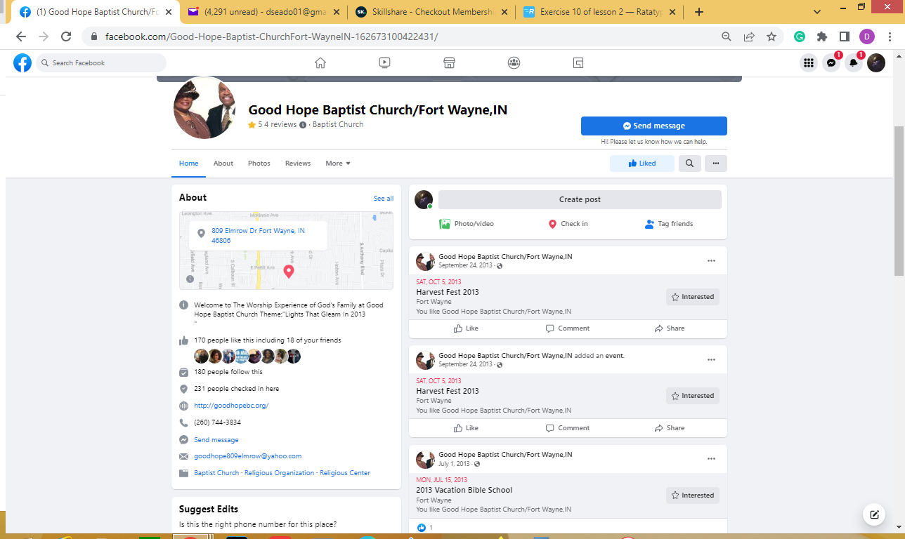

ghbcfw1@gmail.com - ghbc@2020

Greetings,

Honestly, this position and I are just right for each other. As a consultant, I have participated and implemented various mission critical systems. I am SDLC battle tested, I possess the technical aptitude and abilities, business sensibilities and skill set that is necessary for on-site engagements. I work autonomously while constantly striving to be a valuable resource on the project.

I would appreciate the opportunity to pursue the objectives that we both share.

Thank you for the consideration and I look forward to speaking with you.

Donald Seals

Hi Katherine,

COBOL migrations are typically mission-critical conversions from a current state to a proposed state. Thes
e are involved projects with finite budgets and deadlines. One of the critical factors is the resources needed to implement the to-be system, the tools, and technologies needed for implementation. Human resources such as myself help to deliver a successful project. I have the; experience and passion for this type of engagement, the necessary technical aptitude and abilities, and the business acumen to understand the micro and macro views of the project.

Please let's discuss this role as soon as we can.

Best regards,
Don Seals

I have participated in and implemented various mission-critical systems. I am SDLC battle tested, I possess the technical aptitude and abilities, business sensibilities, and skill set that is necessary for this position. I work autonomously while constantly striving to be a trusted and valuable resource on the project.

I would appreciate the opportunity to pursue the objectives and goals that we both share.

Thank you for the consideration and I look forward to speaking with you.

Don Seals

Well hello there and welcome to my foray into creative writing. I am pleased to fulfill your request for a writing sample. Being this is literally my first inquiry for a paid engagement, with your acceptance I will accomplish a huge milestone of establishing a working relation with a client.

I totally understand your goal is the find the best person(s) to provide content for articles, blog posts, email copies and/or website/landing pages. My goal is to capture your attention in the same vain as to capture the attention of your target audience.I know I will do an outstanding job.

My writing experience is from the information technology sector where I prepared documentation that presented concepts for business improvements. As I am transitioning in my life and career the ability to communicate by presenting vivid and clear descriptions of what-is and will-be is will continue to be in high demand. I encourage you to allow us to begin this journey together.

Assuming you were in a similar position at some point in your career, you can appreciate how important any feedback is to continually improve.

Thank you so much for this review and consideration.

Best Regards,
Don Seals
Not much if you don’t have quality content to show. You will need to have damn good content if you are targeting only Indian audience. Something that almost every Indian want to see. Even if you make some content like that, you have to upload videos regularly and keep your subscribers loaded with new videos every week or so.

I have three videos on one of my YouTube channel. All three target global audience. One of these videos have around 8 Lakh views and other two average at around 2 Lakh views. With these videos I was able to fetch approx 6000 INR every three months. It continued for 12 months and then I noticed earnings drop. Why ? because I stopped uploading new videos which ultimately effected my video rankings.

If you want to earn big I would recommend the following:

Think of some content that target global audience.
If your videos contains speech then make sure its in English. If its not provide subtitles at least.
Develop some good video editing skills. I would strongly recommend After Effects.
If your filming something make sure you are having a good video camera and a good quality microphone. No one likes to watch a sloppy video with loud noise going on in background.
Name your YouTube channel that reflects what you upload. Don’t just name it randomly. Once you name it, it cannot be changed again.
Title of your video is very very important. It should contain enough search keywords. Speaking of keywords Tag your videos properly. If you don’t have any idea what tags are, just do a search on google for how to tag your videos effectively.
Once you upload a video on your channel. Promote it. Ask your friends to like and if possible subscribe to your channel. Initial likes and subscribes matter a lot. You can also use like exchange website for example like4like to increase your video likes. Doing this will improve your video rankings.
DON’T EVEN THINK ABOUT COPYING SOMEONE’S CREATION. YOU WILL GET HIT BY COPYRIGHT INFRINGEMENT SOONER OR LATER. This includes any kind of audio tracks or video clips that have copyrights. For example you like some song and you set it as background music for your video. YOUTUBE IS SMART ENOUGH TO DETECT IT. Even if it doesn’t, the content owner will someday notice it and report it. Once this happens you will no longer be able to monetize your video that means no income from that video. Moreover your channel’s reputation will go down which will effect current and future video rankings. In worst case your channel will be suspended. This is the worst thing you can do to your channel.
Upload new videos after a fixed interval. Daily, weekly or monthly. The idea is to make YouTube think you are a active youtuber. So that your rankings and reputation stay intact.

Greetings,

My career is transitioning from an IT background of over 20 years, where I worked on projects from inception to implementation. This has allowed me to build a skill-set from technology to business perspectives. I can provide specific hard and soft skills for any project of any size for any industry. This includes business consulting, project management, business workflow and rules, testing, support, and troubleshooting. I am also looking for other opportunities that may be outside of my domain of IT where I can add new and durable skills while broadening my horizon.

I am well versed in the skills required for this position. Please give me the opportunity to assist you. Not only can I will I complete the data entry in Excel and Word, but I can also contribute if any data processing tasks are necessary. Thank you for the consideration and let’s get to work!

I am well versed in the skills required for this position. Please give me the opportunity to assist you. Not only can I complete the data entry in Excel and Word, but I can also contribute if any data processing tasks are necessary.

My career is transitioning from an IT background of over 20 years, where I worked on projects from inception to implementation. This has allowed me to build a skill-set from technology to business perspectives. I can provide specific hard and soft skills for any project of any size for any industry. This includes business consulting, project management, business workflow and rules, testing, support, and troubleshooting. I am also looking for other opportunities that may be outside of the structure domain of IT project lifecycles.

Thank you for the consideration and let’s get to work!

Greetings,

Thank you for review of this cover letter and associated resume. I have a wealth of experience that I will bring to the table along with a passionate desire to join an organization that shares the same passion.

Please find attached my resume which supports the client relations experience, technical background, and solutions mindfulness that's necessary for the demands of today's evolving marketplace. I am relentless in providing exceptional customer service. It is an absolute must to be detailed oriented and I am certainly willing to go the extra mile to get the job done!

I am excited about the career possibilities you have to offer and to become a part of an organization that is a leader in both its industry and community. Thank you in advance for your time. I certainly appreciate the opportunity for us to discuss my background, aspirations, mutual goals, and objectives that will benefit us both. Please feel free to contact me via email and/or at the phone number provided below.

Kind Regards,

Don Seals
(260) 452-9097

9A03E15X
This keycode is for account verification at Freelancer.com

https://careers-steeldynamics.icims.com/jobs/dashboard?type=4&itemId=19018&iFormSaveAndReturn=1&form=Application&packet=1&job=2515&step=6&hashed=-1144012035

https://alison.com/topic/learn/118296/when-to-proofread#course-plan

Greetings,

My career is in transition, The position drew my interest. After completing college courses I was hired by Lincoln National Corporation. After working there for over 5 years I still have an appreciation of the company culture, the opportunities, and rewards offered to employees, and the standing of LNC in the community.

My resume shows the years of experience I have gained as an IT Specialist which addresses the requirements for this position especially when it comes to becoming a subject matter expert for retirement plan operations, the ability to excel in a fast-paced environment while multi-tasking, and being detailed oriented and the ability to communicate effectively.

Thank you so much for your consideration.

Best Regards,
Don Seals

August 10, 2022

Greetings,

My career is in transition, this position drew my interest. After completing college courses I was hired by Lincoln National Corporation. After working there for over 5 years I still have an appreciation of the company culture, the opportunities, and rewards offered to employees, and the standing of LNC in the community.

My resume shows the years of experience I have gained as an IT Specialist which addresses the requirements for this position especially becoming a subject matter expert for retirement plan operations, the ability to excel in a fast-paced environment while multi-tasking, and being detailed oriented and the ability to communicate effectively. I am also able to work autonomously while being a valuable team resource.

I look forward to the pursuit of the opportunity and I look forward to the next steps.

Thank you so much for your consideration.

Best Regards,
Don Seals

