03_01

List six relational operators.

<, <=, ==, !=, >, >=

03_02

Assuming that x is 1, show the result of the following Boolean expressions:

x > 0

x < 0

x != 0

x >= 0

x != 1

true

false

true

true

false

03_03

boolean b = true;

i = (int)b;

int i = 1;

boolean b = (boolean)i;

No. Boolean values cannot be cast to other types.

03_04

Write an if statement that assigns 1 to x if y is greater than 0.

if (y > 0)

x = 1;

03_05

Write an if statement that increases pay by 3% if score is greater than 90.

if (score > 90)

pay *= 1.03;

03_06

What is wrong in the following code?

if radius >= 0

{

area = radius * radius * PI;

System.out.println("The area for the circle of " +

" radius " + radius + " is " + area);

}

The parentheses is reuqired for the conidition radius >= 0.

03_07

Write an if statement that increases pay by 3% if score is greater than 90, otherwise increases pay by 1%.

if (score > 90)

pay *= 1.03;

else

pay *= 1.01;

03_08

if (number % 2 == 0)

System.out.println(number + " is even.");

else

System.out.println(number + " is odd.");

If number is 30, (a) displays

30 is even

30 is odd

(b) displays

30 is even

If number is 35, (a) displays

35 is odd

(b) displays

35 is odd

03_09

Suppose x = 3 and y = 2; show the output, if any, of the following code. What is the output if x = 3 and y = 4? What is the output if x = 2 and y = 2? Draw a flowchart of the code.

**if** (x > 2) {

**if** (y > 2) {

z = x + y;

System.out.println("z is " + z);

}

}

**else**

System.out.println("x is " + x);

Note: else matches the first if clause. No output if x = 3 and y = 2. Output is "z is 7" if if x = 3 and y = 4. Output is "x is 2" if if x = 2 and y = 2.

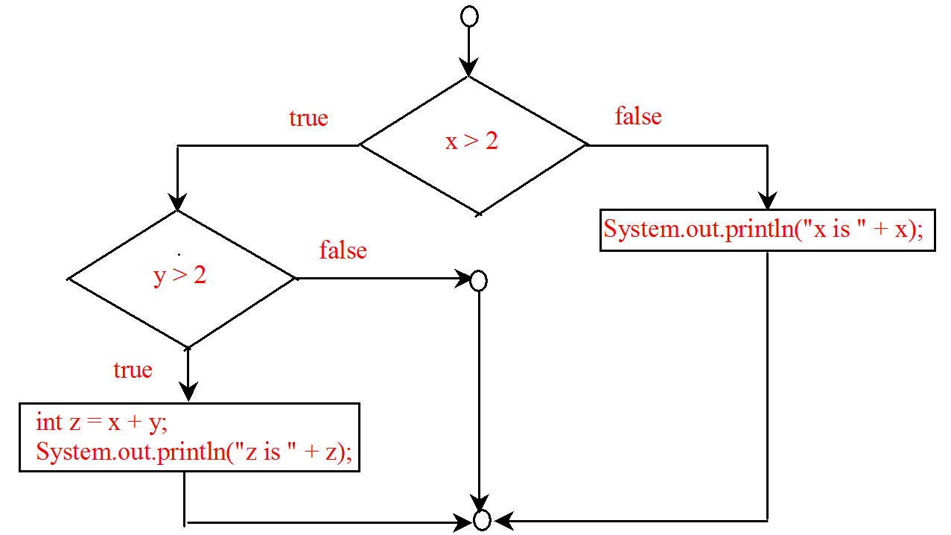

03_10

**if** (score >= 60.0)

System.out.println("D");

**else** **if** (score >= 70.0)

System.out.println("C");

**else** **if** (score >= 80.0)

System.out.println("B");

**else** **if** (score >= 90.0)

System.out.println("A");

**else**

System.out.println("F");

Consider score 90, what will be the grade? It will be D.

03_11

Which of the following statements are equivalent? Which ones are correctly indented?

(a)

**if** (i > 0) **if**

(j > 0)

x = 0; **else**

**if** (k > 0) y = 0;

**else** z = 0;

(b)

**if** (i > 0) {

**if** (j > 0)

x = 0;

**else** **if** (k > 0)

y = 0;

}

**else**

z = 0;

(c)

**if** (i > 0)

**if** (j > 0)

x = 0;

**else** **if** (k > 0)

y = 0;

**else**

z = 0;

(d)

**if** (i > 0)

**if** (j > 0)

x = 0;

**else** **if** (k > 0)

y = 0;

**else**

z = 0;

a, c, and d are the same. (B) and (C) are correctly indented.

03_12

Rewrite the following statement using a Boolean expression:

**if** (count % 10 == 0)

newLine = **true**;

**else**

newLine = **false**;

newLine = (count % 10 == 0);

03_13

Are the following statements correct? Which one is better?

(a)

**if** (age < 16)

System.out.println

("Cannot get a driver's license");

**if** (age >= 16)

System.out.println

("Can get a driver's license");

(b)

**if** (age < 16)

System.out.println

("Cannot get a driver's license");

**else**

System.out.println

("Can get a driver's license");

Both are correct. (b) is better.

03_14

What is the output of the following code if number is 14, 15, or 30?

(a)

**if** (number % 2 == 0)

System.out.println

(number + " is even");

**if** (number % 5 == 0)

System.out.println

(number + " is multiple of 5");

(b)

**if** (number % 2 == 0)

System.out.println

(number + " is even");

**else** **if** (number % 5 == 0)

System.out.println

(number + " is multiple of 5");

For (a) if number is 14, the output is

14 is even

if number is 15, the output is

15 is multiple of 5

if number is 30, the output is

30 is even

30 is multiple of 5

For (b) if number is 14, the output is

14 is even

If number is 15, the output is

15 is multiple of 5

if number is 30, the output is

30 is even

03_14

Which of the following is a possible output from invoking Math.random()?

323.4, 0.5, 34, 1.0, 0.0, 0.234

0.5, 0.0, 0.234

03_15

a. How do you generate a random integer i such that 0 <= i < 20 ?  
b. How do you generate a random integer i such that 10 <= i < 20  
c. How do you generate a random integer i such that 10 <= i <= 50  
d. Write an expression that returns 0 or 1 randomly.

(a) (int)(Math.random() * 20)  
(b) 10 + (int)(Math.random() * 10)  
(c) 10 + (int)(Math.random() * 41)  
(d) (int)(Math.random() * 2)

03_16

Are the following two statements equivalent?

(a)

**if** (income <= 10000)

tax = income * 0.1;

**else** **if** (income <= 20000)

tax = 1000 +

(income - 10000) * 0.15;

(b)

**if** (income <= 10000)

tax = income * 0.1;

**else** **if** (income > 10000 &&

income <= 20000)

tax = 1000 +

(income - 10000) * 0.15;

Yes

03_17

(a) Write a Boolean expression that evaluates to true if a number stored in variable num is between 1 and 100.  
(b) Write a Boolean expression that evaluates to true if a number stored in variable num is between 1 and 100 or the number is negative.

(a) (num > 1) && (num < 100)  
(b) (num > 1) && (num < 100) || num < 0

03_18

(a) Write a Boolean expression for |x - 5| < 4.5.  
(b) Write a Boolean expression for |x - 5| > 4.5.

(a) (x - 5) < 4.5 && (x - 5) > -4.5  
(b) (x - 5) > 4.5 || (x - 5) < -4.5

03_19

Assume that x and y are int type. Which of the following are legal Java expressions?

x > y > 0

x = y && y

x /= y

x or y

x and y

(x != 0) || (x = 0)

x > y > 0 is incorrect  
x = y && y is incorrect  
x /= y is correct  
x or y is incorrect  
x and y is incorrect  
(x != 0) || (x = 0) is incorrect on x = 0. It should be x == 0.

03_20

Are the following two expressions the same?

(a) x % 2 == 0 && x % 3 == 0

(b) x % 6 == 0

Yes

03_21

What is the value of the expression x >= 50 && x <= 100 if x is 45, 67, or 101?

If x is 45, the expression is false.  
If x is 67, the expression is true.  
If x is 101, the expression is false.

03_22

Suppose, when you run the following program, you enter the input 2 3 6 from the console. What is the output?

**public** **class** Test {

**public** **static** **void** main(String[] args) {

java.util.Scanner input = **new** java.util.Scanner(System.in);

**double** x = input.nextDouble();

**double** y = input.nextDouble();

**double** z = input.nextDouble();

System.out.println("(x < y && y < z) is " + (x < y && y < z));

System.out.println("(x < y || y < z) is " + (x < y || y < z));

System.out.println("!(x < y) is " + !(x < y));

System.out.println("(x + y < z) is " + (x + y < z));

System.out.println("(x + y > z) is " + (x + y > z));

}

}

(x < y && y < z) is true  
(x < y || y < z) is true  
!(x < y) is false  
(x + y < z) is true  
(x + y > z) is false

03_23

Write a Boolean expression that evaluates to true if age is greater than 13 and less than 18.

age > 13 && age < 18

03_24

Write a Boolean expression that evaluates to true if weight is greater than 50 pounds or height is greater than 60 inches.

weight > 50 || height > 60.

03_25

Write a Boolean expression that evaluates to true if weight is greater than 50 pounds and height is greater than 60 inches.

weight > 50 && height > 60.

03_26

Write a Boolean expression that evaluates to true if either weight is greater than 50 pounds or height is greater than 60 inches, but not both.

weight > 50 ^ height > 60.

03_27

Write a Boolean expression that evaluates to true if either weight is greater than 50 pounds or height is greater than 60 inches, but not both.

weight > 50 ^ height > 60.

03_28

What happens if you enter an integer as 05?

It will be the same as entering 5.

03_29

What data types are required for a switch variable? If the keyword break is not used after a case is processed, what is the next statement to be executed? Can you convert a switch statement to an equivalent if statement, or vice versa? What are the advantages of using a switch statement?

Switch variables must be of char, byte, short, int, or String types. If a break statement is not used, the next case statement is performed. You can always convert a switch statement to an equivalent if statement, but not an if statement to a switch statement. The use of the switch statement can improve readability of the program in some cases. The compiled code for the switch statement is also more efficient than its corresponding if statement.

03_30

What is y after the following switch statement is executed? Rewrite the code using an if-else statement.

x = 3; y = 3;

**switch** (x + 3) {

**case** 6: y = 1;

default: y += 1;

}

y is 2.

x = 3; y = 3;

if (x + 3 == 6) {

y = 1;

}

y += 1;

03_31

What is x after the following if-else statement is executed? Use a switch statement to rewrite it and draw the flowchart for the new switch statement.

**int** x = 1, a = 3;

**if** (a == 1)

x += 5;

**else** **if** (a == 2)

x += 10;

**else** **if** (a == 3)

x += 16;

**else** **if** (a == 4)

x += 34;

x is 17

switch (a) {

case 1: x += 5; break;

case 2: x += 10; break;

case 3: x += 16; break;

case 4: x += 34;

}

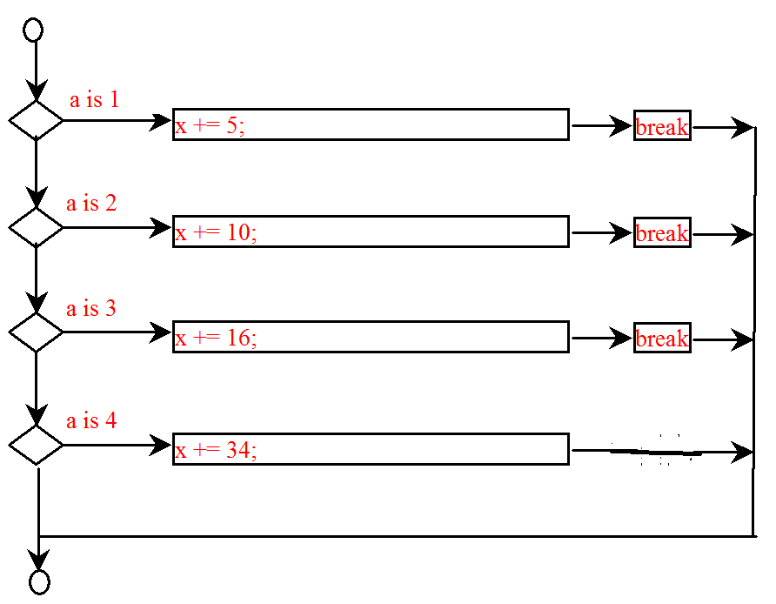

03_32

Write a switch statement that displays Sunday, Monday, Tuesday, Wednesday, Thursday, Friday, Saturday, if day is 0, 1, 2, 3, 4, 5, 6, accordingly.

switch (day) {

case 0: System.out.println("Sunday"); break;

case 1: System.out.println("Monday"); break;

case 2: System.out.println("Tuesday"); break;

case 3: System.out.println("Wednesday"); break;

case 4: System.out.println("Thurday"); break;

case 5: System.out.println("Friday"); break;

case 6: System.out.println("Saturday"); break;

}

03_33

int remainder = year % 12;

if (remainder == 0)

System.out.println("monkey");

else if (remainder == 1)

System.out.println("rooster");

else if (remainder == 2)

System.out.println("dog");

else if (remainder == 3)

System.out.println("pig");

else if (remainder == 4)

System.out.println("rat");

else if (remainder == 5)

System.out.println("ox");

else if (remainder == 6)

System.out.println("tiger");

else if (remainder == 7)

System.out.println("rabbit");

else if (remainder == 8)

System.out.println("dragon");

else if (remainder == 9)

System.out.println("snake");

else if (remainder == 10)

System.out.println("horse");

else

System.out.println("sheep");

03_34

Suppose that, when you run the following program, you enter the input 2 3 6 from the console. What is the output?

**public** **class** Test {

**public** **static** **void** main(String[] args) {

java.util.Scanner input = **new** java.util.Scanner(System.in);

**double** x = input.nextDouble();

**double** y = input.nextDouble();

**double** z = input.nextDouble();

System.out.println((x < y && y < z) ?

"sorted" : "not sorted");

}

}

Sorted

03_35

Rewrite the following if statements using the conditional operator.

**if** (ages >= 16)

ticketPrice = 20;

**else**

ticketPrice = 10;

ticketPrice = (ages >= 16) ? 20 : 10;

03_36

Rewrite the following conditional expressions using if-else statements.  
a. score = (x > 10) ? 3 * scale : 4 * scale;  
b. tax = (income > 10000) ? income * 0.2 : income * 0.17 + 1000;  
c. System.out.println((number % 3 == 0) ? i : j);

(a)

if (x > 10)

score = 3 * scale;

else

score = 4 * scale;

(b)

if (income > 10000)

tax = income * 0.2;

else

tax = income * 0.17 + 1000;

(c)

if (number % 3 == 0)

System.out.println(i);

else

System.out.println(j);

03_37

Write conditional expression that returns -1 or 1 randomly.

(int)(Math.random() * 2) == 0 ? -1 : 1;

03_38

List the precedence order of the Boolean operators. Evaluate the following expressions:

**true** || **true** && **false**

**true** && **true** || **false**

The precedence order for boolean operators is !, ^, &&, and ||  
true || true && false is true  
true && true || false is true

03_39

List the precedence order of the Boolean operators. Evaluate the following expressions:

**true** || **true** && **false**

**true** && **true** || **false**

The precedence order for boolean operators is !, ^, &&, and ||  
true || true && false is true  
true && true || false is true

03_40

True or false? All the binary operators except = are left associative.

True

03_41

Evaluate the following expressions:

2 * 2 - 3 > 2 && 4 - 2 > 5

2 * 2 - 3 > 2 || 4 - 2 > 5

Both are false

03_42

Is x > 0 && x < 10 the same as x > 0 && x < 10?  
Is x > 0 || x < 10 the same as x > 0 || x < 10?  
Is (x > 0 || x < 10) && y < 0 the same as (x > 0 || (x < 10 && y < 0))?

Yes. Yes. Yes.