

Demon Slayer

GDD 201 – Project 1: Design Document

Son Nguyen

Prof. Bertozzi

1/10/2019

# Game Overview

### Game Concept / Genre / Target Audience

Demon Slayer is a side-scrolling RPG fighting game that takes place in Japan in the middle of the Sengoku Jidai (Warring States) period. In this game, the player is working for one of the most elite samurai forces who don’t scare the death and the sinister forces. The player has missions that require to protect the civilians and rescue them from the demons, which have invaded most of Japan. The target audience of this game is teenagers ( 16 +) and people who work in the office.

### Game Flow Summary

* The player clicks on the Mission button and chooses the mission he/she wants to play, then clicks on the Play button to play that mission.
* The player is spawned on the left side of the screen. The player can freely move forward and backward, up and down on the road.
* Demons are spawned on the right side of the screen. They move from right to left, toward the player and attack the player whenever they can.
* The main mission is on the middle top of the screen. They will show what the player needs to know, for example: kill all of the demons, reach the specified point on the screen, rescue civilians who were surrounded by demons, or survive in a specified time, etc.
* The player will pass the level if he/she completes the mission.
* After finishing the level, the player will return to the main menu. In the main menu, there is a world map, which shows where the player can play next. The player can also choose to retry old missions to get a higher score or farming.

### Look and Feel (Visual Design)

“The player discovers some demons appearing near the village.”

Demon Slayer takes place in 16th century in Japan, so this game will have an old historic look. Some missions bring players a calm feeling by the nature view and audio; however, because of the war between samurai forces and demons, the majority of the game takes place in the battlefield which has collapsed castles, burning houses, etc. The feeling is brought by two main colors, yellow and purple, which cover the atmosphere of the game scene. These two complementary colors will show the difference between peace and chaos. While yellow brings the joy and safety for people (areas that the player cleared will appear in yellow), the purple expresses the death and chaos of areas that demons invaded. The heavy bass audio will create the intense feeling each time the player travels to a new battlefield.

# Gameplay and Mechanics

### 2.1 Gameplay

#### 2.1.1 Progression

As section 1.1 mentioned, Demon Slayer is a side-scrolling RPG fighting game. This means the player has to start from the basic characters and gradually gather elements to upgrade them. The player travels to each area in Japan which has the existence of demons. The main quest of each level appears on the mission tab. In general, the player must kill demons whenever he/she meets and do the main/side missions. After completing the mission, the player receives rewards for that level, which depend on how well the player does (total kills, time, killstreak). The reward is variable, which can be money, upgrade elements, or items.

#### 2.1.2 Mission / Puzzle / Objective

There are three main types of mission: Kill, Survive, and Rescue. Each mission has different objectives and puzzles.

- In the Kill mission, the player receives a task that requires he/ she to kill a number of demons. For example, if the task says: “The General needs 50 heads of zombies”, the player will have to find and kill 50 zombies. The player may face the boss in the end of the level. Kill the boss is a requirement to pass the level.

- In the Survive mission, the player walks into the demon spawning area and fights until the timer goes to 0. If the player successfully survives, the demon spawning area will be neutralized, and the player will receive a collectible object and pass the level.

- In the Rescue mission, the player must find and rescue people who were kidnapped by demons. In some missions, the player may face some puzzle on the road like crossing the river or obstructions, finding the way to move through the demon base. The player can interact with the demons’ corpse to solve the puzzle. When the player reaches the kidnapped civilians, he/she must escort them to the safe place to pass the level. The rescue missions usually are special missions that unlock the lore about the origin of demons or the new chapters.

#### 2.1.3 Play Flow

The player moves from the left to the right on the screen. Demons will come from both sides of screen or the underground. The player should run around to dodge projectiles from demons and also kill them as soon as possible. Depend on what level the player is, different types of demons may appear. Some levels require the player to take down the boss. The bosses are usually stronger than the player when he/she approaches in the first time.

### 2.2 Mechanics

#### 2.2.1 Upgrading / Action / Combat

Upgrading takes an important role in Demon Slayer. The player starts with the Ashigaru (Foot soldier). After 3-4 levels, the player will gather enough elements and items and be able to upgrade his/her character to the samurai. There are four Bushido ways that the player can upgrade: Master of Sword, Master of Spear, Master of Bow, and Master of Gun. Each type has its advantages and disadvantages.

* Master of Sword, which requires sword as the main weapon, provides the player the speed as the advantage. The player can slash in high speed and perform a combo quickly. Master of Sword also gives the player an ability to evade/dash, which makes the player immune to damage during the dash. However, sword deals small damage and close-range attack.
* Master of Spear, which requires spear as the main weapon, provides the player the heavy amount of damage as the advantage. The player can pierce many enemies at the same time with one hit. Master of Spear also gives the player an ability to charge forward and kill every demon on the way. However, slow attack-speed is the weakest point of using spear.
* Master of Bow, which requires bow as the main weapon, provides the player far-range attack with high attack speed. The player can rapidly shoot enemies with unlimited arrows. Master of Bow also gives the player an ability to shoot the fire arrow in a short time, which will ignite all the demons the player shot. However, bow deals small damage and weak at melee.
* Master of Gun, which requires gun as the main weapon, provides the player far-range attack with super heavy damage. The player can shoot all the demon if they are in the lineup. Master of Gun also gives the player an ability to increase the critical chance through levels. However, the player needs to reload after every shot, and it’s weak at melee.

After archiving all Bushido ways, the player will receive the General Character as a reward. The General can use any weapon and change weapon during the game. The special ability of the General is summoning other samurai to fight with him (maximum 4). This special reward is an appreciation to the player for unlocking all the Bushido Ways.

Another important upgrading system is the character’s skill tree. This skill tree provides a set of passive skills, which improves the gameplay and the character itself; for example, increasing damage, healing overtime, spreading arrow, etc.

The player can interact with NPC to get information or lore. The player can attack the objects on the road like boxes or hays to get items. The player can move the corpse of demons to help solving the puzzle in the game.

#### 2.2.2 Objects/ Economy

Objects, items, and money in-game will drop after the player kill a demon. The dropping rate of objects and items will be random when the dropping rate of money will be 100% guarantee. Base of what type of demons the player killed, there will be different amount of money and different quality of items.

Objects and items will be used as the upgrading material, for example: magical stone, fire spirit, water spirit, etc. Money is used to buy a new weapon or to upgrade weapon.

#### 2.2.3 Physics / Movement

- The player can walk and run in all directions (the 8-way-run mechanic).

- The player can dodge the projectile by moving to other position that doesn’t have the same x-axis.

- Master of Sword Evade ability can only dash forward or backward.

- Arrow will be affected by gravity if it’s going toward the far-range target.

- The player can’t jump or duck.

- The player can move the corpse of demons and throw it into the river to walk on it.

- Rainy day will affect the accuracy of gun.

- Windy day will affect the accuracy of bow.

- Mud and swamp surface will slow the character’s movement.

- The player can break boxes, hay by attacking it.

#### 2.2.4 Screen Flow

Main menu:

- Start Game

- There is a map in the middle of the screen

- On the bottom of the screen, there are 3 buttons:

- Play ( the selected area on the map )

- Pause Button ( and Resume button after paused )

- Upgrade ( Move to the upgrade menu )

- Inventory ( Move to the inventory )

- Game Option

- Graphic Option ( TBD )

- Audio Option ( TBD )

- HUD Option ( TBD )

- Exit Game

## 2.3 Game Option

There are four options in upgrading that affect the gameplay. As section 2.2.1 mentioned, the player can choose the Bushido way he/she wants to master. The player can master all four options, but it’ll take time to achieve that. As a reward of unlocking four Bushido ways, the General character will be a playable character for the player.

## 2.3 Replaying and Saving / Cheat and Easter Eggs

The player will have a chance to replay the level when he/she fails to pass it, or he/she has already passed it. This game will automatically save the progression of the player.

There will be some Easter eggs about the history of Japan that player can collect. If the player collects all of them, he/she can choose and upgrade a Bushido way without using any items and objects.

# Story, Setting, and Character

### 3.1 Background and Story

The story began in 1572, when the Takeda Clan expanded a large area to the south, after the battle of Mikatagahara with Oda and Ieyasu forces (Kanae, 2017). The field, where the battle took place, created a sinister atmosphere which makes civilians living around suffer the dreadful feeling. Unfortunately, the lunar eclipse occurred after the battle a week, which created a chance for demons to invade the surface. Shortly after the lunar eclipse, a large explosion happened in the middle of the field. Everything was deep in chaos: people ran, babies cried, dogs barked. Hence, an army of the other world came from the portal, which was created by the explosion. They shouted and began to invade the surface. Facing that emergency, the leader of Takeda clan, Takeda Shingen, ordered his army to ready for the fight with the demon.

## Game World

#### General look and feel of world

Because the story of this game takes place in all Japan, so the general look for this game is Japanese civilization, like old villages, castles on the mountain, a blossom tree field, etc. In the yellow area ( peaceful area ), the feel of world will be joyful and happy. In contrast, the purple area ( chaos area ) will bring the horror feeling to player with burned houses/ castles/ rice field.

#### Areas

There are two areas in this game, yellow and purple. Yellow areas are peaceful areas, which are unlocked after the player cleared the purple areas. In the yellow areas, people come back and live in the village, although there are still some demons were left over. Purple areas are chaos areas, which have the portal that spawns the demons. The player has to destroy it in order to turn the purple areas become the yellow areas.

## A picture containing object Description automatically generatedA picture containing object Description automatically generated Characters

The player starts with the Ashigaru in tutorial and few early levels.

Note:

On the right is spear Ashigaru and on the left is bow Ashigaru.

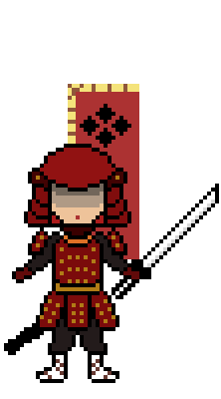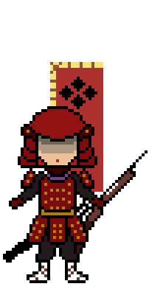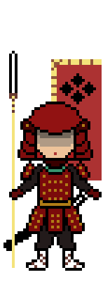

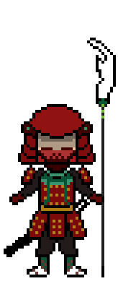

Note:

The Samurai level 1 models

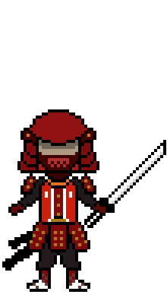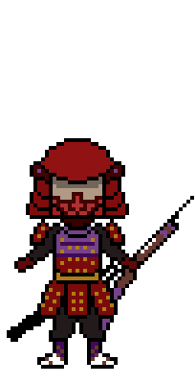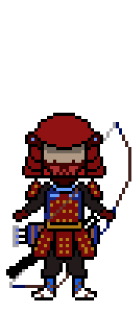

Note:

The Samurai level 2 models

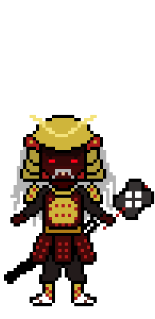

Note:

The General models (Takeda Shingen)

Background: Takeda Shingen, original name Takeda Harunobu, (born December 1, 1521, Kai province [now Yamanashi prefecture], Japan—died May 13, 1573, Komaba, Shinano province [now Nagano prefecture]), daimyo (feudal lord) and one of the most famous military leaders of Japan, who struggled for mastery of the strategic Kantō Plain in east-central Honshu during the chaotic Sengoku (“Warring States”) period of civil unrest in the 16th century. Takeda is especially well known for his series of battles (1553–64) with the noted warrior Uesugi Kenshin, which not only are famous in the annals of Japanese history but are also much celebrated in Japanese drama and folklore (Pletcher, 2014).

Takeda Shingen takes a role as a leader of the demon slayer forces and the most powerful character that the player can unlock in this game. Other samurai and ashigaru are the followers of Takeda Shingen, so they don’t have the background story.

# Level / Interface / Game Art / AI

## 4.1 Levels

Each level has a different background and environment, which depends on which area the character is playing. There is a main road in the middle of the screen, where character, demons, and every action happen on it. The background objects are variable, which can be mountains, houses, castles, depending on the area. The color of the atmosphere is yellow or purple, which also depends on the level, as section 3.2.2 mentioned.

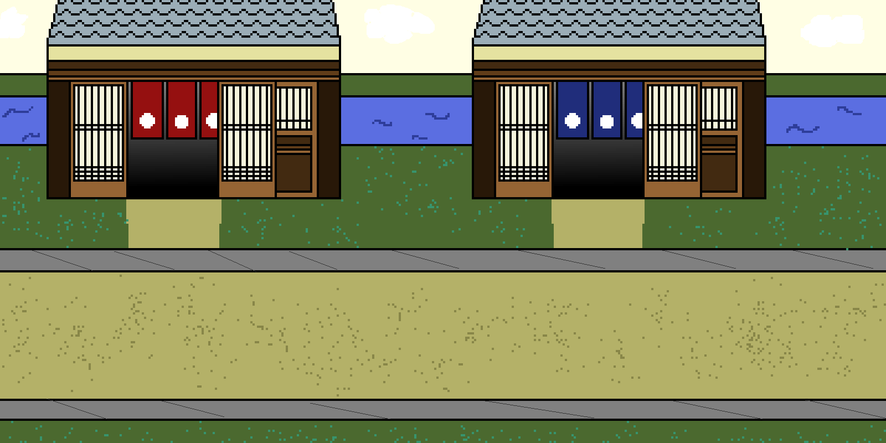

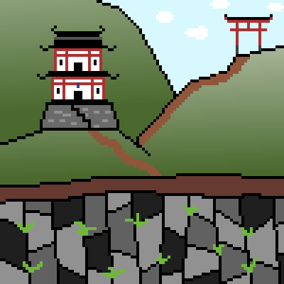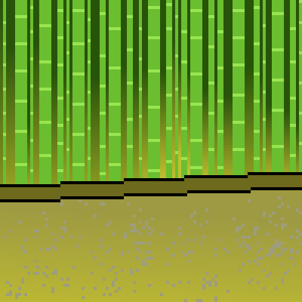

## 4.2 Interface

#### 4.2.1 Visual System

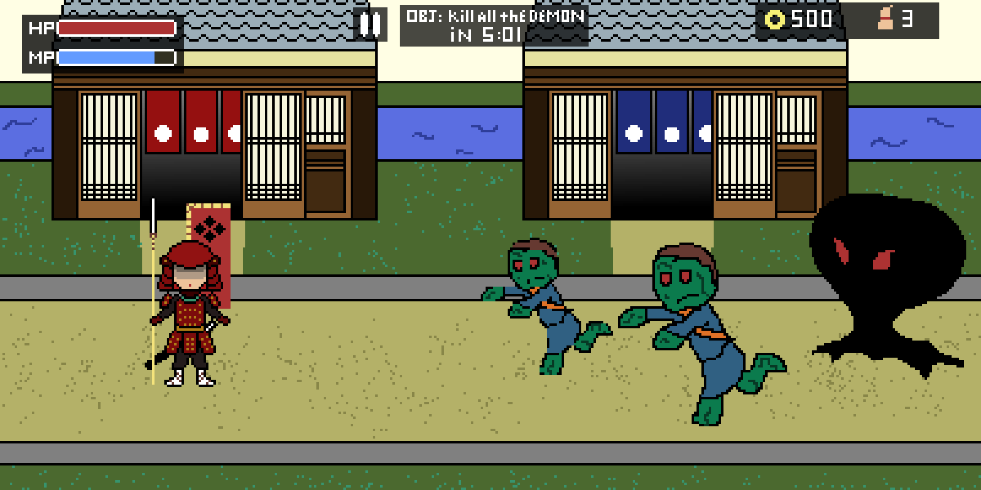The player will have their health bar and energy bar located on the top left of the screen. The collected money and objects on the top right of the screen. The mission tab will appear on the middle top of the screen, and next to it is a pause button.

#### 4.2.2 Control System

- WASD will move the player in all direction.

- J is Attack 1 button

- K is Attack 2 button

- L is Special Skill ( Bushido way )

- N is Guard

- F is Pick up / Interact

- Esc is Pause ( Can use mouse to click on the screen )

- Mouse is used for everything else.

#### 4.2.3 Audio

Demon Slayer will use the traditional Japanese music as the background music. The old war music will be used for the fighting scene.

#### 4.2.4 Help System / Tutorial

There is a tutorial at the beginning of the game. The player will learn how to move, attack, and using skills. There is also a tutorial for the upgrading system.

In the upgrading scene, there will be an explanation for each Bushido way, which states the advantages and the disadvantages of the Bushido way.

## 4.3 Game Art

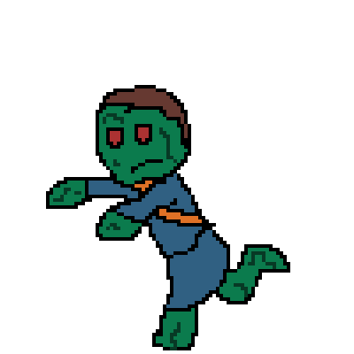 The main art this game uses is pixel art.

 Enemy visual art:

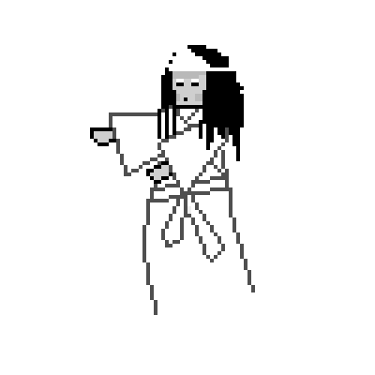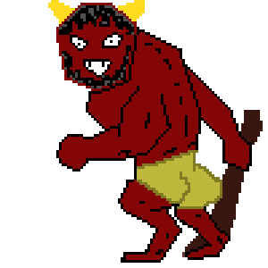

Note: From left to right

Zombie, Spike, White snake, Shadow, Yurei, Lava, Oni

All other game arts are attached to the section they support.

## 4.4 Artificial Intelligence

Enemy AI system will be different depending on the type of enemy it applies to:

For examples:

* Zombie: Low intelligence
* Shadow: Moderate intelligence
* Oni: High intelligence

The scale of AI intelligence defines that AI can accurately shoot / attack or not.

NPC AI system doesn’t do anything besides talking to the players.

# Technical and Requirement

## 5.1 Target Hardware

Low-end PC or laptop

No requirement for GPU

## Development Engine

Unity 2019.2.4f1

WebGL

## Network Requirement

Fine connection to the internet.

# References

Kanae. (2017, Sep 1). *The Battle of Mikatagahara 1573*. Retrieved Sep 2019, from Samurai World: https://samurai-world.com/the-battle-of-mikatagahara-january-25-1573/

Pletcher, K. (2014, 5 30). *Takeda Shingen*. Retrieved from Encyclopædia Britannica: https://www.britannica.com/biography/Takeda-Shingen