# Purpose and background

The company is releasing a report titled ‘Australia's 2030 climate change emissions reduction target – abatement potential’. The report outlines the potential paths Australia can take to reduce our national greenhouse gas emissions by 26 to 28 percent below 2005 levels by 2030. In this report we considered over 70 emissions reduction measures (abatement) that could be pursued.

As part of a communications campaign to promote the report out to industry, the media and commentators, we seek to create an interactive graphic showing the emissions reduction challenge and the contribution different measures can have according to the year in which they are implemented in the lead up to 2030.

We are arguably Australia’s leaders in emissions forecasting and in understanding the commercial realities that determine the success or otherwise of different policy settings. We would like a graphic that reflects this leadership position and attracts and engages the attention of a wide audience.

# Specifications

## Architecture

* The graph should be constructed in HTML (not Flash) and work on the following devices and browsers:
  + Chrome on Windows, Mac and iOS and Android
  + Safari on Mac, iPad and iPhone
  + IE10 and IE 11 on Windows
  + Firefox on Windows, Mac and iOS and Android
* The graph should be responsive if possible.
* The graph should be able to be embedded in other page. We should be able to provide news agencies with HTML code to embed the graph into their pages.
* If possible, end users should not be able to access the raw data behind the graph.

## Design

* The graph should feature an X axis with time in years and a Y axis with emissions in GtCO2-e
* There will be 4 static plots.
  + The current emissions growth path if nothing is done (referred to as “business as usual” or BAU)
  + Australia’s goal to reduce emissions. There will be three target values with a checkbox whereby the user can hide or show any of them.
* The final plot will show the Australia emissions with different “abatement measures” selected. Each abatement measure will reduce the BAU level of emissions. This plot will initially be the same as the BAU plot, but will be reduced as abatement measures are selected.
* The design must include:
  + The five line plots – “Australia’s Target” (28%, 50%, 80%), “BAU” and “BAU with abatement measures”
  + A way of selecting abatement measures
  + A way of selecting the year of commencement for each abatement measure
  + A way of showing the volume of abatement measures for each year and the breakdown of contribution by each abatement measure.
* The way of showing the volume of abatement could be a stacked bar chart showing the contribution of each measure or another means of showing the breakdown.
* If an abatement measure is selected a CSS hover/popup should appear explaining the abatement measure. This should only occur the first time that the abatement measure is selected.

Eg:

|  |  |  |
| --- | --- | --- |
| Measure | Active | Year Commencing |
| Abatement Measure 1 | Yes | 2016 |
| Abatement Measure 2 | No | 2018 |
| Abatement Measure 3 | Yes | 2017 |
| Abatement Measure 4 | Yes | 2016 |

Note: “Active” could be a tick box check box

Note: Year Commencing should be a drop down containing all of the years in the graph.

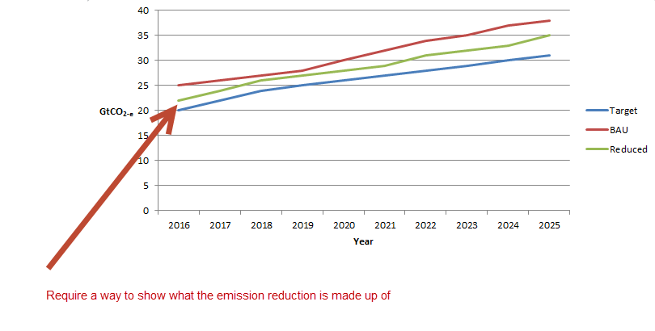

Mockup of potential layout.

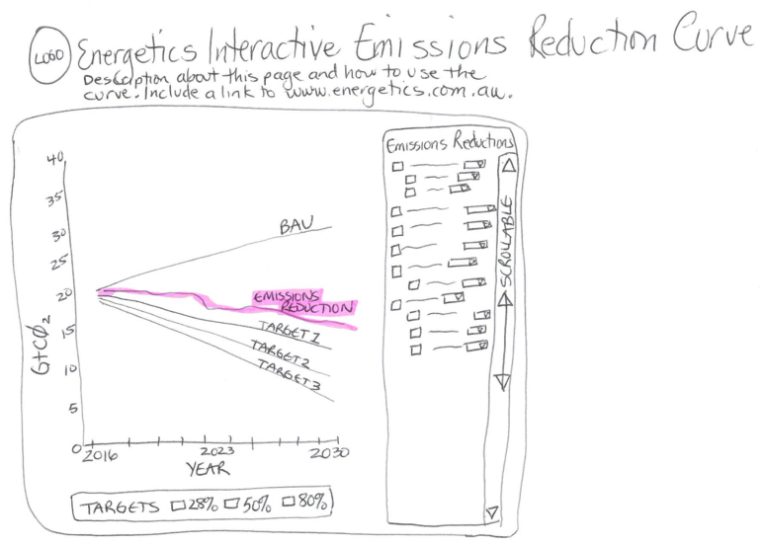

## Abatement Measures

* Each abatement measure will have:
  + An identifying number:
    - Whole numbers are fields (1, 2, 3, etc.)
    - Next level are subfields (1.1, 1.2, 1.3, etc.)
    - Last level are dropdowns (1.1.1, 1.1.2, 1.1.3, etc.)
  + A name
  + Type – field, subfield or dropdown
  + Reduction – the reduction amount for each year

|  |  |  |  |  |  |  |  |
| --- | --- | --- | --- | --- | --- | --- | --- |
| ID Number | Name | Type | Reduction Year 1 | Reduction Year 2 | Reduction Year 3 | Reduction Year 4 | etc |
| 1 | Measure 1 | 2 | 2 | 5 | 5 | 5 | 5 |
| 2 | Measure 2 | 1 | 1 | 4 | 4 | 4 | 4 |
| 3 | Measure 3 | 3 | 2 | 2 | 2 | 2 | 2 |

## Calculating reductions

* The reductions for each year are calculated by adding all of the active emission measure in that year.
* Each emission measure has a reduction amount for each year after it is first activated. For example, if a measure is set to be active in 2018, the “Reduction Year 1” value will apply in that year, “Reduction Year 2” will apply in 2019, “Reduction Year 3” will apply in 2020 and so on.

## Data

* The data for the main chart (target and BAU) should be in a CSV or XML format. The chart should be dynamic so that if further years are added to the CSV/XML file they will be automatically included in the chart.

|  |  |  |
| --- | --- | --- |
| Year | Target | BAU |
| 2016 | 20 | 25 |
| 2017 | 22 | 26 |
| 2018 | 24 | 27 |
| 2019 | 25 | 28 |
| 2020 | 26 | 30 |
| 2021 | 27 | 32 |
| 2022 | 28 | 34 |
| 2023 | 29 | 35 |
| 2024 | 30 | 37 |
| 2025 | 31 | 38 |

* The data for the abatement measures should be in CSV or XML format. The chart should be dynamic so that if further abatement measures are added to the CSV/XML file they will be automatically included in the chart.

|  |  |  |  |  |  |  |  |
| --- | --- | --- | --- | --- | --- | --- | --- |
| ID Number | Name | Type | Reduction Year 1 | Reduction Year 2 | Reduction Year 3 | Reduction Year 4 | etc |
| 1 | Measure 1 | field | 2 | 5 | 5 | 5 | 5 |
| 2 | Measure 2 | field | 1 | 4 | 4 | 4 | 4 |
| 3 | Measure 3 | field | 2 | 2 | 2 | 2 | 2 |

* The data for the hover/popup should be in XML/HTML format, whatever is most appropriate.

Energetics should be able to edit these files to change the chart.

I’d like to build this interactive graph by accessing CSV/XML directly without using database.