To re-create the table in Hive, I used my query from the previous assignment.

*CREATE EXTERNAL TABLE sales*

*(*

*Name string,*

*Platform string,*

*Year_of_Release int,*

*Genre string,*

*Publisher string,*

*NA_Sales float,*

*EU_Sales float,*

*JP_Sales float,*

*Other_Sales float,*

*Global_Sales float,*

*Critic_Score int,*

*Critic_Count int,*

*User_Score int,*

*User_Count int,*

*Developer string,*

*Rating string*

*)*

*ROW FORMAT DELIMITED FIELDS TERMINATED BY ','*

*LINES TERMINATED BY '\n'*

*STORED AS TEXTFILE LOCATION '/vg_sales'*

*TBLPROPERTIES("skip.header.line.count"="1");*

**STEP 1. Create a new table for your analysis call “sales_genre”. Load the table “sales” into this table. Select these columns: Genre, Global_Sales, Critic_Score.**I started by creating the headers for the new table columns.

*CREATE TABLE sales_genre*

*(*

*genre string,*

*global_sales float,*

*critic_score int*

*);*

From there, I overwrote *sales_genre* (the new table) with the data from *sales* (the full table, as downloaded from Kaggle).

*INSERT OVERWRITE TABLE sales_genre*

*SELECT genre, global_sales, critic_score*

*FROM sales;*

Whenever I needed to check if my queries were getting the results I wanted, I would use

*SELECT * FROM sales_genre LIMIT 10*

Final result:

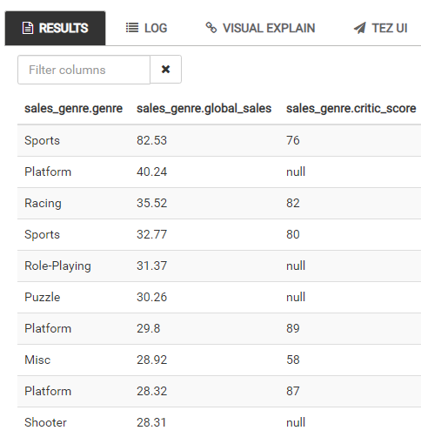

**STEP 2: Round the data found in the “Global_Sales” column.**

My query:

*INSERT OVERWRITE TABLE sales_genre*

*SELECT genre, round(global_sales, 0), critic_score*

*FROM sales_genre;*

Result:

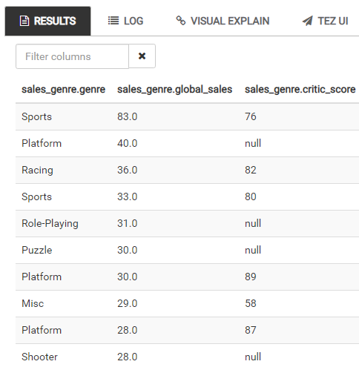

**STEP 3: Filter the data to only look at those items in the “Critic_Score” column that are greater than 0.**

My query:

*INSERT OVERWRITE TABLE sales_genre*

*SELECT \**

*FROM sales_genre*

*WHERE critic_score > 0;*

Final result:

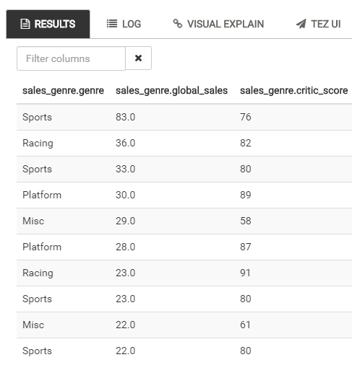

**STEP 4: Order the data in the “Critic_Score” column from highest to lowest.**

My query:

*INSERT OVERWRITE TABLE sales_genre*

*SELECT \**

*FROM sales_genre*

*ORDER BY critic_score DESC;*

Final result:

