Bao cao rieng ve LIME cho RQ2
Cohort ghep cap 1339 flow, seed 42 | XGBoost 15 lop, 78 feature | Bao cao chi tap trung ket qua cua LIME

1. Tom tat
Cau hinh & chat luong surrogate: LIME da giai thich 1339 flow (dung predicted_label, dong bo voi SHAP), voi background 8002 flow phan tang tu train set, kernel_width=6.624, num_samples=5000, num_features=78, discretize_continuous=True. Local R^2 trung binh 0.119 (median 0.068) - THAP hon nguong canh bao 0,3; chuan doan tren tap con 60 flow xac nhan cac cau hinh thay the (num_samples=10.000 hoac discretize_continuous=False) KHONG cai thien R^2 nen cau hinh mac dinh duoc giu nguyen.
On dinh & do nhay: Do on dinh (8 seed, 289 flow, 20/lop): median Jaccard@5 giua cac cap seed = 0.415. Robustness truoc nhieu thoi gian: Jaccard@5 giam nhe tu 0.450 (nhieu 1%) xuong 0.448 (nhieu 10%); ty le doi predicted_label tang tu 3.00% len 5.77%.
Domain & faithfulness: Domain Precision@5 macro-average = 0.111 (thap). Faithfulness (donor-substitution, doi chung ngau nhien) win-rate LIME = 90.44% tai k=5.

2. Chat luong giai thich cuc bo (Local R^2)
Local R^2 la R^2 cua mo hinh Ridge tuyen tinh cuc bo (surrogate) ma LIME fit quanh moi flow. Gia tri thap nghia la surrogate tuyen tinh kho khop voi ham quyet dinh cua XGBoost quanh diem do.
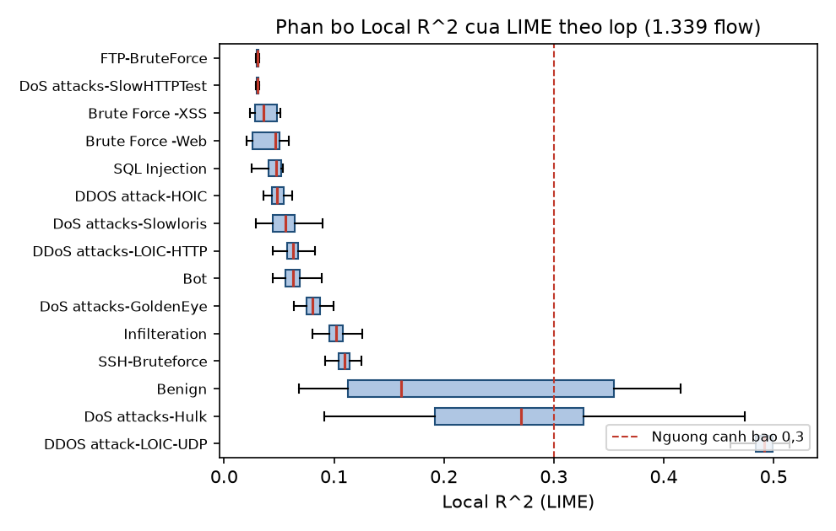
Hinh 1. Phan bo Local R^2 cua LIME theo 15 lop (hop thoi, khong hien fliers). Duong dut la nguong canh bao 0,3.
Cau hinh chuan doan (60 flow) | Median R^2 | Mean R^2 | N
baseline_5000_discretize_true | 0.062 | 0.113 | 60
num_samples_10000 | 0.048 | 0.102 | 60
discretize_false | 0.029 | 0.115 | 60

Ket luan chuan doan: Ca ba cau hinh deu cho R^2 thap tuong duong; tang num_samples hoac tat discretize_continuous KHONG cai thien - day la dac diem cua du lieu/mo hinh (XGBoost phi tuyen manh tren 78 chieu), khong phai loi tham so LIME.

3. Top-5 feature LIME theo lop
Mean |LIME weight| tren cac flow du doan dung cua tung lop. Vi du 4 lop tieu bieu ben duoi; bang day du 15 lop x 5 feature trong lime_top5_by_class.csv.
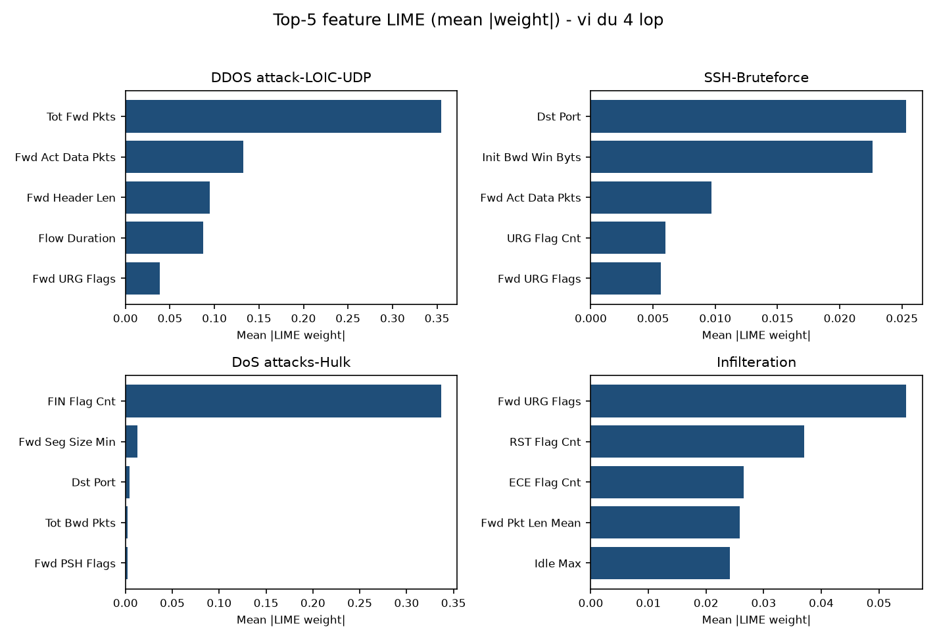
Hinh 2. Top-5 feature LIME (mean |weight|) cho 4 lop vi du.
Lop | Feature Top-1 LIME | Mean |weight|
Benign | FIN Flag Cnt | 0.3084
Bot | Dst Port | 0.0205
Brute Force -Web | RST Flag Cnt | 0.0025
Brute Force -XSS | Bwd Pkts/s | 0.0013
DDOS attack-HOIC | Init Fwd Win Byts | 0.0170
DDOS attack-LOIC-UDP | Tot Fwd Pkts | 0.3546
DDoS attacks-LOIC-HTTP | Fwd Pkts/s | 0.0184
DoS attacks-GoldenEye | Fwd Seg Size Min | 0.0472
DoS attacks-Hulk | FIN Flag Cnt | 0.3367
DoS attacks-SlowHTTPTest | Fwd Seg Size Min | 0.0017
DoS attacks-Slowloris | FIN Flag Cnt | 0.0124
FTP-BruteForce | Fwd Seg Size Min | 0.0018
Infilteration | Fwd URG Flags | 0.0548
SQL Injection | Bwd IAT Std | 0.0019
SSH-Bruteforce | Dst Port | 0.0254

4. Stability giua cac lan chay (seed khac nhau)
Chay lai LIME voi 8 seed khac nhau ([1, 2, 3, 4, 5, 6, 7, 8]) tren tap con 289 flow. Voi moi flow, tinh Jaccard@5 trung binh giua tat ca cap seed; bieu do duoi la median theo lop, sap xep tang dan.
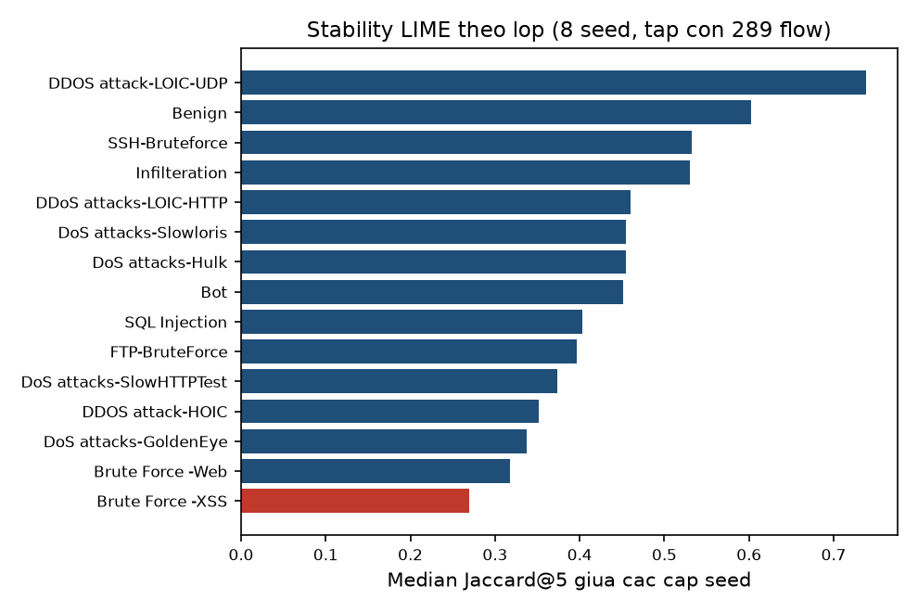
Hinh 3. Stability LIME (median Jaccard@5 giua 8 seed) theo lop. Mau do la lop duoi nguong 0,3 (khong on dinh).
Lop | N | Median Jaccard@5 | Mean | Std
Brute Force -XSS | 20 | 0.269 | 0.263 | 0.052
Brute Force -Web | 20 | 0.318 | 0.285 | 0.119
DoS attacks-GoldenEye | 20 | 0.337 | 0.342 | 0.046
DDOS attack-HOIC | 20 | 0.352 | 0.349 | 0.024
DoS attacks-SlowHTTPTest | 20 | 0.373 | 0.375 | 0.036
FTP-BruteForce | 20 | 0.397 | 0.396 | 0.035
SQL Injection | 9 | 0.403 | 0.477 | 0.147
Bot | 20 | 0.451 | 0.438 | 0.081
DoS attacks-Hulk | 20 | 0.454 | 0.456 | 0.052
DoS attacks-Slowloris | 20 | 0.455 | 0.433 | 0.147
DDoS attacks-LOIC-HTTP | 20 | 0.460 | 0.469 | 0.072
Infilteration | 20 | 0.530 | 0.527 | 0.075
SSH-Bruteforce | 20 | 0.532 | 0.538 | 0.057
Benign | 20 | 0.602 | 0.619 | 0.109
DDOS attack-LOIC-UDP | 20 | 0.738 | 0.743 | 0.044

5. Robustness truoc nhieu thoi gian
Ap dung co che nhieu s = 1 + a*U (U~Uniform[-1,1], a in {1%,5%,10%}) len cac dai luong thoi gian, toc do chia nguoc lai - dung co che SHAP da dung. Lop giai thich giu co dinh la lop du doan TRUOC nhieu.
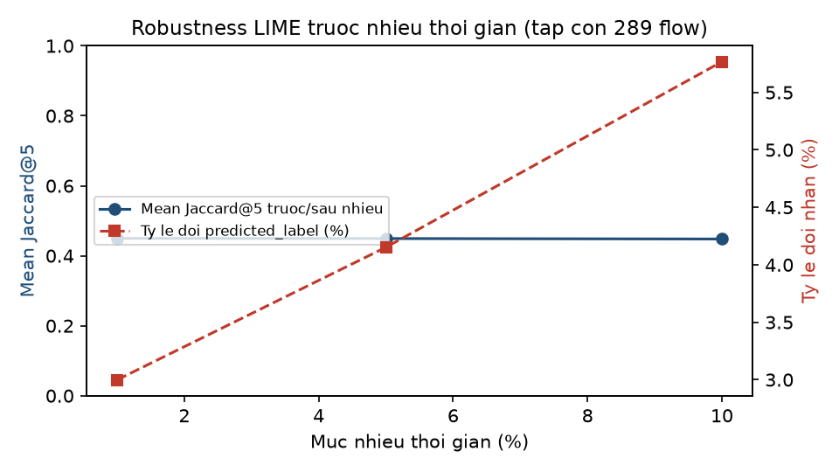
Hinh 4. Jaccard@5 truoc/sau nhieu va ty le doi predicted_label theo muc nhieu.
Muc nhieu | N | Mean Jaccard@5 | Median Jaccard@5 | Ty le doi nhan
1% | 289 | 0.450 | 0.429 | 3.00%
5% | 289 | 0.449 | 0.429 | 4.15%
10% | 289 | 0.448 | 0.429 | 5.77%

6. Domain Precision@5 cua LIME
Ty le feature trong Top-5 LIME khop voi bang expected-signals cua lop that (Bang 8, ke hoach chi tiet), chia cho 5.
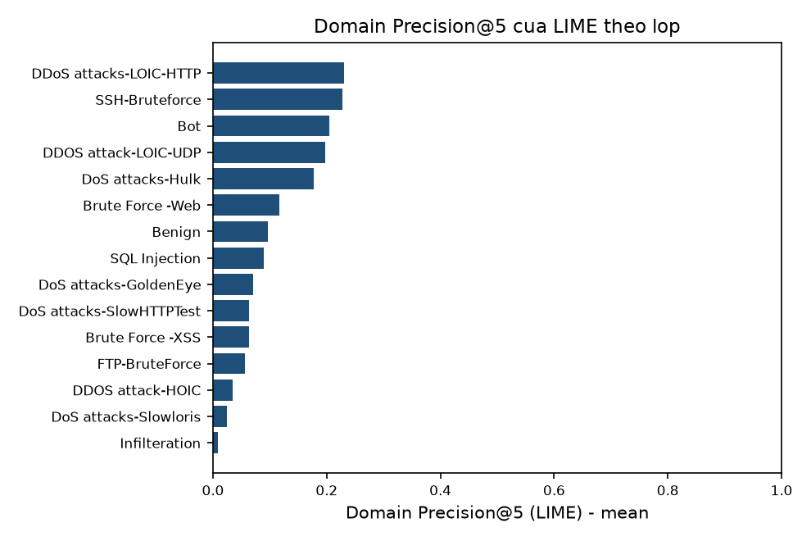
Hinh 5. Domain Precision@5 cua LIME theo lop, sap xep tang dan.
Macro-average (khong trong so, 15 lop) = 0.111 - muc THAP. Day la doi chieu djnh tinh voi kien thuc mien suy tu co che tan cong, khong phai diem chuyen gia SOC doc lap.

7. Faithfulness cua LIME (donor-substitution)
Thay Top-k feature LIME (weight duong) bang gia tri tu 10 dong train (seed 173); doi chung chon ngau nhien k feature tu cung pool duong, lap 20 lan (seed 2026). LIME 'thang' khi muc giam raw margin cua Top-k that su > doi chung, chenh lech qua 1e-6.
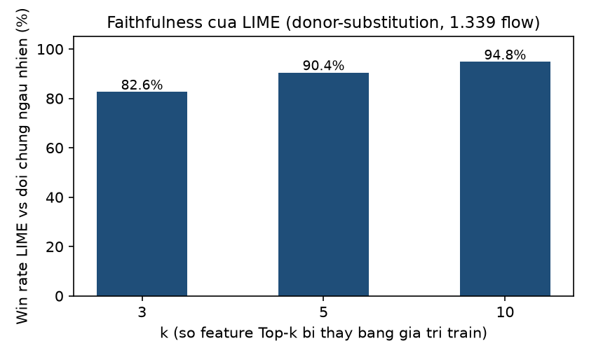
Hinh 6. Win-rate cua LIME so voi doi chung ngau nhien, k=3/5/10, tren 1.339 flow.
k | N | N du dieu kien | Coverage | Win rate LIME
3 | 1339 | 1339 | 100.00% | 82.60%
5 | 1339 | 1339 | 100.00% | 90.44%
10 | 1339 | 1339 | 100.00% | 94.77%

8. Gioi han
Gioi han | Chi tiet
Local R^2 thap | Median 0.068 tren toan cohort - surrogate tuyen tinh kho khop quyet dinh XGBoost phi tuyen tren 78 chieu; da chuan doan hai cau hinh thay the, khong cai thien.
Co mau nho | SQL Injection N=9, Brute Force-XSS N=44 - ket qua chi mang tinh minh hoa cho hai lop nay.
Robustness pham vi hep | Chi chay tren tap con 289 flow (20/lop), khong phai toan bo cohort, do chi phi tinh toan LIME.
Domain signals don gian hoa | Bang expected-signals la kien thuc mien suy luan, khong phai cham diem chuyen gia SOC doc lap.

9. Ket luan ve LIME
Tren cohort 1339 flow, LIME cho Top-5 feature khac nhau ro ret giua cac lop, nhung chat luong surrogate cuc bo thap (local R^2 trung binh 0.119), do on dinh giua cac lan chay o muc trung binh (median Jaccard@5 ~0,42) va giam nhe khi du lieu bi nhieu. Domain Precision@5 va faithfulness cua LIME deu thap hon SHAP tren cung cohort (xem bao cao so sanh RQ2_LIME_Ket_Qua_Final.docx). Day la dac diem cua LIME khi ap dung cho khong gian 78 dac trung mang co tuong tac phi tuyen manh, khong phai loi trien khai.

10. Phu luc bo sung: bieu do co dau (duong/am) cua LIME
Cac bieu do o muc 3 dung |trong so| nen khong cho biet feature day flow VE lop du doan hay KEO RA khoi lop do. Phu luc nay bo sung huong (dau) cua trong so LIME. Mau do = trong so duong (feature ung ho lop du doan); mau xanh = am (feature phan doi). Gia tri la trung binh co dau theo lop tren cohort ghep cap; 5 feature duoc chon theo |trong so| trung binh lon nhat.
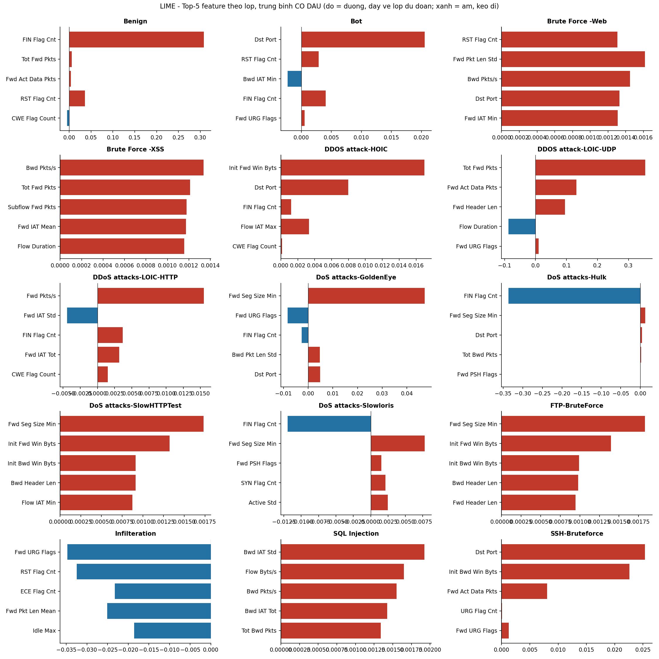
Hinh 10.1. LIME Top-5 co dau cho 15 lop.
Doc bieu do: phan lon feature Top-5 co trong so duong (day ve lop du doan), nhung mot so lop co feature am dang ke, vi du DoS-Hulk co FIN Flag Cnt am rat lon (~ -0,34): flow co co FIN lam giam xac suat lop Hulk.
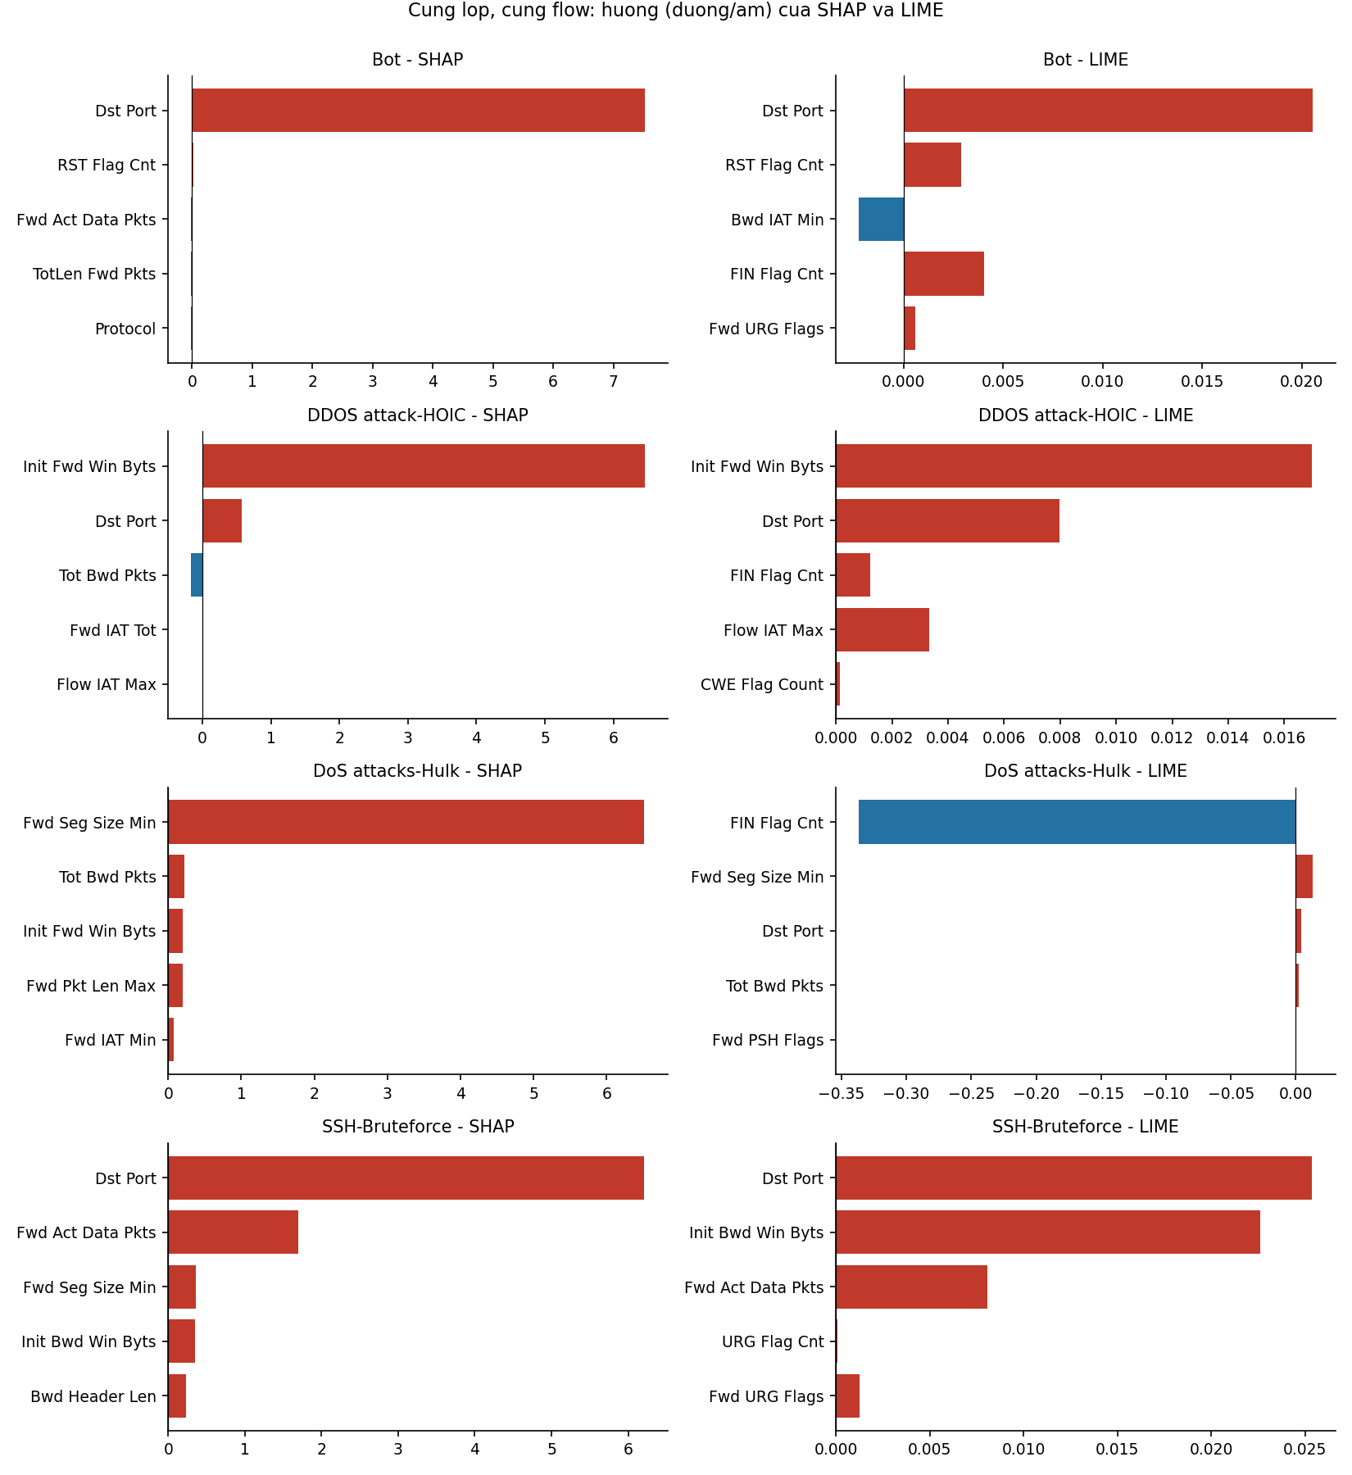
Hinh 10.2. Cung lop, SHAP (trai) va LIME (phai), co dau.
Luu y: thang do khac nhau (SHAP theo margin log-odds, LIME theo xac suat) nen chi so sanh thu tu va huong, khong so sanh do lon. Voi Bot, DDoS-HOIC va SSH-Bruteforce hai phuong phap cung dua Dst Port / Init Fwd Win Byts len dau va cung dau duong; voi DoS-Hulk SHAP chon Fwd Seg Size Min, con LIME chon FIN Flag Cnt voi dau am - day la truong hop hai phuong phap ke hai cau chuyen khac nhau cho cung mot mo hinh.
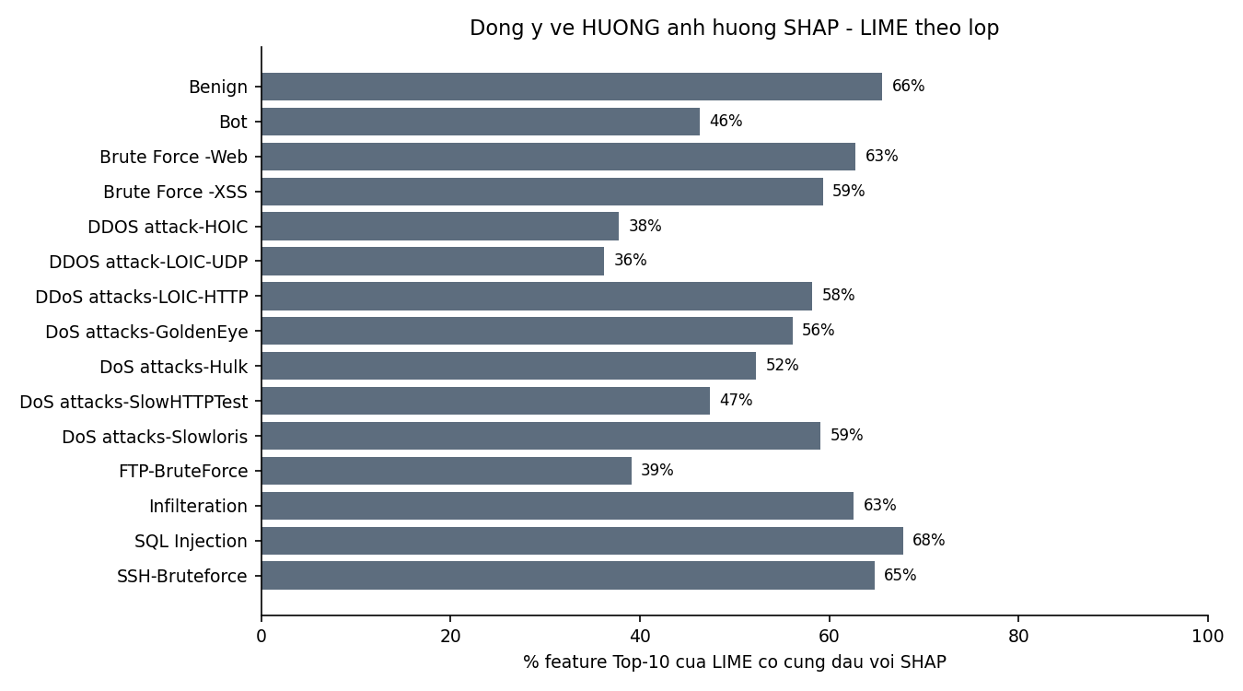
Hinh 10.3. Ty le feature Top-10 cua LIME co cung dau voi SHAP, theo lop.
Tren toan bo Top-10 cua LIME, chi khoang 54% (trung binh 15 lop, thap nhat 36%) feature co cung dau voi SHAP, gan muc ngau nhien. Con so nay KHAC voi ty le dong y dau ~85-96% o Sub-RQ 2.1, vi phep do 2.1 chi tinh tren cac feature CA HAI phuong phap cung chon vao Top-k. Noi cach khac: khi hai ben cung chon mot feature thi thuong dong y huong, nhung nhieu feature LIME chon khong nam trong nhom SHAP quan trong, nen dau cua chung it co y nghia. Day la them mot bieu hien cua Local R2 thap.
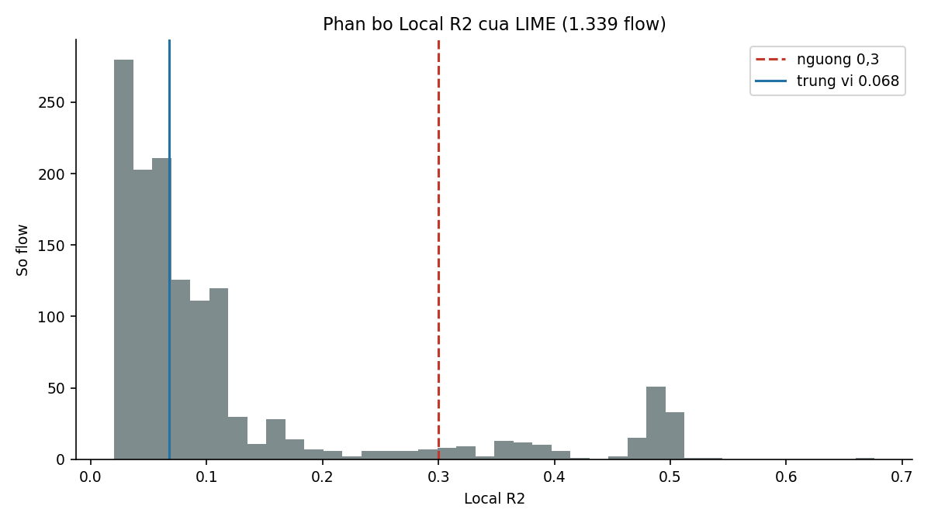
Hinh 10.4. Phan bo Local R2.
Phan bo dinh o vung rat thap (trung vi 0,068), chi 12,3% flow dat nguong 0,3 - la co so de trinh bay LIME cung canh bao do tin cay.
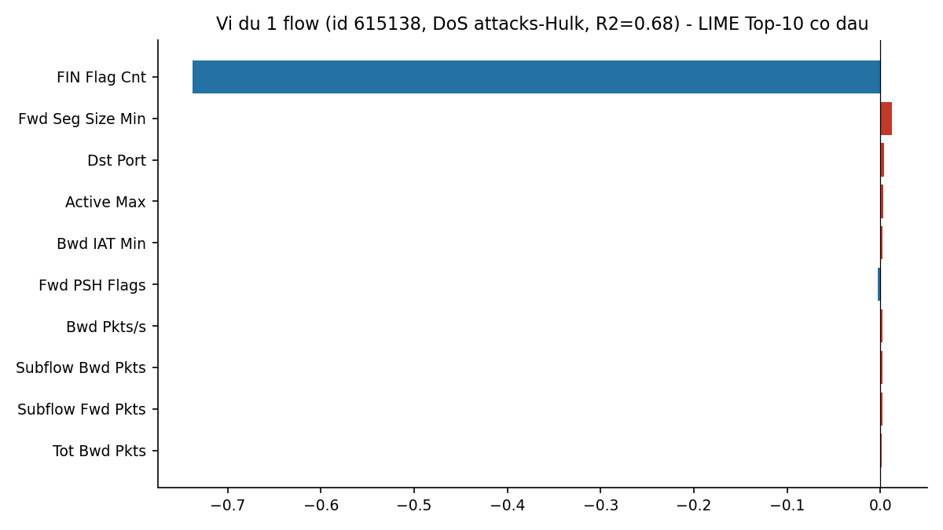
Hinh 10.5. Vi du giai thich LIME cho mot flow (flow co R2 cao nhat).

