RQ2 - Ket qua LIME ghep cap voi SHAP (Sub-RQ 2.1-2.4)
Cohort ghep cap 1339 flow, seed 42 | XGBoost 15 lop, 78 feature | Cap nhat theo du lieu da chay

1. Tom tat dieu hanh
Sub-RQ 2.1 (tuong dong): Tren cung 1339 flow (XGBoost du doan dung, seed 42, toi da 100 flow/lop), Jaccard@5 trung binh giua Top-5 SHAP va Top-5 LIME (macro-average khong trong so 15 lop) la 0.213, Spearman 0.476 va signed agreement 0.896 tren cac feature chung. Muc do tuong dong Top-5 o muc thap-trung binh; hai phuong phap thuong khong chon dung cung mot bo 5 feature nhung khi chung chon trung mot feature thi phan lon cung dau.
Sub-RQ 2.2 (domain validation): Domain Precision@5 (doi chieu Top-5 voi bang expected-signals 15 lop) dat macro-average 0.187 cho SHAP va 0.111 cho LIME - ca hai deu THAP (duoi 20% tren trung binh), cho thay Top-5 dua tren attribution so voi mo hinh thuong KHONG trung voi tap feature ma con nguoi ky vong tu co che tan cong; day la ket qua can bao cao trung thuc, khong phai bang chung ca hai phuong phap 'sai', ma la gioi han cua ca dinh nghia domain signal don gian va cua chinh Top-5.
Sub-RQ 2.3 (stability & robustness): LIME on dinh vua phai giua cac lan chay khac seed (median Jaccard@5 giua cac cap seed = 0.415 tren tap con 289 flow) va giam dan do on dinh khi nhieu thoi gian tang (xem Hinh 1). Local R^2 cua surrogate LIME THAP: median 0.068, mean 0.119 tren toan bo 1339 flow - duoi nguong canh bao 0,3; chuan doan tren tap con 60 flow cho thay tang num_samples len 10.000 hoac tat discretize_continuous KHONG cai thien R^2, nen cau hinh mac dinh (num_samples=5.000, discretize_continuous=True) duoc giu lai va gioi han nay duoc ghi ro o Muc 6.
Sub-RQ 2.4 (faithfulness, quan trong nhat): Voi phep thu donor-substitution giong het thiet ke SHAP full-test nhung chay tren CUNG 1339 flow cho ca hai phuong phap: tai k=5, SHAP thang doi chung ngau nhien o 95.74% flow du dieu kien, LIME o 90.44% - SHAP co win-rate cao hon LIME o ca ba muc k (xem Bang 5). Day la pham vi 1339 flow, KHAC voi con so 99,31% da cong bo tren 700.000 flow cua SHAP goc; hai con so khong duoc gop chung.

2. Sub-RQ 2.1 - Do tuong dong SHAP-LIME theo 15 lop
Jaccard@k = |Top-k SHAP giao Top-k LIME| / |hop|. Spearman va signed agreement chi tinh tren cac feature CHUNG giua hai Top-k (NA neu duoi 2 feature chung). Bang duoi la k=5 (xem CSV day du cho k=3 va k=10 trong summary_by_class.csv).
Lop | N | Jaccard@5 mean | Jaccard@5 median | Spearman mean | Signed agree. mean | N Spearman huu ich
Benign | 100 | 0.091 | 0.111 | -0.375 | 0.782 | 16
Bot | 100 | 0.273 | 0.250 | 0.805 | 0.960 | 100
Brute Force -Web | 86 | 0.166 | 0.111 | -0.148 | 1.000 | 25
Brute Force -XSS | 44 | 0.105 | 0.111 | -0.333 | 0.985 | 6
DDOS attack-HOIC | 100 | 0.355 | 0.250 | 0.992 | 1.000 | 100
DDOS attack-LOIC-UDP | 100 | 0.361 | 0.429 | 0.976 | 0.938 | 100
DDoS attacks-LOIC-HTTP | 100 | 0.341 | 0.250 | -0.420 | 0.681 | 95
DoS attacks-GoldenEye | 100 | 0.257 | 0.250 | 0.982 | 1.000 | 83
DoS attacks-Hulk | 100 | 0.156 | 0.111 | 1.000 | 1.000 | 30
DoS attacks-SlowHTTPTest | 100 | 0.215 | 0.250 | 0.976 | 0.955 | 63
DoS attacks-Slowloris | 100 | 0.175 | 0.111 | 0.727 | 1.000 | 33
FTP-BruteForce | 100 | 0.185 | 0.111 | 0.955 | 0.912 | 44
Infilteration | 100 | 0.043 | 0.000 | 0.000 | 0.333 | 2
SQL Injection | 9 | 0.000 | 0.000 | NA | NA | 0
SSH-Bruteforce | 100 | 0.480 | 0.429 | 0.529 | 1.000 | 100

Luu y co ban: Macro-average khong trong so tren 15 lop (k=5): Jaccard=0.213, Spearman=0.476, Signed agreement=0.896. SQL Injection chi co N=9 flow - Jaccard@5 = 0 va Spearman khong xac dinh (khong du 2 feature chung o hau het flow); day la mau nho, KHONG duoc suy rong ra ket luan chung cho lop nay.

3. Sub-RQ 2.2 - Domain Precision@5: SHAP vs LIME
Domain Precision@5 = (so feature trong Top-5 khop voi bang expected-signals cua LOP THAT) / 5, tinh rieng cho SHAP va LIME tren CUNG cohort de so sanh cong bang.
Lop | N | SHAP Precision@5 mean | LIME Precision@5 mean
Benign | 100 | 0.202 | 0.096
Bot | 100 | 0.200 | 0.204
Brute Force -Web | 86 | 0.216 | 0.116
Brute Force -XSS | 44 | 0.377 | 0.064
DDOS attack-HOIC | 100 | 0.008 | 0.034
DDOS attack-LOIC-UDP | 100 | 0.072 | 0.198
DDoS attacks-LOIC-HTTP | 100 | 0.312 | 0.230
DoS attacks-GoldenEye | 100 | 0.140 | 0.070
DoS attacks-Hulk | 100 | 0.000 | 0.178
DoS attacks-SlowHTTPTest | 100 | 0.278 | 0.064
DoS attacks-Slowloris | 100 | 0.008 | 0.024
FTP-BruteForce | 100 | 0.212 | 0.056
Infilteration | 100 | 0.198 | 0.008
SQL Injection | 9 | 0.244 | 0.089
SSH-Bruteforce | 100 | 0.332 | 0.228

Cach doc: Macro-average: SHAP=0.187, LIME=0.111. Ca hai deu thap; SHAP nhinh hon LIME o hau het lop. Day la doi chieu djnh tinh co cau truc voi bang expected-signals suy tu co che tan cong (Bang 8, ke hoach chi tiet), KHONG phai diem so chuyen gia SOC doc lap, nen khong duoc cong bo nhu 'ty le dung' cua XAI.

4. Sub-RQ 2.3 - Stability va Robustness cua LIME
Stability: chay lai LIME voi 8 seed khac nhau tren tap con 289 flow (20 flow/lop). Voi moi flow, tinh Jaccard@5 trung binh giua tat ca cap seed; bang duoi la median theo lop.
Lop | N | Median Jaccard@5 | Mean | Std
Benign | 20 | 0.602 | 0.619 | 0.109
Bot | 20 | 0.451 | 0.438 | 0.081
Brute Force -Web | 20 | 0.318 | 0.285 | 0.119
Brute Force -XSS | 20 | 0.269 | 0.263 | 0.052
DDOS attack-HOIC | 20 | 0.352 | 0.349 | 0.024
DDOS attack-LOIC-UDP | 20 | 0.738 | 0.743 | 0.044
DDoS attacks-LOIC-HTTP | 20 | 0.460 | 0.469 | 0.072
DoS attacks-GoldenEye | 20 | 0.337 | 0.342 | 0.046
DoS attacks-Hulk | 20 | 0.454 | 0.456 | 0.052
DoS attacks-SlowHTTPTest | 20 | 0.373 | 0.375 | 0.036
DoS attacks-Slowloris | 20 | 0.455 | 0.433 | 0.147
FTP-BruteForce | 20 | 0.397 | 0.396 | 0.035
Infilteration | 20 | 0.530 | 0.527 | 0.075
SQL Injection | 9 | 0.403 | 0.477 | 0.147
SSH-Bruteforce | 20 | 0.532 | 0.538 | 0.057

Robustness: ap dung dung co che nhieu thoi gian cua SHAP (s = 1 + a*U, a in {1%, 5%, 10%}, 3 seed) tren CUNG tap con 289 flow - KHONG phai toan bo cohort hay 700k flow, do chi phi tinh toan LIME. Lop giai thich giu co dinh la lop du doan TRUOC nhieu.
Muc nhieu | N (flow x seed) | Mean Jaccard@5 | Median Jaccard@5 | Ty le doi predicted_label
1% | 289 | 0.450 | 0.429 | 3.00%
5% | 289 | 0.449 | 0.429 | 4.15%
10% | 289 | 0.448 | 0.429 | 5.77%

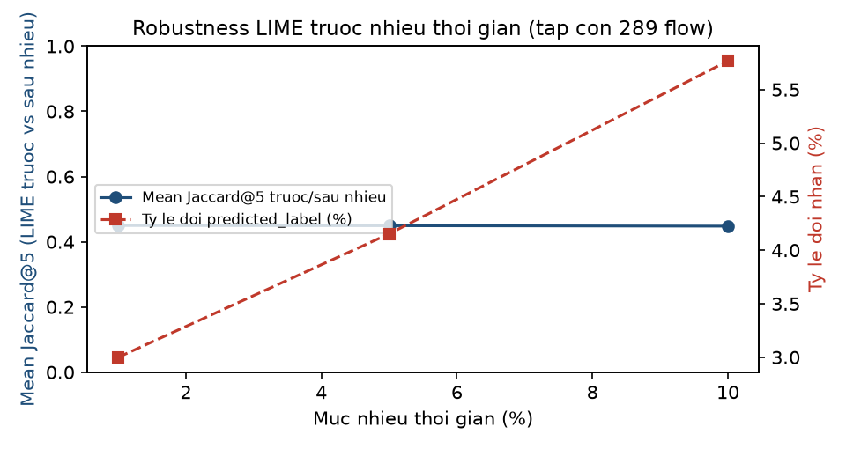
Hinh 1. Do on dinh Top-5 LIME (Jaccard@5) va ty le doi nhan du doan khi tang muc nhieu thoi gian, tren tap con.

5. Sub-RQ 2.4 - Faithfulness ghep cap SHAP vs LIME (quan trong nhat)
Ap dung DUNG protocol donor-substitution cua shap_faithfulness_full_test.py (10 donor tu train, seed 173; 20 lan doi chung ngau nhien, seed 2026; k = 3, 5, 10; nguong thang 1e-6) cho CA SHAP VA LIME tren CUNG 1339 flow cua cohort.
Phuong phap | k | N | N du dieu kien | Coverage | Win rate | Margin drop (method) | Margin drop (random)
LIME | 3 | 1339 | 1339 | 100.00% | 82.60% | 7.687 | 1.064
SHAP | 3 | 1339 | 1339 | 100.00% | 98.88% | 9.960 | 3.250
LIME | 5 | 1339 | 1339 | 100.00% | 90.44% | 8.071 | 1.724
SHAP | 5 | 1339 | 1339 | 100.00% | 95.74% | 10.875 | 4.974
LIME | 10 | 1339 | 1339 | 100.00% | 94.77% | 8.806 | 3.270
SHAP | 10 | 1339 | 1076 | 80.36% | 99.81% | 11.522 | 6.805

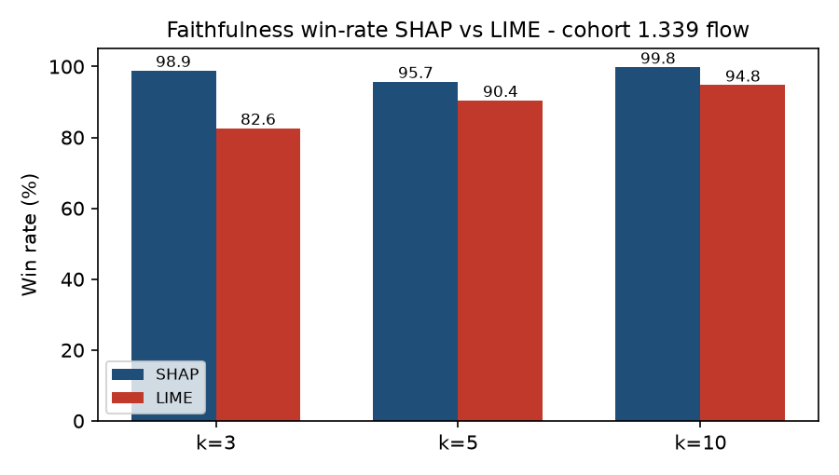
Hinh 2. Win-rate SHAP vs LIME (donor-substitution) tren cohort 1.339 flow, k=3/5/10.
Ket luan Sub-RQ 2.4: SHAP thang doi chung ngau nhien o ty le cao hon LIME tai ca ba k (k=3: SHAP 98.88% so LIME 82.60%; k=10: SHAP 99.81% so LIME 94.77%). Luu y k=10 cua SHAP chi co coverage 80.36% vi mot so flow khong co du 10 feature voi SHAP duong.
Canh bao pham vi (KHONG duoc bo qua): KHONG duoc gop ket qua nay voi 99,31% da cong bo truoc do cho SHAP tren 700.000 flow test set day du. Hai con so do TREN HAI PHAM VI KHAC NHAU (700k flow toan bo vs 1.339 flow cohort ghep cap dung de so sanh voi LIME) va co the KHONG bang nhau ve mat so hoc dan du cung mot phuong phap. 99,31% chi duoc trich dan lam bang chung global BO SUNG cho do tin cay cua SHAP, khong thay the bang so sanh truc tiep o day.

6. Gioi han
Gioi han | Chi tiet
Co mau nho | SQL Injection N=9 va Brute Force-XSS N=44 (trong tong 1.339 flow) qua nho de ket luan manh o cap lop; cac chi so cua hai lop nay chi mang tinh minh hoa, khong dai dien thong ke.
LIME phu thuoc cau hinh | kernel_width=0,75*sqrt(78)~6.6238 va num_samples=5.000 la lua chon co dinh truoc. Local R^2 thap (median 0.068) cho thay surrogate tuyen tinh cuc bo kho khop voi ham quyet dinh phi tuyen cua XGBoost tren khong gian 78 chieu; day la dac diem cua chinh phuong phap LIME tren du lieu nay, khong phai loi cau hinh.
Domain signals | Bang expected-signals (Bang 8, ke hoach chi tiet) la kien thuc mien suy luan tu co che tan cong, khong phai diem so tu chuyen gia SOC doc lap hay doi chieu PCAP thuc te.
Robustness LIME pham vi hep | Chi chay tren tap con toi da 20 flow/lop (289 flow), khong phai toan bo cohort hay 700k flow nhu SHAP, do chi phi tinh toan LIME lon hon nhieu.
Khong tron cac loai ty le | Jaccard, Domain Precision@5, win-rate faithfulness va Local R^2 do CAC KHIA CANH KHAC NHAU cua loi giai thich; khong duoc gop thanh mot con so duy nhat.

7. Ket luan RQ2
Tren cohort ghep cap 1339 flow (XGBoost du doan dung, seed 42, toi da 100 flow/lop, phan tang 15 lop), macro-average (khong trong so, 15 lop) cho Jaccard@5 SHAP-LIME la 0.213 - muc tuong dong Top-5 THAP-TRUNG BINH. Domain Precision@5 macro-average la 0.187 cho SHAP va 0.111 cho LIME, ca hai deu thap khi doi chieu voi bang expected-signals suy tu co che tan cong. Faithfulness (donor-substitution, k=5, CUNG 1339 flow) cho win-rate 95.74% voi SHAP va 90.44% voi LIME - SHAP bam sat quyet dinh cua XGBoost hon LIME tren cohort nay xet theo phep thu da chon. LIME co Local R^2 trung binh thap (0.119) va do on dinh Top-5 giua cac seed o muc trung binh, giam khi nhieu thoi gian tang.
Kết luận cuối cùng: Bon chi so - Jaccard (2.1), Domain Precision@5 (2.2), win-rate faithfulness (2.4) va Local R^2/on dinh (2.3) - do BON khia canh khac nhau cua chat luong giai thich va KHONG duoc gop thanh mot con so 'RQ2 dung X%' duy nhat. Ket luan co dieu kien: tren du lieu CSE-CIC-IDS2018 va mo hinh XGBoost da huan luyen, SHAP va LIME thuong khong chon trung Top-5 feature, ca hai deu co do phu hop domain thap khi doi chieu voi kien thuc tan cong o muc don gian hoa hien tai, va SHAP the hien faithfulness cao hon LIME trong pham vi phep thu donor-substitution da ap dung tren chinh cohort nay.

