MINISTRY OF EDUCATION & TRAINING

**HO CHI MINH CITY UNIVERSITY OF ECONOMICS AND FINANCE**



**SOFTWARE DETAIL DESIGN**

**Course: Software Engineering**

**Course code: ITE1125E**

**ADMISSION MANAGEMENT**

**Đỗ Như Thành - 215052268**

**Lê Ngọc Phúc - 215050281**

**Phạm Tuấn Thành - 215052134**

**Nguyễn Thành Trung - 215052148.**

**Class : A02E**

**Lecturer: Nguyễn Thị Thanh Trúc**

**Ho Chi Minh city - 4, 2024**

# TABLE OF CONTENTS

TABLE OF CONTENTS i

LIST OF FIGURES ii

Chapter 1 . Model Diagram 1

1.1 Sequence diagram 1

1.2 Activity diagram 9

1.3 State diagram 22

1.4 Class diagram 23

Chapter 2 . Entity Relationship diagram 24

Chapter 3 . Graphical user interface 25

# LIST OF FIGURES

Figure 1.1: Account registration sequence diagram 1

Figure 1.2: Login sequence diagram 1

Figure 1.3: Exam registration sequence diagram 2

Figure 1.4: Pay fee sequence diagram 2

Figure 1.5: Registration profiles management sequence diagram 3

Figure 1.6: Exam notification management sequence diagram 3

Figure 1.7: Exam notification information inquiry 4

Figure 1.8: Exam score notification management sequence diagram 4

Figure 1.9: Check exam results sequence diagram 5

Figure 1.10: Question bank management sequence diagram 5

Figure 1.11: Subject management sequence diagram 6

Figure 1.12: Exam management sequence diagram 7

Figure 1.13: Subject combinations management sequence diagram 8

Figure 1.14: Account registration activity diagram 9

Figure 1.15: Login activity diagram 10

Figure 1.16: Exam registration activity diagram 11

Figure 1.17: Pay fee acitvity diagram 12

Figure 1.18: Registration profiles management activity diagram 13

Figure 1.19: Exam notification management activity diagram 14

Figure 1.20: Exam notification information inquiry activity diagram 15

Figure 1.21: Exam score notification management activity diagram 16

Figure 1.22: Check exam results activity diagram 17

Figure 1.23: Question bank management activity diagram 18

Figure 1.24: Subject management activity diagram 19

Figure 1.25: Exam management activity diagram 20

Figure 1.26: Subject combination management activity diagram 21

Figure 1.27: Candidate state diagram 22

Figure 1.28: Registration state diagram 22

Figure 1.29: Exam notification state diagram 22

Figure 1.30: Score notification state diagram 22

Figure 1.31: Class diagram 23

Figure 2.1: ERD 24

Figure 3.1: Register interface 25

Figure 3.2: Login Interface 25

Figure 3.3: Home page 26

Figure 3.4: Account management (Candidates) 26

Figure 3.5: Exam location details (Candidates) 27

Figure 3.6: Exam result (Candidates) 27

Figure 3.7: Admin page – Exam management (Exam management board) 28

Figure 3.8: Admin page – Question management (Exam management board) 28

Figure 3.9: Admin page – Course management (Exam management board) 29

Figure 3.10: Admin page – Subject combination management (Exam management board) 29

Figure 3.11: Admin page – Location management (Admission board) 30

Figure 3.12: Admin page – Score notification management (Exam management board) 30

Figure 3.13: Admin page – Payment detail (Admission board) 31

Figure 3.14: Admin page – Candidate management (Admission board) 31

Figure 3.15: Admind page - BenchMarks (Exam management board) 32

Figure 3.16: Exam registration (Candidates) 32

# Model Diagram

## Sequence diagram

Figure .: Account registration sequence diagram

Figure .: Login sequence diagram

Figure .: Exam registration sequence diagram

Figure .: Pay fee sequence diagram

Figure .: Registration profiles management sequence diagram

Figure .: Exam notification management sequence diagram

Figure .: Exam notification information inquiry

Figure .: Exam score notification management sequence diagram

Figure .: Check exam results sequence diagram

Figure .: Question bank management sequence diagram

Figure .: Subject management sequence diagram

Figure .: Exam management sequence diagram

Figure .: Subject combinations management sequence diagram

## Activity diagram

Figure .: Account registration activity diagram

Figure .: Login activity diagram

Figure .: Exam registration activity diagram

Figure .: Pay fee acitvity diagram

Figure .: Registration profiles management activity diagram

Figure .: Exam notification management activity diagram

Figure .: Exam notification information inquiry activity diagram

Figure .: Exam score notification management activity diagram

Figure .: Check exam results activity diagram

Figure .: Question bank management activity diagram

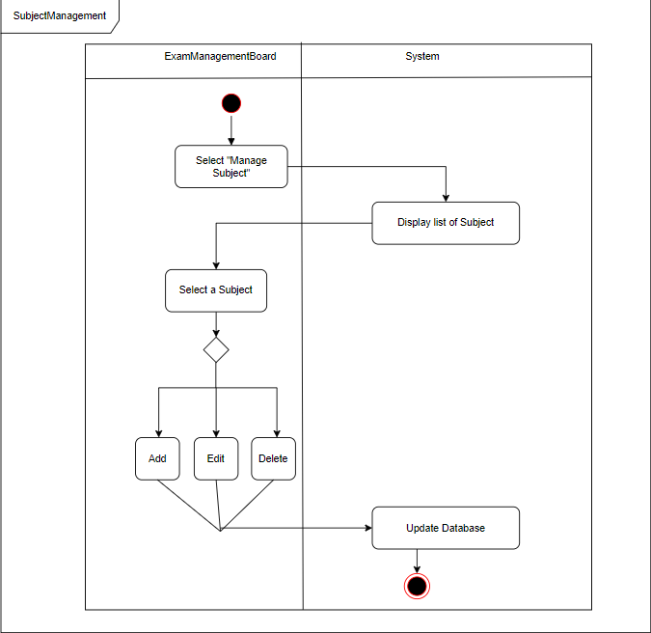

Figure .: Subject management activity diagram

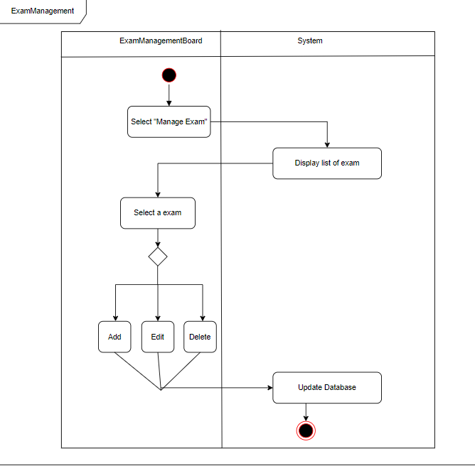

Figure .: Exam management activity diagram

Figure .: Subject combination management activity diagram

## State diagram

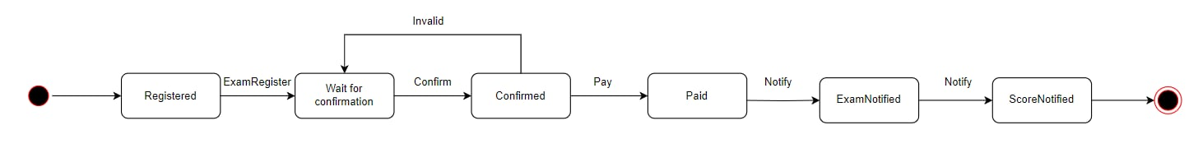

Figure .: Candidate state diagram

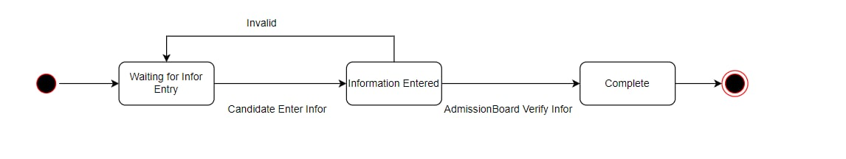

Figure .: Registration state diagram

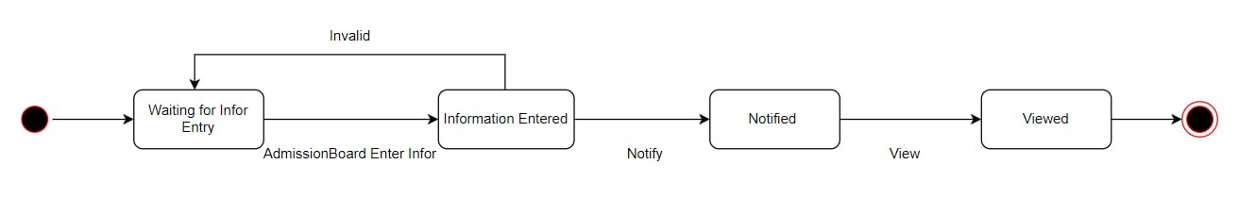

Figure .: Exam notification state diagram

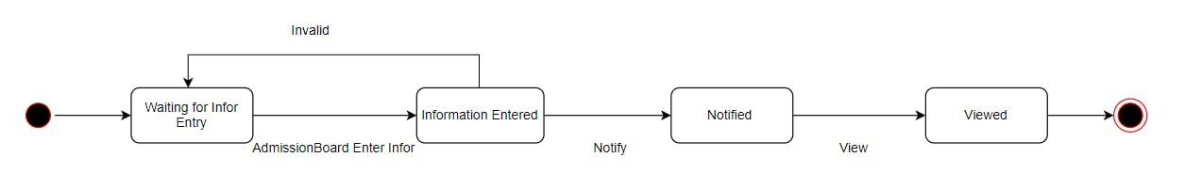

Figure .: Score notification state diagram

## Class diagram

Figure .: Class diagram

# Entity Relationship diagram

Figure .: ERD

# Graphical user interface

Figure .: Register interface

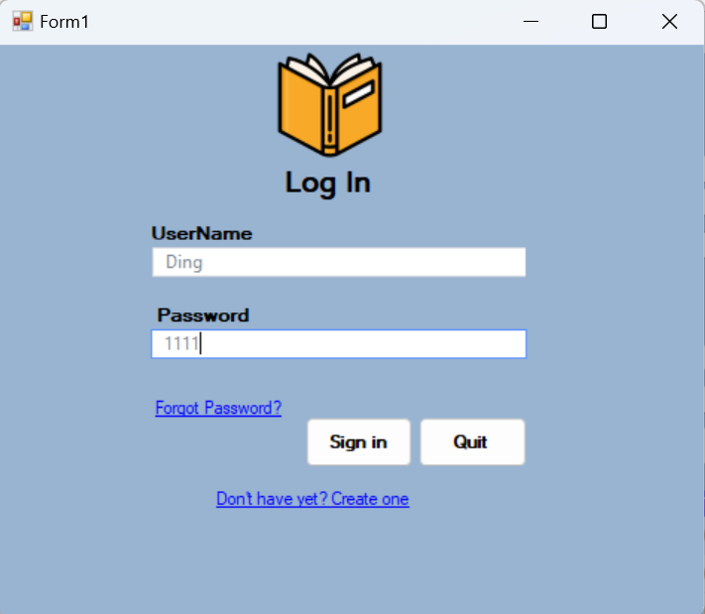

Figure .: Login Interface

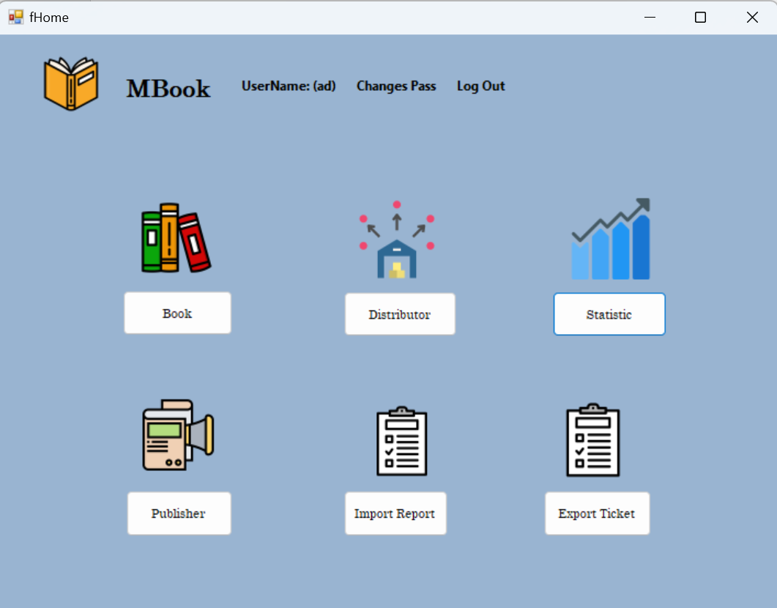

Figure .: Home page

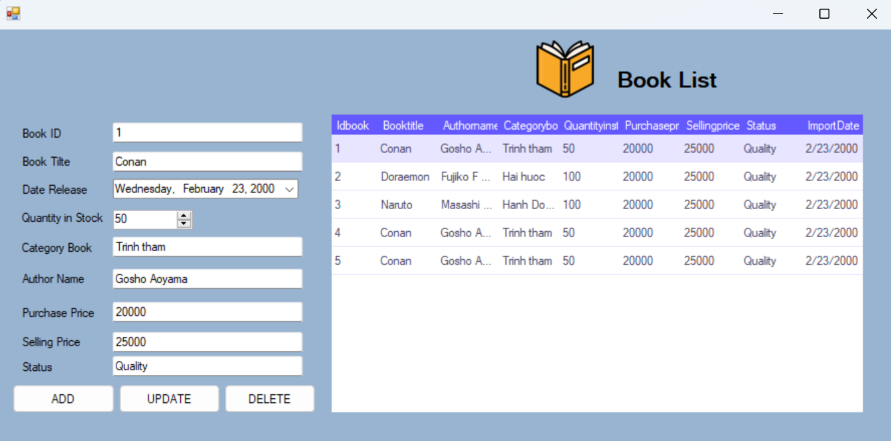

Figure .: Book Infomation

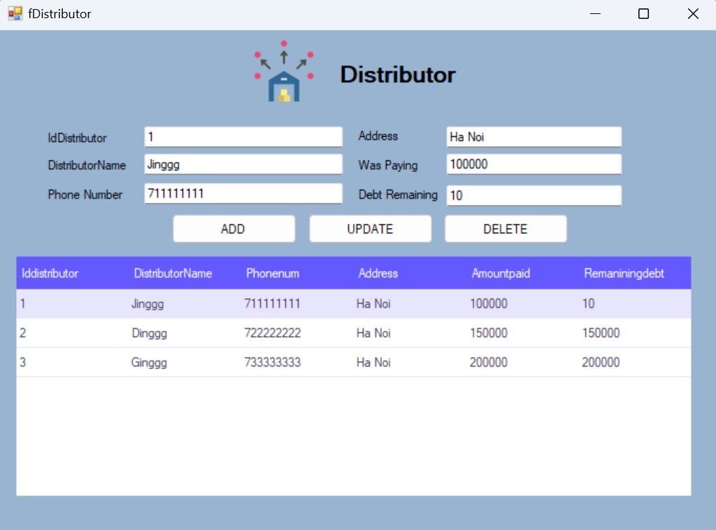

Figure .: Distributor Information

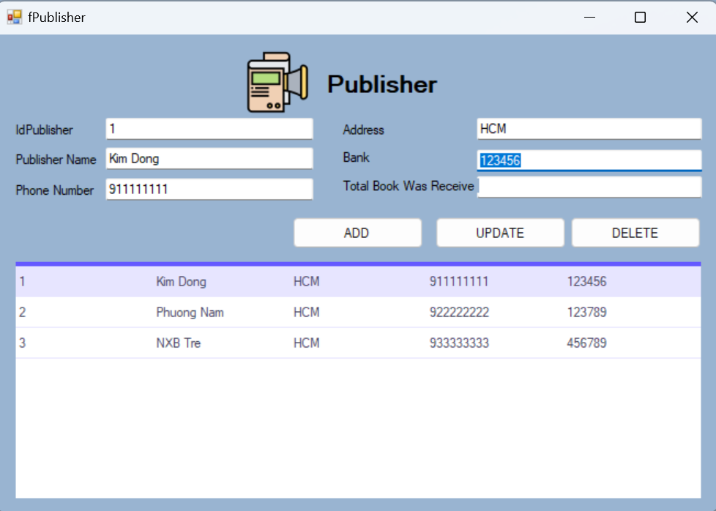

Figure 3.6: Publisher Information

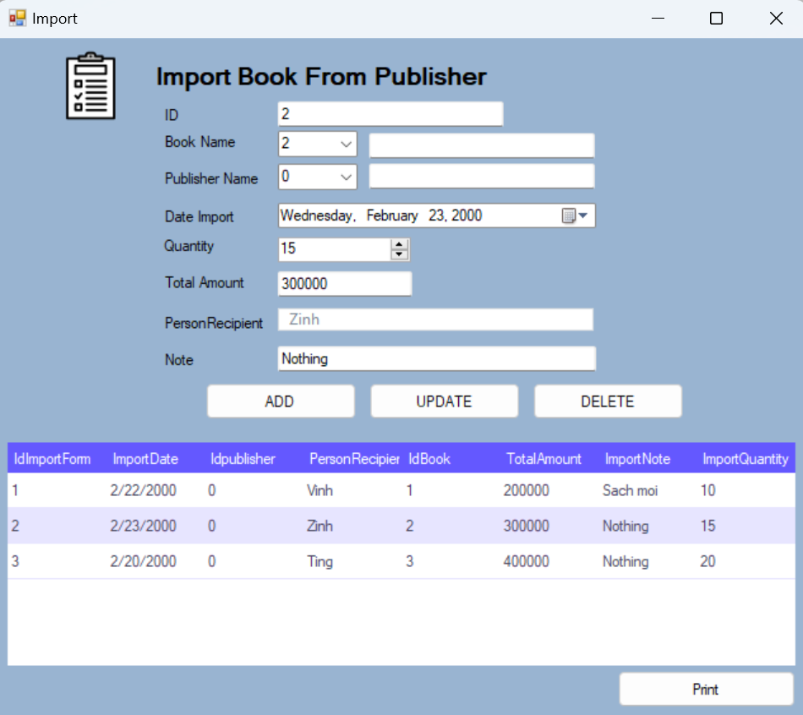

Figure .7: Report Import Information

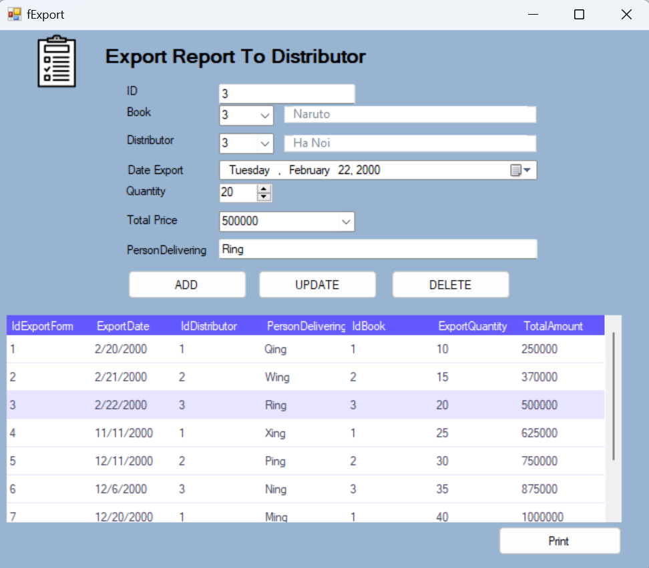

Figure 3.8: Report Export Information

Figure .: Admin page – Course management (Exam management board)

Figure .: Admin page – Subject combination management (Exam management board)

Figure .: Admin page – Location management (Admission board)

Figure .: Admin page – Score notification management (Exam management board)

Figure .: Admin page – Payment detail (Admission board)

Figure .: Admin page – Candidate management (Admission board)

Figure .: Admind page - BenchMarks (Exam management board)

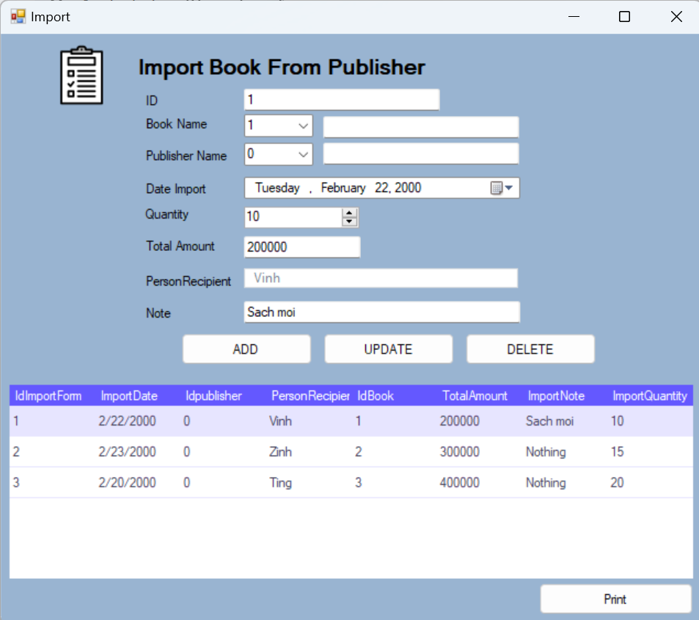

Figure .: Exam registration (Candidates)