MINISTRY OF EDUCATION & TRAINING

**HO CHI MINH CITY UNIVERSITY OF ECONOMICS AND FINANCE**

**SOFTWARE DETAIL DESIGN**

**Course: Software Engineering**

**Course code: ITE1125E**

**ADMISSION MANAGEMENT**

**Nguyễn Hoàng Sơn - 215052129**

**Ngô Hữu Vinh – 215052155**

**Đinh Ngọc An Thơ - 225053085**

**Trương Hoàng Phúc - 225052263**

**Class: A02E**

**Lecturer: Nguyễn Thị Thanh Trúc**

**Ho Chi Minh city - 10, 2024**

Software Requirements Specification

for

Admissions Management System, Release 1.0

**Table of Contents**

**1. Introduction 1**

1.1 Purpose 1

1.2 Document Conventions 1

1.3 Project Scope and Product Features 1

1.4 References 2

**2. Overall Description 2**

2.1 Product Perspective 2

2.2 User Classes and Characteristics 2

2.3 Operating Environment 3

2.4 Design and Implementation Constraints 3

2.5 Assumptions and Dependencies 3

**3. System Features 4**

3.1 Account registration 4

3.2 Log In 5

3.3 Exam Registration 7

3.4 Pay fee 8

3.5 Registration Profiles Management 10

3.6 Exam Notification Management 11

3.7 Exam Notification Information Inquiry 12

3.8 Exam Score Notification Management 13

3.9 Check Exam Results 14

3.10 Question Bank Management 15

3.11 Subject Management 16

3.12 Exam Management 18

3.13 Subject Combinations Management 19

**4. ERD 21**

4.1 Data Dictionary 21

4.2 Data Integrity, Retention, and Disposal 22

**5. Activity Diagram and Sequence Diagram 24**

5.1 Activity Diagram 24

5.2 Sequence Diagram 37

**6. State Diagram 50**

**7. Architecture Diagram 51**

# Introduction

## Purpose

The purpose of this project is to develop a bookstore management system that includes functions for importing and exporting books. The system will ensure that the number of books sold is statistically recorded and information about books, publishers, and distributor

## Document Conventions

* Source code will be written in C# programming language.
* Attributes and methods will be separated by underscores if necessary.
* Using .net framework
* Using three-layer model:
* User interface layer: Winforms and C#
* Business logic layer: C#
* Data access layer: SQL

## Project Scope and Product Features

The project will include the following features:

- Inventory Management: Add, edit, and delete book information, Track book quantity in stock

* Show information about distributor: It processes exam results and generates reports for candidates and admissions boards.
* Show information about publisher: The system facilitates communication between candidates and admissions boards for inquiries, updates, and notifications.
* Log in: Users can log in to access functions based on their roles.
* **Sales** book to Distributor: Process book sales to distributors or individual customers and make Stock Outward Note
* Buy book from Publisher: Process book receive from publisher, and make Sales Note
* Revenue statistics from Distributor: The staff receives information revenue from distributor and statistic it. Then export excel file to publisher
* Exam Management: Exam management board members can add, modify, delete, or import exams to PDF.
* Subject Combinations Management: Exam management board members can add, modify, or delete subjects for subject combinations.

## References

# Overall Description

## Product Perspective

The system serves as a comprehensive tool for managing the inventory, distribution, and sales of books within a publishing company. Its primary focus is on facilitating the smooth flow of books from publishers to distributors and eventually to end customers. Here's an overview of the system's functionalities and perspectives from the product standpoint:

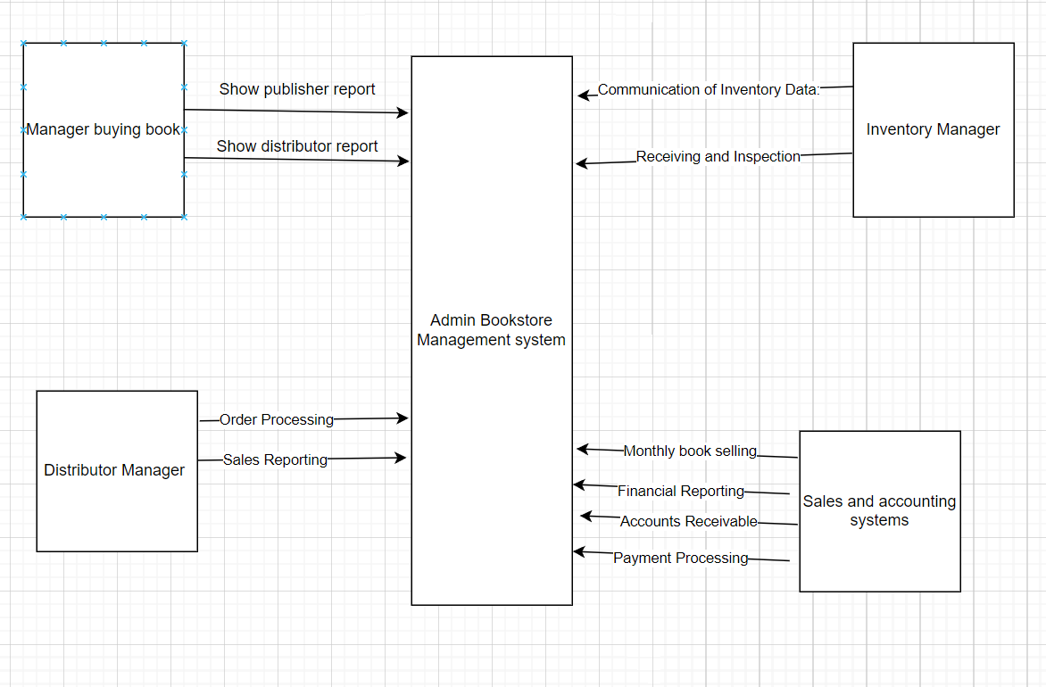

**Figure 1. Context Diagram**

## User Classes and Characteristics

Inventory Management: The people who will input information into the computer include inputting import and export reports, publisher information, and distributors.

Administrators: Administrative staff responsible for managing the guys who was check who was do the entering to the systems

## Operating Environment

OE-1: The application should be compatible with various Windows operating systems, such as Windows 7, Windows 8, Windows 10, and potentially Windows Server editions.

OE-2: The application requires the appropriate version of the .NET Framework or .NET Core runtime installed on the target system to run. Ensure compatibility with the required .NET version.

OE-3: Visual Studio IDE or another development environment is needed to build and debug the application. Make sure the development environment meets the system requirements for the chosen version of Visual Studio.

## Assumptions and Dependencies

AS-1: The application assumes that it will be deployed on Windows operating systems compatible with the version of .NET Framework or .NET Core used for development.

DE-1: It is assumed that the development environment, such as Visual Studio, is properly configured and functional for building and debugging the application.

## Account registration

|  |  |
| --- | --- |
| Use Case ID | UC-1 |
| Use Case Name | Account registration |
| Description | The staff create an account |
| Actors­ | Staff |
| Pre-conditions |  |
| **Events Flow** | **Basic:**   1. The system displays the default interface for users. 2. Candidates select the register function on the system interface. 3. Candidates enter all the information required. 4. Candidates confirm the registration. 5. The system show successful registration notification   **Exception:**.  4.1. If the registration information is invalid, display an error message and request users to re-enter. |
| **Post-conditions** |  |
| **Business Rules** |  |
| **Non-Functional Requirement** | * The registration process should be user-friendly and intuitive, guiding the candidate through each step |

## Log In

|  |  |
| --- | --- |
| **Use Case ID** | UC-2 |
| **Use Case Name** | Log In |
| **Description** | Users log in to access functions assigned according to their roles. |
| **Actors­** | Staff, Admin |
| **Pre-conditions** | Users have created or been provided with accounts. |
| **Events Flow** | **Basic:**   1. The system displays the default interface for users. 2. Users select the login function on the system interface. 3. Users enter the created or provided account, password. 4. Users confirm the login. 5. The system verifies the login information. If valid, users are redirected to the home page.   **Exception:**  3.1. If users forget login information, the system provides login information via email.  5.1. If login information is invalid, display an error message and request users to re-enter. |
| **Post-conditions** | * Users have access rights to use functions according to their roles. * The system records login information, including time and IP address, for monitoring and security. |
| **Business Rules** | User access rights must reflect their roles accurately. |
| **Non-Functional Requirement** | The system needs to authenticate and authorize users correctly to protect information. |

## Buying books from Publishers

|  |  |
| --- | --- |
| ID and Name: | UC-3 - Buying books from Publishers |
| Created By: | Nguyễn Hoàng Sơn |
| Primary Actor: | Book-entry manager |
| Description: | Managers make reports and enter information from publishers into the system |
| Trigger: | The book-entry manager receives information from publishers about new books available for purchase. |
| Preconditions: | The book is successfully stored in the system, and the books are receive from the publisher. |
| Postconditions: | Information about new books is stored in the system |
| Main Success Scenario : | 1. The employee selects information Import function 2. The employee enters import information to create a form adding to systems 3. Adding the export information in to system   Choosing the print function to print excel file to publisher |
| Extepsions: | Import Error: System notifies employee of import error. Employee corrects input information and retries import process. |

## Buying books from Publishers

|  |  |
| --- | --- |
| ID and Name: | UC-4 - Buying books from Publishers |
| Created By: | Nguyễn Hoàng Sơn |
| Primary Actor: | Book-entry manager |
| Description: | Managers make reports and enter information from publishers into the system |
| Trigger: | The book-entry manager receives information from publishers about new books available for purchase. |
| Preconditions: | The book is successfully stored in the system, and the books are receive from the publisher. |
| Postconditions: | * Information about new books is stored in the system |
| **Business Rules** | Candidates are required to pay the examination fee after their exam registration got confirmed by the Admission Board |
| **Non-Functional Requirement** | The fee payment process should be user-friendly and secure, ensuring candidates can easily complete the transaction without encountering technical difficulties. |

## Saving Book Data

|  |  |
| --- | --- |
| ID and Name: | UC-5 – Saving Book Data |
| Created By: | Nguyễn Hoàng Sơn |
| Primary Actor: | Staff |
| Description: | The employee enters book information to system |
| Trigger: |  |
| Preconditions: | The employee is logged into the system |
| Postconditions: | The books which is receiving from publisher |
| Main Success Scenario | 1. The employee selects Book function 2. The employee enters book information to adding to systems 3. Adding the export information in to system   Display book availability information |
| Extensions: | Import Error: System notifies employee of import book error. Employee corrects input information and retries import process. |

## Saving Distributor information

|  |  |
| --- | --- |
| ID and Name: | UC-6 – Saving Distributor information |
| Created By: | Nguyễn Hoàng Sơn |
| Primary Actor: | Staff |
| Description: | The employee enters Distributor information to system |
| Trigger: |  |
| Preconditions: | The employee is logged into the system and having information about distributor |
| Postconditions: |  |
| Main Success Scenario | 1. The employee selects Distributor function 2. The employee enters distributor information to adding to systems 3. Adding the distributor information in to system   Display book availability information |
| Extensions: | Import Error: System notifies employee of import distributor information error. Employee corrects input information and retries import process. |

## Saving Publisher information

|  |  |
| --- | --- |
| ID and Name: | UC-7 – Saving Publisher information |
| Created By: | Nguyễn Hoàng Sơn |
| Primary Actor: | Staff |
| Description: | The employee enters Publisher information to system |
| Trigger: |  |
| Preconditions: | The employee is logged into the system and having information about publisher |
| Postconditions: |  |
| Main Success Scenario | 1. The employee selects Publisher function 2. The employee enters publisher information to adding to systems 3. Adding the publisher information in to system   Display book availability information |
| Extensions: | Import Error: System notifies employee of import publisher information error. Employee corrects input information and retries import process. |

## Distributor's revenue statistics and put it to publisher

|  |  |
| --- | --- |
| ID and Name: | UC-8 – Distributor's revenue statistics and put it to publisher |
| Created By: | Nguyễn Hoàng Sơn |
| Primary Actor: | Staff |
| Description: | The employee receive revenue and statistic it, then make a report to publisher |
| Trigger: | The distributor provides revenue statistics to the staff for reporting purposes to the publisher. |
| Preconditions: | 1. The staff member is logged into the system and has access to the revenue data provided by the distributor for the reporting period. |
| Postconditions: | The revenue statistics report is generated and sent to the publisher, facilitating financial transparency and business insights |
| Main Success Scenario | 1. The staff selects statistics function 2. The employee statistics the book was being sell in this month 3. The employee chooses print function to export an excel file 4. Adding the publisher information in to system   Display data of revenue statistics |
| Extensions: | Error in Revenue Data: Staff verifies and resolves discrepancies with distributor. |

## 

# ERD

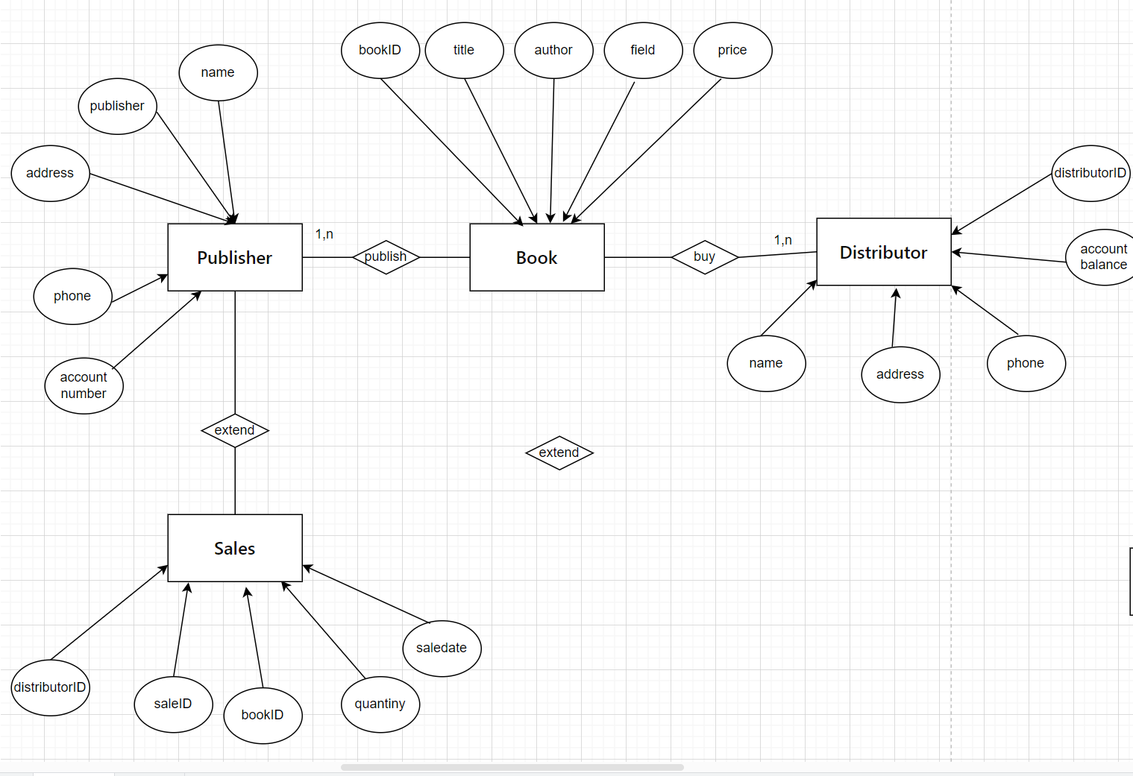

**Figure . E for Admissions Management System .**

## Data Dictionary

|  |  |  |  |  |
| --- | --- | --- | --- | --- |
| **Field Name** | **Description** | **Data Type** | **Length** | **Additional Info** |
| MaSo(ApplicantID) | Unique identifier for each applicant | Numeric |  | Primary Key, Unique |
| HoTen (FullName) | Full name of the applicant | String |  |  |
| NoiSinh (PlaceOfBirth) | Place of birth of the applicant | String |  |  |
| NgaySinh (DateOfBirth) | Date of birth of the applicant | Date |  |  |
| HoKhauThuongTru (PermanentAddress) | Permanent address of the applicant | String |  |  |
| KhuVuc (Region) | Region of examination | String |  |  |
| DoiTuong (ObjectType) | Object type of examination | String |  |  |
| NamTotNghiepTH (YearOfGraduation | Year of high school graduation | Numeric |  |  |
| HeThi (ExamLevel) | Level of examination (Specialized, Non-specialized) | String |  |  |
| KhoiThi (ExamCluster) | Exam cluster (CB, KCB) | String |  |  |
| DiaChiBaoTin (ContactAddress) | Contact address of the applicant | String |  |  |
| MaPhong (RoomID) | Unique identifier for each exam room | Numeric |  | Primary Key, Unique |
| SoPhong (RoomNumber) | Room number of the exam room | Numeric |  |  |
| DiaDiemThi (ExamLocation) | Location of the exam room | String |  |  |
| SoLuongTS (NumberOfCandidates) | Number of candidates assigned to the exam room | Numeric |  |  |
| MaBaoThi (EnvelopeID) | Unique identifier for each exam envelope | Numeric |  | Primary Key, Unique |
| MaPhach (ExamCode) | Exam code associated with the exam envelope | String |  |  |
| MaPhong (RoomID) | Foreign key referencing the PhongThi table | Numeric |  | Foreign Key |
| Bảng "KetQuaThi" (ExamResult) | Unique identifier for each exam result |  |  |  |
| MaKetQua (ResultID) | Unique identifier for each exam result | Numeric |  | Primary Key, Unique |
| MaBaoThi (EnvelopeID) | Foreign key referencing the ThiSinh table | Numeric |  | Foreign Key |
| MaSinhVien (ApplicantID) | Foreign key referencing the ThiSinh table | Numeric |  | Foreign Key |
| DiemMon1 (ScoreSubject1) | Score for subject 1 | Numeric |  |  |
| DiemMon2 (ScoreSubject2) | Score for subject 2 2 | Numeric |  |  |
| DiemMon3 (ScoreSubject3) | Score for subject 3 | Numeric |  |  |
| TongDiem (TotalScore) | Total score of the applicant | Numeric |  |  |
| TrungTuyen (Admitted) | Admission status (Trạng thái trúng tuyển) | String |  |  |

## Data Integrity, Retention, and Disposal

Data Integrity, Retention, and Disposal Policy for Admissions Management System

1. Integrity: Maintain data accuracy, consistency, and reliability through validation checks and audits.

2. Retention:

- Applicant enrollment records retained for 5 years.

- Exam results and document status kept for 2 years.

- Payment records stored for 3 years.

- Unused application data disposed of annually.

3. Disposal: Securely dispose of data after retention period, ensuring compliance and documentation.

4. Compliance: Adhere to data protection laws, conduct regular audits, and provide staff training.

5. Review: Update policy as needed to align with regulations and business requirements, and communicate changes to stakeholders.

# 

# Activity Diagram and Sequence Diagram

## Activity Diagram

UC-1

UC-2

## Sequence Diagram

UC-1

UC-2

# State Diagram

Export Book’s Report

Registration:

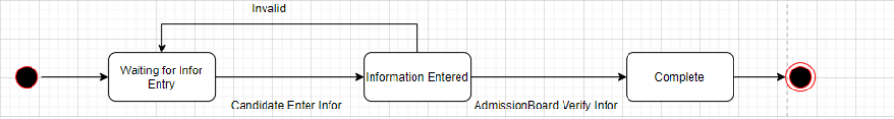

Import Book’s Report

# Architecture Diagram

