BSSSC Parking Booking Portal
User Guide
For Staff and Administrators
Version 1.0
April 2026

Table of Contents
Table of Contents 2
Introduction 4
1. Accessing the Portal 5
2. Logging In 6
2.1 If Login Fails 6
3. Staff Dashboard Overview 7
4. Checking Availability & Booking 8
4.1 Selecting a Date 8
4.2 Understanding the Colour Codes 8
4.3 Making a Booking 9
5. Viewing the Full Parking Map 10
6. Managing Your Bookings 11
6.1 Cancelling a Booking 11
7. Logging Out 12
8. Administrator Login 14
8.1 Accessing Admin Login 14
9. Admin Dashboard 15
9.1 Grid Controls 15
9.2 Creating a Booking (Admin) 15
9.3 Viewing & Deleting Bookings 16
9.4 Restricted Slots 16
10. Management Page 17
10.1 Users Tab 17
Adding a Single User 17
Bulk Importing Users (CSV) 18
Managing Existing Users 18
10.2 Bookings Tab 19
Creating a Manual Booking 19
Viewing & Filtering Bookings 20
Exporting Bookings 20
Cancelling Bookings 20
10.3 Parking Slots Tab 21
Edit Mode 21
Adding a New Slot 21
10.4 Settings Tab 22
Booking Rules 22
Parking Space Management 22
System Statistics 22
11. Quick Reference 23
Colour Codes 23
Common Tasks 23
Need Help? 23

PART 1: STAFF USER GUIDE

Introduction
This guide explains how to use the BSSSC Parking Booking Portal to book short-term parking spaces. The system allows staff to:
• Check parking space availability
• Book spaces up to 14 days in advance
• View and manage existing bookings
• Cancel bookings when plans change

1. Accessing the Portal
When you first access the parking portal, you will see the landing page with the school logo and a Staff Login button.
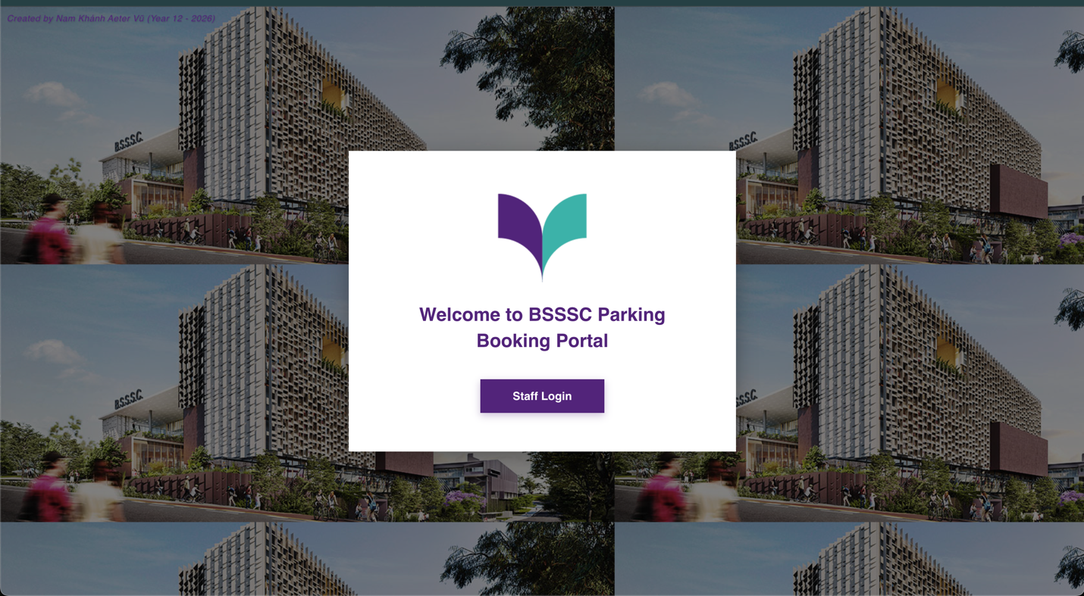
Step 1: Navigate to the parking portal URL provided by your administrator.
Step 2: Click the "Staff Login" button to proceed to the login page.
💡 Note: If you are already logged in, you will be automatically redirected to your dashboard.

2. Logging In
Enter your school email address and password to access the system.
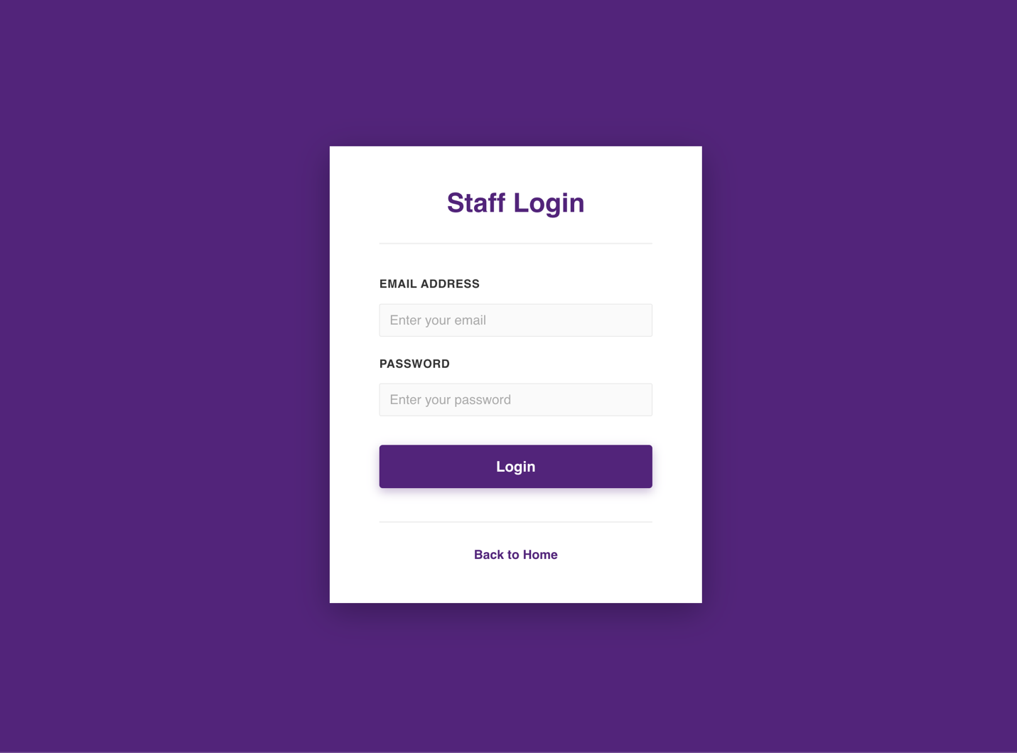
Step 1: Enter your email address in the "Email Address" field.
Step 2: Enter your password in the "Password" field.
Step 3: Click the "Login" button.

2.1 If Login Fails
If you enter incorrect credentials, an error message will appear below the login button.
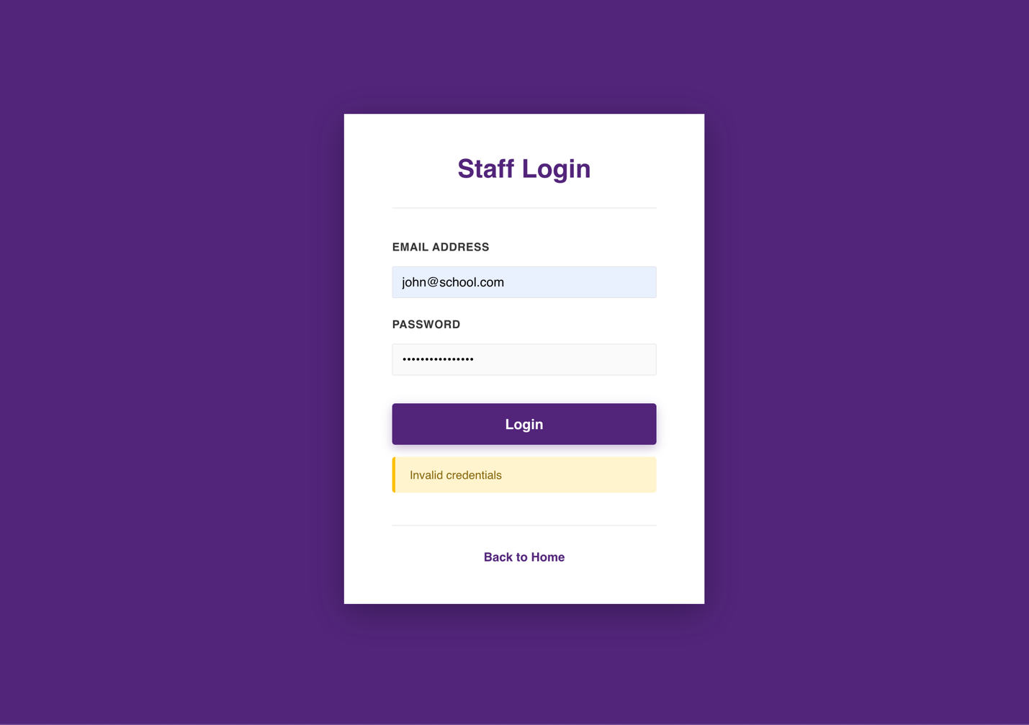
Double-check your email and password and try again. If you continue to have issues, contact your administrator to reset your password.

3. Staff Dashboard Overview
After logging in, you will see the Staff Dashboard. This is your main screen for booking parking spaces and managing your bookings.
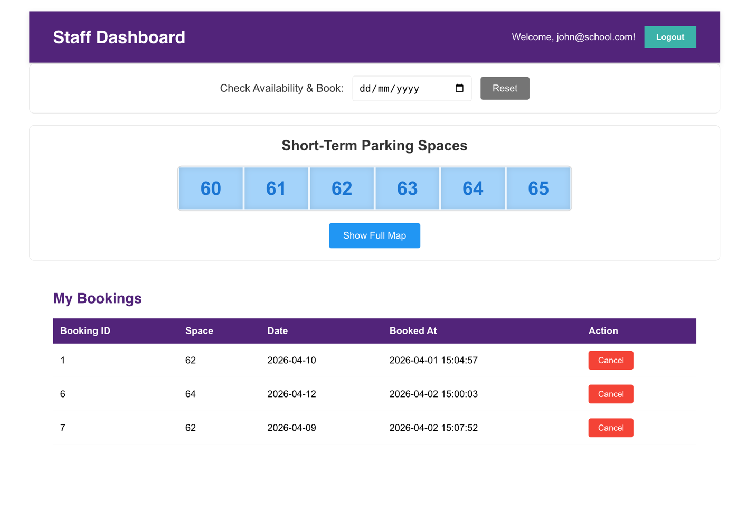
The dashboard contains the following sections:
• Header bar: Shows your email address and a Logout button
• Date picker: Select a date to check availability
• Parking space grid: Shows the 6 short-term spaces (60-65)
• Show Full Map button: View the complete parking lot layout
• My Bookings table: Shows all your current reservations

4. Checking Availability & Booking

4.1 Selecting a Date
To check which spaces are available, first select a date using the date picker.
Step 1: Click on the date field next to "Check Availability & Book".
Step 2: Select a date within the next 14 days.
Step 3: The parking spaces will update to show availability.

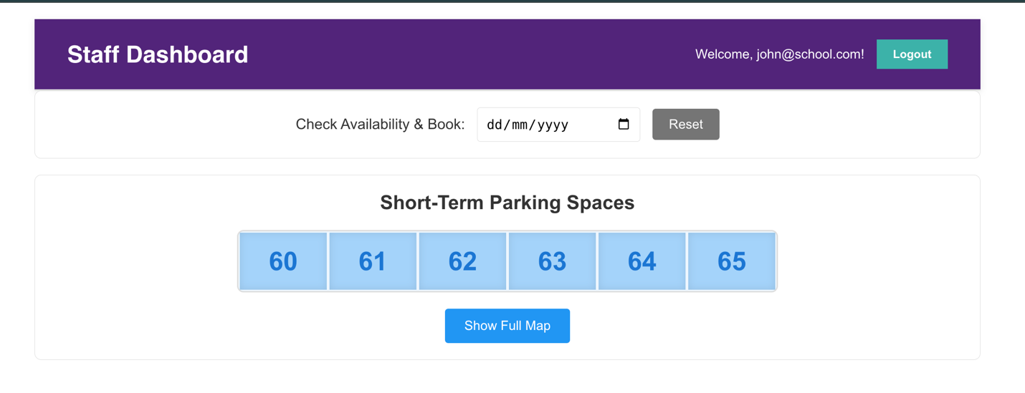

4.2 Understanding the Colour Codes
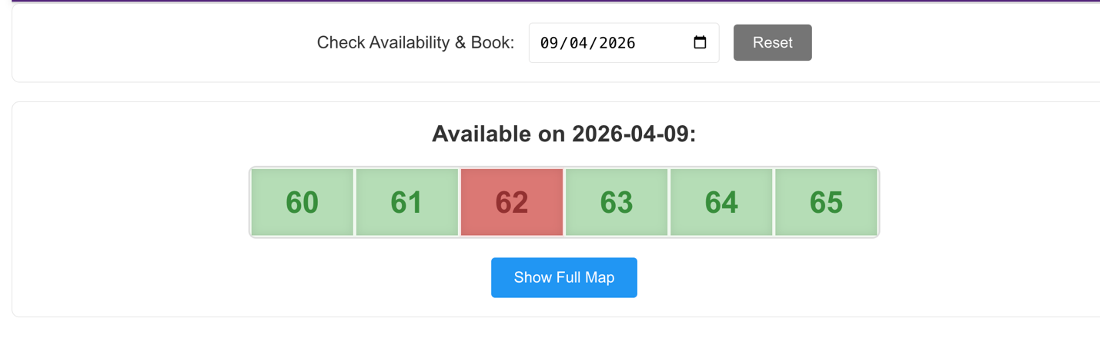
The parking spaces use colour coding to show their status:
• Green: Available for booking
• Red: Already booked by another staff member
• Blue/Grey: No date selected yet

4.3 Making a Booking
Step 1: Select a date using the date picker.
Step 2: Click on any green (available) space.
Step 3: A confirmation dialog will appear.
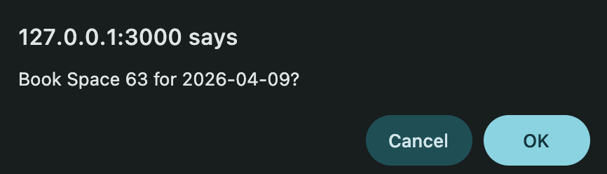
Step 4: Click "OK" to confirm your booking, or "Cancel" to go back.
Once confirmed, the space will turn red and appear in your "My Bookings" table.

5. Viewing the Full Parking Map
To see where the short-term parking spaces are located within the school grounds, click the "Show Full Map" button.
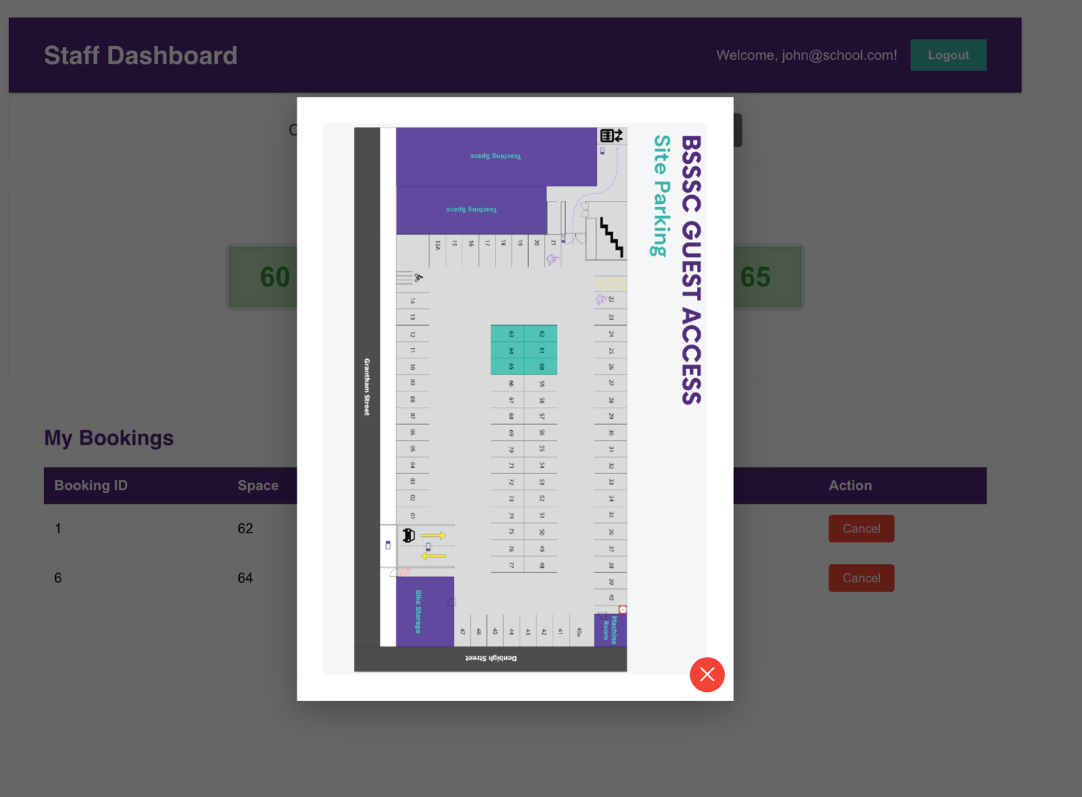
The map shows the entire parking facility. The bookable short-term spaces (60-65) are highlighted. Click the X button to close the map and return to the dashboard.

6. Managing Your Bookings
The "My Bookings" section at the bottom of the dashboard shows all your current reservations.
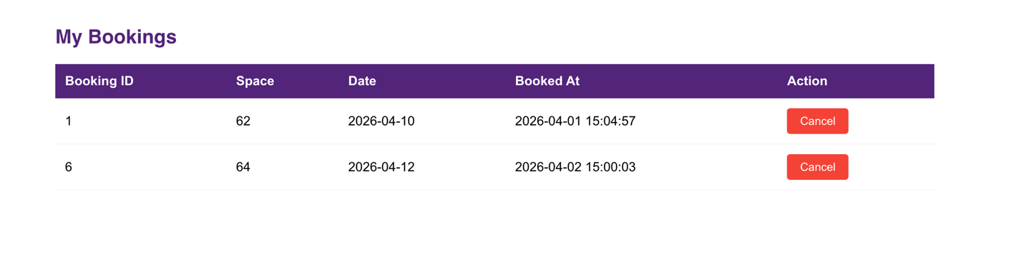
The table displays:
• Booking ID: A unique reference number for each booking
• Space: The parking space number you booked
• Date: The date of your booking
• Booked At: The timestamp when you made the reservation
• Action: A Cancel button to remove the booking

6.1 Cancelling a Booking
Step 1: Find the booking you want to cancel in the "My Bookings" table.
Step 2: Click the red "Cancel" button on that row.
Step 3: A confirmation dialog will appear.
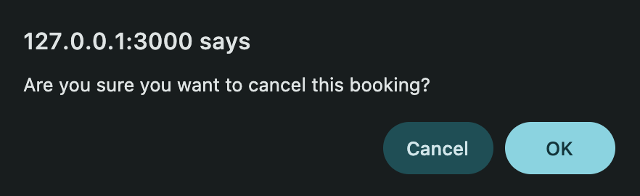
Step 4: Click "OK" to confirm the cancellation, or "Cancel" to keep your booking.
The booking will be removed from your table and the space will become available for others to book.

7. Logging Out
When you are finished using the portal, click the "Logout" button in the top-right corner of the header bar. This will return you to the landing page.
💡 Note: For security, always log out when using a shared or public computer.

PART 2: ADMINISTRATOR USER GUIDE
This section covers administrator functions including user management, booking oversight, parking slot configuration, and system settings.

8. Administrator Login
Administrators access the system through a separate login page.

8.1 Accessing Admin Login
The admin login is accessed via a hidden method on the landing page:
Step 1: Go to the landing page.
Step 2: Triple-click on the school logo.
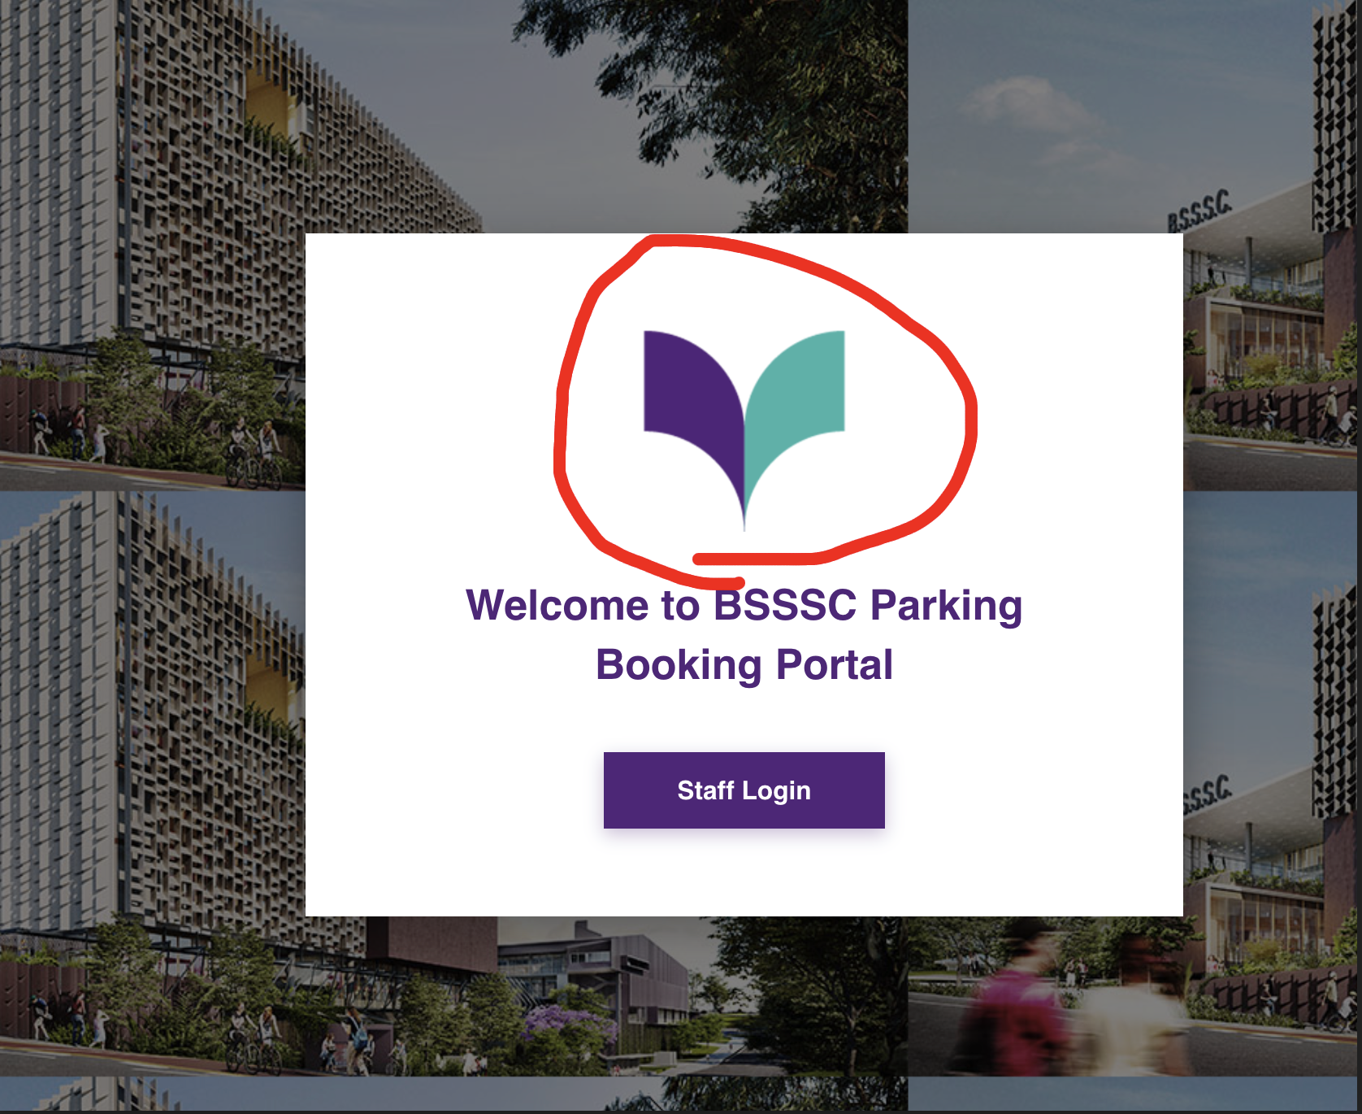
Step 3: The Administrator Login page will appear.
Step 4: Enter your admin email and password, then click Login.

9. Admin Dashboard
The Admin Dashboard provides an overview of all bookings across all users, displayed in a grid format.

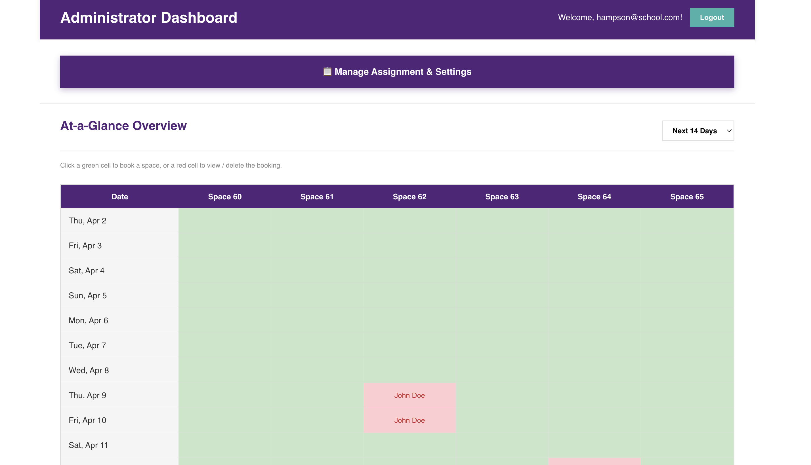

9.1 Grid Controls
At the top of the grid, you can adjust the view:
• Days dropdown: Switch between "Next 7 Days" and the maximum booking window
• Restricted toggle (🔒): Show or hide restricted parking slots

9.2 Creating a Booking (Admin)
Step 1: Click on any green (available) cell in the grid.
Step 2: The "Book This Space" modal will appear.
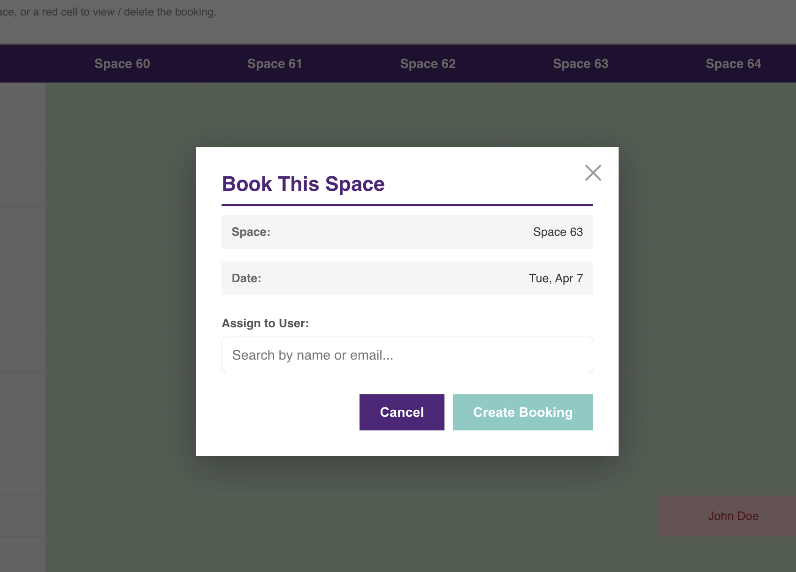
Step 3: Search for a user by name or email.
Step 4: Select the user from the dropdown.
Step 5: Click "Create Booking".

9.3 Viewing & Deleting Bookings
Step 1: Click on any red (booked) cell in the grid.
Step 2: The "Booking Details" modal will appear.
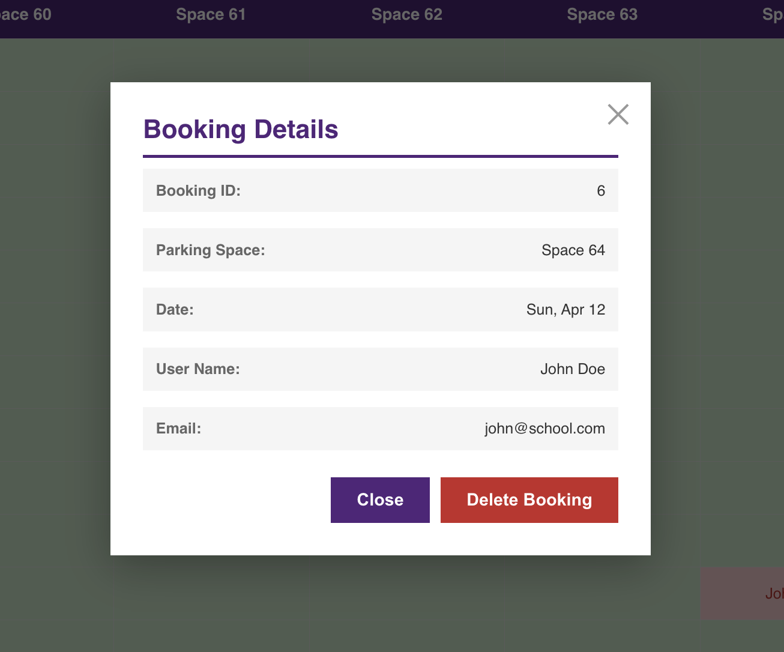
The modal shows: Booking ID, Space, Date, User Name, and Email.
Step 3: To delete: Click "Delete Booking" and confirm.
Step 4: To close without changes: Click "Close".

9.4 Restricted Slots
Restricted slots are admin-only spaces that regular staff cannot see or book. They appear with a purple tint and a lock icon (🔒) in the column header.
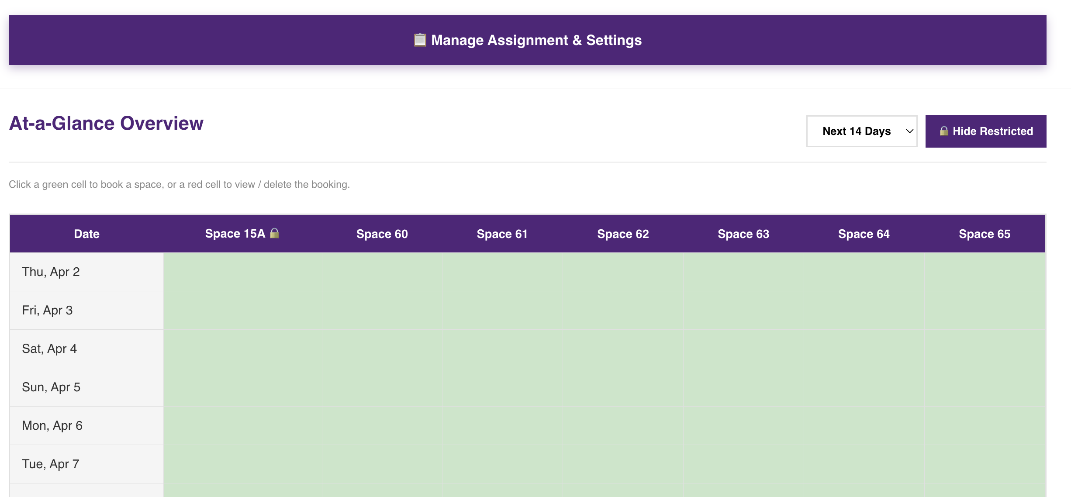

10. Management Page
Click "📋 Manage Assignment & Settings" on the Admin Dashboard to access the Management Page. This page has four tabs: Users, Bookings, Parking Slots, and Settings.

10.1 Users Tab
The Users tab allows you to create, edit, and delete user accounts.

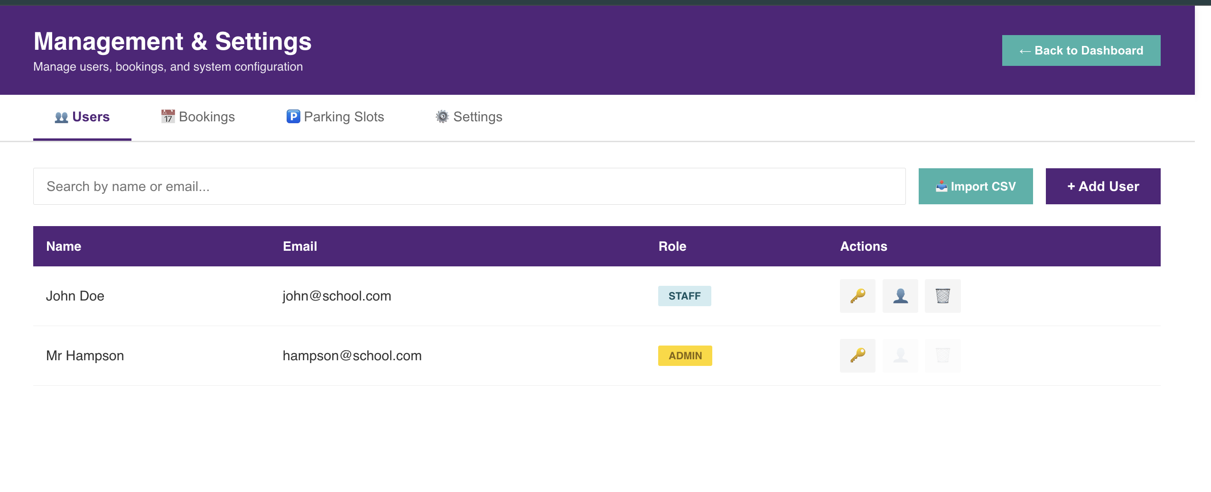

Adding a Single User
Step 1: Click the "+ Add User" button.
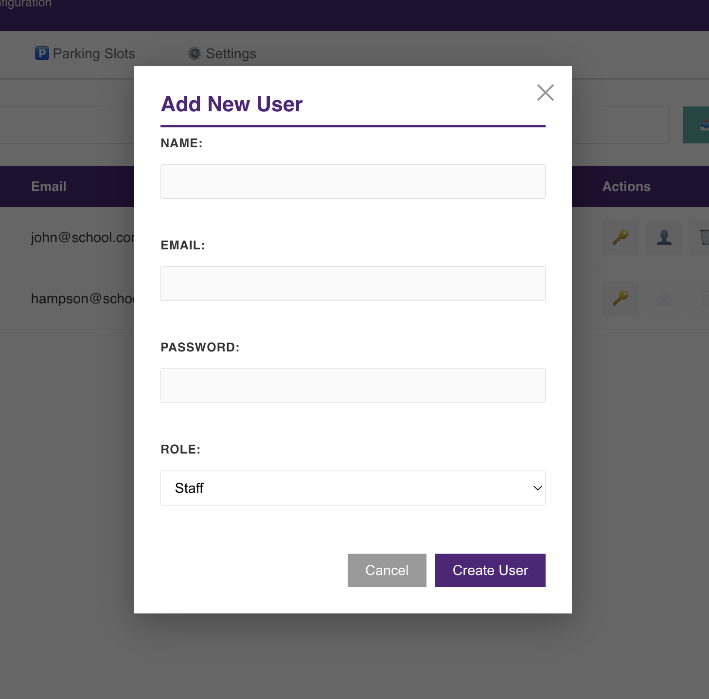
Step 2: Fill in Name, Email, Password, and select a Role (Staff or Admin).
Step 3: Click "Create User".

Bulk Importing Users (CSV)
Step 1: Click the "📥 Import CSV" button.
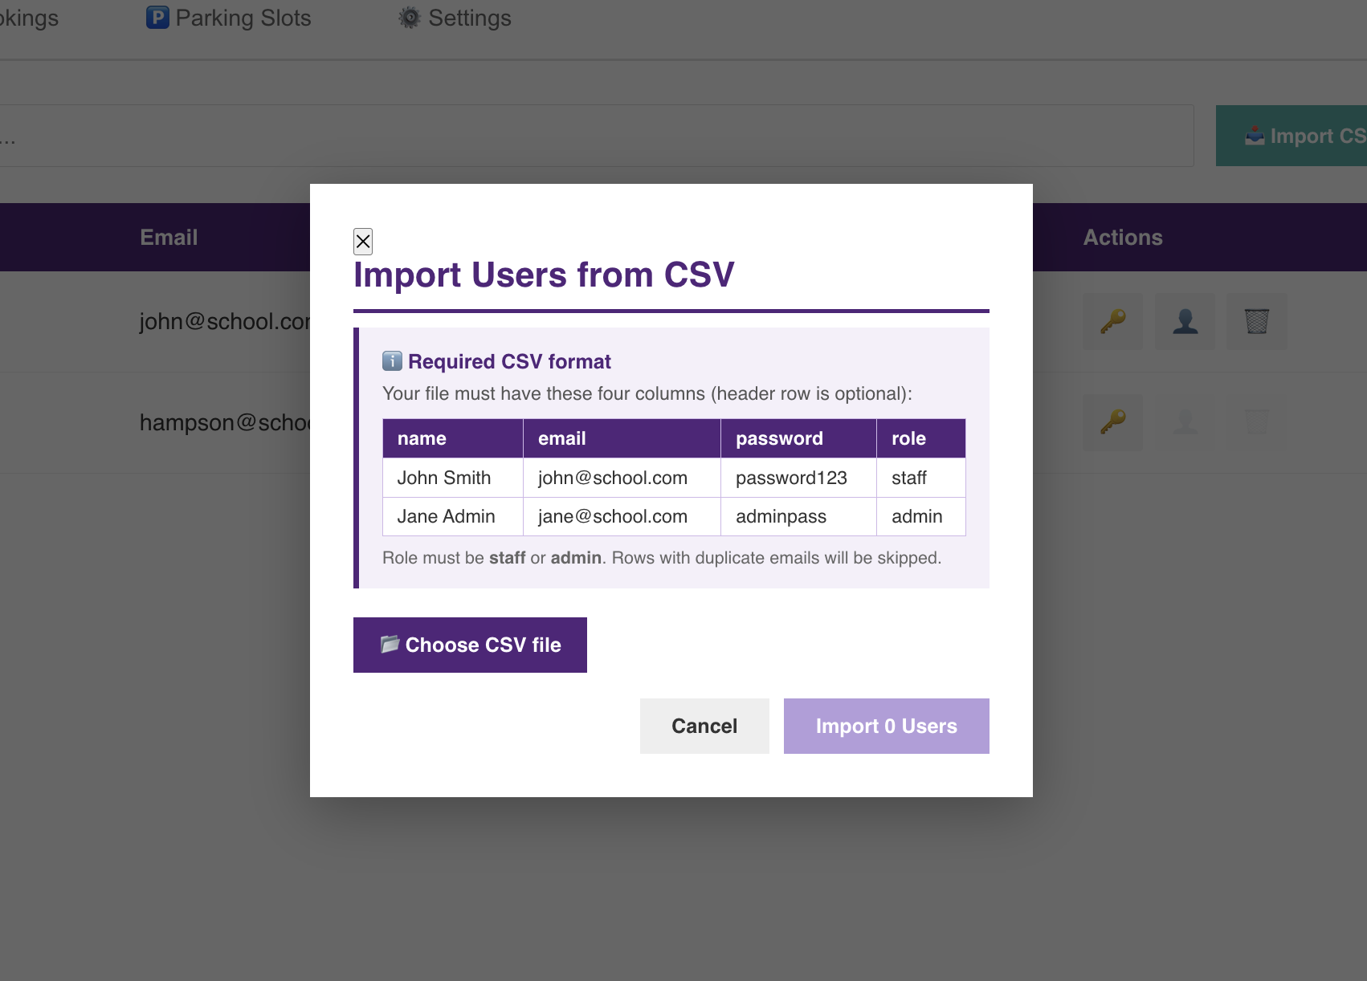
Step 2: Review the format guide. Your CSV must have columns: name, email, password, role
Step 3: Click "Choose File" and select your CSV file.
Step 4: Review the preview table showing valid and invalid rows.
Step 5: Click "Import X User(s)" to proceed.
Step 6: Review the results showing who was created vs skipped.

Managing Existing Users
For each user in the table, you can:
• 🔑 Change Password: Click to set a new password
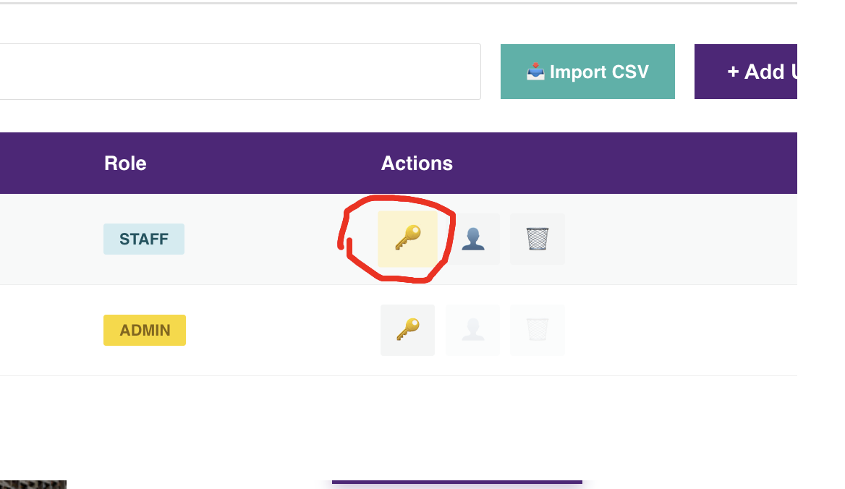
• 👤 Change Role: Click to switch between Staff and Admin
• 🗑️ Delete: Click to remove the user and all their bookings (requires confirmation)

10.2 Bookings Tab
The Bookings tab allows you to view all bookings, manually create bookings for any user, and export booking data.

Creating a Manual Booking
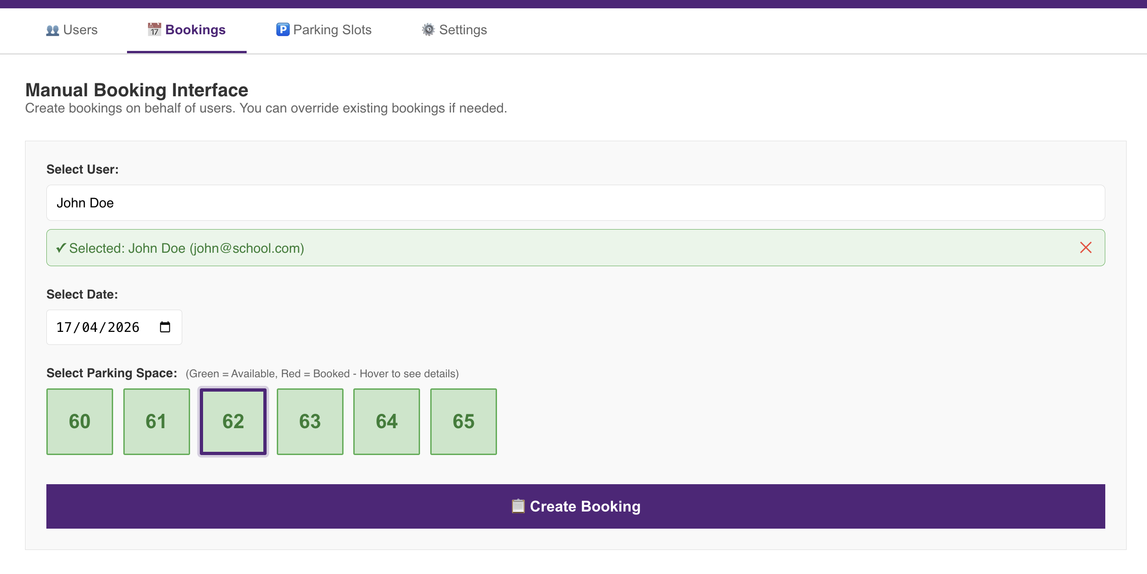Step 1: Search and select a user.
Step 2: Select a date.
Step 3: Click an available (green) space.
Step 4: Click "📋 Create Booking".
💡 Note: Hover over a red (booked) space to see who currently has it booked.

Viewing & Filtering Bookings
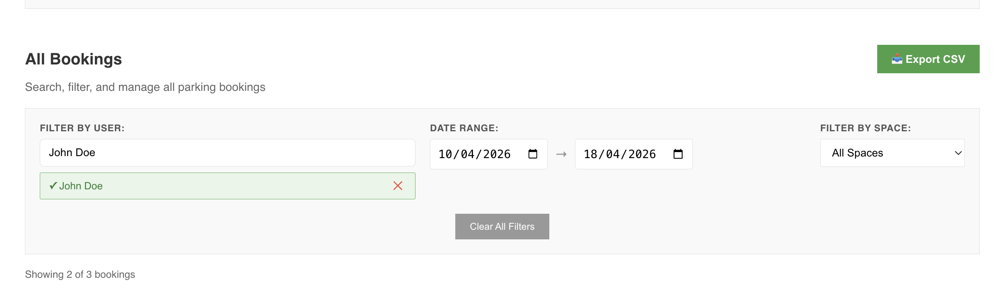
The bookings table supports:
• Filter by User: Search for a specific user
• Date Range: Set start and end dates
• Filter by Space: Select a specific parking space
• Sortable columns: Click any header to sort
• Results count: Shows "Showing X of Y bookings"
• Clear All Filters: Reset all filters at once

Exporting Bookings
Click the "📥 Export CSV" button to download all visible/filtered bookings as a CSV file. The export includes: Booking ID, User, Space, Date, and Created timestamp.

Cancelling Bookings
Click the "Cancel" button on any booking row to remove it. A confirmation dialog will appear.

10.3 Parking Slots Tab
The Parking Slots tab allows you to add, delete, and manage the restriction status of parking spaces.

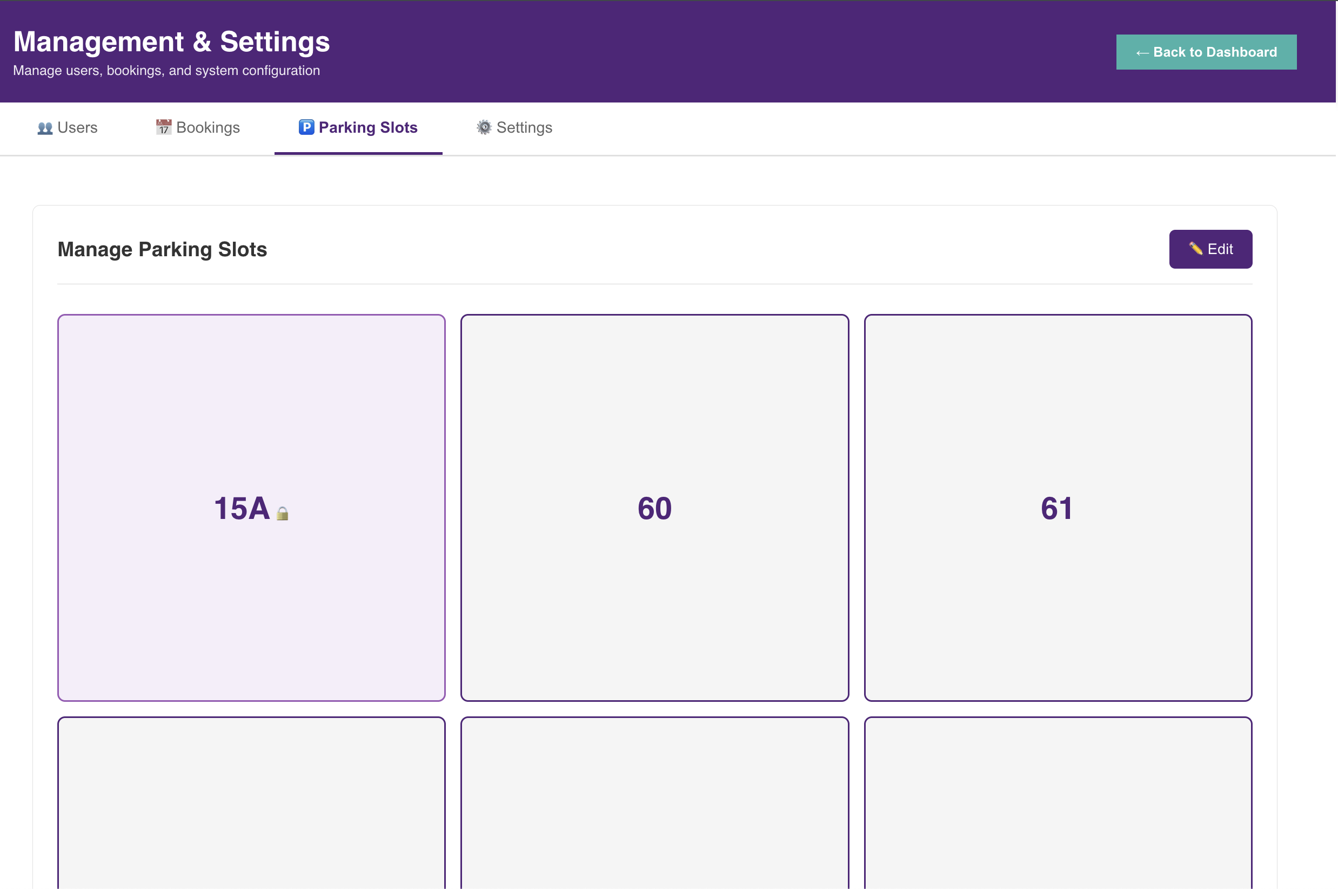Edit Mode
Step 1: Click "✏️ Edit" to enter edit mode.
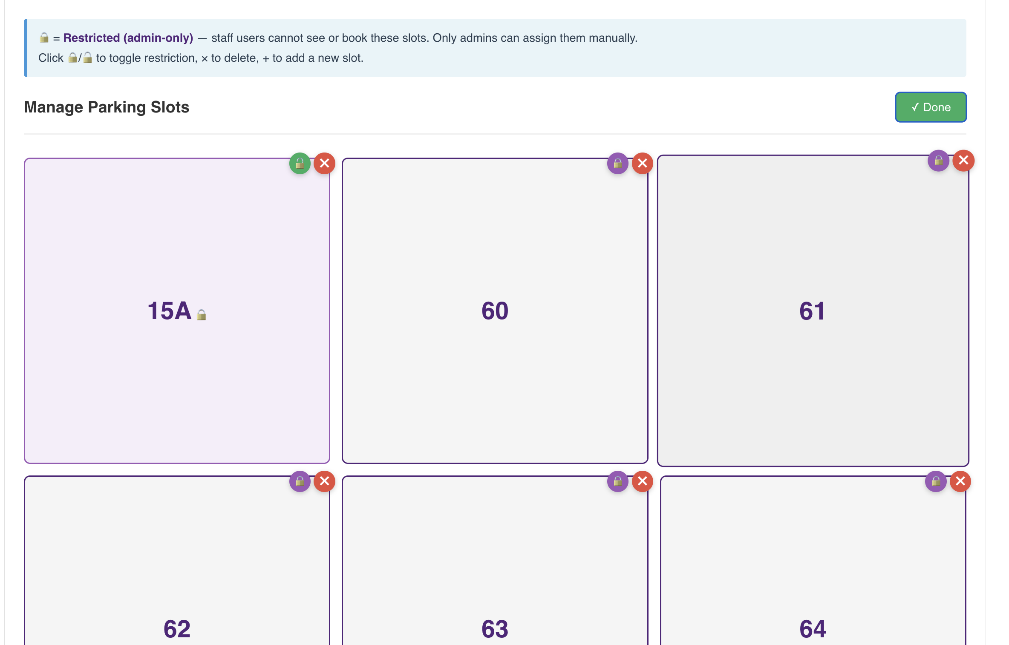In edit mode, you can:
• Click 🔒 to make a slot restricted (admin-only)
• Click 🔓 to make a slot public (staff can see and book)
• Click × to delete a slot (warning: also deletes all bookings for that slot)

Adding a New Slot
Step 1: In edit mode, at the bottom of the screen, click the "+ " block.
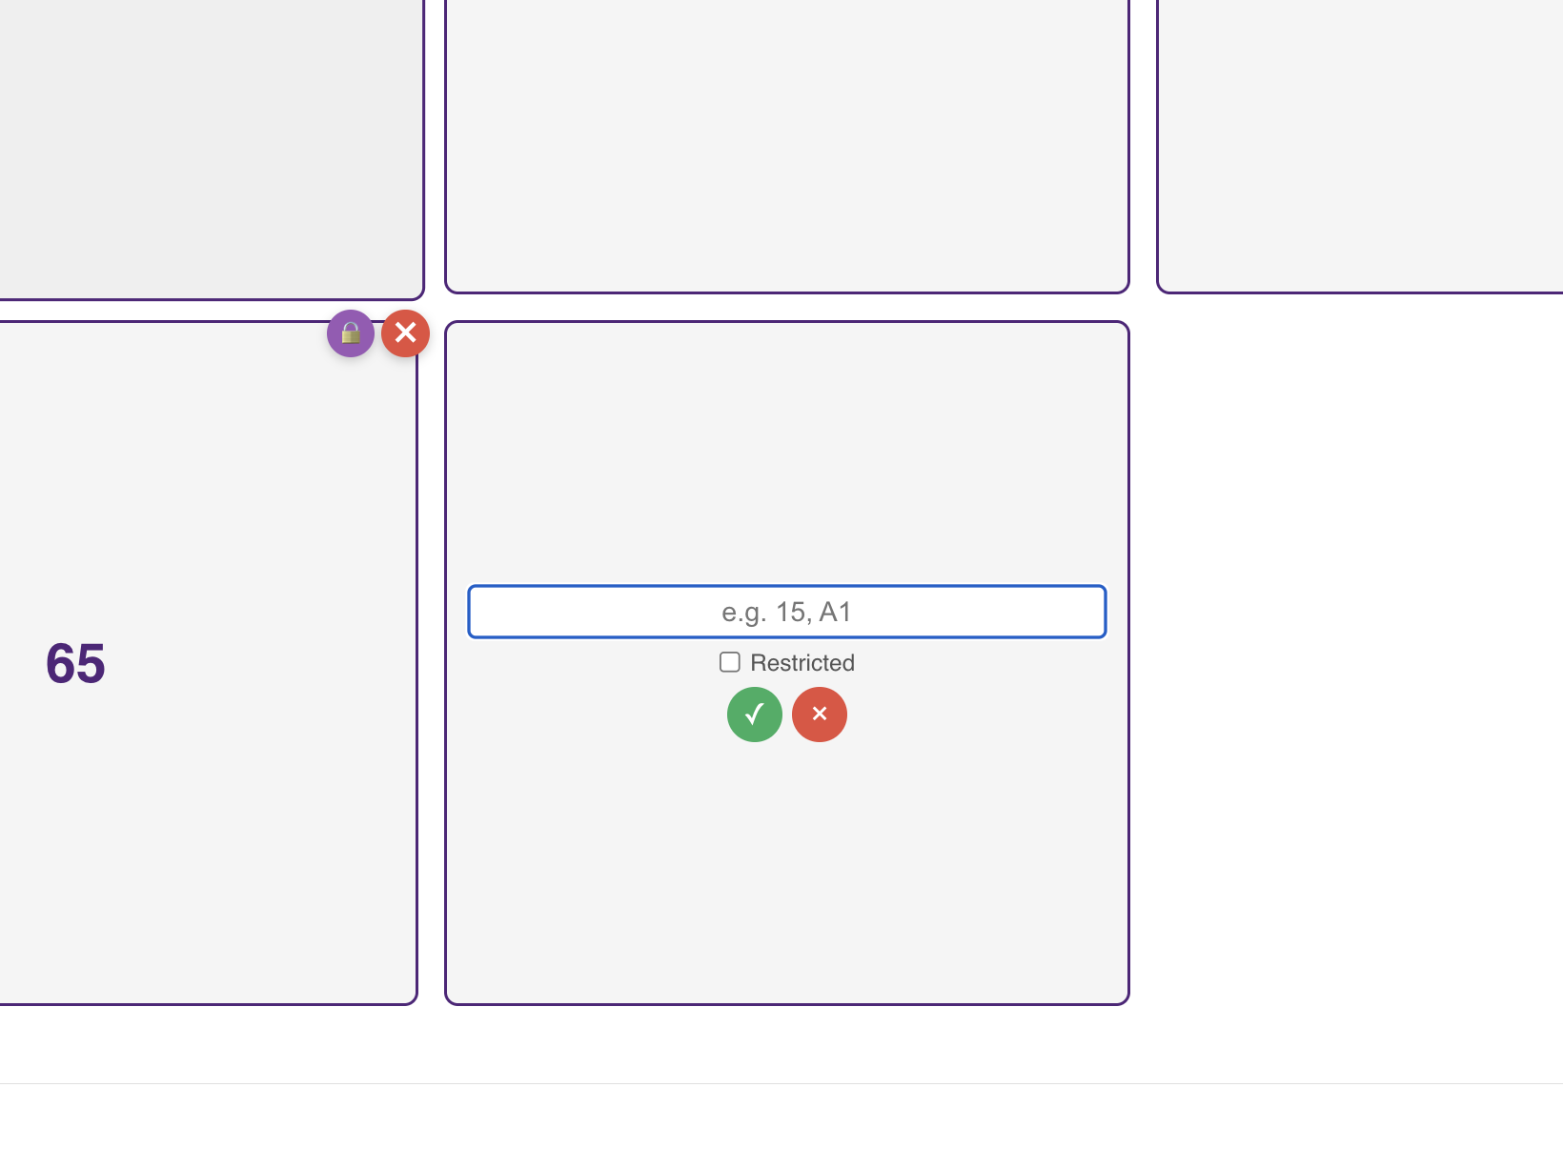
Step 2: Enter the slot number (e.g., 66, A1, 12B).
Step 3: Tick "Restricted" if it should be admin-only.
Step 4: Click ✓ to confirm or × to cancel.
Step 5: Click "✓ Done" to exit edit mode.

10.4 Settings Tab
The Settings tab allows you to configure booking rules and view system statistics.

Booking Rules
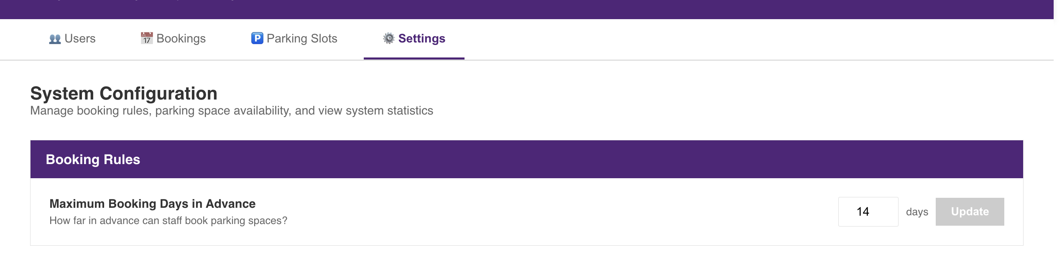Maximum Booking Days in Advance: Set how far ahead staff can book (1-365 days). The default is 14 days.
Step 1: Enter the desired number of days.
Step 2: Click "Update" to save.
💡 Note: A warning will appear if you have unsaved changes.

Parking Space Management
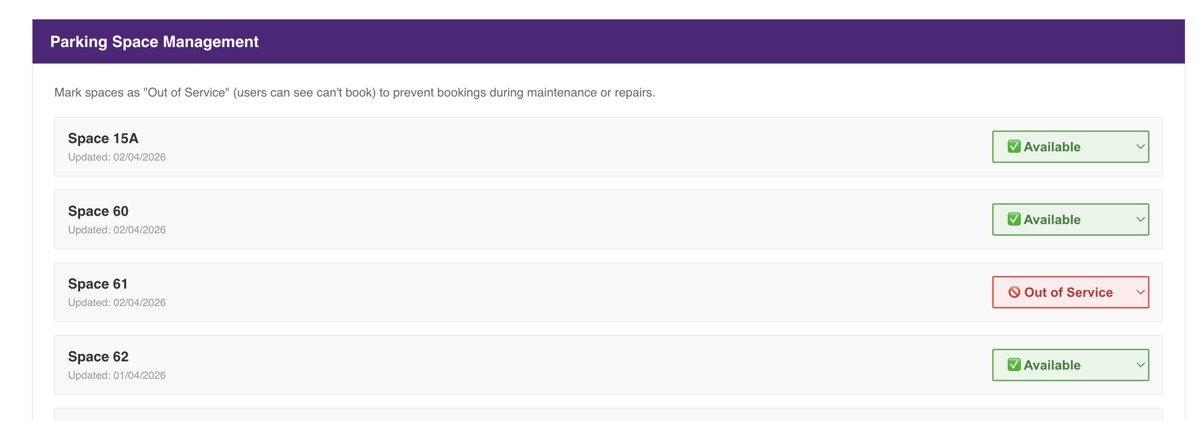
For each parking space, you can set its status:
• ✅ Available: Staff can see and book this space
• 🚫 Out of Service: Staff can see the space but cannot book it (useful for maintenance)
Changes save immediately when you select a new status.

System Statistics
The statistics section displays:
• Total Users: Number of registered users
• Total Bookings: All-time booking count
• Active Bookings: Future bookings only
• Most Booked Space: The most popular parking space

11. Quick Reference

Colour Codes
• Green: Available for booking
• Red: Already booked
• Blue/Grey: No date selected
• Purple (Admin only): Restricted slot

Common Tasks
• Book a space: Select date → Click green space → Confirm
• Cancel booking: My Bookings → Cancel button → Confirm
• Add user (Admin): Management → Users → + Add User
• Export bookings (Admin): Management → Bookings → Export CSV
• Add parking slot (Admin): Management → Parking Slots → Edit → + block

Need Help?
Contact your system administrator if you experience any issues or have questions about using the parking booking system.

End of User Guide

