Sandeep Heera

Test Cases

NOTE: Buttons must be clicked on meaning you must press them and keep the cursor over them until the button is released otherwise it will not register.

**View Workouts**

Click on Workouts (Note the name of the user shows up above the menu)

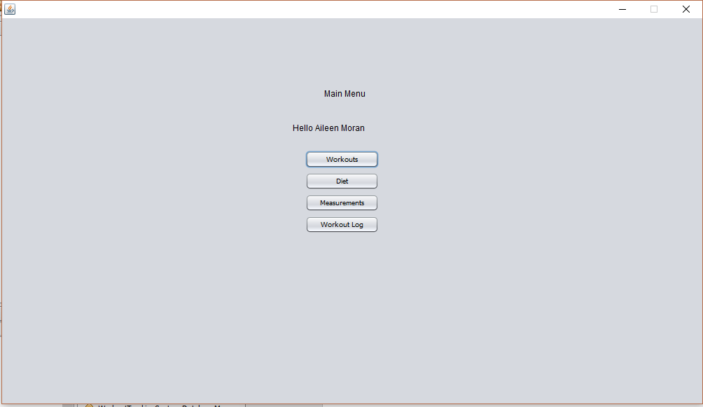

Click on the dropdown menu titled select menu and select the workout.

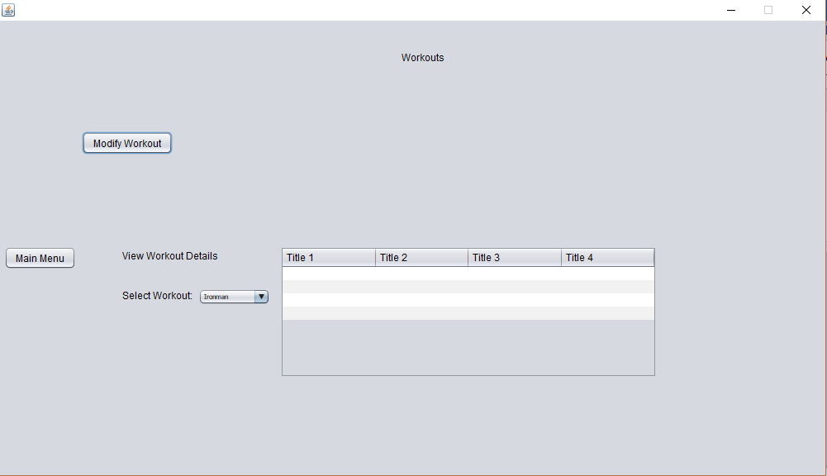

Displaying Ironman II

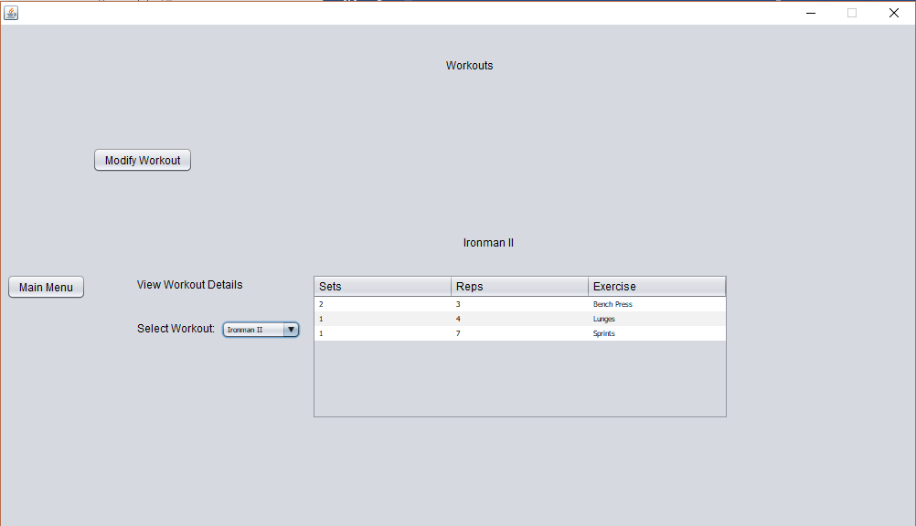

**Add exercise to a workout**

From the above step, click on Modify Workout and you should end up here

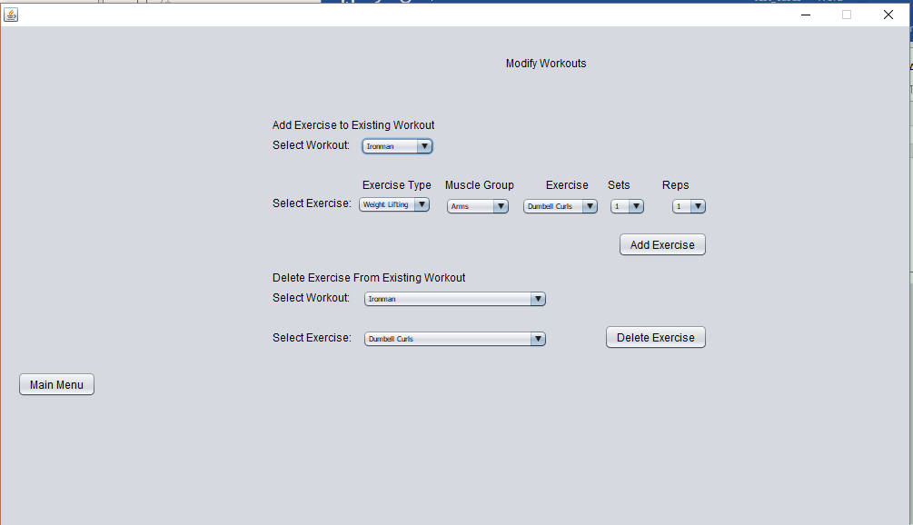

Going to add the squat to Ironman II for 5 sets of 3 reps. Note the menus update via mysql queries. Clicked on the Add Exercise button.

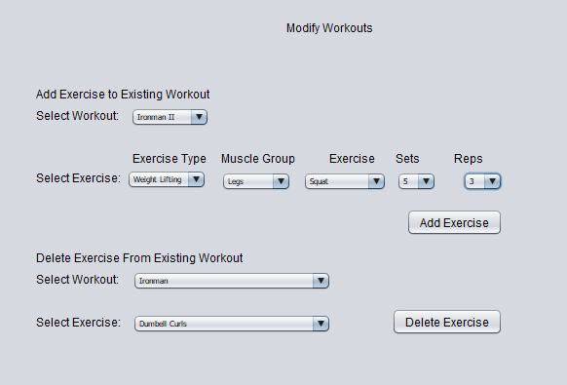

I will navigate back to the workouts menu by selecting Main Menu in the bottom left-hand corner and then selecting workouts again. From here, select Ironman II form the select workout menu and you will see the newly added exercise.

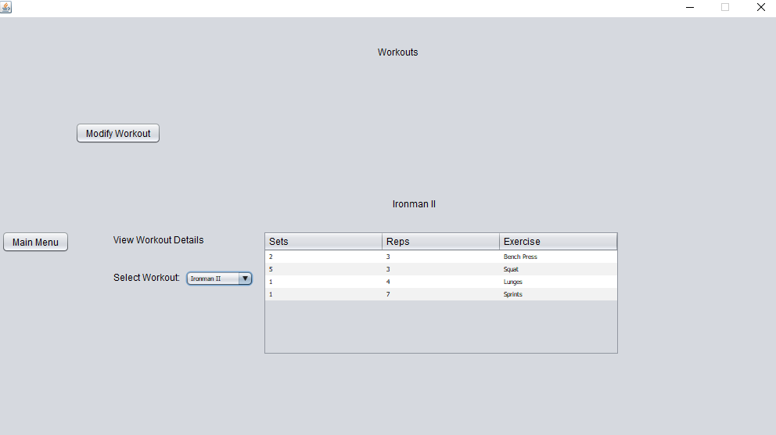

**Delete exercise**

Going to delete the exercise I just added. Click on Modify Workout and click on the dropdown menu for Select workout and select Ironman II. Then click on the dropdown menu for the select exercise button and select squat. Press the Delete Exercise button. Once again, note the options for the dropdown menu are update dynamically via mysql queries.

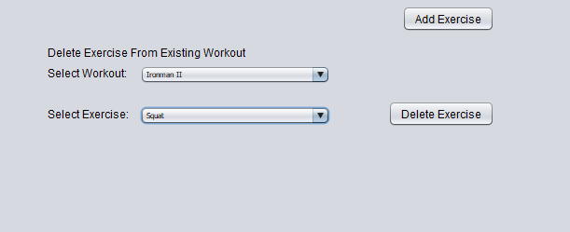

Navigate back to workouts as before and select the Ironman II workout in the view workout details table. The squat is now gone after our successful delete. Notice again the buttons and how they must be clicked and released on otherwise they will not register. If you have an issue, do the operation again and ensure the button is properly clicked.

