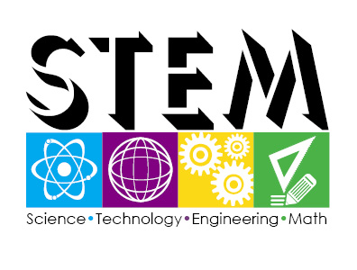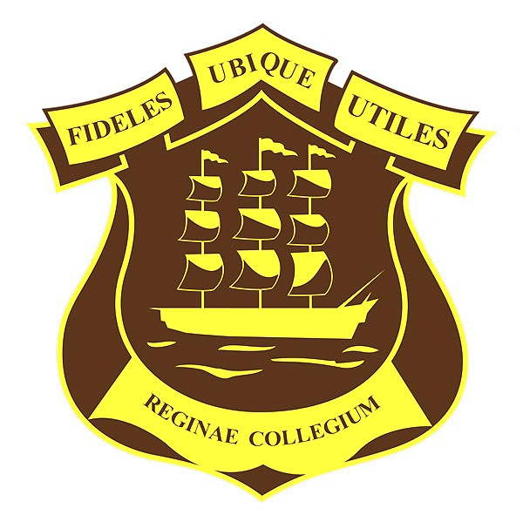

Fair **2016**

Region: Demerara-Mahaica/Georgetown

Division: 6th Form

Student(s): Deenauth Mohabeer

Keoma Grant

Sonny Kothapally

Exhibit: Critical Thinking Tool (CTT): Interactive Media Journal

Category: Open

*Theme: “Enhancing traditional technologies to sustain modern societies through S.T.E.M”*