Title: Finding the height of a tree

Aim: To calculate the height of a tree using proportional measurements

Materials: Metre rule, Graph Paper

Diagram:

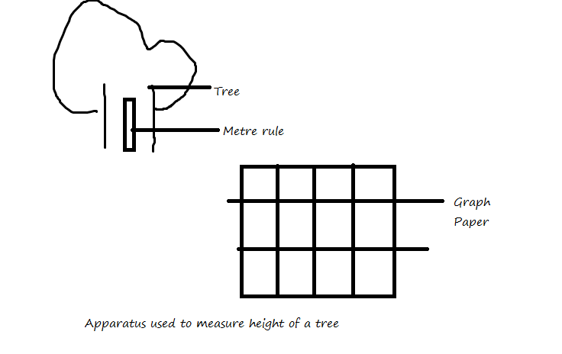

Procedure: A metre rule was placed at the base of a tree. A suitable distance was taken and a sheet of graph paper was held between the eye and the tree.

The base of the tree, the top of the rule and the top of the tree was marked in the graph paper.

The actual height of the tree was calculated by using the proportions.

Treatment of results:

Calculations:

Metre rule = 39.6m

The tree was two(2) times the length of the metre rule.

Therefore, Height of the tree = 39.6m X 2

= 79.2m

Graph: mark the :- top of tree(79.2) – top of metre rule(39.6m) – base of tree(0m)

Title: Geotropism

Aim: To find out which part(s) of a plant are geotropic and whether the geotropism is positive or negative.

Materials: Five been seeds, bathroom tissue, transparent jar, tapwater, a sheet of clear perforated plastic, rubberband

Diagram:

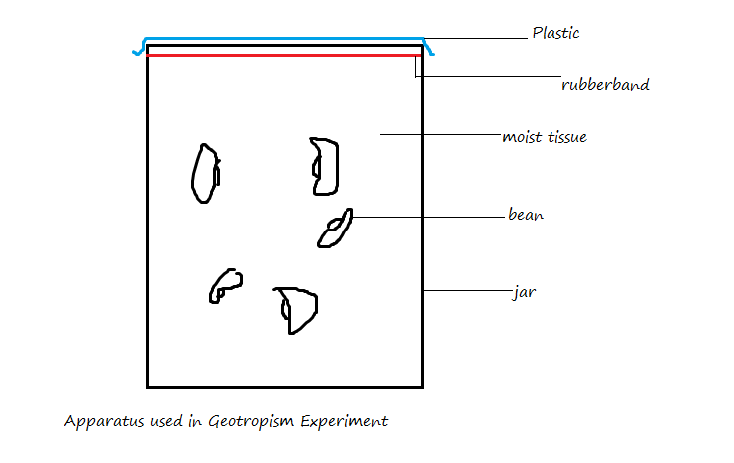

Procedure: Five bean seeds were obtained.

Five layers of tissue paper were left in a jar and was carefully moistened so that it would cling to the side of the jar.

The seeds were distributed around the jar and were placed midway down the jar between the moistened tissue and the side of the jar.

The seeds were germinated until roots were visible.

The plumule and radicle was noted on the seedling and it was observed which one emerges from the testa first.

The seeds were observed everyday and observations were recorded. Fully Large diagrams were drawn as the observation.

Results: Day1 - Beans were placed

Day 2 - Bean is swollen

Day 3 - Radicle emerges

Day 4 - Plumule emerges

Day 5 - Shoot and root

Day 6 - Leaf develops

Day 7 - Leaves grow.

Discussion: Geotropism is the response of plants to gravity. The plumule was found to have a negative response to geotropism. Whereas, the radicle was found to have a positive response to geotropism. The positions of the seeds in this experiment were altered to prove the theory of geotropism. One of the seeds was turned on it’s side and another upside down to see if the root and plumule would respond to gravity, which it did. The plants were placed in the dark to see if it requires sunlight to germinate. They did not need sunlight.

Conclusion: It was concluded that the plumule (shoot) had a negative response toward geotropism and the radicle (root) has a positive response towards geotropism.

Title: Effects of exercise on the rate of heartbeat

Aim: To investigate the effects of exercise on the rate/pulse rate and to find the recovery time

Materials: Stopwatch

Diagram:

Procedure: The pulse was located by placing the index finger of one hand, just below the base of the thumb of the other hand.

The normal heart rate was found by counting the number of beats for a minute. This was repeated twice and the results recorded.

The subject then took part in running for two minutes. The pulse was taken soon after that.

The pulse was then taken every minute until it returned to the initial pulse rate.

The last three processes were repeated twice and results were recorded.

Results: Results of Resting Heart/Pulse Rate

Attempts - Heart/pulse

1 - 89

2 - 93

3 - 90

Table two(2)

Pulse rate

Initial pulse rate 90

Pulse rate after exercising 160

One minute after 147

Two minutes after 123

Three minutes after 103

Four minutes after 92

Graph: Time/seconds(x), Pulse Rate(y) – Table 2

Title: Enzymes

Case study: Mr. Campbell the baker noticed that on rainy days has bread dough takes a longer time to raise than on a sunny day.

Aim: To determine the temperature of respiration on yeast.

Hypothesis: The rate at which yeast increases with the increasing temperature.

Materials: Dough (bread mixture), stopwatch, warm water, ice water, beaker, test tube.

Procedure: Label test tubes A and B.

Place equal amounts of dough in each test tube.

Place A in a beaker with ice.

Place B in a beaker with warm water.

Observe for 45 minutes to 1 hour.

Variables:

Dependent - Time taken for dough to rise

Independent- temperature

Manipulated-

Results:

Observations

Test tube A - Test tube B

Discussion: What is an enzyme?

Precautions

Sources of error

Conclusion: It can be concluded that…

Title: Reproduction

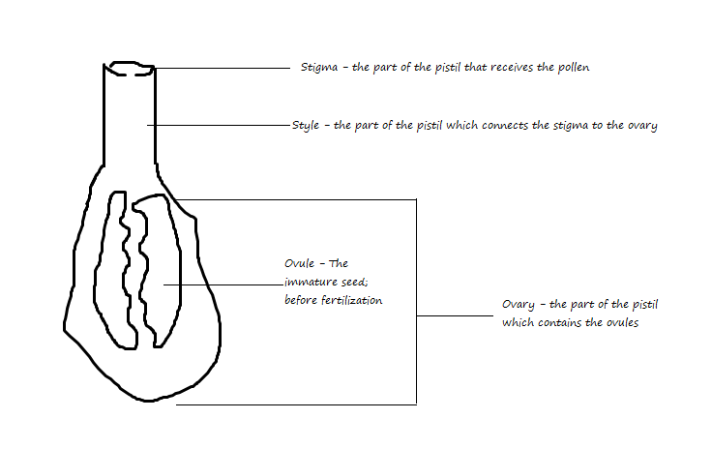

Diagram of the pistil

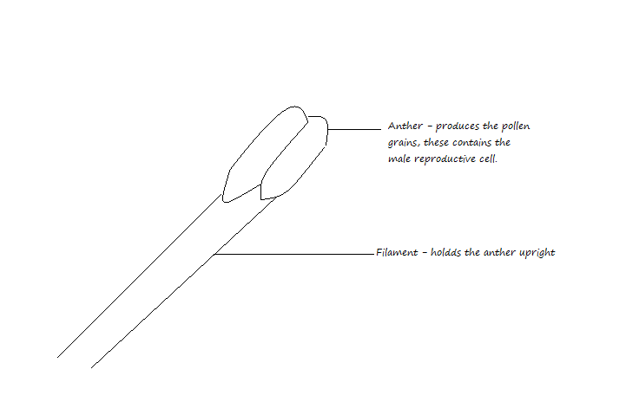

Diagram of the stamen

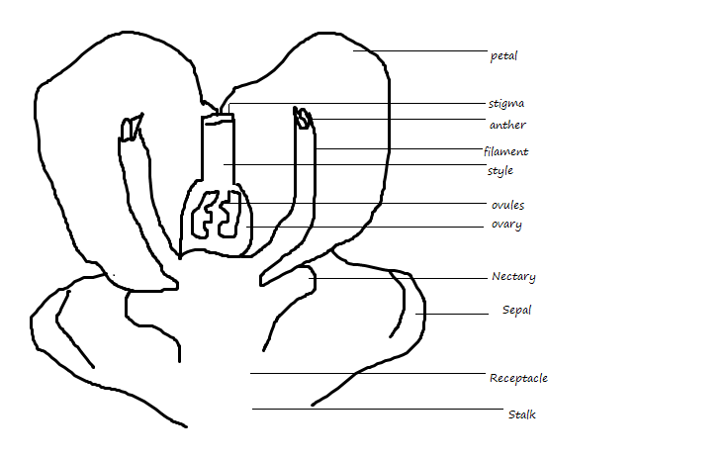

Parts of a flower