CHAPTER 1

Essential elements for plant growth and their sources

Essential elements for plant growth

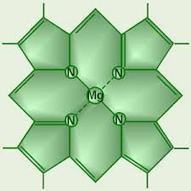There are 10 essential elements of plant growth. They are carbon, hydrogen, oxygen, nitrogen, phosphorus, potassium, sulfur, calcium, magnesium and iron.

Carbon, hydrogen and oxygen are required for making carbohydrates. Carbohydrates are made when carbon dioxide (compound of C and O) and water (compound of H and O) are split in the chlorophyll molecule using energy from the sun. Oxygen is a by-product

6CO2 + 6H2O energy from sunlight> C6H12O6 + O2

During respiration, carbohydrate and oxygen are converted back into carbon dioxide and water giving off energy which plants use for the daily tasks.

C6H12O6 + 6O2 🡪 6CO2 + 6H20 + energy

Some of the glucose is converted to starch, which is required for cellulose, and water.

nC6H12O6 🡪 (C6H10O5) n + nH2O

Plants create proteins using the elements nitrogen, sulfur, carbon, hydrogen and oxygen.

Nitrogen is needed for growth and chlorophyll. Phosphorus promotes strong root growth and accelerates ripening and seed formation. Potassium is vital for the development of fruits and seeds and for strengthening a plant’s resistance to disease.

Secondary nutrients required include magnesium, sodium, sulfur and calcium. The trace elements boron, manganese, copper and zinc are required in small quantities

Sources of the essential elements

Carbon and oxygen required for photosynthesis is present in the air as carbon dioxide. Hydrogen is obtained from water in the soil. Some of the compounds are present in the soil in a soluble state and can be obtained by the roots of the plant. Some of the essential elements are supplied by the disintegrated rocks. For example, limestone, granite, phosphate rocks. Most nutrients can also be obtained from the humus in the soil.

Fertilizers are the most primary way of providing nutrients. The elements N, P, and K are vital to the plant and need to be provided by artificial means. The Haber process is an alternative to nitrogen-fixing bacteria.

Firstly, nitrogen and hydrogen are reacted at 200atm and 500OC using an iron catalyst, forming ammonia.

N2 (g) + 3H2 (g) 🡪 2NH3 (g)

The ammonia is dissolved in water and reacted with sulfuric acid to form ammonium sulfate.

NH3 (aq) + H2SO4 (aq) 🡪 (NH4)2SO4 (aq)

Ammonia can be converted into nitric acid and then to nitrates.

4NH3 + 5O2 🡪 4NO +6H2O

2NO + O2 🡪 2NO2

3NO2 + H2O 🡪 2HNO3 + NO

NH3 + HNO3 🡪 NH4NO3

By reacting ammonia and carbon dioxide under pressure, urea is formed.

2NH3 (g) + CO2 (g) 🡪 CON2H4 (s) + H2O (l)

Phosphorus is primarily derived from phosphate rock. Phosphate rock is mostly available as insoluble calcium phosphate. Therefore, it is made soluble when the rock phosphate reacts with sulfuric acid.

Ca3 (PO4)2 + 2H2SO4 🡪 2CaSO4 + Ca (H2PO4)2

Potassium is also mined and is present in the potassium chloride. Potassium salts are obtained from dried up lakes and from water of lakes rich in these salts.

Animal and vegetable wastes added to the soil contain the three major nutrients as well as secondary and trace elements.

CHAPTER 2

Effects when elements are deficient

Deficiencies of elements

Nitrogen deficiency causes small leaves and poor growth. Pale green and yellow leaves are also a sign of nitrogen deficiency.

Phosphorus deficiency cause poor roots and improper growth. There are less blossoms and leaves tend to fall off resulting in low yield of grain/fruit. The leaves are generally dull, blue-green or very dark-green in color.

Other nutrient deficiencies affect growth and health of plants. Magnesium deficiency leads to a poor leaf growth and leaves and generally pale green in color due to the lack of chlorophyll.

CHAPTER 3

Nitrogen compounds in home gardening – organic manure versus fertilizers, the nitrogen cycle

The Nitrogen Cycle

The nitrogen cycle is the circulation of nitrogen in nature.

Nitrogen-fixing bacteria first convert the nitrogen in the air into nitrates which are absorbable by the plant.

Plants obtain nitrogen by absorbing soluble nitrates through their roots from the soil. The nitrates are then changed into amino acids in the plant. When an animal eats the plant, the nitrogen in the plant protein is used to make animal protein.

Decaying plant and animal material contain proteins which are converted by decomposers and bacteria into ammonia which form ammonium compounds. Nitrifying bacteria oxidize the ammonium compounds to nitrites (NO2-) and finally to nitrates (NO3-) which can be taken up in solution by the plants.

NH4+ + 3[O] 🡪 2H+ + NO2- + H2O

H+ + NO2- + [O] 🡪 H+ + NO3-

Denitrifying bacteria change nitrates into nitrites, ammonia and even nitrogen.

Lightning causes nitrogen and oxygen to form nitric oxide, which then forms nitrogen dioxide and is washed down as nitric acid by rain.

N2 + O2 🡪 2NO

NO + O2 🡪 NO2

4NO2 + O2 + 2H2O 🡪 4HNO3

The Nitrogen Cycle in Nature

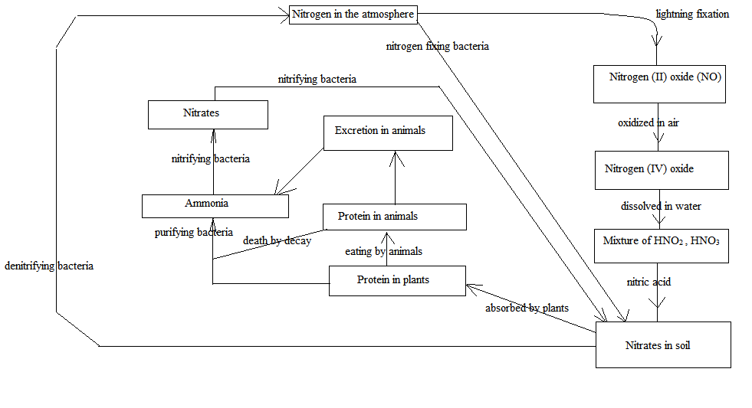

Organic vs Inorganic Fertilizers

A plant requires sufficient air, water, temperature, light and nutrients. Most of the requirements listed are already provided to the plant from our environment and surroundings. However, not all soils contain the nutrients required. Therefore it is important that fertilizers be used to sustain plant growth. Before providing fertilizers, one needs to choose a type, inorganic or organic.

Organic fertilizers are made (decomposed) from natural and raw materials (mostly waste). The advantages of using organic fertilizers is that they are natural, provide good nutrients, transform sandy and clay soils to grow the plant, regulate the pH (potential hydrogen) of the soil and are very cheap. However, they take a longer time to provide nutrients, generally are low in supply, and have a bad odor.

Inorganic fertilizers are artificial unlike organic fertilizers and need to be manufactured. Contrary to organic fertilizers, inorganic fertilizers work immediately since they are already in a form absorbable by plants. They have a great balance of the nutrients, are affordable and are convenient to use. However, leeching (leeching is washing away of inorganic fertilizers when watering or irrigating) is very prevalent in many farms. In addition, some are not affordable and accumulate toxic wastes.

It is therefore better to use both and choose depending on which is best suited for the farm at hand. It is generally known that organic fertilizers are best for small-scale farms whereas the latter is best for larger farms. Though this is not always true, it is right for most cases. Organic fertilizers are great to use on long-term crops while inorganic fertilizers are better on short-term crops.

After choosing the fertilizer, it is important that the fertilizer is given at the right time. This is very crucial when growing the plant. Too much fertilizer causes the soil to become too acidic and too less fertilizer does not promote necessary growth. Therefore it is always recommended to check the pH of the soil before attempting to provide fertilizers.

CHAPTER 4

Humus, why we need it!

Humus

Humus is organic matter which is derived from decayed plant or animal material. It is very rich in plant nutrients. In places where vegetation flourishes, the soil is rich in essential elements as decayed vegetation constantly provides nutrients to new crops. The bacterial decay of humus produces nitrates and mineral salts needed for plant growth.

Color and physical properties of the soil are affected by humus in that humus is black and forms a coating over the soil causing them to stick together, thus making the soil a more efficient absorber of water. Hood moisture retentions helps to use mineral salts more efficiently and easily. Sandy soils deficient in humus tend to be easily blown away if exposed by ploughing.

CHAPTER 5

Lime and soil

Lime

Soil from different places differ in pH. In many places, the soil is neutral (pH7). In others, it may be acidic or alkaline.

In testing soil pH, different soil samples are shaked with distilled water in separate test tubes. It is allowed to settle and is the aqueous mixture/supernatant liquid is tested with pH paper.

Certain species of plants only grow in acidic/basic soil but not in the other.

Soils grow best in neutral pH. Basic soils restrict plant growth and cause yellowing. Acidic soils however reduce soil nutrient supply to the soil.

To increase soil pH, lime is added. The reactions which occur are:

Ca (OH) 2 + 2H+ 🡪 Ca++ + 2H2O

2H+ + CaCO3 🡪 Ca++ + CO2 + H2O

Lime also has a chemical action on clay causing the particles to come together forming loose crumbs.

Lime and Ammonium Fertilizers

Lime must not be used with ammonium fertilizers because the base, lime, causes nitrogen to be lost as ammonia by the reaction with the ammonium salts.

2OH- + NH4+ 🡪 NH3 + H2O

Soil

The soil provides a variety of minerals and water to plants and also supports them. It mainly consists of minerals, organic matter, water and air. The quality of the soil is crucial to growing successful plants. It should not be easily water-logged when holding air and moisture.

Soils are classified as either sandy, clay, or loam. Gardens generally are mixtures of all, varying the proportions of each soil. Sandy soils are loose and drainage is prevalent. Clay soils are compact and has poor drainage and is easily water-logged. Loam is a mixture of sand and clay soils but also contains large amounts of humus. Humus provides nutrients to the soil.

The nutrients enter the plant through the root and root hairs where ions are interchanged between the soil and the soil solution. However, the soil solution is replenished again from the soil fragments.

CHAPTER 6

Chemical and biological control of pests

Chemical and biological control of pests

Chemical used to destroy pests (insects, rodents and molluscs) are called pesticides.

There are a number of effects the use of pesticides has caused. Some are:

* The chemicals are toxic.
* Crops build resistance when heavy amounts of pesticide is used.
* The natural enemies of the pests are destroyed as well.
* Beneficial insects like bees are destroyed.
* Birds and other wildlife are killed.
* Water is contaminated.
* Substantial death of fish and small invertebrates which are an important source of food for the fish.

Pesticides have greatly reduced agricultural pests and contribute to disease control.

Biological control does not require the use of toxic chemicals. It is more cheap and safe than pesticides. Some biological control examples are:

* The use of ladybirds to feed on aphids and mealy bugs.
* Some parasitic wasps destroy mealy bugs.
* Bacillus thuringiensis, a naturally occurring bacterium kills the caterpillar of butterflies and moths.
* Ducks, chickens and geese are used to rid fields of both insect pests and weeds.

Biological organisms can self-reproduce.

* A few praying mantises or ladybugs released in a garden will keep reproducing and protect the fruits and vegetables from many pests.
* Insect repelling plants such as garlic and marigolds will keep insect pests from crops.
* Genetically improved plant varieties with built-in pest resistance are more resistant to pests.
* Releasing sterile males to mate with female pests prevents the production of offspring.

CHAPTER 7

Herbicides

Herbicides

Herbicides are plant-killing chemicals. It is mainly used to kill weeds that compete with crops. Herbicides can be either selective (kill undesired weeds) or non-selectively (toxic to all crops). Selective herbicides are used widely in agriculture while non-selective herbicides are used to clear areas of all vegetation.

Herbicides are grouped into two categories, plant growth substances and substances that are designed to selectively disrupt the photosynthesis process.

Weeds are generally broad-leaved and have a different biochemistry than crops like grains. 2, 4-D (2, 4-dichlorophenoxyacetic acid) is a plant hormone, stimulates rapid growth in broad-leaved plants thus killing them in the process.

Paraquat and its stronger derivatives are used to interfere with photosynthesis and is generally practiced when reduced or no-tillage farming is present. It is applied directly to the leaves by spraying.

Careful tillage, cultivation, seeding and fertilizing are still better long term alternatives to biological controls. Uninhibited use of herbicides eventually gives harmful effects such as the development of weed resistance and chemical build up.

CHAPTER 8

Hydroponics

Hydroponics

Hydroponics is the term used to describe the process of growing plants without soil. An "inert" medium is used to which is added a nutrient solution containing all the essential elements needed by the plant for growth.

Methods of hydroponics

* Water culture is a method used in hydroponics, this is where seedlings are set in the growth medium composed of a porous material such as wood fiber or peat. The medium is supported in a wire framework centimeters above the surface of the nutrient solution with the roots of the seedling in the solution.
* Using sand and gravel is another method of hydroponics, this method the nutrient solution is applied from above and drains through the growing medium or pumped into the bottom of the medium and then allowed to drain. The growing medium used is one in which the gravel is fine enough to hold sufficient moisture but coarse enough to allow excess solution to drain.

Some advantages of hydroponics are:

* Hydroponics can be used where agriculture is impossible such areas the soil is infertile.
* Hydroponics also allow intensive food production in a limited area. In this type of farming there is no competition for nutrients because nutrients is always available.
* In hydroponics there is no soil borne diseases.
* In hydroponics plants mature more quickly so there is no long waiting periods.
* In hydroponics crops may be grown out if season.

Some disadvantages of hydroponics are:

* Hydroponics requires a large amount of money to maintain. It requires tanks, pumps, reservoirs and sometimes glass houses.
* Nutrients are difficult to be provided constantly on a daily basis. Risk of massive failure if there are slight variations in calculation, mixing and delivery of nutrient solution to the crop.

Bibliography

http://en.wikipedia.org/wiki/Manure

http://www.knowledgebank.irri.org/ckb/agronomy-wheat/organic-and-inorganic-fertilizers.html

http://www.tfi.org/voice/what-role-fertilizer-today%E2%80%99s-society

http://www.basicsofgardening.com/advantages-and-disadvantages-of-using-organic-fertilizers.html

http://www.basicsofgardening.com/advantages-and-disadvantages-of-using-inorganic-fertilizers.html

http://en.wikipedia.org/wiki/Soil_pH