LineLens AI: A Privacy-First Edge Vision Toolkit for Industrial Ergonomics and Safety

1. Research Title
LineLens AI: A Privacy-First, Edge-Computing Vision Toolkit for Industrial Ergonomics and Safety

2. Prototype Blueprint
The LineLens AI prototype is architected as an end-to-end, privacy-centric computer vision pipeline tailored for industrial shop-floor environments:
- • Input Subsystem: Edge camera feed buffers video in a lightweight 10-second rolling queue.
- • Privacy Pre-Processing: MediaPipe isolates facial regions and completely applies a heavy Gaussian blur before any central processing logic executes. No unblurred data is stored.
- • Core Tracking Engine: YOLOv8-pose extracts 17-point structural body keypoints for multiple concurrent workers. A centroid-matched simple tracking algorithm persistently tracks individuals across frames.
- • Heuristic Logic Modules:
- - Ergonomics Engine: Monitors multi-joint angles (trunk bends > 45°, deep knee squats < 90°, and overhead reaches > 2 seconds).
- - SOP & Zone Tracking: Maps worker positions to predefined safe/hazard polygons and compares sequences of zones entered to the expected Standard Operating Procedure (SOP) to calculate "SOP Drift".
- - Event Detection: Monitors queue lengths, exact walking distance (spaghetti tracking), idle durations, and near-miss intersection (radius < 150 pixels).
- • Output Engine: Actuates localized LED Buzzers for immediate warning, asynchronously saves 10-second alert clips, and records aggregated KPI telemetry into JSON packets for a generated HTML Shift Report.

3. Software & Hardware Specifications

Software Infrastructure
- • Computer Vision Core: Ultralytics YOLOv8 (yolov8n-pose.pt) for high-performance multi-person keypoint extraction on edge computing constraints.
- • Face Anonymization: Google MediaPipe Face Detection for rigorous preprocessing privacy.
- • Data Processing & Logic: Python (OpenCV, NumPy).
- • Visualization & Reporting: HTML/Vanilla CSS dashboards powered by aggregated JSON logs, displaying heatmaps and spaghetti movement diagrams.

Hardware Infrastructure (Completed)
- • Edge Node System: Devices deployed robustly on edge compute hardware (e.g., Raspberry Pi) fitted with wide-angle camera lenses.
- • External Peripherals: Interactive GPIO-driven LED clusters and buzzers for immediate haptic/audio floor warnings.

4. Scalability Strategy
- The LineLens architecture scales linearly and cheaply because of its decentralized design:
- • Edge-First Processing: Since 100% of the video processing happens directly on the edge node, deploying 100 cameras requires 0 additional cloud GPU capacity. Only aggregated text-based telemetry (JSON logs) is transmitted.
- • Plug-and-Play Script: The entire pipeline logic is condensed into a unified modular setup ("run_all.py"), making OTA (Over-The-Air) updates to 1,000 devices seamless.
- • No Bandwidth Overhead: Factory networks are rarely designed for handling 4K concurrent streams. LineLens inherently avoids this constraint by being fully closed-loop.

5. How Are We Making It People-Centric?
- • Non-Punitive Ergonomics First: The primary goal of LineLens is to secure the musculoskeletal health of workers by identifying fatiguing postures (overhead reach, sharp spine bending). It acts as an active digital coach to prevent injuries, rather than just an enforcer of productivity.
- • Radical Privacy & Anonymization: Unlike legacy CCTV which surveils identity, our "Blur-First" approach actively redacts faces before AI tracking occurs. Metrics track structural body positions across the entire shift rather than targeting specific individuals.
- • Contextual Transparency: Local LED buzzers immediately notify the operator when they stray into danger, giving control back to the operator before any management-level reports are formalized.

6. Tied Social Impact (SDGs)
- LineLens actively aligns with key United Nations Sustainable Development Goals (SDGs):
- • SDG 3: Good Health and Well-being: Directly intercepts the chronic physical toll of repetitive industrial labor, heavily decreasing musculoskeletal disorders (MSD).
- • SDG 8: Decent Work and Economic Growth: Propels an inclusive work environment that guarantees safer shifts, actively extending the operational longevity for an aging manual workforce.

7. Infographics & Project Pictures
Below is the architectural prototype blueprint and a rendered system representation of the factory tracking.
System Pipeline Blueprint
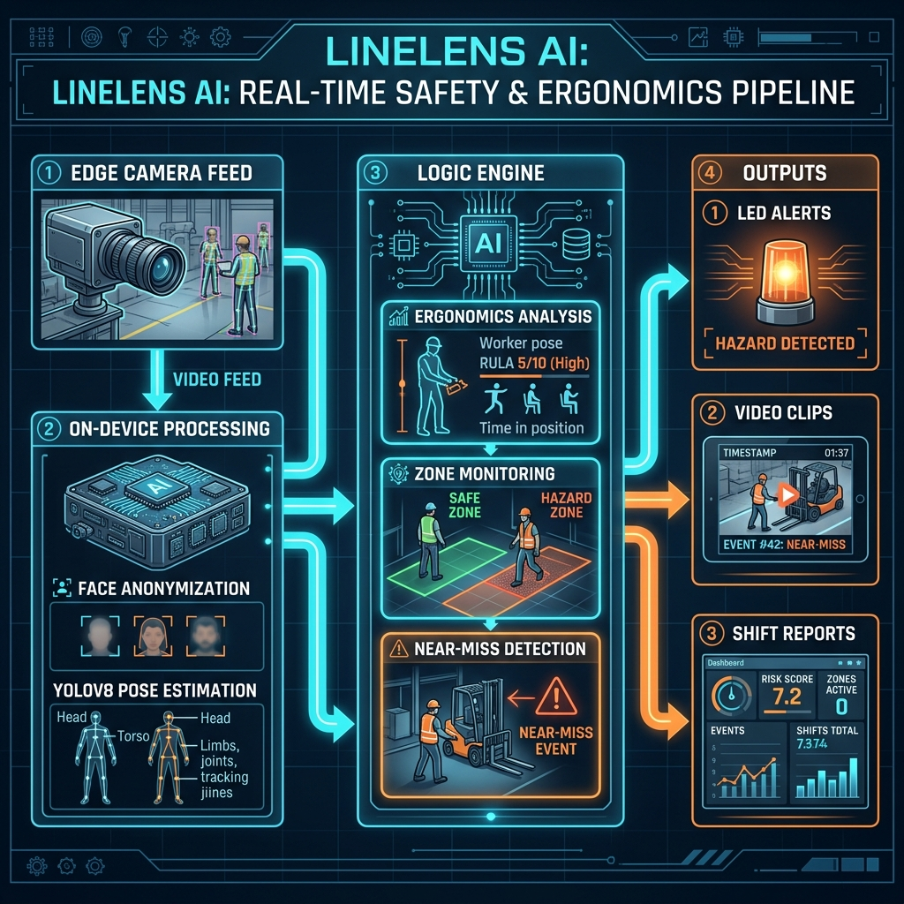

System Representation on Factory Floor
