Anthony Hsieh Hsie0015

Alex Praschifka Pras0075

Chuah Hui Ren Chua0142

Vincent Pezzaniti Pezz0009

Group report

Assignment 1 Phase 1

# Executive Summary

The group report encompasses every aspect of the development process that the group has followed through. The group worked together and established a communication system that allowed everyone to share information. Everything was agreed upon as a group and software tools were used accordingly.

Contents

Executive Summary 1

Introduction 3

Appendix A 4

Appendix B 5

Appendix C 6

# Introduction

The objective for this project is to provide a style guide for an existing website and analyse the resulting structure. Develop an information architecture diagram of the current website and provide further analyse of the changes of the structure suggested by the group. Our group decided to choose the Arkaroola website to analyse and create a style guide for. The accompanying software and decisions about the style guide are made by the group through discussion and agreements. The style guide is a representation of the current sites formatting, font selection and colour palette developed by downloading a template, and then editing the structure and style to the needs of the project. The accompanying Information architecture appendix will entail the changes that would be implemented into the site to improve user experience.

For the styleguide our group chose to follow the template, created by Sebastiano Guerrieroas for Codyhouse (“Style Guide Template in CSS | CodyHouse,” 2014). The group decided to use the template as it fit closely to the components that we needed to represent for our proposed Arkaroola site. The Arkaroola site is relatively simple, so it is easier to fit it into the template, rather than creating a styleguide from scratch. The structure of the styleguide is created by editing the HTML (Hyper Text Markup Language), and the style by editing the SASS (Syntactically Awesome Style Sheets) files. These files are edited on the Oracle Virtual Machine, as this allows for an easier setup, and easier cleanup after the project is finished. The site is then hosted on an NginX webserver.

Our group agreed on using Facebook, FLO Forums and emails as the main source of communication between group members. Our initial contact was made through the university email system, where we organised our first group meeting to be held. When the group met up and had a discussion on which medium to use as our primary method of communication we agreed on Facebook to be our communication method. We created a group on Facebook and contacted each other on Facebook if any problems arose.

We as individuals were very independent group members and a group leader was never chosen for the purpose of leading the group and managing it. We assigned each other different roles according to our strengths and weaknesses and gave each other deadlines for each task that had to be met. Everyone agreed to this kind of management format and carried out their tasks according to due dates and tasks assigned. At no stages throughout the project did any group members object to any deadlines being placed on them. If there was a disagreement in dates then we as a group would find a work around that everyone agreed upon before writing it down.

Code sharing wasn’t present in this group due to our timetable clashes and time limitations. We opted for a standard approach and gave the development work to two members of the group which contacted each other with Facebook and email. These two group members worked through the style guide element of the project without the use of any code sharing programs. They relied entirely on group meetings and cooperative working times together to finalise the style guide for the group.

Additional software used to develop our style guide includes text editors such as Nano and Notepad++. It was chosen to use these text editors, rather than Integrated Development Environments, as this is a small site with only a few files to edit. Making quick changes to the site, opening and closing the editor, was much faster than I would have been with an IDE. Some components of the styleguide were tested written on Notepad++ and tested on the local machine, before being added to the full site on the virtual machine through Nano. The template also uses Bourbon, a mixin library, as an addition to SASS. The Javascript plugin “Fount” was used to identify fonts on websites that the group found well-made, as well as the site “Color Combos” to identify colour specific colours.

The chosen template makes use of two Javascript libraries: jQuery and Modernizr. Modernizr works to detect which features a user’s browser is running, and then adjust the site accordingly. Modernizr will disable features of a website that the client’s browser is not capable of running.

The template also uses jQuery for event handling, AJAX interactions and easier HTML document traversing.

# Appendix A

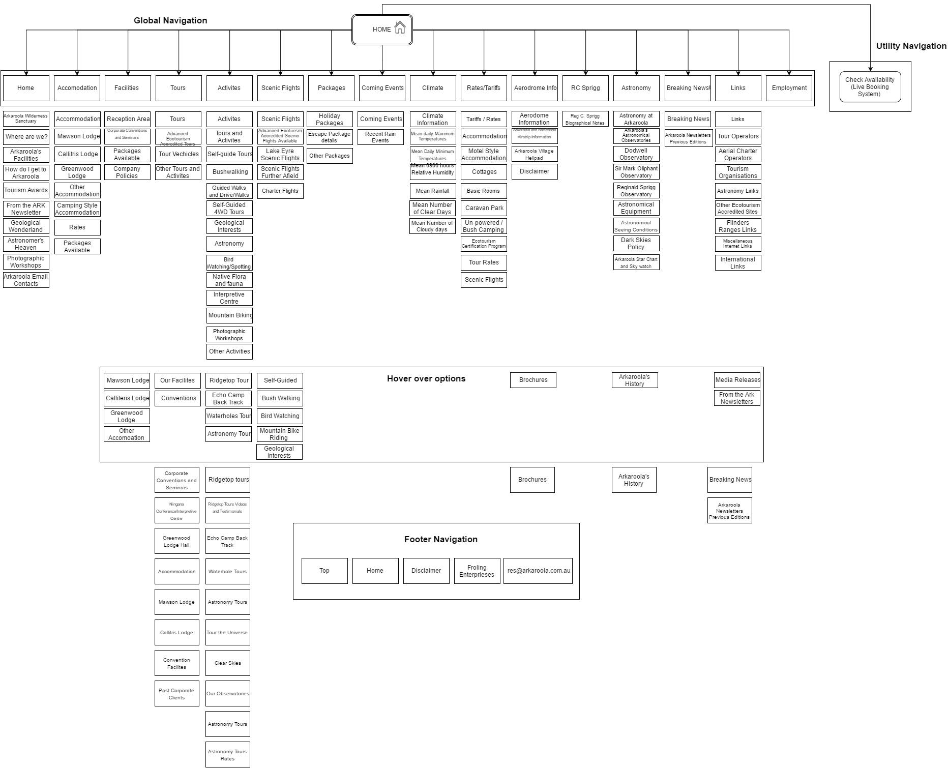

**Diagram 1: Original system architecture of Arkroola Website**

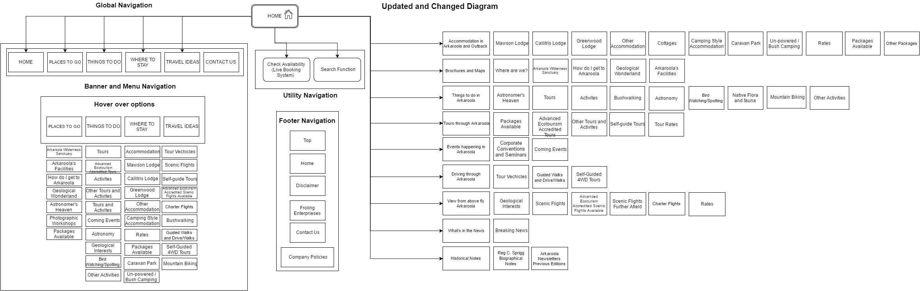

**Diagram 2: Changes that we made for Arkroola website**

**Information architecture**

Information architecture is important that web design is very difficult to design and it helps to reduce the cost of productivity of a company. Furthermore, not only usability of the website is important, information architecture can help to determine the success of a website. Users tend to focus more on the task that can be done on a website but not the structure of the website. But if the users study about the structure of the website they would have the knowledge of improving tasks that can be done to a website. Information architecture is defined as a structural information of a space to help task completion and access to content, also helping to manage information of a website. (Rosenfeld and Morville, 2002)

Information architecture components includes eight different principles. Firstly, principle of objects which means content should keep improving as it needs to have a lifecycle. As in every content have to have its own special attributes and functions, but in order to utilize those contents it is better to be recognize and also guide the users. For example, it was better that listing out all the content types and how they relate to each other which can help to provide information of the site.

Principle of choices which means offer user useful choices and focus for being specific instead of including too much complicated content which overwhelm and negatively affect the user experience. Categorizing and subcategorizing is helpful to manage the contents and also avoid long list of options. Additionally, principle of disclosure stated that it is important to give useful information for the user. The information of the user must be including their needs only but not more than that and also need to meet the user’s expectation when they access the content. Therefore, the solution is to limit the content that is shown to the user so that they can absorb the information by not overloading them. For example, use tools to guide users to the information they needed and make them feel easy and accessible.

Principles of exemplars is use to describe an example of a category information for the user to understand which leads to improving user experience. Besides that, principles of front doors described that most of the user will enter the home page most of the time which means every page needs to provide basic information of the webpage and also top level navigation. Users will not stay long on a website if they could not find information that they search. Major sites that users might access first will normally come from a link directly from social media or search engine. Therefore, major sites must give clear and direct information for the user. Principle of multiple classification describes that people use different methods to find information on the website. For example, some users need to search a product and also search a particular price range by giving them multiple options. In addition, principle of focused navigation helps user navigate to a particular content with ease and also classified clearly. Lastly, principle of growth describes that a website need to be fluid and the navigation at the menu needs to future proof to fit in more contents without redesigning the whole structure of the website or making new extensions. The key of this principle is to create a strategic and effective information structure that needs early planning throughout the beginning and later phase of the website development project. (“The ultimate guide to information architecture,” n.d.)

In Diagram 1, the first changes that we have had made was the global navigation was filled with too much content which confuse and not directly link to the needs of a user which relate to principle of choices and principle of objects. The global navigation system of the original website shown in diagram 1 have the same amount of content at the top navigation and the side navigation which makes the website very clunky and messy with too much contents. As our solution, we simplify the top navigation from 16 different navigations to only 6 navigations which categorize the content specifically with categorizing and subcategorizing information. By applying the principle of disclosure, comparing diagram 1 and diagram 2 we reduce the contents to a reasonable amount that we only provide useful and direct contents for the user by removing unnecessary contents such as climate and aerodrome info. Therefore, the user can access the information they needed with ease. Besides that, we also change the wordings of the top navigation to places to go, things to do, where to stay, contact details and contact us which fits the principle of front doors that it describes the information clearly on the main page to lead the user to access which content they wanted to do by using simple description like “things to do” instead of complicated names of activity. In Diagram 2, we also included a search function that help the user to access the content they search.

# Appendix B

The accompanying code for our style guide can be found within the zip file.

**PLEASE ZIP EVERYTHING UP TOGETHER AND HAND EVERYTHING AS A ZIP FILE**

# Appendix C

Styleguide Template:  
Sebastiano Guerriero. 2014. Codyhouse. [ONLINE] Available at: https://codyhouse.co/gem/css-style-guide-template/. [Accessed 23 September 2016].

Fount – Font Identifier:  
Art Equals Work. n.d. Fount - Identify any web font you see. [ONLINE] Available at: https://fount.artequalswork.com/. [Accessed 23 September 2016].

Color Combos – Color Identifier:  
Grab Website Colors - Color Scheme Extraction Tool [WWW Document], n.d. URL http://www.colorcombos.com/grabcolors.html (accessed 9.23.16).

CSS Dropdown menus:  
CSS Dropdowns [WWW Document], n.d. URL http://www.w3schools.com/css/css_dropdowns.asp (accessed 9.23.16).

Code box template:  
html - Creating “Programming Code Box” on my website w/ xhtml/css? - Stack Overflow [WWW Document], April 2011, URL http://stackoverflow.com/questions/5793214/creating-programming-code-box-on-my-website-w-xhtml-css (accessed 9.23.16).

Search bar template:  
How To Make an Animated Search Form [WWW Document], n.d. URL http://www.w3schools.com/howto/howto_css_animated_search.asp (accessed 9.23.16).

Information Architecture:

Rosenfeld, L., Morville, P., 2002. Information Architecture for the World Wide Web. O’Reilly Media, Inc.

The ultimate guide to information architecture, n.d. . Webdesigner Depot.

**PLEASE ADD YOUR OWN REFERENCE ITEMS TO THE LIST FORMAT AS HARVARD REFERENCING STYLE**