The report contains the following:

1. **Overview** of the analysis: This report is created on the performance of the deep learning model created for Alphabet Soup dataset.

The nonprofit foundation Alphabet Soup wants a tool that can help it select the applicants for funding with the best chance of success in their ventures. With your knowledge of machine learning and neural networks, you’ll use the features in the provided dataset to create a binary classifier that can predict whether applicants will be successful if funded by Alphabet Soup.

From Alphabet Soup’s business team, you have received a CSV containing more than 34,000 organizations that have received funding from Alphabet Soup over the years. Within this dataset are a number of columns that capture metadata about each organization

1. **Results**:

* Data Preprocessing
  + What variable(s) are the target(s) for your model?

The Target variable is ‘IS_SUCCESSFUL’, a flag to indicate whether participants were successful in their funding from Alphabet Soup.

* + What variable(s) are the features for your model?

APPLICATION_TYPE

AFFILIATION

CLASSIFICATION

USE_CASE

ORGANIZATION

STATUS

INCOME

SPECIAL CONSIDERATIONS

ASK_AMT

* + What variable(s) should be removed from the input data because they are neither targets nor features?

The EIN and NAME variables were removed since they were not features for the model.

* Compiling, Training, and Evaluating the Model
  + How many neurons, layers, and activation functions did you select for your neural network model, and why?

There were three layers of total for each model after applying Neural Networks. The number of hidden nodes were dictated by the number of features.

* + Were you able to achieve the target model performance?

890 parameters were created by a three-layer training model. The first attempt was just over 73% accuracy.

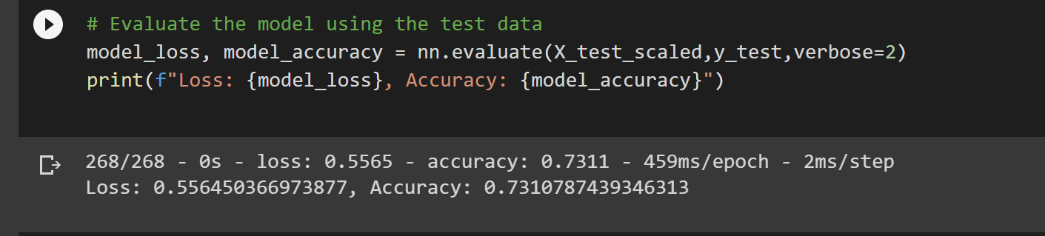

* + What steps did you take in your attempts to increase model performance?

Optimization : Another attempt was made to do the optimization with the NAME column in the dataset. Achieved an accuracy of around 79%. This is 4% over than target 75% with 3,298 parameters.

1. **Summary**: Using multiple layers during deep learning can fine tune the model which in turn can help predict and classify data more accurately.