

**Fall 2016**

CMPE 277 – Smartphone App Development

**Activity Life Cycle**

**Instructor:**

**Chandrasekar Vuppalapati**

**Submission Date** **Submitted By**

September 18, 2016 Son Thai

When Application get started, after the activity A is created, it starts and resumes. Then Activity A comes to foreground. The thread counter is 1.

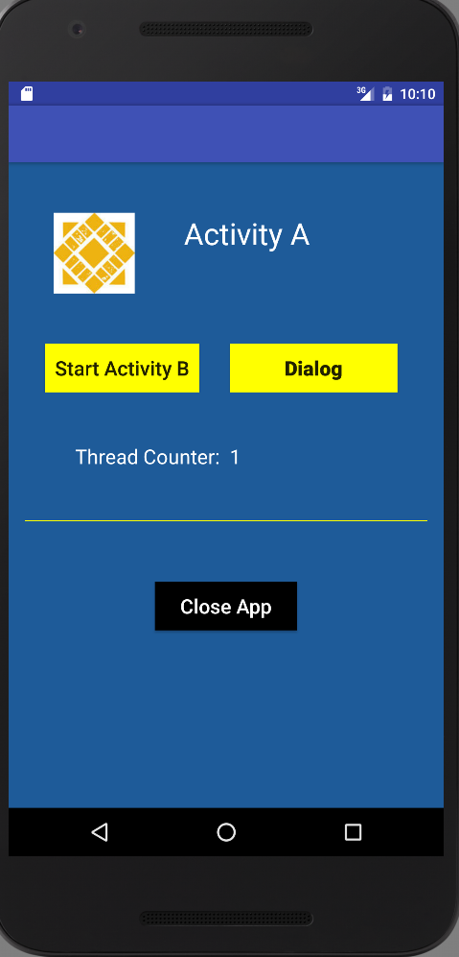

Clicking on Start Activity B button, the Activity A will be paused, stopped and pushed to background. After clicking on Finish B button, Activity B will be destroyed and Activity A will start, resume, and come to foreground. Therefore, thread counter is 2.

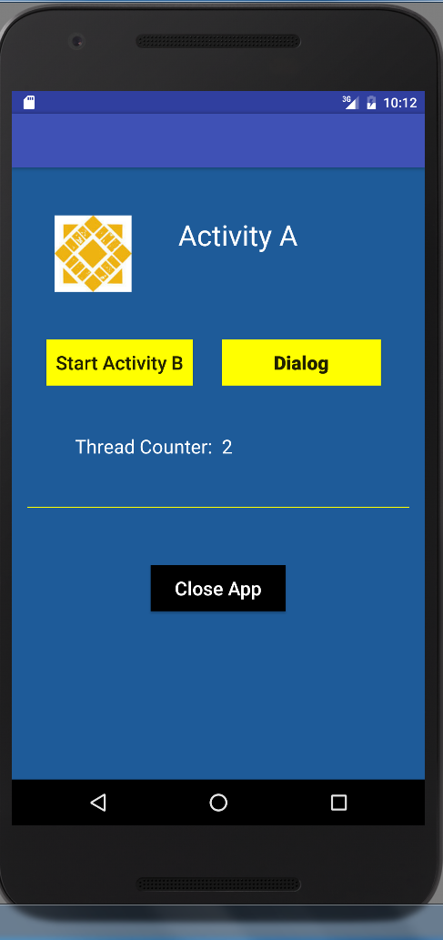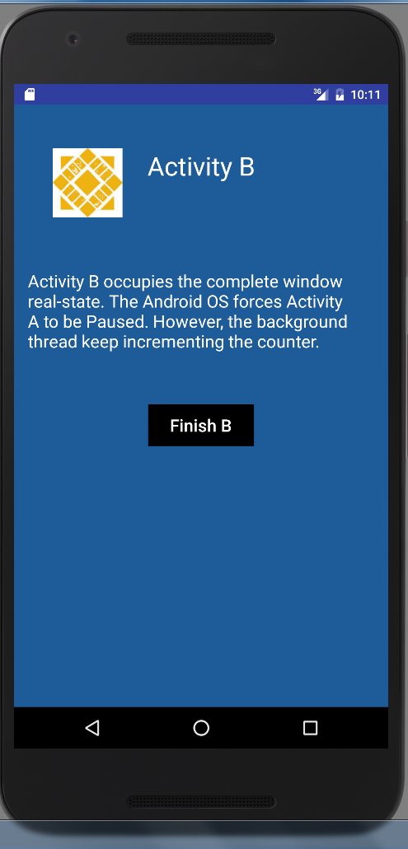

Clicking on Dialog Button, there will be a Dialog popping up.

* If the Dialog is an Activity implemented, then Activity A will be paused and pushed to the background, and Dialog Activity will be on the top of Activity stack. After clicking on Close Button on the Dialog, Activity A will start, resume, and come to foreground. The thread counter will be incremented by 1 (which will be 3).
* If the Dialog is not an Activity implemented, then the Dialog will stay on the top of Activity A, but Activity A will not be paused, stopped, it will not be pushed into background. Instead, Activity A will still stay in foreground. Therefore, when clicking on Close Button on Dialog, the thread counter will not be incremented (which will still be 2) since there is not switch between background to foreground of Activity A.

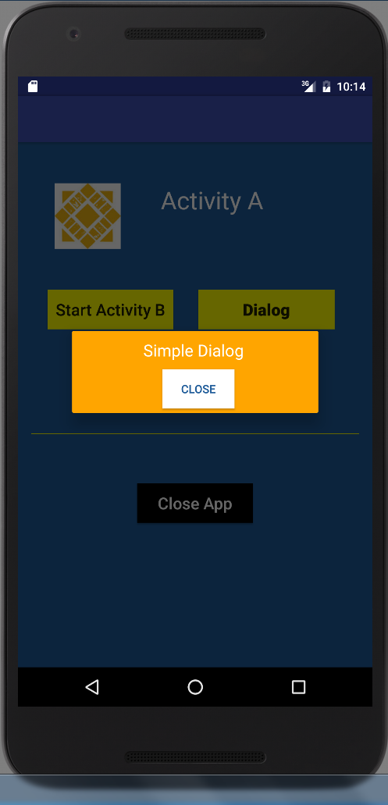

When clicking the back button, the Activity A will be paused, stopped, and pushed into background. When clicking on the Application again, Activity A will start, resume, and come to foreground. Therefore, thread counter will be incremented to 3.

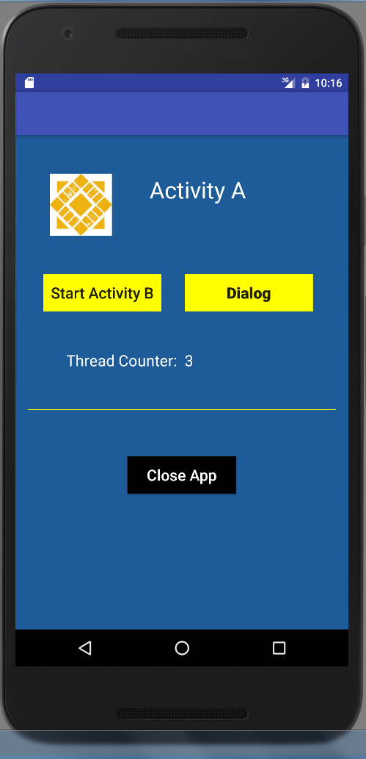

When clicking on Close App Button, Activity A will be paused, stopped, and destroyed. When user opens open the App again, the Activity will be created, and it starts, and resumes again. The thread counter will be 1.

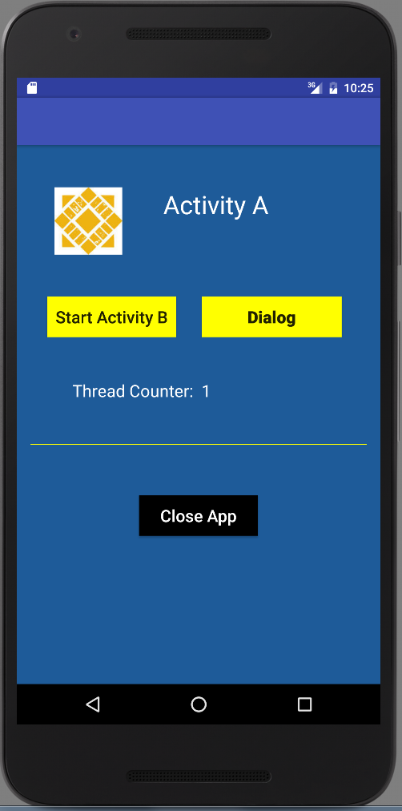

Open as many as application, and push Activity Life Cycle to the bottom of application Stack. Let the application be there for a while, the application will get killed. Open the application again, the Activity A will get re-created. The Activity A will start and the thread counter will be initialized to 0. Before the Activity A resumes, the onRestoreInstanceState() will get called and reload the value of thread counter which get saved when it was stopped and pushed to the background. When the Activity A resumes and comes to foreground, the thread counter will be incremented to 2.

