

**Fall 2016**

CMPE 277 – Smartphone App Development

**Implicit Intents**

**Instructor:**

**Chandrasekar Vuppalapati**

**Submission Date** **Submitted By**

September 20, 2016 Son Thai

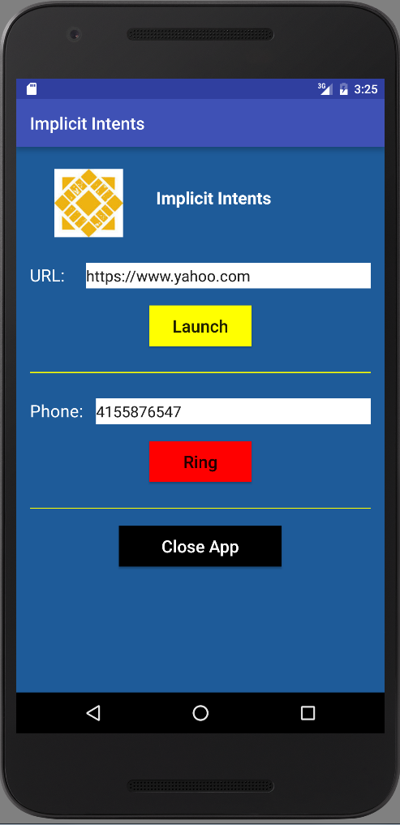

When user clicks on the “Launch” button, a dialog will be popped up asking user to choose which browser to open. After user chooses which browser to open, a browser will open with the url in the edit text field.

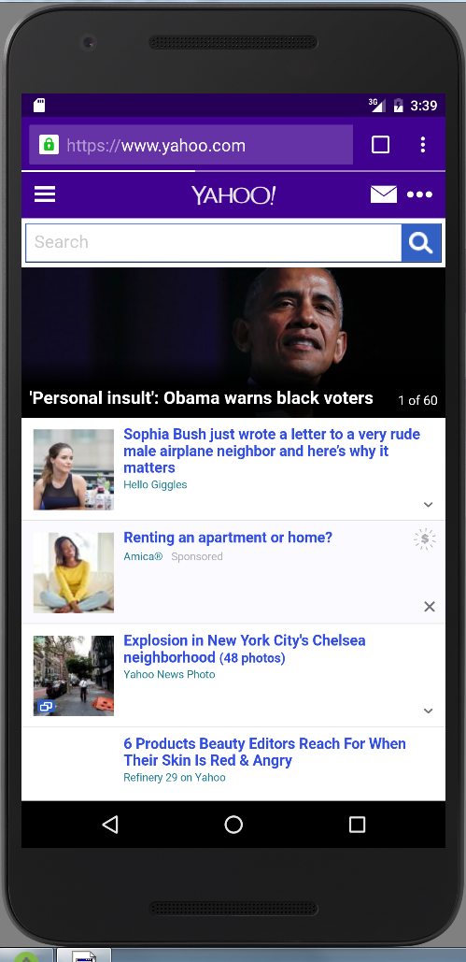

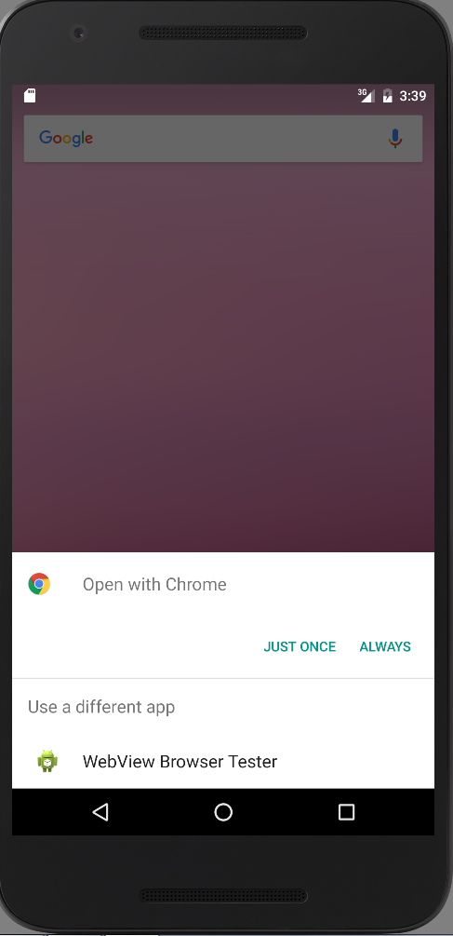

When user clicks on “Ring” button, an activity will pop up, then user can click on the call button.

