

**Fall 2016**

CMPE 277 – Smartphone App Development

**Farm IoT App (Broadcast Receiver)**

**Instructor:**

**Chandrasekar Vuppalapati**

**Submission Date** **Submitted By**

September 22, 2016 Son Thai

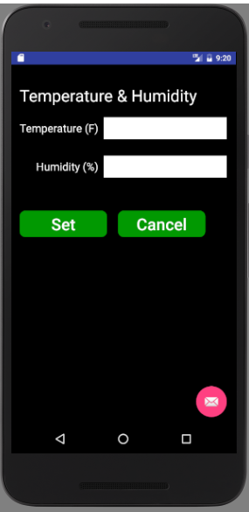

**Temperature and Humidity App UI**

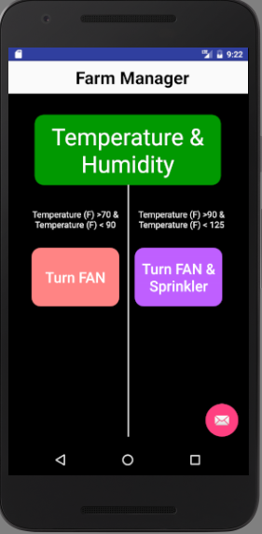

**Farm Manager App UI**

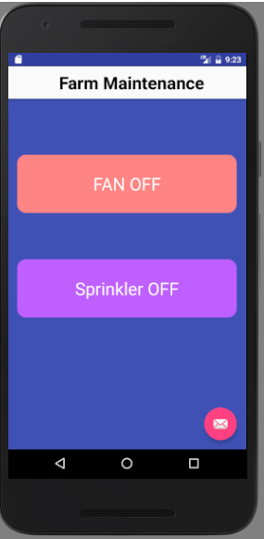

**Farm Maintenance App UI**

When user set the temperature on the Temperature and Humidity Application, it will set the flag in the intent, broadcast, and send the temperature and humidity information to Farm Manager Application.

On the receiver of Farm Manager Application, it will listen to the broadcast that is set in the intent filter. When it receives temperature data, depending on the temperature, it will decide either turn on fan or turn on both fan and sprinkler. Based on the temperature, the Farm Manager Application will set a flag in the intent and broadcast it.

On the receiver of Farm Maintenance Application, it will listen to the broadcast which contains the flag set in the Intent sent from Farm Manager Application. Depending on the flag set in the Intent, the text view on the application will display the state of the fan and sprinkler.

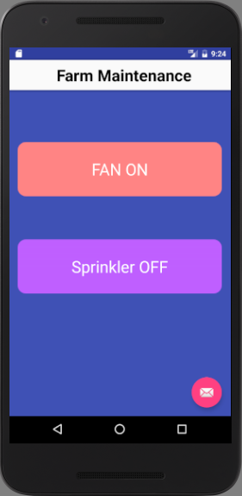

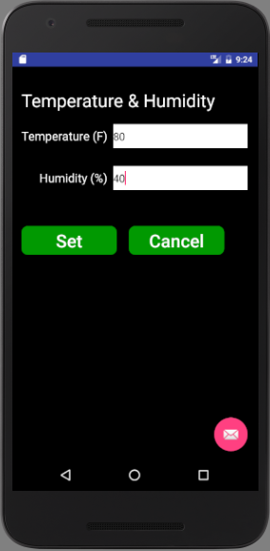

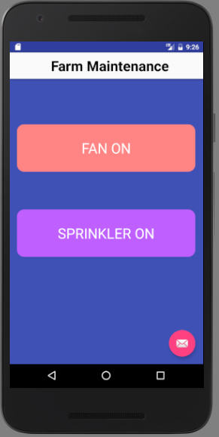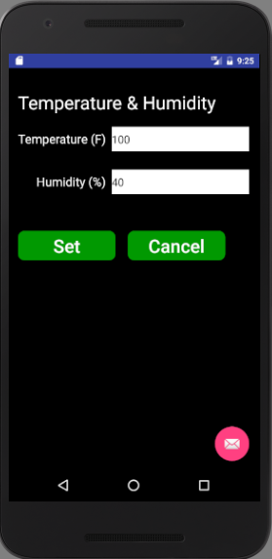

Also, user can use the Farm Manager Application to turn on/off fan and sprinkler and it will display fan and sprinkler state in the Farm Maintenance Application.

