

**Fall 2016**

CMPE 277 – Smartphone App Development

**Data Storage Application**

**Instructor:**

**Chandrasekar Vuppalapati**

**Submission Date** **Submitted By**

September 29, 2016 Son Thai

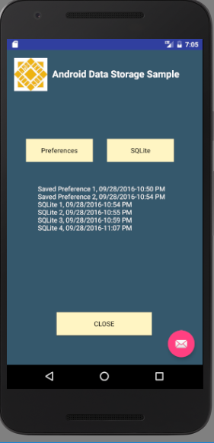

**Main Activity UI**

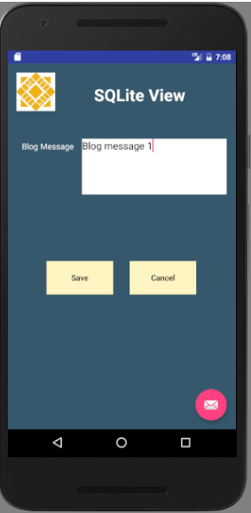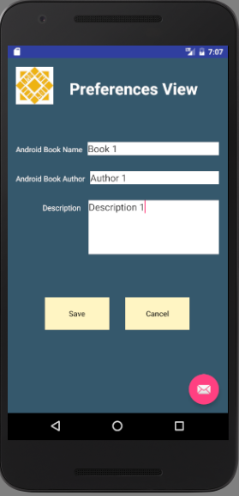

**Preference UI SQLite UI**

The below screen shows the code which the app uses to save the counter for number of time preference is saved in a local file using SharedPreferences.

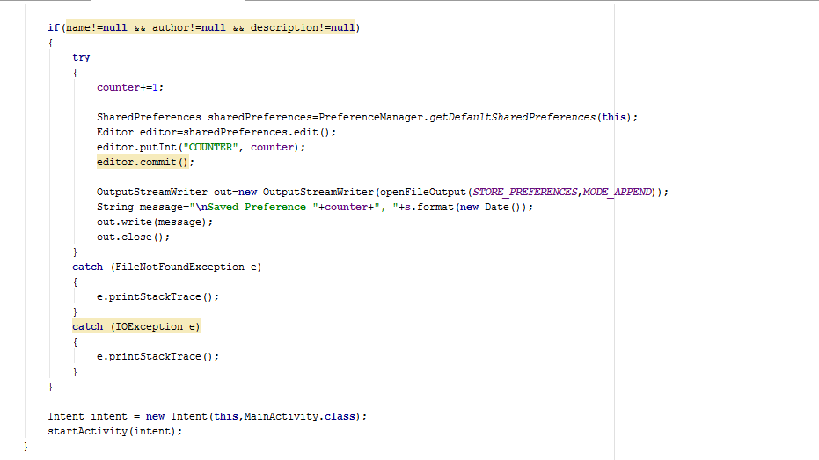

The below screen shows the code which the app uses to save data into the sqlite database and save the counter for data saved in sqlite in a local file, using SharedPreferences.

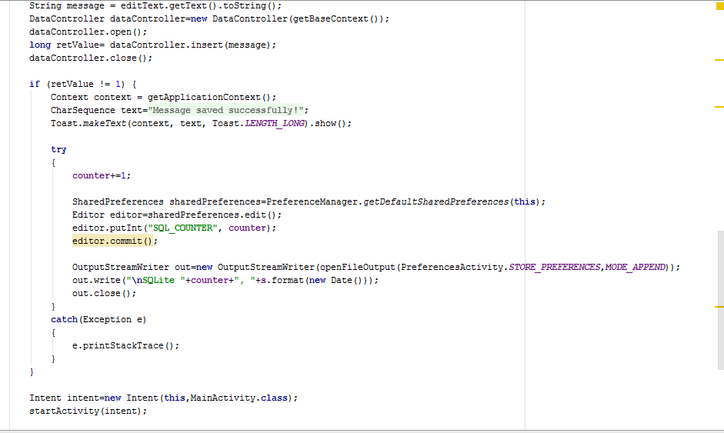

The code below is used to read data (counter) saved in the local file to display on the Main Activity UI.