

**Fall 2016**

CMPE 277 – Smartphone App Development

**Sevice App**

**Instructor:**

**Chandrasekar Vuppalapati**

**Submission Date** **Submitted By**

October 2, 2016 Son Thai

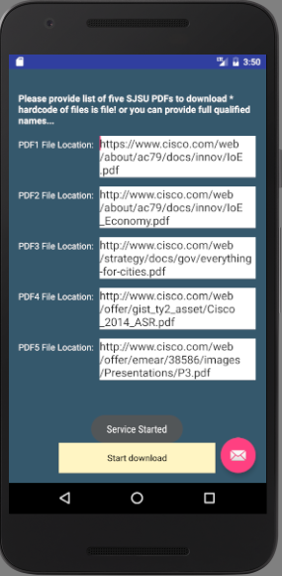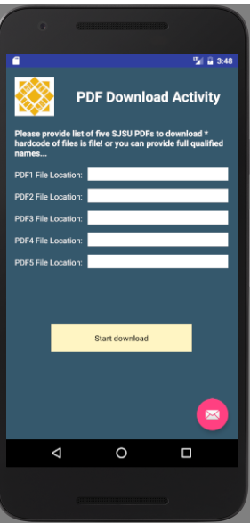

**Main Activity UI**

The screenshot show the service is running when the application is in frontground. The download is 20% and 40% done

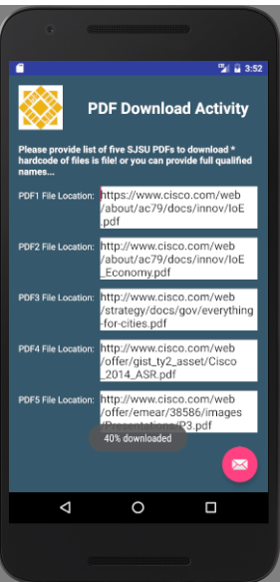

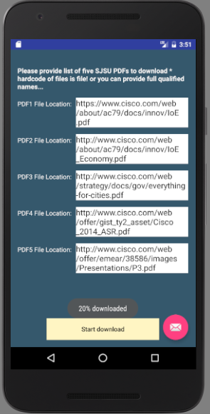

The screenshots show the service is still running and update the status though the application is in the background, and it keeps going until it finishes all the files.

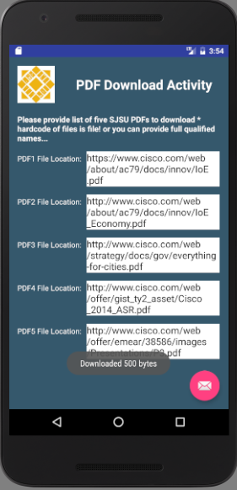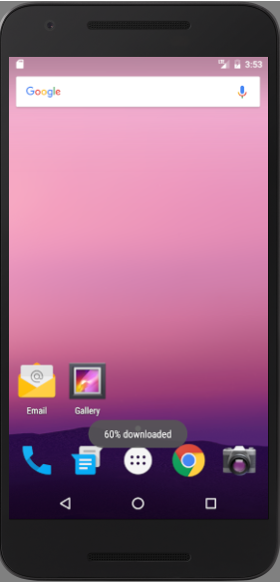

The code below is used to read data (counter) saved in the local file to display on the Main Activity UI.

The service gets destroyed when it’s done with downloading.

