

**Fall 2016**

CMPE 277 – Smartphone App Development

**Clap App**

**Instructor:**

**Chandrasekar Vuppalapati**

**Submission Date** **Submitted By**

October 8, 2016 Son Thai

When the app starts, it will show the image at the “far” location as in the screenshot.

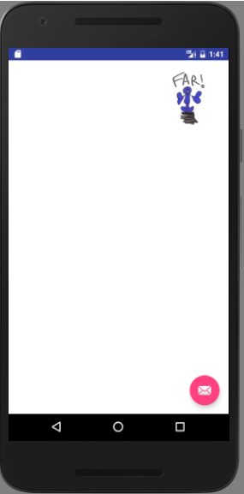

When I move the hand to close to the phone’s screen, the picture will move to “near” location since the Proximity sensor detect something close to the screen view.

