

**Fall 2016**

CMPE 297 – Special Topic

Archives vs. Keyed Archives

**Instructor:**

**Chandrasekar Vuppalapati**

**Submission Date** **Submitted By**

November 14, 2016 Son Thai

The screenshot shows that user can input the data, then save the data to archive

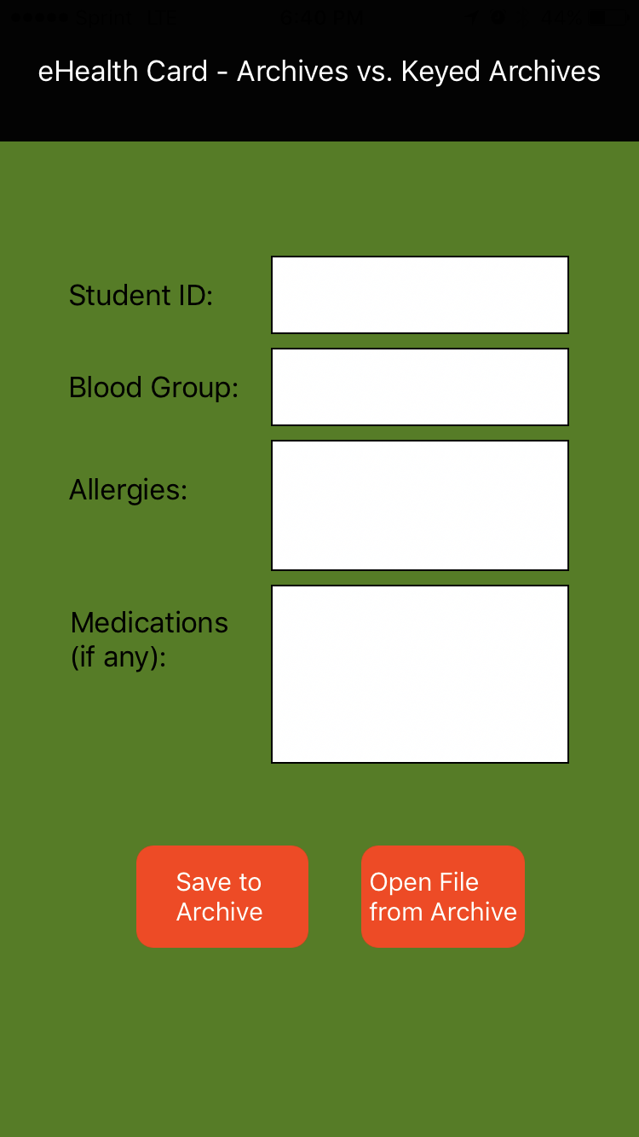

The screenshot shows data can be retrieved from Archive after user clicks on the button Open File from Archives

