

**Fall 2016**

CMPE 297 – Special Topic

File Storage

**Instructor:**

**Chandrasekar Vuppalapati**

**Submission Date** **Submitted By**

November 17, 2016 Son Thai

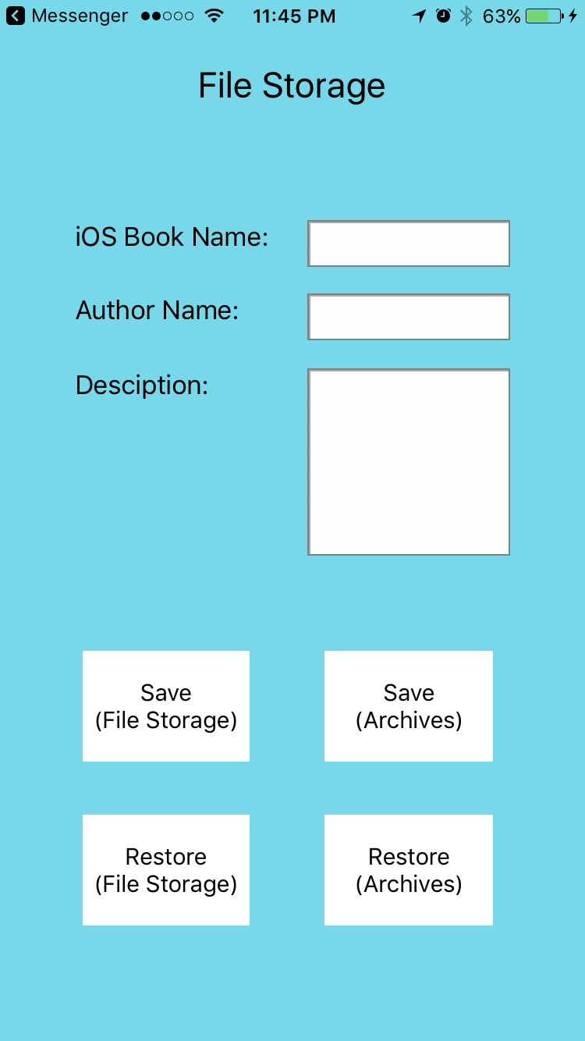

The screen shot shows data retrieved using Archiver.

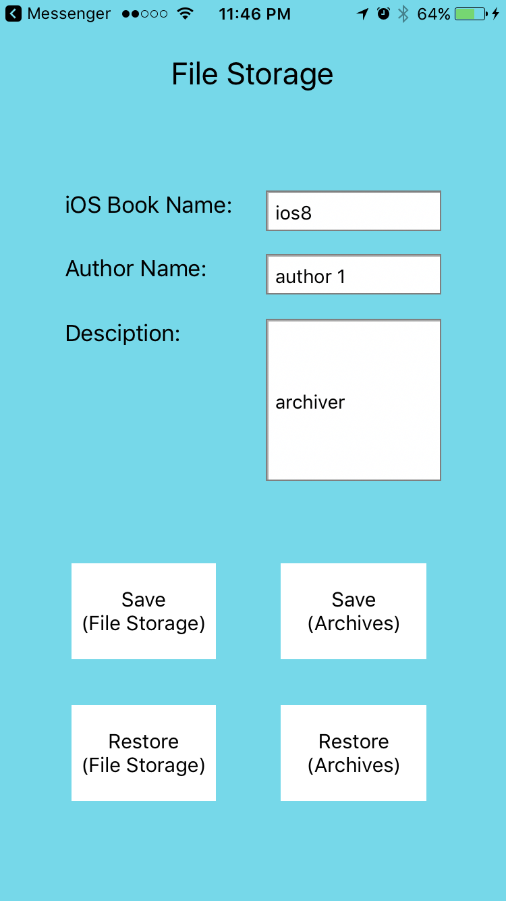

The screen shot show data retrieved using File Manager.

