

**Fall 2016**

CMPE 297 – Special Topic

Bluetooth

**Instructor:**

**Chandrasekar Vuppalapati**

**Submission Date** **Submitted By**

November 26, 2016 Son Thai

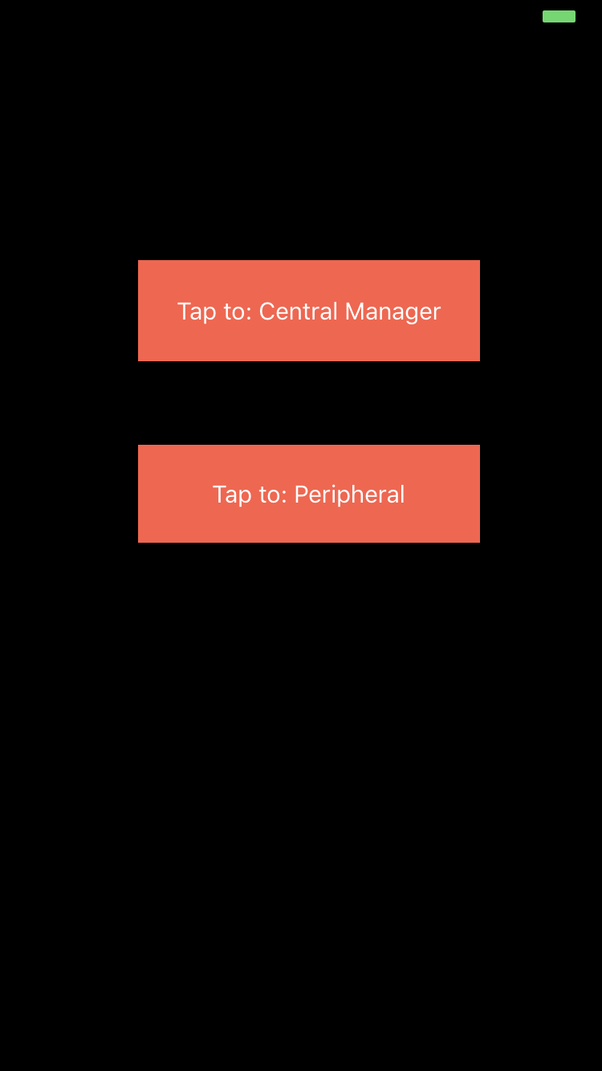

When user broadcasts message from peripheral, the message will be sent to central in other device via the Bluetooth.

