

**Fall 2016**

CMPE 297 – Special Topic

Hadoop

**Instructor:**

**Chandrasekar Vuppalapati**

**Submission Date** **Submitted By**

December 5, 2016 Son Thai

Install the Cloudera and set up cloudera manager

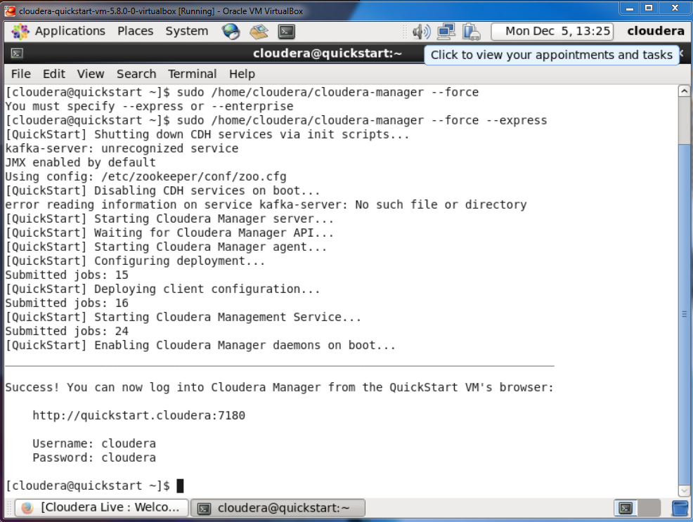

Start services

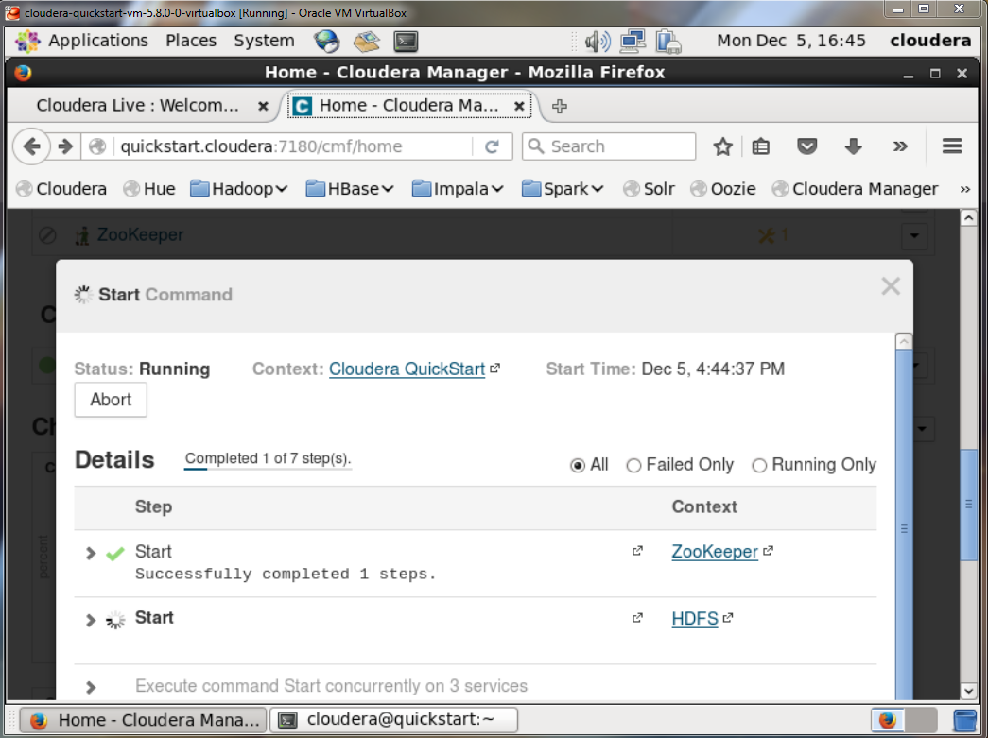

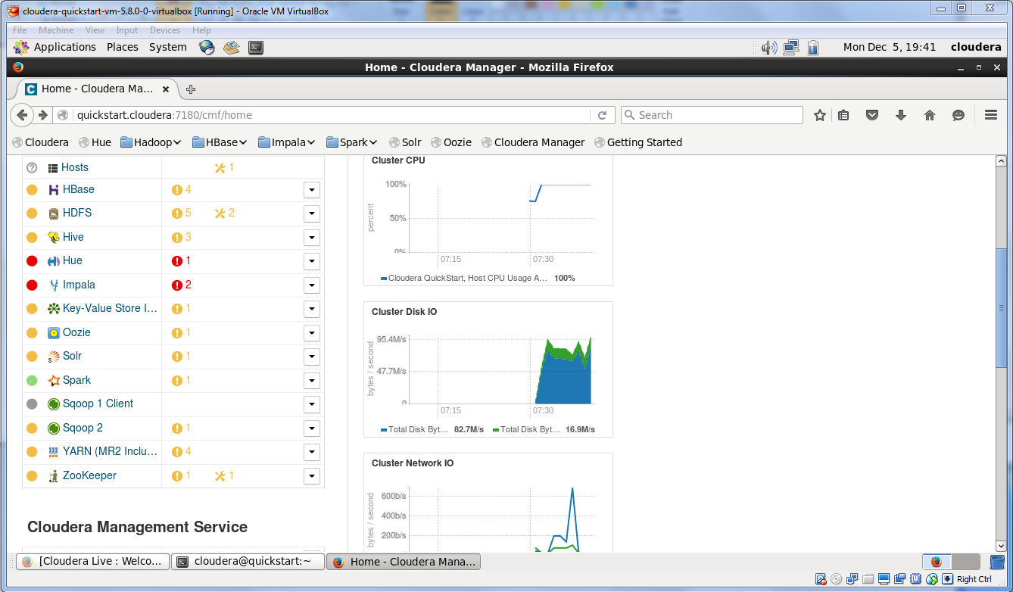

Start word count job

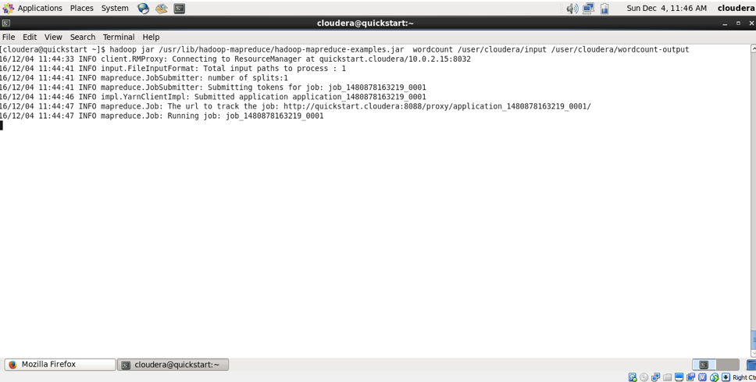

Word count service result

