**HO CHI MINH NATIONAL UNIVERSITY**

**INTERNATIONAL UNIVERSITY - SCHOOL OF INFORMATION TECHNOLOGY**

**FINAL REPORT**

BANK MANAGEMENT SYSTEM

Subject: **Object Oriented Programming**

Sem 1 (2020 - 2021)

**Group 13**

Ngo Thanh Son -ITITIU18106

**Contributions:**

* Ngo Thanh Son : Analyze and design ERD, UML class diagram, do the coding using Java, write the report, do the Powerpoint and present(all).

**Version control:**

Github: <https://github.com/sonthanhngo/BankManagement.git>

**Contents:**

Chapter 1 : Introduction 3

1. Why did we choose this topic? 3

2. Project specification 3

Chapter 2 : Workflow 4

I. Analyze requirements & Design ERD 4

1. Analyze requirements 4

2. Entity Relationship Diagram 4

3.UML class diagram 4

II. Create Java program 5

Chapter 3 : Demo 6

Chapter 4 : Conclusion 10

I. What we have done 10

II. Future improvements 10

III. What we have learned 10

Figure 1:ER diagram 4

Figure 2:UML class diagram 5

Figure 3: Account 6

Figure 4:Transaction 6

Figure 5:Login 7

Figure 6: Home page 8

Figure 7:Transaction screen 8

Figure 8:Transaction history 9

## Chapter 1 : Introduction

#### Why did we choose this topic?

All banks need to deal with information about there account, transaction. Doing it manually will take a lot of effort so it might be convenient if we could have an app to ease it. Also I have deep passion for finance so I think it’s great choosing this topic since it combine IT and finance.

#### Project specification

A bank contains of many Accounts. Each account is owned by one or many Users. It could be saving account, current account…. For each account it could have various of functionality. But in my app, I only considerate doing the current account since the time is limit. So basically the current account will have the main functionality is doing Transaction. It could be transact to another user, withdraw, deposit.

## Chapter 2 : Workflow

### I. Analyze requirements & Design ERD

#### Analyze requirements

Based on the project’s specification, the entities of the bank database will be: user, account, transaction. A department has a name and id, a student and an instructor have an id.

An user may have 1 or many account but an account is only belong to one and only one user

=> one to many relation

An account can perform 1 or many transaction but the transaction is only belong to one and only one account

=> one to many relation.

#### Entity Relationship Diagram

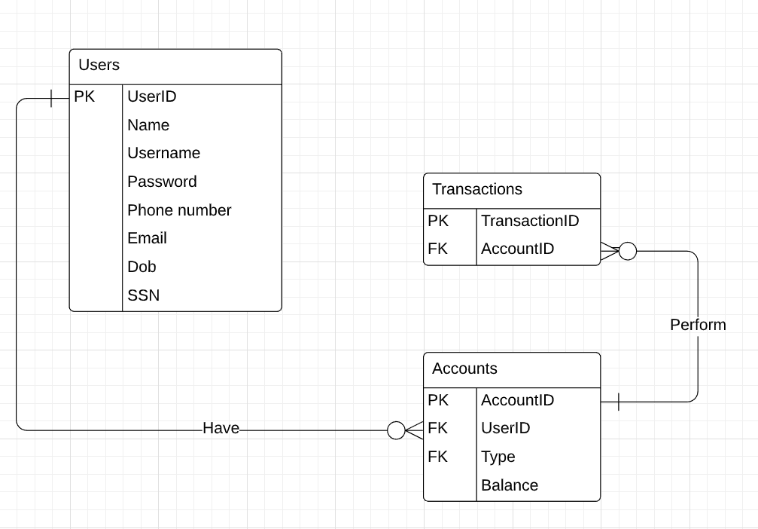

Figure 1:ER diagram

#### 3.UML class diagram

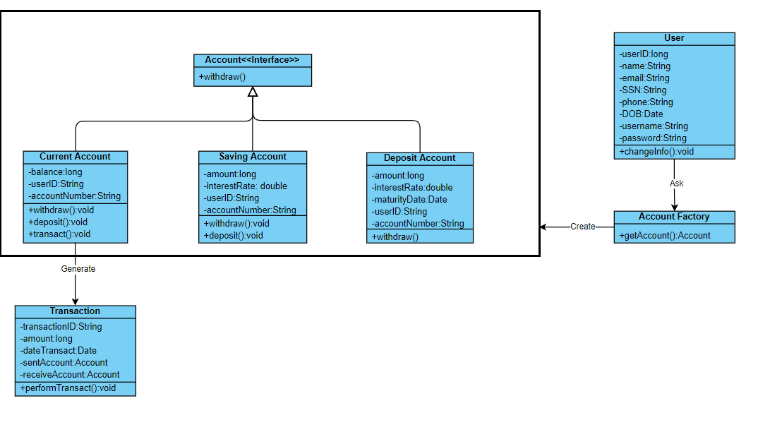

Figure 2:UML class diagram

### II. Create Java program

First of all we create major class such as Account, Transaction. They have fields that match with above UML class diagram.

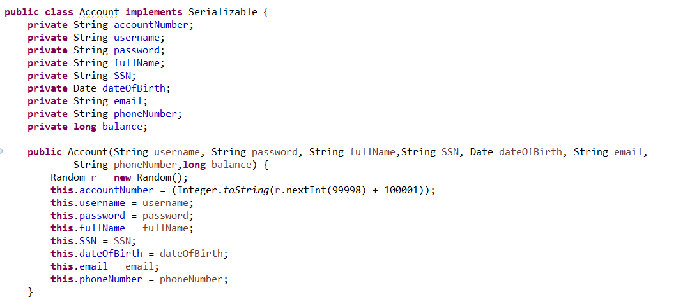

Figure 3: Account

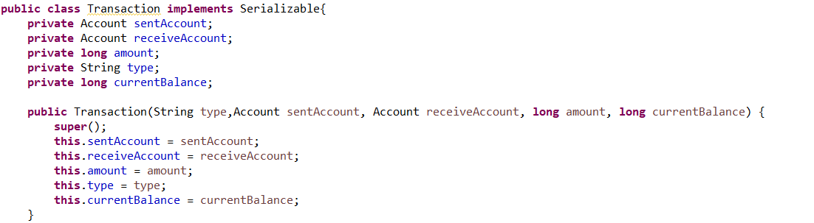

Figure 4:Transaction

Than we build the functionality and GUI, its pretty long and boring to capture all the code so I leave it for presentation

## Chapter 3 : Demo

This system enables user to register account to the bank, than user can transact to another user or withdraw or deposit their money.

Here is the login interface:



Figure 5:Login

They can log in as a user. All they need to access is to provide an username and password.

Here’s the index interface when you have access:

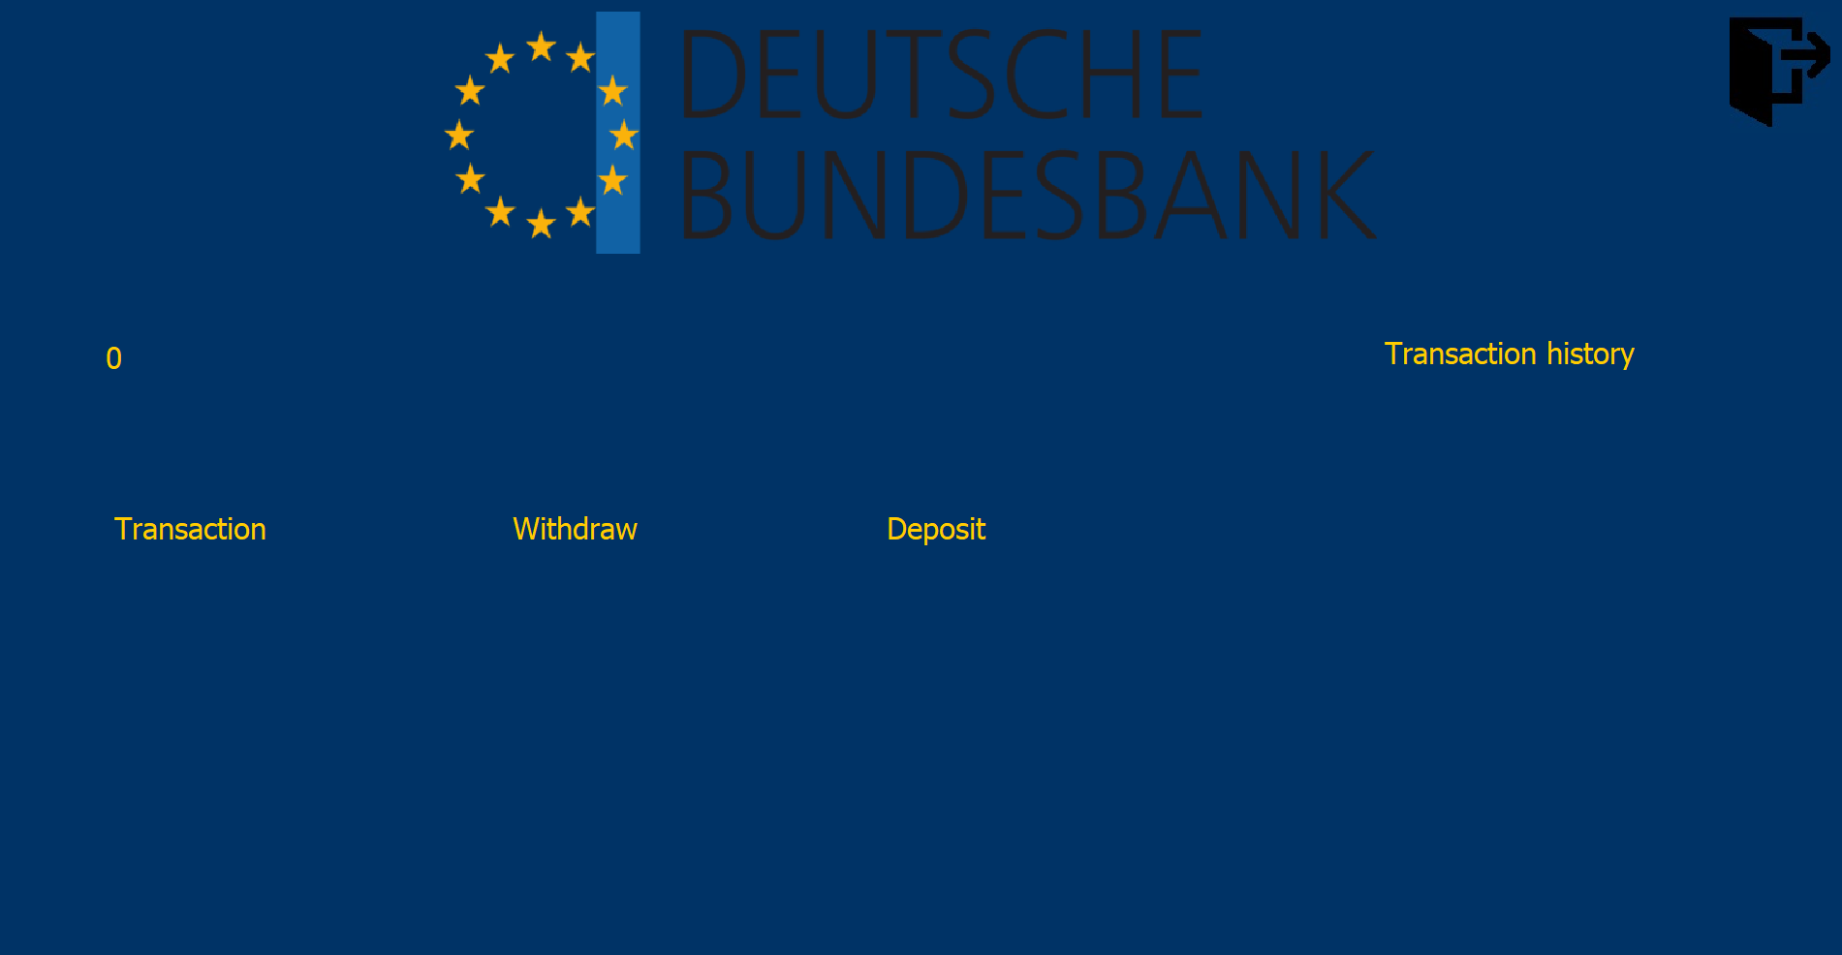

Figure 6: Home page

The user when logged in the system, he can deposit, withdraw or do the transaction to whom that he wants, and then press “Perform” to perform the transaction

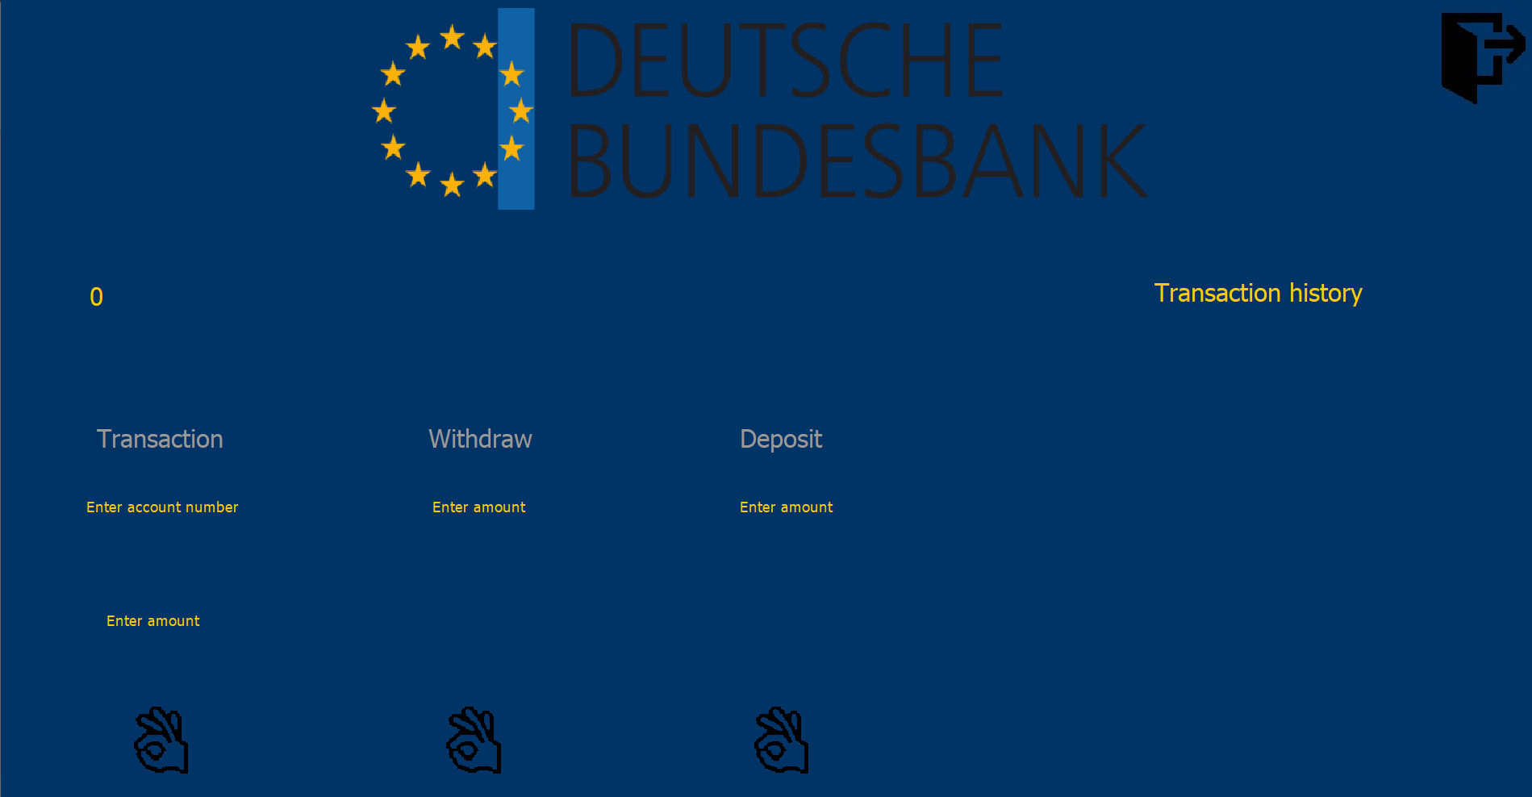

Figure 7:Transaction screen

This small area here is the place to display the recent transaction of your account.

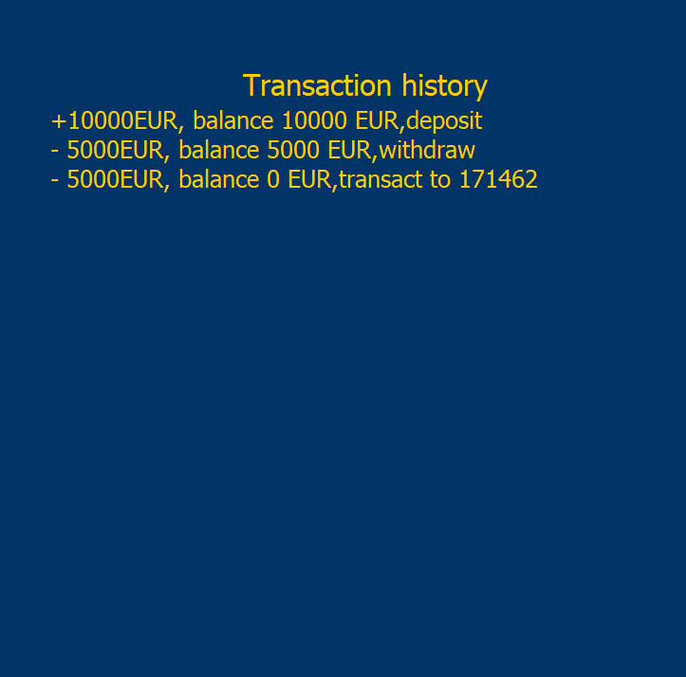

Figure 8:Transaction history

## Chapter 4 : Conclusion

### I. What we have done

* We have designed the ERD,UML class diagram through analyzing the requirements in the project’s specification
* We have built a Java program to provide the users an interface for easy interactions.

### II. Future improvements

* Our program still runs in local machines, we maybe develop it to be able to run remotely.
* There are some places in the program that are hard-coded, it is hard to fix the program since it could damage the whole code. I can improve it later.
* There are many missing functionality like actual program, like pay the bill.. I can fill in the gaps in the future.
* The passwords are not encrypted, anyone who has access to the database can steal them easily. I can add in the encryption later.

### III. What we have learned

* I have learned many solid things about building the app from scratch, learned how to deal with database, how to create GUI…
* We have learned about the bank management systems in general, how the entities interact with one another and what functionalities they need from our system.