# Adding Search to a Relational Database

We’re going to explore using Search technologies with a relational database, and compare it to SQL queries.

The relational database is [MusicBrainz](https://musicbrainz.org/), an open encyclopedia of music metadata, with information on much music currently available, over 23 million tracks. Like most relational databases, its information is organized in normalized tables:

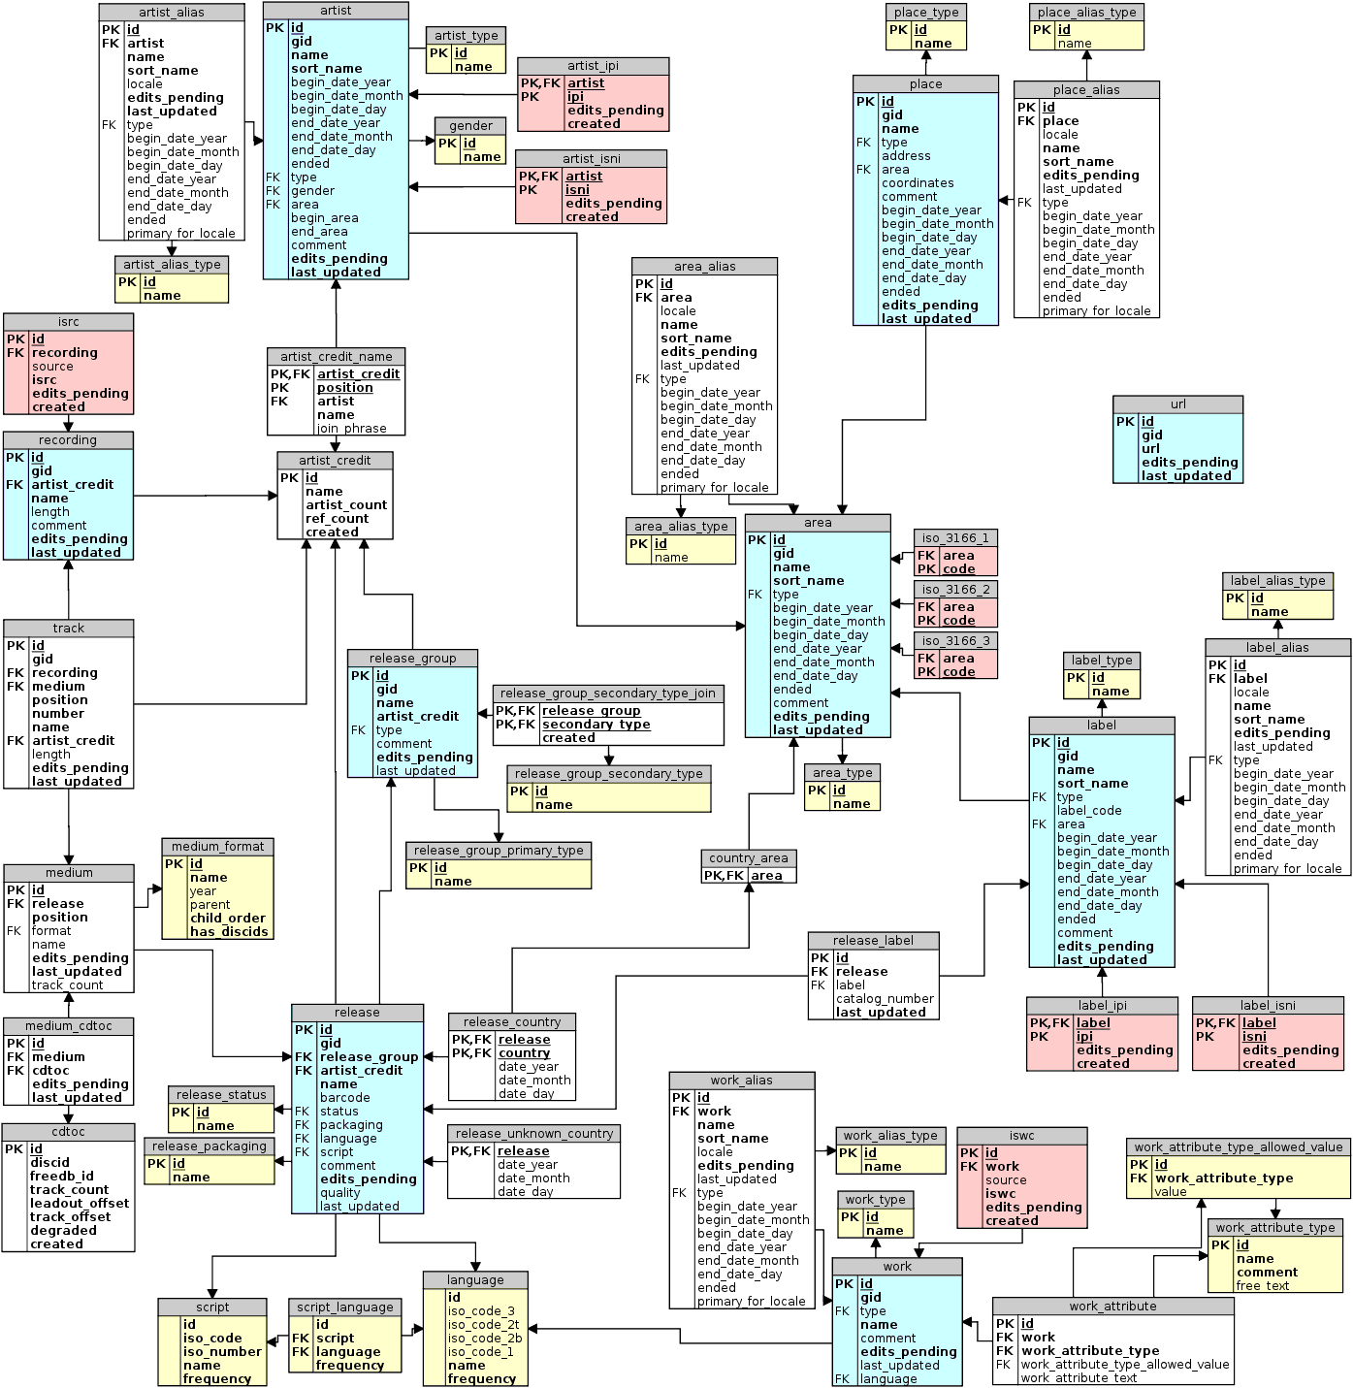

We’ll be using a copy of this database implemented in RDS PostgreSQL.

All user-created environments in this lab are eligible for [AWS Free Tier](https://aws.amazon.com/free/). If you are not eligible for Free Tier, the environment used will generate a charge of approximately US$0.03 per hour.

## Step 1: Create an Amazon Elasticsearch Service Domain

* Using a web browser, login to the **AWS Console** at <https://aws.amazon.com/>
* Chose the **Elasticsearch Service**
* Choose the region you will use for this lab (the database cluster is located in us-west-2 [Oregon]), but you can use any AWS commercial region
* Click **Create a new domain**
* Give the domain a name. **Choose Elasticsearch version 5.5** and click **Next**
* Set an **Instance count** of 1, **Instance type** of t2.small.elasticsearch, and leave all other settings at their default. Click **Next**
* Choose **Public access**. For Access policy, Select the **Allow open access to the domain** template, then acknowledge you accept the risk in the confirmation window. (Note that these are not advisable settings for production environments, but they are useful for a lab exercise.) Click **Next**
* Review the domain settings and click **Confirm**

## Step 2: Create an EC2 Instance

* Using a web browser, login to the **AWS Console** at <https://aws.amazon.com/>
* Be sure you are using the same region you used for the Elasticsearch domain
* Choose the **EC2** service, then **Launch Instance**
* Select the **Ubuntu Server 16.04 LTS (HVM), SSD Volume Type** AMI
* Select a general purpose t2.micro instance type, then click **Next**
* Leave the default Instance Details and click **Next**
* Use the default Storage and click **Next**
* Leave the Tags blank and click **Next**
* Use the default Storage and click **Next**
* Configure a Security Group to allow access to PostgreSQL. Choose **Add Rule**, then select a **Type** of **PostgreSQL** and a **Source** of **Anywhere**. (Note that these are not advisable settings for production environments, but they are useful for a lab exercise.) Click **Review and Launch**
* Review your settings, ignore the warning that your security group is open to the world. Click **Launch**
* Select or create a keypair. If you are creating a new keypair, be sure to download the .pem file. Check the box to acknowledge you have access to the private key file (.pem) and click **Launch Instance**

## Step 3: Install PostgreSQL and Python tools

* From the **AWS Console**, choose the **EC2** service. Click **Running instances**, then select the instance you created in Step 2. Note the **Public DNS** of your instance.
* Login to your EC2 instance
  + If you have a terminal application (such as Mac Terminal or Linux XTerm), connect with an ssh command:  
      
    ssh –i <your keyfile.pem> ubuntu@<your EC2 public DNS>
  + If you are using Microsoft Windows and don’t already have a terminal application, use PuTTY following the instructions at <http://docs.aws.amazon.com/AWSEC2/latest/UserGuide/putty.html>
* From your Linux terminal, install PostgreSQL and Python tools and update your server software

sudo add-apt-repository "deb http://apt.postgresql.org/pub/repos/apt/ xenial-pgdg main"

wget --quiet -O - https://www.postgresql.org/media/keys/ACCC4CF8.asc | sudo apt-key add -

sudo apt-get update

sudo apt-get install postgresql-9.6 postgresql-server-dev-9.6 postgresql-contrib-9.6

sudo apt install python python-psycopg2

sudo apt upgrade

## Step 4: Connect to PostgreSQL Musicbrainz and run queries

* We’ll be using a copy of Musicbrainz hosted on RDS PostgreSQL:

Hostname: searchlab.cxpjiluhh0c9.us-west-2.rds.amazonaws.com

User name: musicbrainz

Password: musicbrainz

* From your Linux terminal, connect to the database

psql -h searchlab.cxpjiluhh0c9.us-west-2.rds.amazonaws.com -U musicbrainz

(see credentials above for the password)

* From the psql prompt in your Linux terminal, run some queries
  + To count the number of tracks in the database:

SELECT COUNT(*) FROM track;

* + To see recent releases from The Beatles:

SELECT track.name AS track, medium.name AS recording, artist_credit.name AS artist, release_country.date_year AS year, area.name AS country FROM (((((track INNER JOIN artist_credit ON track.artist_credit = artist_credit.id) INNER JOIN medium ON track.medium = medium.id)

INNER JOIN release ON medium.release = release.id)

INNER JOIN release_country ON release_country.release = release.id)

INNER JOIN area ON release_country.country = area.id)

WHERE release_country.date_year > 2016 AND artist_credit.name = 'The Beatles';

* + Explore the database, choosing other artists (perhaps using LIKE for a fuzzy search), date ranges, or other constraints
  + Export to a file all US tracks released after 2000 that are part of an album

\o tracks.txt

SELECT track.name AS track, medium.name AS recording, artist_credit.name AS artist, release_country.date_year AS year, area.name AS country

FROM (((((track INNER JOIN artist_credit ON track.artist_credit = artist_credit.id) INNER JOIN medium ON track.medium = medium.id)

INNER JOIN release ON medium.release = release.id)

INNER JOIN release_country ON release_country.release = release.id)

INNER JOIN area ON release_country.country = area.id)

WHERE release_country.date_year > 2000 AND medium.name <> '' AND area.name = 'United States';

* + Exit psql using CTRL-D
  + From the Linux prompt, verify that you have created the tracks.txt file

ls -lh tracks.txt

You should see a file of 170 – 200MB containing the results of your query.

## Step 5: Convert data to JSON and Ingest with Elasticsearch

* From your Linux terminal, run Python

python

* From the python prompt, convert the data in tracks.txt to JSON:

import csv

import json

f = open('tracks.txt','rU')

csv.register_dialect('piper', delimiter='|')

reader = csv.DictReader(f,dialect = 'piper',fieldnames = ("track","recording","artist","year","country"))

title = reader.fieldnames

csv_rows = []

for row in reader:

csv_rows.extend(['{"index": {"_index":"track", "_type":"track"}}'])

csv_rows.extend([{title[x]:row[title[x]] for x in range(len(title))}])

out = json.dumps(csv_rows)

out = out.replace(" ","")

out = out.replace("\\","")

out = out.strip('[]')

out = out.replace('"{"','\n{"')

out = out.replace('", {','\n{')

out = out.replace('"},','"}')

f = open('tracks.json','w')

f.write(out)

* Exit python using CTRL-D
* From the Linux prompt, verify that you have created the tracks.json file

ls -lh tracks.json

Since the conversion to JSON removed a lot of white space, tracks.json is much smaller than tracks.txt

* The first five lines of tracks.json are “junk” – header lines from the database query output. From the Linux prompt, remove them with:

sed '1,5d' tracks.json > tracks.tmp ; mv tracks.tmp tracks.json

* Amazon Elasticsearch Service limits bulk imports to 10MB. Since we have more data than that, we will need to split tracks.json into smaller files. From the Linux prompt, run:

mkdir tracks

cd tracks

split -l 80000 ../tracks.json

This will create a set of files that each have 80,000 lines, so the right size to ingest!

* From the AWS Console, choose the Elasticsearch Service and choose your domain. Copy your Elasticsearch **Endpoint** (note that this is a different URL than your Kibana link!)
* From the Linux prompt, run a batch to send each file to Elasticsearch:

for x in `ls`; do curl -s -XPOST 'https://<your Elasticsearch Service endpoint>/track/track/_bulk' --data-binary @$x; done

While this is running, go to the AWS Console for Elasticsearch Service. You’ll be able to see your Searchable Documents count increasing in the Dashboard.

## Step 6: Use Kibana to run searches

* From the AWS Console, choose the Elasticsearch Service and choose your domain. Click on the Kibana link to open a new browser tab.
* Since this is your first use of Kibana for your domain, you will need to perform some initial setup.
  + As the **search index**, enter **\*** (an asterisk)
  + As the **timeseries**, choose “None” from the drop-down menu
  + Click **Continue**
* On the menu panel on the left, choose **Discover**. Run some searches!
  + If you want to explore the JSON interface, choose **Dev Tools** to send queries through the RESTful console