**MSSQL Assignment**

**THÔNG TIN SINH VIÊN**

|  |  |
| --- | --- |
| **Mã số sinh viên:** | GC01081 |
| **Họ và tên:** | Trần Ngọc Sơn |
| **Lớp:** | GC1006 |
| **Mã Assignment** | DBM_Assignment01 |

**THIẾT KẾ CƠ SỞ DỮ LIỆU**

* Diagram

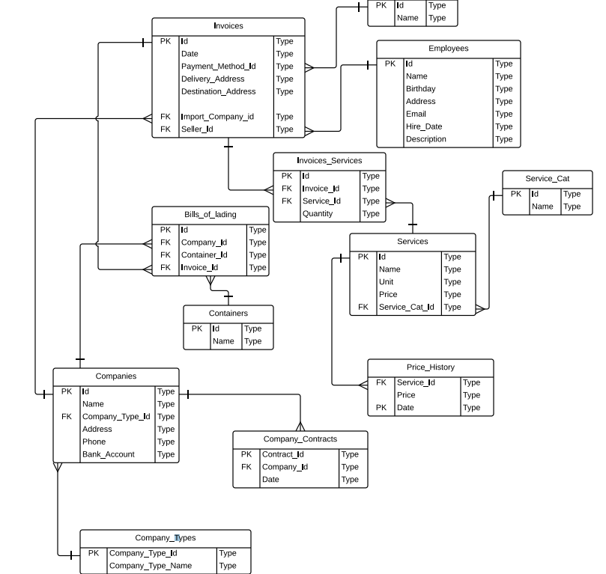

* Các bảng trong CSDL

|  |  |  |  |  |
| --- | --- | --- | --- | --- |
| Companies | | | | |
| Têntrường | **Kiểudữliệu** | **Kíchthước** | **Ràngbuộc** | **Ghichú** |
| Id | Varchar | 5 | PRIMARI KEY |  |
| Name | Varchar | 30 | NOT NULL |  |
| Address | Varchar | 100 |  |  |
| Phone | Varchar | 20 |  |  |
| Bank_Account | Varchar | 20 |  |  |
| Company_Type | Varchar | 5 | FOREIGN KEY |  |

|  |  |  |  |  |
| --- | --- | --- | --- | --- |
| Company_Types | | | | |
| Têntrường | **Kiểudữliệu** | **Kíchthước** | **Ràngbuộc** | **Ghichú** |
| Id | Varchar | 5 | PRIMARY KEY |  |
| Name | Varchar | 30 | NOT NULL |  |

|  |  |  |  |  |
| --- | --- | --- | --- | --- |
| Containers | | | | |
| Têntrường | **Kiểudữliệu** | **Kíchthước** | **Ràngbuộc** | **Ghichú** |
| Id | Varchar | 5 | PRIMARY KEY |  |
| Name | Varchar | 30 | NOT NULL |  |

|  |  |  |  |  |
| --- | --- | --- | --- | --- |
| Employees | | | | |
| Têntrường | **Kiểudữliệu** | **Kíchthước** | **Ràngbuộc** | **Ghichú** |
| Id | Varchar | 5 | PRIMARY KEY |  |
| Name | Varchar | 30 | NOT NULL |  |
| Birthday | Date |  |  |  |
| Address | Varchar | 100 |  |  |
| Email | Varchar | 100 |  |  |
| Hire_Date | Date |  |  |  |
| Description | Varchar | 200 |  |  |

|  |  |  |  |  |
| --- | --- | --- | --- | --- |
| Services | | | | |
| Têntrường | **Kiểudữliệu** | **Kíchthước** | **Ràngbuộc** | **Ghichú** |
| Id | Varchar | 5 | PRIMARY KEY |  |
| Name | Varchar | 30 | NOT NULL |  |
| Unit | Varchar | 30 |  |  |
| Price | Money |  |  |  |
| Service_Cat_Id | Varchar | 5 | FOREIGN KEY |  |

|  |  |  |  |  |
| --- | --- | --- | --- | --- |
| Service_Cat | | | | |
| Têntrường | **Kiểudữliệu** | **Kíchthước** | **Ràngbuộc** | **Ghichú** |
| Id | Varchar | 5 | PRIMARY KEY |  |
| Name | Varchar | 30 | NOT NULL |  |

|  |  |  |  |  |
| --- | --- | --- | --- | --- |
| Price_History | | | | |
| Têntrường | **Kiểudữliệu** | **Kíchthước** | **Ràngbuộc** | **Ghichú** |
| Service_Id | Varchar | 5 | FOREIGN KEY |  |
| Date | Date |  |  |  |
| Price | Money |  |  |  |

|  |  |  |  |  |
| --- | --- | --- | --- | --- |
| Payment_Methods | | | | |
| Têntrường | **Kiểudữliệu** | **Kíchthước** | **Ràngbuộc** | **Ghichú** |
| Id | Varchar | 5 | PRIMARY KEY |  |
| Name | Varchar | 30 | NOT NULL |  |

|  |  |  |  |  |
| --- | --- | --- | --- | --- |
| Bill_Of_Lading | | | | |
| Têntrường | **Kiểudữliệu** | **Kíchthước** | **Ràngbuộc** | **Ghichú** |
| Id | Varchar | 5 | PRIMARY KEY |  |
| Company_Id | Varchar | 5 | FOREIGN KEY |  |
| Container_Id | Varchar | 5 | FOREIGN KEY |  |
| Invoice_Id | Varchar | 5 | FOREIGN KEY |  |

|  |  |  |  |  |
| --- | --- | --- | --- | --- |
| Invoices | | | | |
| Têntrường | **Kiểudữliệu** | **Kíchthước** | **Ràngbuộc** | **Ghichú** |
| Id | Varchar | 5 | PRIMARY KEY |  |
| Date | Date |  |  |  |
| Payment_Method_Id | Varchar | 5 | FOREIGN KEY |  |
| Delivery_Address | Varchar | 100 |  |  |
| Destination_Address | Varchar | 100 |  |  |
| Import_Company | Varchar | 5 | FOREIGN KEY |  |
| Seller_Id | Varchar | 5 | FOREIGN KEY |  |

|  |  |  |  |  |
| --- | --- | --- | --- | --- |
| Invoices_Services | | | | |
| Têntrường | **Kiểudữliệu** | **Kíchthước** | **Ràngbuộc** | **Ghichú** |
| Id | Varchar | 5 | PRIMARY KEY |  |
| Invoice_Id | Varchar | 5 | FOREIGN KEY |  |
| Service_Id | Varchar | 5 | FOREIGN KEY |  |
| Quantity | Int |  |  |  |

**CÁC CÂU LỆNH SQL**

* Tạo CSDL:

use master

go

IF EXISTS(SELECT*FROM sys.databases WHERE name='Assignment')

DROP DATABASE Assignment

GO

CREATE DATABASE Assignment

GO

USE Assignment

GO

--Tạocácbảng:

CREATE TABLE Payment_Methods

(

Id varchar(5)NOT NULL,

CONSTRAINT PK_Payment_Methods PRIMARY KEY(Id),

Name varchar(30)

)

GO

CREATE TABLE Employees

(

Id varchar(5)NOT NULL,

CONSTRAINT PK_Employees PRIMARY KEY(Id),

Name varchar(30),

Birthday Date,

Address varchar(100),

Email varchar(100),

Hire_Date Date,

[Description]varchar(200)

)

GO

CREATE TABLE Service_Cat

(

Id varchar(5)NOT NULL,

CONSTRAINT PK_Service_Cat PRIMARY KEY(Id),

Name varchar(30)

)

GO

CREATE TABLE Services

(

Id varchar(5)NOT NULL,

CONSTRAINT PK_Services PRIMARY KEY(Id),

Name varchar(30),

Unit varchar(30),

Price money,

Service_Cat_Id varchar(5),

CONSTRAINT FK_Service_Cat_Services FOREIGN KEY(Service_Cat_Id)REFERENCES Service_Cat(Id)

)

GO

CREATE TABLE Price_History

(

Service_Id varchar(5)NOT NULL,

CONSTRAINT FK_Services_Price_History FOREIGN KEY(Service_Id)REFERENCES Services(Id),

[Date]Date NOT NULL PRIMARY KEY,

Price money

)

GO

CREATE TABLE Company_Types

(

Id varchar(5)PRIMARY KEY,

Name varchar(30)NOT NULL

)

GO

CREATE TABLE Companies

(

Id varchar(5)PRIMARY KEY,

Name varchar(30)NOT NULL,

Address varchar(100),

Phone varchar(20),

Bank_Account varchar(20),

Company_Type_Id varchar(5)

CONSTRAINT FK_Company_Types_Companies FOREIGN KEY(Company_Type_Id)REFERENCES Company_Types(Id)

)

GO

CREATE TABLE Containers

(

Id varchar(5)PRIMARY KEY,

Name varchar(30)

)

GO

CREATE TABLE Invoices

(

Id varchar(5)PRIMARY KEY,

[Date]Date,

Payment_Method_Id varchar(5),

CONSTRAINT FK_Payment_Methods_Invoices FOREIGN KEY(Payment_Method_Id) REFERENCES Payment_Methods(Id),

Delivery_Address varchar(100),

Destination_Address varchar(100),

Import_Company_Id varchar(5),

CONSTRAINT FK_Import_Company_Invoices FOREIGN KEY(Import_Company_Id)REFERENCES Companies(Id),

Seller_Id varchar(5),

CONSTRAINT FK_Employees_Invoices FOREIGN KEY(Seller_Id)REFERENCES Employees(Id)

)

GO

CREATE TABLE Bills_Of_Lading

(

Id varchar(5)PRIMARY KEY,

Company_Id varchar(5),

CONSTRAINT FK_Companies_BOL FOREIGN KEY(Company_Id)REFERENCES Companies(Id),

Container_Id varchar(5),

CONSTRAINT FK_Containers_BOL FOREIGN KEY(Container_Id)REFERENCES Containers(Id),

Invoice_Id varchar(5),

CONSTRAINT FK_Invoices_BOL FOREIGN KEY(Invoice_Id)REFERENCES Invoices(Id)

)

GO

CREATE TABLE Invoices_Services

(

Id varchar(5)PRIMARY KEY,

Invoice_Id varchar(5),

CONSTRAINT FK_Invoices_Invoice_Services FOREIGN KEY(Invoice_Id)REFERENCES Invoices(Id),

Service_Id varchar(5),

CONSTRAINT FK_Services_Invoice_Services FOREIGN KEY(Service_Id)REFERENCES Services(Id),

Quantity int

)

GO

--Thêmcácràngbuộc:

ALTER TABLE Companies

ADD CONSTRAINT Chk_Company_Phone CHECK (Phone LIKE'[0-9][0-9][0-9][0-9].[0-9][0-9][0-9][0-9][0-9][0-9][0-9]'OR PHONE LIKE'[0-9][0-9][0-9][0-9].[0-9][0-9][0-9][0-9][0-9][0-9]')

GO

-- Email

ALTER TABLE Employees

ADD CONSTRAINT Chk_Employee_Email CHECK (Email LIKE '%@%')

GO

-- Price > 0

ALTER TABLE Services

ADD CONSTRAINT Chk_Service_Price_Greater_Than_0 CHECK (Price > 0)

GO

-- Quantity > 0

ALTER TABLE Invoices_Services

ADD CONSTRAINT Chk_Invoice_Service_Quantity_Greater_Than_0 CHECK (Quantity > 0)

GO

--Tạo INDEX

CREATE INDEX IX_Service_Name ON Services(Name)

GO

CREATE INDEX IX_Companies ON Companies(Name)

GO