Grocery Information Tracking Program Documentation

Overview

This program is designed to track grocery information, including the frequency of items purchased

Structure

* Main Program (main.cpp): Acts as the entry point of the program, presenting a menu for user interaction.
* GroceryRecord Class: Handles the core functionality of reading, processing, and storing grocery information.
* Input Files: Utilizes CS210_Project_Three_Input_File.txt for input data and creates a backup file frequency.dat.

Features

* Input Data Handling:
  + Reads grocery purchase data from CS210_Project_Three_Input_File.txt.
  + Populates an unordered map with item-frequency pairs.
* User Interaction:
  + Presents a menu with options to find item frequencies, print all frequencies, generate a histogram, and exit.
  + Validates user inputs and provides feedback for invalid choices.
* Data Visualization:
  + Displays item frequencies in a clear format through the printMap and printHistogram methods.
  + Generates a histogram representation of item frequencies using ASCII characters.
* Backup Functionality:
  + Creates a backup file frequency.dat to save item frequencies before program exit.

Screenshots

* MenuDisplay:
  + 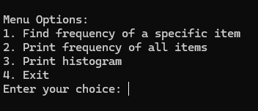
* Item Frequency Output
  + 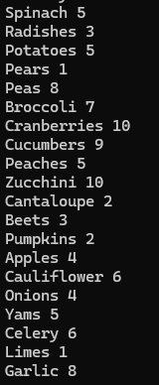
* Histogram
  + 