# 

# Acknowledgement

I would like to extend my sincere gratitude to everyone who gave me the chance to write this report. I would especially want to express my gratitude to Mrs. Sweety Patel, the project manager for our senior project, whose contribution of energizing suggestions and encouragement helped me to coordinate my project, particularly in composing this report.

Every task one completes successfully depends on the ongoing encouragement, support, and goodwill of those around them. I would want to take this opportunity to thank all the people who contributed their time, support, and collaboration to the project's development.

Additionally, I would like to express my gratitude for the employee of Tatvasoft info service, for their crucial contribution in granting me permission to use all necessary resources and equipment in order to do the project "Book Store Web application". A special thank you to all the members of my team, who assisted me in putting the parts together and offered advice on the assignment " Book Store Web application ". Last but not least, many thanks go to the project's supervisor, Mrs. Sweety Patel and my internal guide Mrs. Priyanka Patel who gave their all to help the team work toward the desired outcome. I must express my gratitude for the advice provided by other supervisors and the panels, especially with regards to our project presentation, which was enhanced by their comments and suggestions.

Thanks,

Dev Kapadia

20IT050

# Abstract

This report is a reflection on my three-month internship experience as well as an overview of the key lessons I took away from my mistakes, my work responsibilities, and the value of Tatvasoft info service’s internship program. As a React developer and cloud engineer, the knowledge I have learned about creating web applications, discovering new frameworks, and operating in an office setting is excellent. My job as an intern was to study and focusing on projects involving web applications. In this report, I've emphasized my job area and described the accomplishments I've made thanks to my internship at Tatvasoft info service’s internship.

Training for internships is a crucial stage in student life. The development of a professional mindset is greatly aided by a well-planned, well carried out, and critically evaluated internship training. It fosters the awareness of the industrial approach to issue solving, which is based on a thorough comprehension of organizational process and mode of operation. The goal and inspiration for this internship program is to provide me as a student studying information technology with the discipline, skills, teamwork, and technical knowledge I need. I was given projects to complete throughout a month-long training term at Tatvasoft info service’s internship, during which we completed work including React JS. A straightforward, feature-rich, component-based JavaScript UI library is ReactJS. Both tiny and large, complicated applications can be created with it. ReactJS offers a basic yet reliable feature set to get a web application off the ground. React community supports React library by offering a sizable collection of pre-made components to quickly construct web applications. On top of the React library, the React community also offers sophisticated concepts like state management, routing, etc.

# Description Of Company/Organization

# We are a Consummate Custom Software Development company delivering splendid business IT Solutions and related services to customers across the globe. Our development services are led by our dedicated and passionate team to provide best industry practices combined with technology expertise and business domain knowledge to drive digital transformation. Our proficiency in understanding business challenges and professional competence allows us to create a better experience for our customers.

# We have emerged and marked our presence in different continents by providing Bespoke software development services to all major Industry Domains.

# At TatvaSoft, we care for our employees and our customers, they are our most important assets. We embrace clan organizational culture where every individual gets an equal opportunity of growth, exposure, and nurturing. We value our team and provide work-life balance and make their career progressive and worthy.

**AAAAAAA**

**AAddresses:-**

**United Kingdom**

307B, Warnford Court,  
29 Throgmorton Street,  
London EC2N 2AT

[**+44 (0)207 947 4950**](tel:+44(0)2079474950)

TatvaSoft House,  
Rajpath Club Road,  
Ahmedabad, Gujarat, 380054

# [+91 960 142 1472](tel:+919601421472)

**Canada**

4711 Yonge Street, 10th Floor,  
Toronto, Ontario,  
M2N 6K8

[**+1 416 567 7664**](tel:+14165677664)

**United Kingdom**

307B, Warnford Court,  
29 Throgmorton Street,  
London EC2N 2AT

[+44 (0)207 947 4950](tel:+44(0)2079474950)

**Table of Contents**

[Acknowledgement](#_bookmark0) 1

[Abstract](#_bookmark1) 2

[List of Figures](#_bookmark2) 3

[List of Tables](#_bookmark3) 5

[Description Of Company/Organization 5](#_bookmark4)

[ReactJS Tutorials](#_bookmark5) 6

[React JS Introduction 4](#_bookmark6)

[2.1 Advantages of React JS 4](#_bookmark7)

[Adding React JS to a website 7](#_bookmark8)

[React Environment Setup 7](#_bookmark9)

[Ways to create React app 9](#_bookmark10)

* 1. [create react app 9](#_bookmark11)
  2. [Next.js 9](#_bookmark12)
  3. [Gatsby 9](#_bookmark13)

[Create React app 11](#_bookmark14)

[JSX in react JS 15](#_bookmark16)

* 1. [Why use JSX? 15](#_bookmark17)
  2. [JSX's Nested Elements 15](#_bookmark18)
  3. [Attributes in JSX 15](#_bookmark19)
  4. [JSX Comments 15](#_bookmark20)

[Components in React JS 17](#_bookmark21)

[Creating a react app 17](#_bookmark22)

[Styling in React JS 19](#_bookmark23)

[Props in React JS 21](#_bookmark24)

[9.1 Prop types in React 21](#_bookmark25)

[Functional components 21](#_bookmark26)

[Class components 21](#_bookmark27)

[Event Management in React JS 23](#_bookmark28)

[State in React JS 25](#_bookmark29)

[11.1 Conventions of Using State in React 26](#_bookmark30)

[Hooks in React JS 28](#_bookmark31)

* 1. [What do Hooks do? 28](#_bookmark32)
  2. [Why is Hooks necessary? 28](#_bookmark33)

[Router in React JS 31](#_bookmark34)

Strapie Introduction 32

13.1 What is Strapie 33

13.2 How to use Strapie 34

Stripe Introduction 35

14.1 How to use stripe for checkout page 36

Amazon Web Service 37

15.1 Introduction of AWS 38

15.2 AWS Coognito 39

Project Introduction 36

[Conclusion](#_bookmark43) 37

[References](#_bookmark44) 38

# List of Figures

Fig 1 Strapie Dashboard 32

Fig 2 React Home page 33

Fig.3 AWS Cognito 34

Fig.4 Stripe Checkout Page 35

Fig.5 Order Details In Strapie 36

# 

**Chapter 1: React JS Tutorials**

**ReactJS Tutorials**

A JavaScript package called React is used to create user interfaces.

Declarative: React makes building interactive user interfaces simple. React will effectively update and render the appropriate components as your data changes if you provide straightforward views for each state in your application. Declarative views improve the predictability, clarity, and debuggability of your code.

Build encapsulated components that can handle their own state, then combine them to create complicated user interfaces (UIs). You can simply transmit rich data through your app and keep the state out of the DOM because component functionality is implemented in JavaScript rather than templates.

We don't make assumptions about the other technologies in your stack, so you can develop new features in React without having to rewrite any current code. Learn Once, Write Anywhere.

**Chapter 2: React JS Introduction**

**React JS Introduction**

React is a free and open-source front-end JavaScript toolkit for creating user interfaces based on UI components. It is sometimes known as React.js or ReactJS. It is kept up-to- date by Meta (previously Facebook) and a group of independent programmers and businesses. With frameworks like Next.js, React can be the foundation for single-page, mobile, or server-rendered applications. Making React apps typically necessitates the use of extra libraries for routing and specific client-side functionality because React is only concerned with state management and presenting that information to the DOM.

Utilizing a virtual Document Object Model, or virtual DOM, is another noteworthy aspect. React effectively changes the browser's shown DOM by first creating an in-memory data- structure cache, calculating the differences, and updating that. Reconciliation is the name given to this procedure. While the React libraries only render the subcomponents that really change, this enables the programmer to write code as though the full page is updated on each change. Significant efficiency improvements are made by this selective rendering. It eliminates the need to manually recalculate the CSS style, page layout, and rendering for the entire page.

The incredible JavaScript framework ReactJS has greatly streamlined the development process. Additionally, it offers dependable ReactJS apps with appropriate interfaces. ReactJS is regarded as a highly desired choice for the creation of user-friendly and very appealing websites and applications because it offers a variety of opportunities for developers to express their creativity.

## Advantages of React JS

### Intuitive

ReactJS offers interaction to any UI layout and is incredibly simple to use. Additionally, it enables the rapid and quality-assured development of applications, saving time for both clients and developers.

### Declarative

Significant data changes are made possible via ReactJS, which causes selected user interface elements to change automatically. You don't need to undertake any additional tasks to update your user interface because of its progressive functionality.

### Provides Reusable Components

ReactJS offers reusable components that programmers are free to utilise to build new applications. For developers, reusability functions exactly like a cure. This platform allows the developers the freedom to repurpose parts created for one application for use in another

### library for JavaScript

The usage of a robust JavaScript and HTML grammar blend streamlines the entire process of writing code for the intended project. The JS library has a number of functions, one of which translates the HTML elements into necessary functions and simplifies the overall project.

### Support for Components

ReactJS is the ideal fusion of HTML elements and JavaScript. Utilizing HTML elements and JS codes makes it simple to manage a sizable collection of data that contains the document object model. ReactJS serves as a mediator at this period, acting as the DOM's representative and helping to determine which component changes are necessary to obtain the desired effects.

### SEO-friendly

After extensive investigation and development by Facebook, React JS was released. It stands out from the competition and enables designers to create outstanding, search engine optimised user interfaces for all browsers and engines.

### Successful Data Binding

One-way data binding is behind ReactJS. This indicates that every change made to any specific data segment may be tracked by anyone. This represents how straightforward it is.

**Chapter 3: Adding React JS to a website**

**Adding React JS to a website**

This chapter explains the installation of React library and its related tools in your machine. Before moving to the installation, let us verify the prerequisite first.

React provides CLI tools for the developer to fast forward the creation, development and deployment of the React based web application. React CLI tools depends on the Node.js and must be installed in your system. Hopefully, you have installed Node.js on your machine. We can check it using the below command −

node --version

You could see the version of Nodejs you might have installed. It is shown as below for me,

v14.2.0

If *Nodejs* is not installed, you can download and install by visiting [https://nodejs.org/en/download/.](https://nodejs.org/en/download/)

## React Environment Setup

Now, open the **src >> App.js** file and make changes which you want to display on the screen. After making desired changes, **save** the file. As soon as we save the file, Webpack recompiles the code, and the page will refresh automatically, and changes are reflected on the browser screen. Now, we can create as many components as we want, import the newly created component inside the **App.js** file and that file will be included in our main **index.html** file after compiling by Webpack.

Next, if we want to make the project for the production mode, type the following command. This command will generate the production build, which is best optimized.

* + 1. $ npm build

**Chapter 4:Ways to create react app**

## create react app

**Ways to create React app**

The ideal method to begin developing a new single-page application in React is with Create React App, which provides a welcoming learning environment for the technology.

It optimises your app for production, sets up your development environment so you can leverage the most recent JavaScript capabilities, and offers a pleasant developer experience. Node >= 14.0.0 and npm >= 5.6 must be installed on your computer. Run: to create a project.

npx create-react-app my-app cd my-app

npm start

Because Create React App only constructs a frontend build pipeline, you can use it with any backend you choose because it doesn't handle backend logic or databases. It uses Babel and Webpack internally, but you don't need to be familiar with any of them.

Running npm run build will produce an optimised build of your app in the build folder when you're ready to push to production.

## Next.js

A well-liked and compact framework for React applications that are static and server- rendered is Next.js. It presupposes that you're using Node.js as your server environment and comes with styling and routing solutions out of the box.

## Gatsby

The greatest React tool for building static webpages is Gatsby. While allowing you to use React components, it generates pre-rendered HTML and CSS to provide the quickest page load possible.

# Create React app

Once the React installation is successful, we can create a new React project using create- react-app command. Here, I choose "reactapp" name for my project.

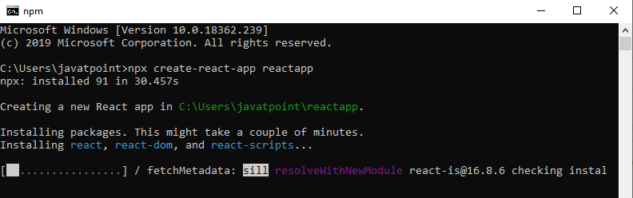

*Fig 5.1 create react app in command prompt*

After completion of this process react will be started on port number 3000. So now go to your browser. In url field type localhost:3000 or 127.0.0.1:3000. You will see a starting page of react JS which looks like this.

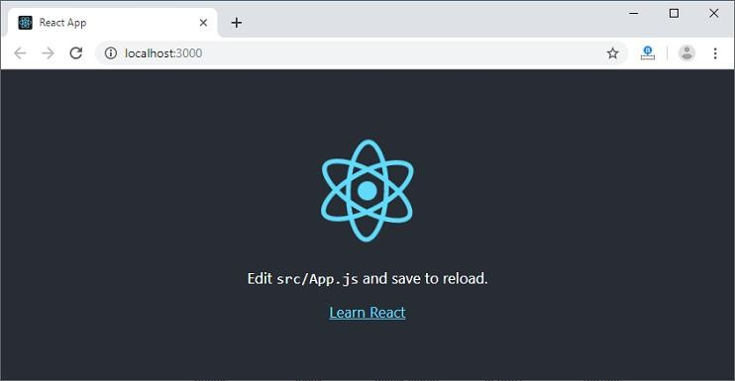

*Fig 5.2 1starting page of react app*

Now open this project in any of the code editor. In vs code it will look like this.

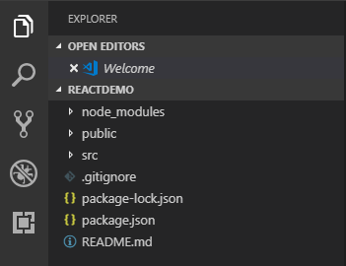

*Fig 5.3 Folder structure of react app*

It is very important to understand this structure to learn react. Let’s have a look one by one.

### node modules

React js dependencies will all be located in this folder.

### .gitignore

When committing code, the source control tool uses this file to specify which files and folders to include or ignore.

### package.json

Dependencies and scripts necessary for the project are contained in this file.

### Index.js

The file that will be called once the project has been launched is index.js.

**Chapter 6: JSX in react JS**

**JSX in react JS**

React JSX is a JavaScript extension, as we already knew. It enables developers to use XML syntax to build virtual DOM. It reduces the code to only JavaScript (React.createElement function calls). It can be used inside any legitimate JavaScript code because it compiles to JavaScript.

## Why use JSX?

* It does optimization when converting the code to JavaScript, making it faster than standard JavaScript.
* React employs components that combine markup and logic rather than splitting technologies by putting them in distinct files. Components will be covered in a later section.
* It is type-safe, and the majority of the problems are discovered during compilation.
* It facilitates the creation of templates.

## JSX's Nested Elements

You must enclose it in one container element if you want to use more than one element. In this case, the div element serves as a container for three nested items.

## Attributes in JSX

Like standard HTML, JSX uses attributes with HTML components. Because class is a reserved keyword in JavaScript, JSX employs camelcase naming conventions for attributes rather than the conventional naming convention of HTML. For example, a class in HTML becomes className in JSX. In JSX, we may also use our own unique custom characteristics. Data- prefix must be used for custom attributes. As an attribute for the tag in the example below, we have utilised a custom attribute called data-demoAttribute.

## JSX Comments

JSX permits the use of comments that start with /\* and end with /\*, as well as their curly brace enclosing, just like JSX expressions. The JSX sample below demonstrates how to use comments.

**Chapter 7 : Components in React JS**

**Components in React JS**

The foundation of a React application is a React component. In this chapter, let's learn how to create a new React component and about its features.

A small section of the user interface on a webpage is represented by a React component. A React component's main responsibility is to render and update its user interface whenever its internal state changes. Along with rendering the UI, it also controls the events related to that UI. To sum up, the React component offers the following features.

An interface's first rendering. processing and managing occurrences.

anytime there is a change to the internal state, update the user interface. React components use three ideas to implement these features.

The component can receive input thanks to its properties.

Events: Make the component capable of controlling DOM events and user interaction.

State Allow the component to continue being stateful. With regard to its state, a stateful component modifies its user interface.

## Creating a react app

React library has two component types. The types are categorized based on the way it is being created.

* Function component − Uses plain JavaScript function.
* ES6 class component − Uses ES6 class.

The core difference between function and class component are −

Function components are very minimal in nature. Its only requirement is to return a *React element*

**Chapter 8: Styling in React JS**

**Styling in React JS**

Generally speaking, React's className feature allows components to be styled with CSS classes. Since React JSX allows for JavaScript expression, many common CSS techniques can be applied. Below are a few of the best choices:

* Normal CSS styles and className are contained in the CSS file.
* Inline styling uses JavaScript objects with camelCase properties and CSS styles.
* Locally scoped CSS styles — CSS modules.
* Component level styles refer to styled components.
* By translating the styles to standard CSS at build time, the Sass stylesheet supports Sass-based CSS styles.

By transforming the styles to standard CSS at build time, the post processing stylesheet supports post processing styles.

In this chapter, let's learn how to employ the three key methodologies to style our component.

* Stylesheet in CSS
* styling inline
* Modules in CSS

**Chapter 9: Props in React JS**

**Props in React JS**

By using components, you may separate the user interface into separate, reusable parts and consider each one separately. An introduction to the concept of components is given on this page. A thorough reference to the component API may be found here.

Components are conceptually similar to JavaScript functions. They take unrestricted inputs, or "props," and return React elements that describe what should be displayed on the screen.

Using something called props (stands for properties), React allows us to pass information to a Component. In essence, props are a type of global variable or object. In this chapter, we will learn more about things in-depth.

## 9.1 Prop types in React

PropTypes was included in the react package prior to the release of React 15.5.0, but you'll need to add a dependency to your project if you're using a later version of React. By employing the command provided below, you may include the dependency in your project:

npm install prop-types --save

There are primarily two sorts of components in ReactJS.

1. Functional Components
2. Class Elements

## Functional components

Function components are a means to create components in React that don't have their own state and only have a render method. They are merely JavaScript functions that might or might not include parameters that contain data. We can write a function that accepts the props(properties) argument and outputs the displayed result.

## Class components

Functional components are simpler than class components. You must develop a render method that returns a React element by extending from React Component. Data can be passed between classes and between class components. By defining a class that extends Component and has a render function, you can create a class.

**Chapter 10: Event management in React JS**

**Event Management in React JS**

An event is a potential action that might be brought on by a user action or a system- generated event. Events include things like mouse clicks, web page loads, key presses, window resizing, and other interactions.

React features a built-in event handling framework that is quite similar to how DOM element events are handled. Synthetic Events is the name given to the react event handling system. A cross-browser wrapper for the native event of the browser is the synthetic event.

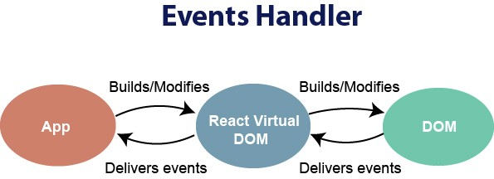

*Fig 10.1 Event handling*

There are various grammatical distinctions between react event processing and DOM event handling. Which are:

1. CamelCase names rather than lowercase ones are used for react events.
2. With JSX, a function rather than a string is supplied as the event handler.

We cannot return false in react to override the default behaviour. To stop the default behaviour, we must explicitly invoke the preventDefault event.

**Chapter 11 : State in React JS**

**State in React JS**

One of the crucial and inevitable components of every dynamic application is state management. State management in a React component is supported via a straightforward and adaptable API that React offers. In this chapter, let's learn how to keep state in a React application.

Describe state.

The state of a React component at a certain instance represents the value of one of its dynamic attributes. For each component, React provides a dynamic data store. This provides access to the internal data, which depicts the state of a React component. state a component member variable. When a component's state changes, it will automatically re- render itself by invoking the render() method with the updated state.

Analyzing a real-time clock component might serve as a straightforward example to help one grasp state management. The primary function of the clock component is to display the current location's date and time. The clock component should keep the current date and time in its state because the current time will change every second. The render() method of the clock is called every second because the state of the clock component changes every second, and the render() method uses the clock's current state to display the current time.

Describing state.

The state is a React Component instance. A class can be described as an object with a number of observable properties that regulate how a component behaves. In other words, a component's state is an object that contains data that could change throughout the course of the component's existence. Consider the clock we built in this article as an example. We called the render() method explicitly once every second, but React offers a better approach to accomplish the same goal by using State and storing the value of time as a member of the component's state. Later on in the article, we shall investigate this in further detail.

Describe state. Props are objects that carry data to control the behaviour of a specific component, which sounds a lot like states but are very different from one another. We have already studied about props. Let's distinguish between the two.

Props are immutable, which means they cannot be altered once they are set, whereas States are observable objects that are used to retain data that may change over time and to regulate behaviour after each change.

Class components and functional components can use states through the usage of React Hooks (useState and other methods), although props are exempt from this restriction.

Properties are set by the parent component, whereas event handlers typically update State. Consider the GeeksforGeeks "IDE" page's toggleable theme as an example. State can be used to implement it, with the IDE changing colour depending on whether the State's likely values are light or dark.

* 1. Conventions of Using State in React:
     + A component's state should remain constant over the course of its lifespan, thus we must first have some starting state, which we should define in the function of the component's class.
     + State should never be explicitly modified. React employs an observable object as the state, which keeps track of any state changes and guides component behaviour as a result. The homepage won't re-render itself, for instance, if we modify the state of any component like the one below since React State won't be able to recognise the changes.
     + React offers its own method setState as a result (). The setState() function accepts a single parameter and an object that should hold the updated set of values. The method implicitly invokes the render() method to re-paint the page after the change is complete.
     + We are only permitted to explicitly define the state in the function to provide the starting state.
     + React employs asynchronous state changes, which allow it to update numerous setState() updates at once. React is very efficient. So it's possible that utilising the value of the current state doesn't always produce the desired outcome. Take, for instance, a situation where we must maintain a count (Likes of a Post).
     + Updates to the state are independent. Several attributes may be present in the state object of a component, and React enables the use of the setState() function to update only a portion of those attributes as well as the use of multiple setState() methods to individually update each attribute value.

**Chapter 12**

**Hooks in React JS**

## What do Hooks do?

**Hooks in React JS**

In React 16.8, hooks are a brand-new feature. They enable programmers to utilise state and additional React capabilities without creating a class. For instance, Condition of an element

It is crucial to remember that hooks are not utilised within classes.

## Why is Hooks necessary?

The introduction of Hooks was driven by a number of factors, the significance of which varies depending on the developers' level of expertise in creating React products. Here are a few of them:

* + - Use of the word "this": The first explanation has more to do with javascript than with React specifically. To deal with classes, one must comprehend how the javascript "this" keyword operates, which is considerably different from how it operates in other languages. Props, state, and unidirectional data flow concepts are simpler to comprehend, however utilising the keyword "this" may make it difficult to construct class components. Event handlers must be connected to the class components as well. The React development team has also noted that classes don't concise effectively, which results in hot reloading being unreliable. Hooks can be used to fix this issue.
    - Reusable stateful logics: The render props pattern and higher-order components (HOC) are two advanced React concepts that are touched with in this reason. Stateful component logic can be reused in React in a variety of ways. Although the HOC and render properties patterns can be used to fix this issue, doing so leads to an inefficient code base that is difficult to follow because one must wrap components in multiple other components in order to share functionality. Without altering the component hierarchy, hooks enable much better and cleaner stateful logic sharing.
    - Simplifying difficult scenarios: It's possible that all relevant code is dispersed across many life cycle methods when developing components for complex scenarios like data fetching and event subscription.

For instance, data fetching is often carried out in componentDidMount or componentDidUpdate, and event listeners are typically implemented in componentDidMount or componentWillUnmount. These create a situation in which entirely unrelated routines, such as data fetching and event listeners, end up in the same code block. Due to stateful logic, it is also impossible to break down components into smaller components. Hooks address these issues instead of imposing a separation based on the life-cycle technique. Hooks that enable you to divide one function into more manageable ones depending on the pieces are related.

When utilizing hooks, keep these points in mind:

* + - React 16.8 and later versions support hooks.
    - All hooks are fully opt-in. Without altering any current code, use it partially for a few components or base the entire project on it, depending on your needs.
    - Hooks are completely backward-compatible and don't have any breaking changes.
    - The React team does not have any plans to get rid of classes.
    - Although hooks cannot be utilised inside class components, the app can clearly combine class-based and functional hooks.
    - Hooks don't contradict any of the fundamental React ideas. Hooks, on the other hand, offer a direct API to respond concepts like props, state, context, refs, and life-cycle.

**Chapter 13 : Router in React JS**

**13.1 Router in React JS**

A common library for routing in React is called React Router. It permits switching between views of different React Application components, permits changing the browser URL, and keeps the UI in sync with the URL.

To install react router DOM use following command

***npm install – -save react-router-dom***

Add the components of react-router-dom to your React application after installation.

Incorporating React Router Components: React Router's principal parts are:

Utilizing the HTML5 history API (pushState, replaceState, and the popstate event), BrowserRouter is a router implementation that keeps your UI in sync with the URL. All other components are kept in the parent component, which serves as their storage location.

Routes is an upgraded and new component that was added in version 6. Routes over Switch has the following primary benefits:

Instead of being traversed in order, Relative s and s Routes are selected based on the best match.

Route: Route is a component that is only displayed if its route matches the URL that is currently being displayed.

Link: The component "Link" is used to build linkages to various routes and implement application navigation. Like an HTML anchor tag, it functions.

**Chapter 13 : Introuction of Strapie**

**13.1 What is Strapie?**

The original purpose of the project was to help Boot**strap** your **API**: that's how Strapi was created. Now, Strapi is an open-source headless CMS that gives developers the freedom to choose their favorite tools and frameworks and allows editors to manage and distribute their content using their application's admin panel. Based on a plugin system, Strapi is a flexible CMS whose admin panel and API are extensible - and which every part is customizable to match any use case. Strapi also has a built-in user system to manage in detail what the administrators and end users have access to.

Strapi is an open-source project (see [LICENSE](https://github.com/strapi/strapi/blob/master/LICENSE) file for more information). The core project, as well as the documentation and any related tool can be found in the [Strapi](https://github.com/strapi" \t "_blank) GitHub organization.

As it goes hand in hand with the open-source ecosystem, Strapi is open to contributions. The Strapi team appreciates every contribution, be it a feature request, bug report, or pull request. The following GitHub repositories are open-source and contributions-friendly:

* [strapi/strapi](https://github.com/strapi/strapi): main repository of Strapi, which contains the core of the project. You can find the admin panel, core plugins, plugin providers, and the whole code that runs your Strapi application. Please read the [CONTRIBUTING.md](https://github.com/strapi/strapi/blob/master/CONTRIBUTING.md) file to have more information about contributions to the main repository.
* [strapi/documentation](https://github.com/strapi/documentation): contains the whole documentation of Strapi. Please read the [contribution guide](https://github.com/strapi/documentation/blob/main/CONTRIBUTING.md) to have more information about contributions to the Strapi documentation.
* [strapi/design-system](https://github.com/strapi/design-system): is the design system that is used in the admin panel. It brings consistency between the different admin plugins.
* [strapi-community/awesome-strapi](https://github.com/strapi/awesome-strapi): contains everything the community built and all managed plugins. It is used as a central place to find and submit new packages such as plugins, middlewares, hooks, and general enhancements to the core of Strapi.

**13.2 How to use Strapie?**

### Step 1: Create collection types with the Content-type Builder[​](https://docs.strapi.io/dev-docs/quick-start#step-1-create-collection-types-with-the-content-type-builder)

The Content-type Builder plugin helps you create your data structure. When creating an empty project with Strapi, this is where to get the party started!

#### Create a "Restaurant" collection type[​](https://docs.strapi.io/dev-docs/quick-start#create-a-restaurant-collection-type)

Your restaurants directory will eventually include many restaurants, so we need to create a "Restaurant" collection type. Then we can describe the fields to display when adding a new restaurant entry:

1. Click on the **Create your first Content type** button.  
   If it's not showing up, go to Plugins  [Content-type Builder](http://localhost:1337/admin/plugins/content-type-builder) in the main navigation.
2. Click on **Create new collection type**.
3. Type Restaurant for the Display name, and click **Continue**.
4. Click the Text field.
5. Type Name in the Name field.
6. Switch to the Advanced Settings tab, and check the **Required field** and the **Unique field** settings.
7. Click on **Add another field**.
8. Choose the Rich text field.
9. Type Description under the Name field, then click **Finish**.
10. Finally, click **Save** and wait for Strapi to restart.

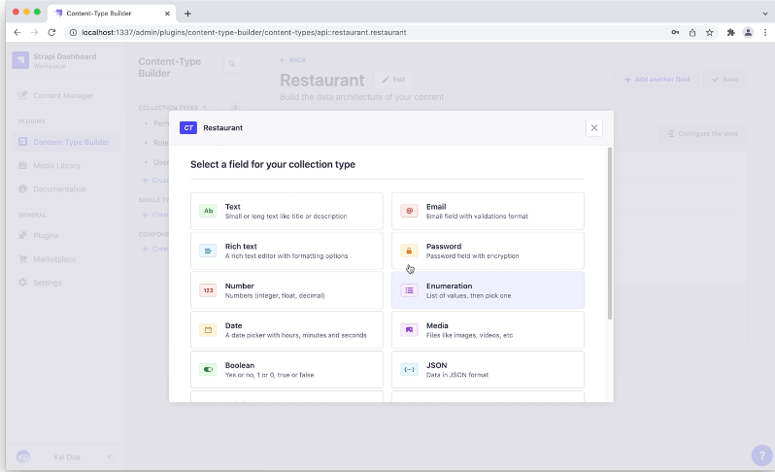

Figure 1.1 Contain builder

**Chapter 14 : Use of Stripe**

**14.1 How to use stripe ?**

* Using Stripe for a checkout page involves integrating the Stripe payment gateway into your web application. Stripe provides APIs and SDKs that make it relatively straightforward to implement secure and customizable checkout functionality. Below is a general outline of the steps to use Stripe for a checkout page:
* Sign up for a Stripe Account: If you haven't already, go to the Stripe website ([https://stripe.com](https://stripe.com/)) and sign up for a Stripe account. After signing up, you'll get access to the Stripe Dashboard, where you can find your API keys and configure your account settings.
* Install Stripe Library: Depending on your programming language and platform, you need to install the appropriate Stripe library or SDK. Stripe provides libraries for various programming languages such as JavaScript, Python, PHP, Ruby, and more.
* Set Up Server-Side Integration: To handle payment processing securely, you'll need to create a server-side endpoint to interact with Stripe's API. Your server will make requests to Stripe using the secret API key, which must not be exposed on the client-side.
* Create a Checkout Session: On your server, create a new Checkout Session using the Stripe API. A Checkout Session defines the details of the payment, such as the amount, currency, and success/failure URLs.
* Redirect to Checkout Page: After creating the Checkout Session, redirect the user to the Stripe-hosted Checkout page. Stripe will handle the payment details and collect the necessary information from the user.
* Handle Payment Confirmation: Once the user completes the payment on the Stripe Checkout page, they will be redirected back to your success or failure URL. Stripe will also send a webhook event to your server to confirm the payment's success or failure.
* Verify Payment on Server: Upon receiving the webhook event, verify the payment's status on your server using the Stripe API to ensure the payment is successful and valid.
* Finalize the Checkout Process: On your server, complete the order process, update the order status in your database, and provide the user with a confirmation page or email.

**Chapter-15: Amazon Web Service**

**15.1 Introduction of AWS**

* AWS, or Amazon Web Services, is a comprehensive and widely-used cloud computing platform provided by Amazon. It offers a broad range of cloud services, including computing power, storage options, databases, networking, machine learning, analytics, and more. Launched in 2006, AWS has since become a dominant player in the cloud computing industry, catering to individuals, businesses, and government organizations around the world.
* Key Components of AWS:
* Compute Services: AWS provides various compute options, such as Amazon Elastic Compute Cloud (EC2), which enables users to launch and manage virtual machines in the cloud. It also offers AWS Lambda for serverless computing, allowing developers to run code without provisioning or managing servers.
* Storage Services: AWS offers scalable and flexible storage solutions, including Amazon Simple Storage Service (S3) for object storage, Amazon Elastic Block Store (EBS) for block-level storage volumes, and Amazon Glacier for long-term archival storage.
* Database Services: AWS provides managed database services like Amazon RDS (Relational Database Service) for relational databases, Amazon DynamoDB for NoSQL databases, and Amazon Redshift for data warehousing.
* Networking Services: AWS offers Virtual Private Cloud (VPC) to create isolated network environments, Amazon Route 53 for domain name registration and DNS, and various load balancing and content
* Machine Learning Services: AWS has an array of machine learning services, such as Amazon SageMaker for building, training, and deploying machine learning models, and Amazon Rekognition for image and video analysis.
* Analytics Services: AWS provides services like Amazon Athena, Amazon EMR (Elastic MapReduce), and Amazon QuickSight for data processing, analysis, and visualization.
* Security and Compliance: AWS offers various security features, including identity and access management (IAM), encryption, and DDoS protection, to help users secure their applications and data. It also complies with multiple industry standards and certifications.
* Internet of Things (IoT): AWS IoT services enable users to connect and manage IoT devices securely, process and analyze IoT data, and build IoT applications.
* Serverless Computing: AWS Lambda allows developers to run code in response to events without managing servers, leading to cost efficiency and scalability.
* AWS's pay-as-you-go pricing model allows users to pay only for the resources they consume, making it highly cost-effective. Its global infrastructure spans multiple regions and Availability Zones, ensuring high availability and redundancy.
* Overall, AWS has revolutionized the IT industry by providing a robust, scalable, and cost-effective platform for businesses to build, deploy, and manage applications and services in the cloud. It has empowered organizations of all sizes to innovate, scale, and achieve their digital transformation goals.

**15.2 AWS Cognito**

* AWS Cognito is a fully managed service provided by Amazon Web Services (AWS) that facilitates user sign-up, sign-in, and access control for web and mobile applications. It helps developers easily add user authentication, registration, and access control capabilities to their applications without the need for building and managing the entire authentication system from scratch.
* Key Features of AWS Cognito:
* User Pool: AWS Cognito provides a user pool, which is a user directory that handles user registration, authentication, and account recovery. It supports various sign-in options, including username and password, social identity providers (such as Google, Facebook, and Amazon), and SAML-based identity providers.
* Identity Pool: Identity pools allow users to obtain temporary security credentials to access AWS services directly or through API calls. These identity pools federate with external identity providers, enabling users to authenticate using their existing credentials from sources like Google or Facebook.
* Multi-Factor Authentication (MFA): Cognito supports MFA, providing an extra layer of security by requiring users to verify their identity using a second factor, such as a one-time password (OTP) sent to their mobile device.
* Customizable User Interfaces: Cognito provides customizable and mobile-friendly web UIs and SDKs for different platforms, making it easy for developers to integrate the authentication and user management features into their applications.
* User Profiles and Attributes: Developers can store custom user attributes in Cognito user pools, allowing them to capture and manage additional information about users beyond the basic authentication data.
* User Data Synchronization: Cognito allows developers to sync user data across devices and platforms, ensuring a consistent experience for users accessing the application from multiple devices.
* Authentication Flows: It supports different authentication flows, including interactive sign-up and sign-in, as well as silent token refresh for maintaining user sessions.
* Scalability and Availability: Cognito is highly scalable and distributed across AWS regions, providing high availability and low-latency access to user data.
* Integration with AWS Services: Cognito integrates seamlessly with other AWS services, such as Amazon API Gateway, AWS AppSync, and AWS Lambda, allowing developers to build serverless and scalable applications.
* AWS Cognito is an essential component for building secure and user-friendly applications that require user management and authentication features. By leveraging Cognito, developers can save time and effort and focus on building the core functionalities of their applications while ensuring robust user authentication and access control.

**Chapter : 16 – Project Details**

**Project Flow:-**

**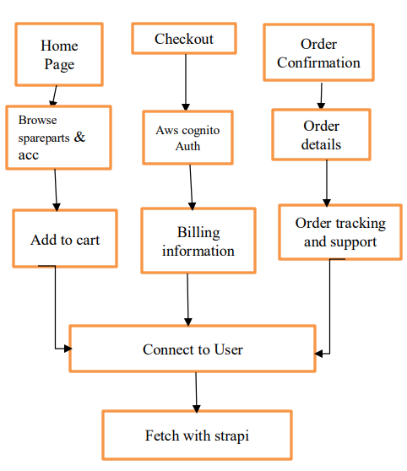**

Figure 2 Flowchart of project

**Introduction of Project:-**

The demand for book store web application has been increasing rapidly over the years. With the growth of e-commerce, customers prefer buying spare parts and accessories online. In this paper, we propose a solution for creating a web application and chatbot for vehicle spare parts and accessories using AWS, Google Dialog flow, Strapi, Stripe, and React. The solution aims to provide customers with a user-friendly interface to browse, search, and purchase spare parts and accessories, and also provides businesses with a comprehensive order and inventory management system.

The proposed solution aims to provide an end-to-end solution for businesses looking to sell book store web application online. The solution includes a web application and a chatbot, which provides customers with a user-friendly interface to browse, search, and purchase spare parts and accessories. The solution also provides businesses with a comprehensive order and inventory management system.

The book industry is a highly competitive and growing market, and many businesses are looking to sell their products online. However, building an e-commerce website can be a complex and time consuming process, especially for businesses without technical expertise. The proposed project aims to provide businesses with an end-to-end solution for selling their vehicle spare parts and accessories online, by leveraging modern technologies such as AWS, Google Dialog flow, Strapi, Stripe, and React. The web application and chatbot provide businesses with a user-friendly interface for customers to browse, search, and purchase products, and also includes a comprehensive order and inventory management system. The application can be easily customized and scaled to meet the specific needs of any business, allowing them to sell their products online and reach a wider audience. The use of cloud technologies such as AWS and Google Dialog flow provides businesses with a highly scalable and secure platform for their ecommerce operations, while Strapi provides a flexible and powerful content management system for managing product information and other content. Stripe provides a secure and reliable payment processing solution, allowing businesses to accept payments from customers around the world. Finally, React provides a modern and responsive front-end framework for building dynamic and interactive user interfaces.

**Project Photos:-**

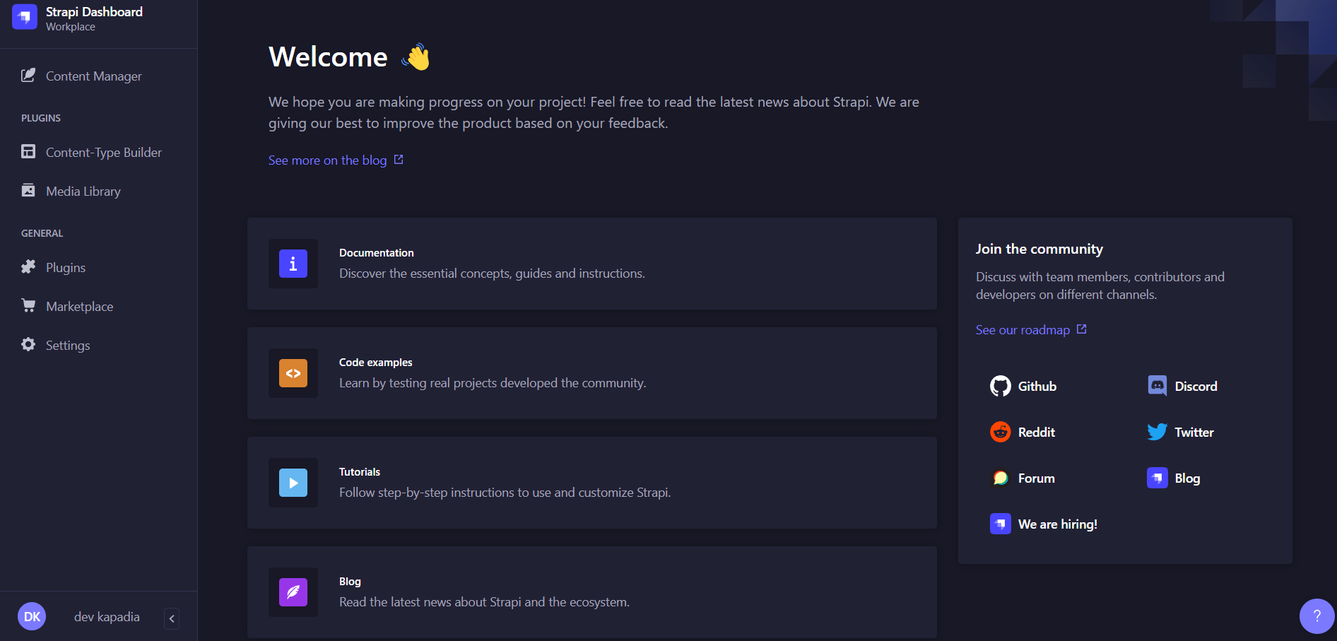

Fig 3 Strapie Dashboard

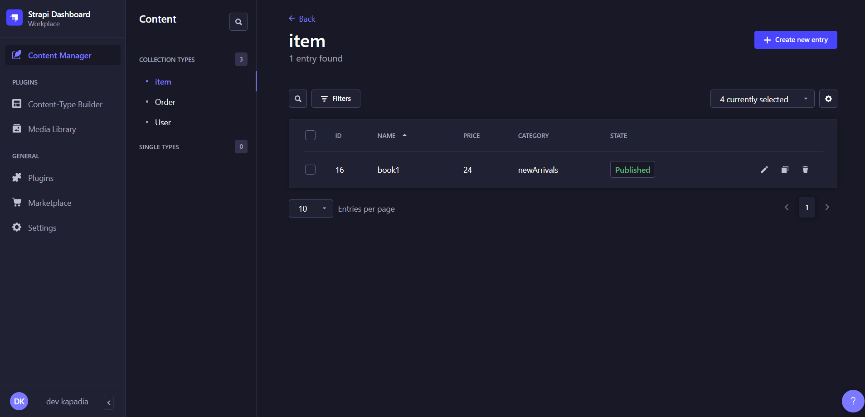

Fig 4 Strapie photo Storage



Fig 5 React frontend

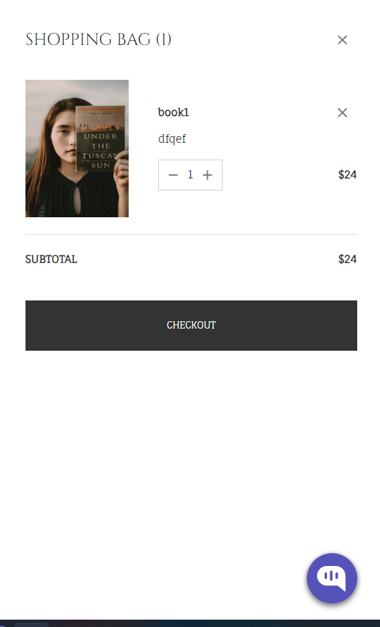

Fig 6 Checkout Detail

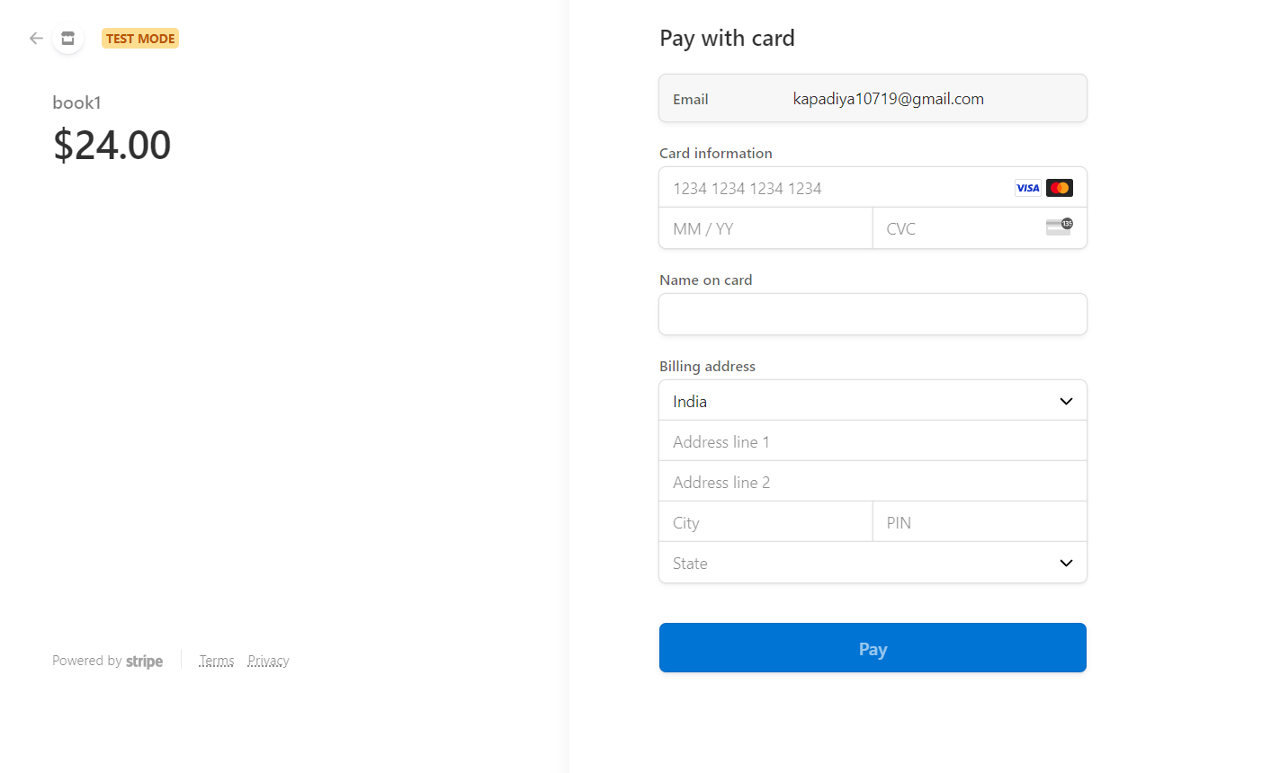

Fig. 7.1 Stripe Checkout Page

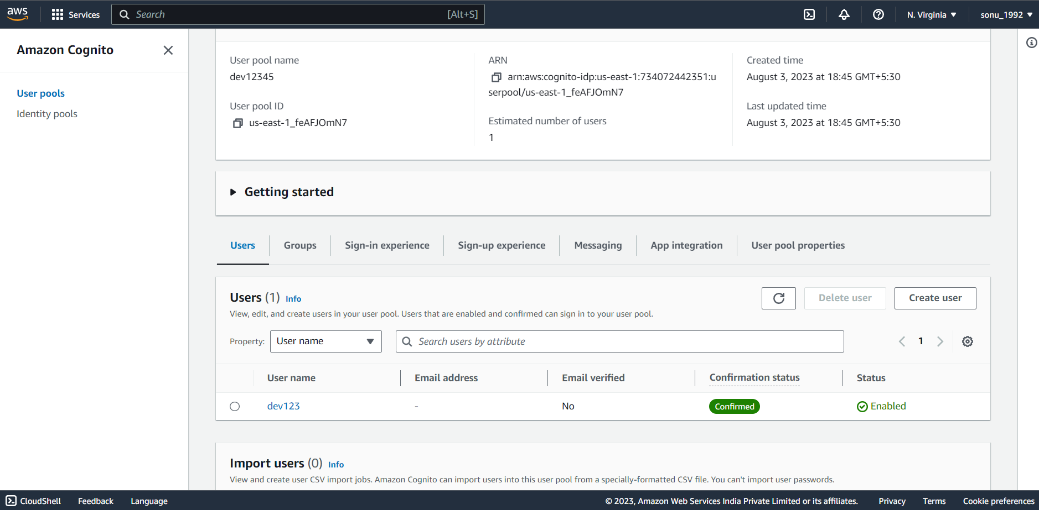

Fig 8 AWS User Information

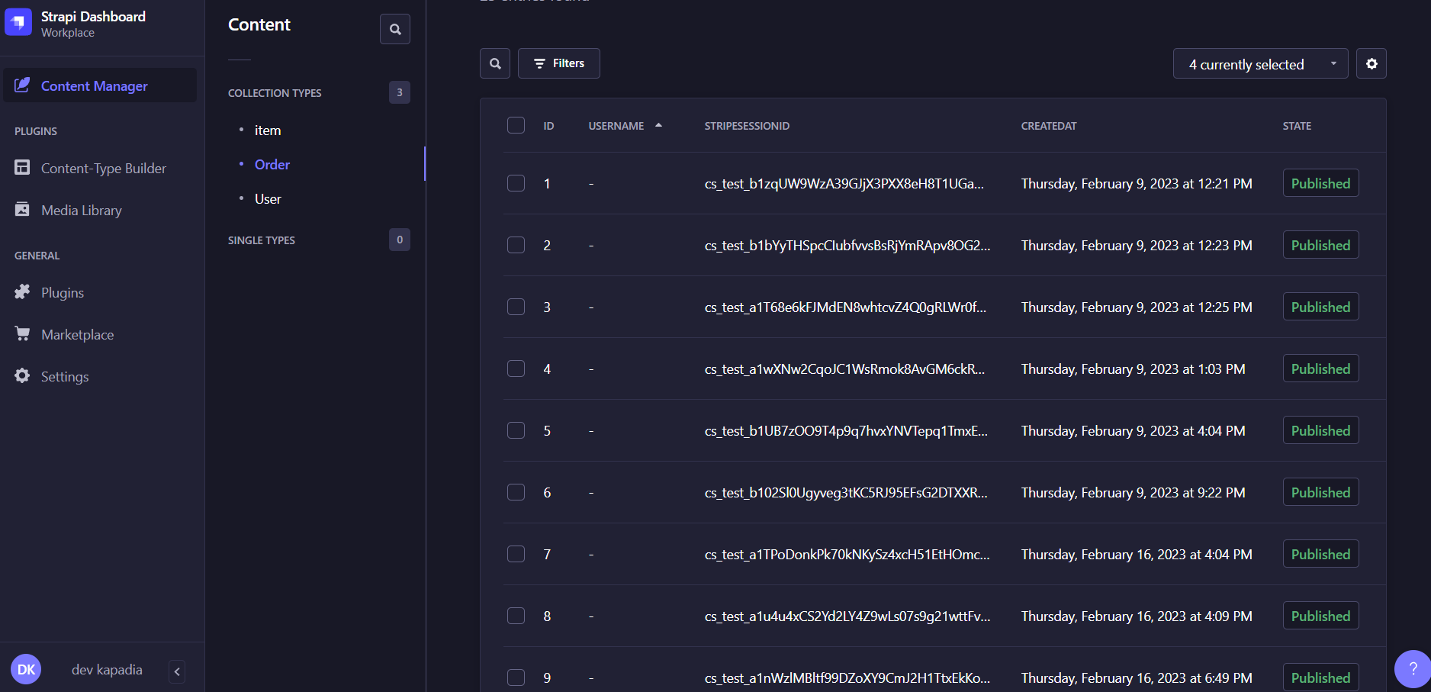

Fig 9 Order Details

# Conclusion

From this report we can have understanding of react JS which is a very useful and powerful front-end framework. We can learn various concepts of react JS like state, components, lifecycle, styling, event handling, hooks and router. We can use this concepts to make a attractive front-end for any website. Alongside, we have created a food delivery app where user can order food in cinema.

# References:-

1. <https://www.javatpoint.com/reactjs-tutorial>

# <https://www.geeksforgeeks.org/reactjs-tutorials/>

# https://docs.strapi.io/

# <https://dashboard.stripe.com>

1. <https://www.javatpoint.com/reactjs-tutorial>

# <https://www.geeksforgeeks.org/reactjs-tutorials/>