ANGULAR

1. Why Angular
2. Angular bootstrapping (main.ts)
3. Ng Module structure
4. Pollyfil.js & webpack.js
5. Component Life cycle
6. Data Flow b/w components
7. Parent to Child
8. Child to Parent
9. Directive
10. Http Interceptor
11. JIT vs. AOT
12. Promise vs. Observable
13. Observables
14. HOT vs. COLD
15. Observable Subject

# Why Angular

* Mvc Architecture support
* Two way binding support
* Default Ivy renderer - optimized bundle size, faster component loading
* Di support
* Modular
* Component based development
* JIT/AOT compilation support
* Support SPA
* Declarative user interface
* Google support
* Cross-Platform
* Easy integration
* Angular integration is pre-built into several frameworks, for example, Ionic, Telerik’s Kendo UI, Wijmo, etc. Hence, integration of third-party features is easy with Angular. So, if you want to add some high-quality user interface components, you can easily do so by using any of the above-mentioned frameworks!
* Angular can be used to make any of the following types of applications:
  + Web applications: Angular can be used for web development. Also, from Angular 5 onwards, progressive web applications can also be developed. Such applications have high performance and can work offline as well.
  + Native mobile applications: Native mobile applications can be built using Angular.
* Desktop applications: Angular can be used to create desktop-installed applications for Mac, Windows, and Linux.

# Angular bootstrapping

### main.ts Application entry point

The main.ts file is as shown below.

import { enableProdMode } from '@angular/core';

import { platformBrowserDynamic } from '@angular/platform-browser-dynamic';

import { AppModule } from './app/app.module';

import { environment } from './environments/environment';

if (environment.production) {

  enableProdMode();

}

platformBrowserDynamic().bootstrapModule(AppModule)

  .catch(err => console.error(err));

platformBrowserDynamic is the module, which is responsible for loading the Angular application in the desktop browser.

The Angular Applications can be bootstrapped in many ways and in many platforms. For example, we can load our application in a Desktop Browser or in a mobile device with Ionic or NativeScript.

If you are using the nativescript, then you will be using platformNativeScriptDynamic from nativescript-angular/platform library and will be calling platformNativeScriptDynamic().bootstrapModule(AppModule).

# Ng Module structure

The [@NgModule](https://www.tektutorialshub.com/angular/angular-modules/#ngmodule) has several metadata properties.

## imports

We need to list all the external modules required including other Angular modules, that is used by this Angular Module

## Declarations

The Declarations array contains the list of components, directives, & pipes that belong to this Angular Module. We have only one component in our application AppComponent.

## Providers

The [Providers](https://www.tektutorialshub.com/angular/angular-providers/) array, is where we register the services we create. The [Angular Dependency injection](https://www.tektutorialshub.com/angular/angular-dependency-injection/) framework injects these [services](https://www.tektutorialshub.com/angular/angular-services/) in components, directives. pipes and other services.

## Bootstrap

The component that angular should load, when this Angular Module loads. The component must be part of this module. We want AppComponent load when AppModule loads, hence we list it here.

@NgModule({

  declarations: [

    AppComponent

  ],

  imports: [

    BrowserModule,

    AppRoutingModule

  ],

  providers: [],

  bootstrap: [AppComponent]

})

export class AppModule { }

# Component Life cycle

* **Constructor()**
* **ngOnChanges( )** This hook/method is called before ngOnInit and whenever one or more input properties of the component changes. This method/hook receives a Simple Changes object which contains the previous and current values of the property.
* **ngOnInit( )** This hook gets called once, after the ngOnChanges hook.

It initializes the component and sets the input properties of the component.

* **ngDoCheck ( )** It gets called after ngOnChanges and ngOnInit and is used to detect and act on changes that cannot be detected by Angular. We can implement our change detection algorithm in this hook.
* **ngAfterContentInit ( )** It gets called after the first ngDoCheck hook. This hook responds after the content gets projected inside the component.
* **ngAfterContentChecked()** It gets called after ngAfterContentInit and every subsequent ngDoCheck. It responds after the projected content is checked.
* **ngAfterViewInit()** It responds after a component's view, or a child component's view is initialized.
* **ngAfterViewChecked()** It gets called after ngAfterViewInit, and it responds after the component's view, or the child component's view is checked.
* **ngOnDestroy()** It gets called just before Angular destroys the component. This hook can be used to clean up the code and detach event handlers.

# Data Flow b/w Components: Parent to Child

## Using @Input decorator:

Consider the following parent component:

@Component({

selector: 'app-parent',

template: `

<app-child [data]=data></app-child>

` ,

styleUrls: ['./parent.component.css']

})

export class ParentComponent{

data:string = "Message from parent";

constructor() { }

}

In the above parent component, we are passing “data” property to the following child component:

import { Component, Input} from '@angular/core';

@Component({

selector: 'app-child',

template:`

<p>{{data}}</p>

`,

styleUrls: ['./child.component.css']

})

export class ChildComponent {

@Input() data:string

constructor() { }

}

In the child component, we are using @Input decorator to capture data coming from a parent component and using it inside the child component’s template.

# Data Flow b/w Components: Child to Parent

## Using @ViewChild decorator

**Child component:**

import {Component} from '@angular/core';

@Component({

selector: 'app-child',

template:`

<p>{{data}}</p>

`,

styleUrls: ['./child.component.css']

})

export class ChildComponent {

data:string = "Message from child to parent";

constructor() { }

}

**Parent Component:**

import { Component,ViewChild, AfterViewInit} from '@angular/core';

import { ChildComponent } from './../child/child.component';

@Component ({

selector: 'app-parent',

template: `

<p>{{dataFromChild}}</p>

` ,

styleUrls: ['./parent.component.css']

})

export class ParentComponent implements {

dataFromChild: string;

@ViewChild(ChildComponent,{static:false}) child;

ngAfterViewInit(){

this.dataFromChild = this.child.data;

}

constructor () { }

}

In the above example, a property named “data” is passed from the child component to the parent component.

**@ViewChild** decorator is used to reference the child component as “child” property. Using the **ngAfterViewInit** hook; we assign the child’s data property to the *messageFromChild* property and use it in the parent component’s template.

## Using @Output and EventEmitter

In this method, we bind a DOM element inside the child component, to an event (click event for example) and using this event we emit data that will captured by the parent component:

**Child Component:**

import {Component, Output, EventEmitter} from '@angular/core';

@Component({

selector: 'app-child',

template:`

<button (click)="emitData()">Click to emit data</button>

`,

styleUrls: ['./child.component.css']

})

export class ChildComponent {

data:string = "Message from child to parent";

@Output() dataEvent = new EventEmitter<string>();

constructor() { }

emitData(){

this.dataEvent.emit(this.data);

}

}

As you can see in the child component, we have used ***@Output***property to bind an EventEmitter. This event emitter emits data when the button in the template is clicked.

**In the parent component’s template we can capture the emitted data like this:**

**<app-child (dataEvent) ="receiveData ($event)"></app-child>**

Then inside the receiveData function we can handle the emitted data:

receiveData($event){

this.dataFromChild = $event;

}

# Directive

A directive is a class in Angular that is declared with a @Directive decorator.

Every directive has its own behavior and can be imported into various components of an application.

## Types of directives

**Component directives:**

These form the main class in directives. Instead of @Directive decorator we use @Component decorator to declare these directives. These directives have a view, a stylesheet and a selector property.

**Structural directives**

These directives are generally used to manipulate DOM elements.

Every structural directive has a ‘*’ sign before them.

We can apply these directives to any DOM element.

Let’s see some built-in structural directives in action:

<div *ngIf="isReady" class="display_name">

{{name}}

</div>

<div class="details" *ngFor="let x of details" >

<p>{{x.name}}</p>

<p> {{x.address}}</p>

<p>{{x.age}}</p>

</div>

In the above example, we can *ngIf and *ngFor directives being used.

*ngIf is used to check a boolean value and if it’s truthy,the div element will be displayed.

*ngFor is used to iterate over a list and display each item of the list.

**Attribute Directives**

These directives are used to change the look and behavior of a DOM element. Let’s understand attribute directives by creating one:

How to create a custom directive?

We’re going to create an attribute directive:

In the command terminal, navigate to the directory of the angular app and type the following command to generate a directive:

ng g directive blueBackground

The following directive will be generated. Manipulate the directive to look like this:

import { Directive, ElementRef } from '@angular/core';

@Directive({

selector: '[appBlueBackground]'

})

export class BlueBackgroundDirective {

constructor(el:ElementRef) {

el.nativeElement.style.backgroundColor = "blue";

}

}

Now we can apply the above directive to any DOM element:

**<p appBlueBackground>Hello World!</p>**

# Http Interceptor

*"Interceptors in Angular, as the name suggests, is a simple way provided by the framework to intercept and modify the application’s http requests globally before they are sent to the server. That really comes in handy, allowing us to configure authentication tokens, add logs of the requests, add custom headers that out application may need and much more."*

**Implementing an Interceptor**

In order to implement an Interceptor, you need to create a class that implements the intercept method of the *HttpInterceptor* interface.

So let’s suppose you want to log in the console every single http request made by the application. Below, I’ve created a simple interceptor that would achieve the following.

@Injectable()

export class RequestLogInterceptor implements HttpInterceptor {

intercept(

request: HttpRequest<any>, next: HttpHandler

) : Observable<HttpEvent<any>> {

console.log(request.url);

return next.handle(request);

}

}

# JIT vs. AOT

### ****JIT (Just in Time) Compilation****

The name itself describes the working; it compiles the code just in the time of loading the page in browser. The browser will download the compiler and build the application code and renders it. ***It will be good for development environment***.

### ****AoT (Ahead of Time) Compilation****

It compiles all the code at the time of building the application. So the browser doesn't want to download the compiler and compile the code. In this method browser can easily render the application by just loading the already compiled code. ***Can be used in the production environment.***

We can compare the JiT and AoT compilation as below:

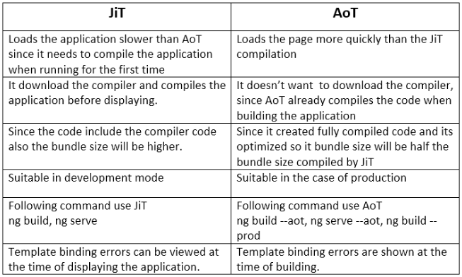

# Promise vs. Observable

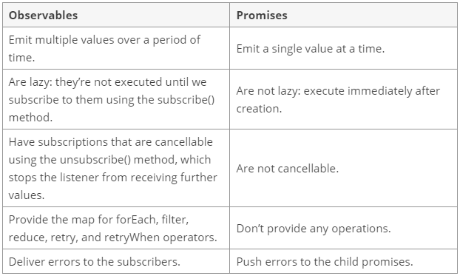

# Observables

## HOT vs. Cold Observables

***“When the data is produced by the Observable itself, we call it a cold Observable. When the data is produced outside the Observable, we call it a hot Observable.”***

### Cold Observable:

|  |  |
| --- | --- |
|  | import * as Rx from ‘rxjs’  const random = Math.random() |
|  |  |
|  | const observable = Rx.Observable.create((observer) => { |
|  | observer.next(random); |
|  | }); |
|  |  |
|  | // subscription 1 |
|  | observable.subscribe((data) => { |
|  | console.log(data); // 0.11208711666917925 (random number) |
|  | }); |
|  |  |
|  | // subscription 2 |
|  | observable.subscribe((data) => { |
|  | console.log(data); // 0.11208711666917925 (random number) |
|  | }); |

### Hot Observables

import * as Rx from ‘rxjs’

|  |  |
| --- | --- |
|  | const observable = Rx.Observable.fromEvent(document, 'click'); |
|  |  |
|  | // subscription 1 |
|  | observable.subscribe((event) => { |
|  | console.log(event.clientX); // x position of click |
|  | }); |
|  |  |
|  | // subscription 2 |
|  | observable.subscribe((event) => { |
|  | console.log(event.clientY); // y position of click |
|  | }); |

### Observable Subject

Subject is a special type of Observable in RxJs Library in which we can send our data to other components or services. A Subject is like an Observable but can multicast to many observers which means subject is at the same time an Observable and an Observer.

Here are some important points of subjects

* A Subject is a Special type of Observable that allows value to be multicasted to many Observers.
* Subjects are like event emitters.
* No Initial Value

*const subject =****new****Subject<datatype>();*

**Behavior Subject:**

Behavior Subject is similar to subject but only difference is that we can set the initial value .

A variant of subject that requires initial value.

1. **const** subject =**new** BehaviorSubject(0); //0 is the initial value.

**One of the common uses of *Observable subjects* is to use for communication between components.**

**Example:**

Message Service with Observable Subject:

import { Injectable } from '@angular/core';

import { Observable, Subject } from 'rxjs';

@Injectable({ providedIn: 'root' })

export class MessageService {

private subject = new Subject<any>();

sendMessage(message: string) {

this.subject.next({ text: message });

}

clearMessages() {

this.subject.next();

}

getMessage(): Observable<any> {

return this.subject.asObservable();

}

}

Component that receives the message:

The app component uses the message service to subscribe to new messages and push them into the messages array which is displayed in the app component template. If an empty message is received then the messages array is cleared which automatically removes the messages from the UI.

import { Component, OnDestroy } from '@angular/core';

import { Subscription } from 'rxjs';

import { MessageService } from './_services/index';

@Component({ selector: 'app', templateUrl: 'app.component.html' })

export class AppComponent implements OnDestroy {

messages: any[] = [];

subscription: Subscription;

constructor(private messageService: MessageService) {

// subscribe to home component messages

this.subscription = this.messageService.getMessage().subscribe(message => {

if (message) {

this.messages.push(message);

} else {

// clear messages when empty message received

this.messages = [];

}

});

}

ngOnDestroy() {

// unsubscribe to ensure no memory leaks

this.subscription.unsubscribe();

}

}

Component that sends the message:

import { Component } from '@angular/core';

import { MessageService } from '../_services/index';

@Component({ templateUrl: 'home.component.html' })

export class HomeComponent {

constructor(private messageService: MessageService) { }

sendMessage(): void {

// send message to subscribers via observable subject

this.messageService.sendMessage('Message from Home Component to App Component!');

}

clearMessages(): void {

// clear messages

this.messageService.clearMessages();

}

}