DATA STRUCTURES

* What is Data Structure?
* Write a recursive function to calculate the height of a binary tree
* Write code to count number of nodes in a binary tree

# What is Data Structure?

<https://www.interviewbit.com/data-structure-interview-questions/>

* Data structure is a fundamental concept of any programming language, essential for algorithmic design.
* It is used for the efficient organization and modification of data.
* DS is how data and the relationship amongst different data is represented, that aids in how efficiently various functions or operations or algorithms can be applied.

**There are two types of data structures:**

* Linear data structure: If the elements of a data structure result in a sequence or a linear list then it is called a linear data structure. Example: Arrays, Linked List, Stacks, Queues etc.
* Non-linear data structure: If the elements of data structure results in a way that traversal of nodes is not done in a sequential manner, then it is a nonlinear data structure. Example: Trees, Graphs etc.

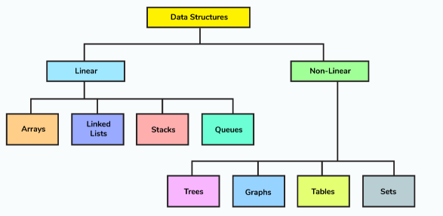

# Write a recursive function to calculate the height of a binary tree

public class Node{

int data;

Node left;

Node right;

}

int heightOfBinaryTree(Node node)

{

if (node == null)

return 0; // If node is null then height is 0 for that node.

else

{

// compute the height of each subtree

int leftHeight = heightOfBinaryTree(node.left);

int rightHeight = heightOfBinaryTree(node.right);

//use the larger among the left and right height and plus 1 (for the root)

return Math.max(leftHeight, rightHeight) + 1;

}

}

# Write code to count number of nodes in a binary tree

int countNodes(Node root)

{

int count = 1; //Root itself should be counted

if (root ==null)

return 0;

else

{

count += count(root.left);

count += count(root.right);

return count;

}

}