**R Plot Programs**

**1.**

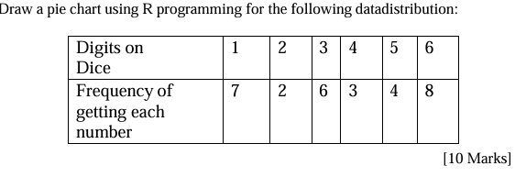

# Data

digits <- c(1, 2, 3, 4, 5, 6)

frequency <- c(7, 2, 6, 3, 4, 8)

# Create labels with digits

labels <- paste("Dice ", digits, sep = "")

# Plot pie chart

pie(frequency,

labels = labels,

main = "Pie Chart of Dice Roll Frequencies",

col = rainbow(length(frequency)),

clockwise = TRUE)

**2.**

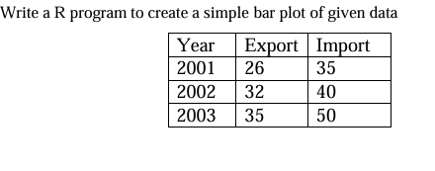

# Data

year <- c("2001", "2002", "2003")

export <- c(26, 32, 35)

import <- c(35, 40, 50)

# Combine Export and Import into a matrix

data <- rbind(export, import)

# Create bar plot

barplot(data,

beside = TRUE, # Side-by-side bars

names.arg = year, # Year labels

col = c("skyblue", "orange"), # Colors for export/import

main = "Export and Import (2001–2003)",

xlab = "Year",

ylab = "Value")

# Add legend

legend("topright",

legend = c("Export", "Import"),

fill = c("skyblue", "orange"))