
INDIAN INSTITUTE OF TECHNOLOGY KHARAGPUR
Department of Mining Engineering
Material Dynamics Laboratory

Stage 1: Validation and Parameter Identification of a
2-DOF Euler–Lagrange Model of a P&H-Class Cable Shovel
Research Progress Report · Milestone M1

Submitted by
Suhail Majeed Sheikh
Junior Research Fellow
Department of Mining Engineering, IIT Kharagpur
Under the supervision of
Prof. Sunita Mishra
Department of Mining Engineering, IIT Kharagpur
Sponsored Research Project No. IIT/SRIC/R/AEH/2026/104
in applied collaboration with CMPDI


July 2026

Acknowledgement
I record my sincere gratitude to my supervisor, Prof. Sunita Mishra of the Department of Mining Engineering, Indian Institute of Technology Kharagpur, for her guidance throughout this work. Her insistence that every derivation be verified independently, and every parameter traced to its source, is the standard this report has attempted to meet.
I thank the Central Mine Planning and Design Institute (CMPDI) for sponsoring this research and for providing the applied context, the operational and economic realities of production cable shovels, that keeps the work grounded in a genuine industrial need.
This work forms part of an interdisciplinary program pursued jointly with the Department of Electrical Engineering, Indian Institute of Technology Kharagpur.
I acknowledge the Department of Mining Engineering, Indian Institute of Technology Kharagpur, for the computational resources and the research environment that made this work possible.
Suhail Majeed Sheikh
July 2026

Abstract
Electric cable shovels lose on the order of US$100,000 per hour when unavailable, yet their internal condition is not directly measurable: motor signals mix the effects of motion, external load, and machine health into a single reading. This program separates those effects by subtracting exact rigid-body physics from measured drive torque, leaving a residual that carries load and condition information. This report documents the program's foundation (Milestone M1): a two-degree-of-freedom Euler–Lagrange model of a P&H-class cable shovel dipper–handle subsystem, saddle rotation and crowd extension, validated against an independently constructed Simscape multibody simulation acting as a numerical oracle. With joint accelerations sensed rather than numerically differentiated, both derived equations reproduce the oracle to machine precision (R² = 1.000000; residuals at the 10⁻¹³ level against MN·m-scale signals), and blind least-squares identification recovers all five model parameters exactly, with a correctly identified null for the deliberately excluded Coulomb term. A controlled comparison shows that numerical differentiation of encoder velocities biases the identified inertia by 56%, establishing sensed or observer-based acceleration as a hard instrumentation requirement for the field phase. The validated model now serves as the exact subtraction reference for the load-observer program: Milestone M2 requires recovery of a known injected dipper force to within 2–3% NRMSE, the first demonstration of the diagnostic channel this program exists to build.

Table of Contents
Abstract 2
Table of Contents 3
Nomenclature 4
1. Problem Statement 5
2. Dynamic Model 5
2.1 Abstraction: the 2-DOF dipper–handle subsystem 5
2.2 Equations of motion 6
2.3 Parameters and assumptions 7
3. Verification Methodology 7
3.1 An independent oracle 7
3.2 The isolation protocol 7
3.3 Sensed accelerations, data conditioning, and the startup transient 8
4. Parameter Identification 8
4.1 Linear-in-parameters formulation 8
4.2 Conditioning and excitation design 9
4.3 Metrics and provenance 9
5. Results 9
5.1 Excitation and forward validation 9
5.2 Blind parameter identification 11
5.3 Differentiated vs sensed accelerations 11
5.4 Startup-transient ablation 12
6. Scope and Outlook 12
6.1 What has and has not been proven 12
6.2 Outlook: from validated model to health monitor 13
References 14
Appendix A, Full Derivation Steps 15
Appendix B, Supplementary Evidence 17
B.1 Design-decision ledger 17
B.2 Full parameter table 17
B.3 Provenance and reproducibility 18

Nomenclature
Symbol correspondence with [1]: Rasuli writes joint angles θᵢ and collects parameters in Φ; this report writes coordinates q and collects parameters in θ. The symbol tables differ; the physics is identical.
Symbol | Description | Unit
q₃ | Saddle (dipper-handle) rotation angle about the saddle pivot | rad
d₄ | Crowd extension of the dipper handle (prismatic coordinate) | m
M_{d} | Combined mass of dipper and handle assembly | kg
I_{zz} | Moment of inertia of the dipper–handle assembly about the spin-parallel axis through the COG | kg·m²
L | Centre-of-gravity offset of the dipper–handle assembly | m
r, c | Derived geometric quantities of the COG position: r = d₄ + c, lever arm and its constant offset | m
f_{v3}, f_{c3} | Viscous and Coulomb friction coefficients, saddle (revolute) joint | N·m·s/rad, N·m
f_{v4}, f_{c4} | Viscous and Coulomb friction coefficients, crowd (prismatic) joint | N·s/m, N
K_{H}, K_{C} | Hoist and crowd motor force constants (armature current to force) | N/A
τ₃ | Generalized torque on the saddle coordinate | N·m
F₄ | Generalized force on the crowd coordinate | N
g | Gravitational acceleration | m/s²
θ (Φ) | Vector of identified (grouped) dynamic parameters | -
Y | Regressor matrix (linear-in-parameters formulation) | -
τ_{load} | Residual torque attributed to external load and condition effects | N·m

1. Problem Statement
An electric cable shovel is the single most production-critical machine in a large open-pit mine: when a production cable shovel stops, the truck fleet behind it stops, at a cost Rasuli documents at more than US$100,000 per hour of normal operation [2], his own field campaign interrupted production for roughly eight hours across four days, itself an argument for estimation methods that work from normal-operation data. Health monitoring and payload measurement are therefore decisive economics, not instrumentation luxuries. Yet the machine's internal condition cannot be measured directly. The signals that exist, motor currents, voltages, and speeds already present in the drive system, mix three causes into every reading: the commanded motion, the external load on the dipper, and the mechanical condition of the machine. A rising hoist current may mean a heavier pass, a change in operator style, or a bearing beginning to fail; the current alone cannot say which.
Rasuli, Tafazoli and Dunford [1] demonstrated the enabling half of the solution: motor signals encode the full dynamic state of the shovel, sufficient to identify its inertial and friction parameters and to estimate payload. But their estimator explicitly excludes the digging cycle, because during digging an unmeasurable external force acts on the dipper, precisely the phase in which faults are loaded, payload is acquired, and monitoring matters most. The estimator is blind exactly where the machine lives.
The resolution pursued by this program is observability by subtraction. Of the three mixed causes, the motion-induced torque is exactly computable from rigid-body physics once the machine's geometry and parameters are known. Subtracting it isolates what remains:
Equation 1. The core idea: exact physics turns motor signals into a load-and-condition channel.
Everything in this program depends on the subtracted model being exact, an error in τ_{model} appears in τ_{load} disguised as load or as fault. This report documents the construction and verification of that foundation, Milestone M1: a two-degree-of-freedom dynamic model of the dipper–handle subsystem, validated to machine precision against an independent multibody simulation, with all parameters recovered blind from simulated data. Sections 2–4 present the model, the verification methodology, and the identification machinery; Section 5 reports the results; Section 6 states the honest limits of what has been proven and the path from here to a field-deployable health monitor, the promise this report exists to underwrite.

2. Dynamic Model

2.1 Abstraction: the 2-DOF dipper–handle subsystem
The cable shovel is abstracted to the smallest subsystem that contains every class of term the full machine will exhibit: the dipper–handle assembly, moving in the saddle rotation q₃ (revolute) and the crowd extension d₄ (prismatic). Swing, hoist-rope actuation, and boom compliance enter at later milestones (M5–M6); the boom is passive geometry at this stage. The decisive geometric feature is the time-varying lever arm: the assembly's centre of gravity sits at distance r = d₄ + c from the saddle pivot, with c = −1.32 m the constant offset composed of the pivot-to-handle transform and the COG position, so extending the crowd genuinely changes the plant, its inertia about the pivot, its gravity moment, and its velocity coupling. One coordinate convention differs from the source: Rasuli measures d₄ from the saddle pivot itself (his crowd and saddle frames coincide by his stated assumption a₃ = 0), whereas this model measures d₄ from a datum 1.5 m along the handle; the two coordinates differ by that constant, only the lever arm r is physical, and the offset is absorbed exactly into the identified c.
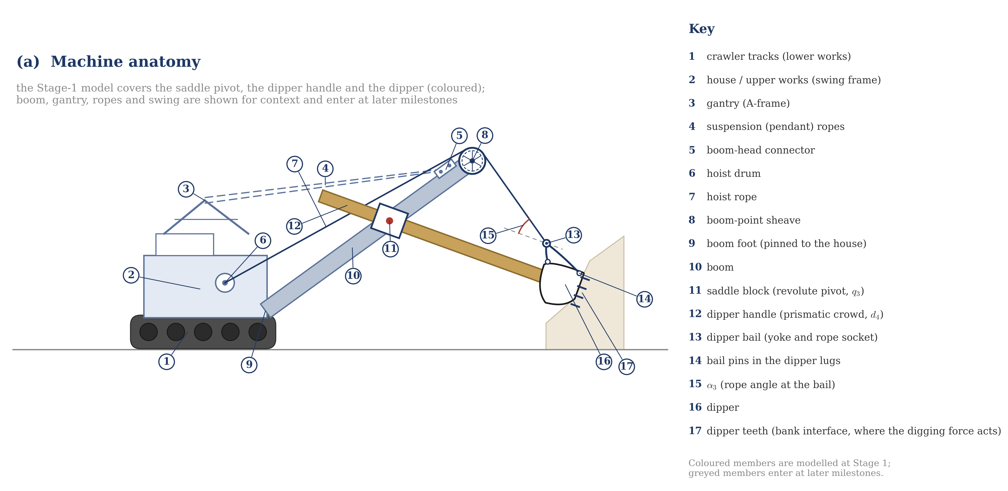
(a) Machine anatomy
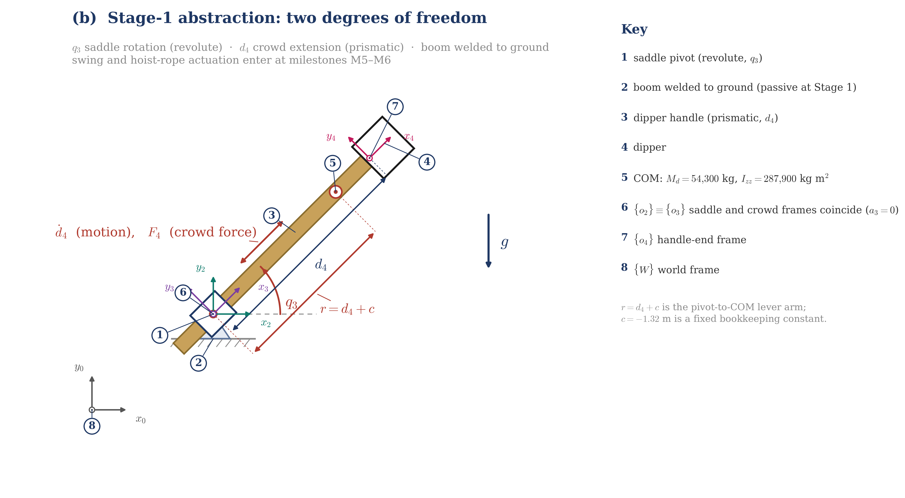
(b) Stage-1 two-degree-of-freedom abstraction
Figure 1. Cable shovel anatomy and the Stage-1 modelling abstraction (schematic, not to scale). (a) Machine anatomy in side elevation, with the members modelled at Stage 1 shown in colour and the remainder as context. (b) The two-degree-of-freedom abstraction: saddle rotation q₃, crowd extension d₄, and the time-varying lever arm r = d₄ + c. Frame convention and the coincident-origin assumption (a₃ = 0) in (b) follow Rasuli [2].

2.2 Equations of motion
The equations are derived by the Euler–Lagrange formalism, an energy-based route that avoids explicit bookkeeping of internal constraint forces:
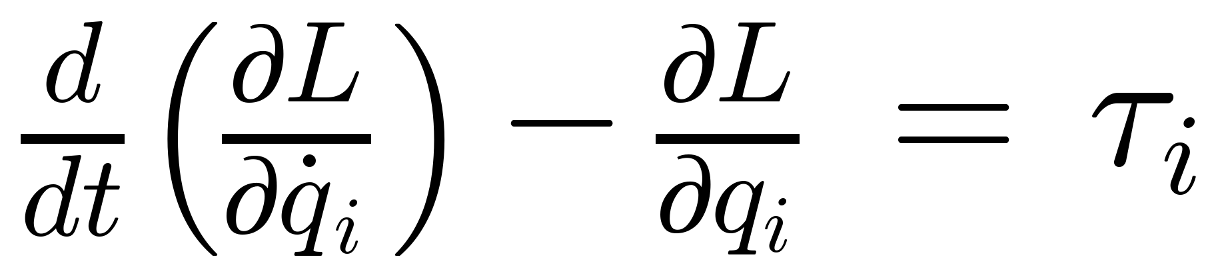
Equation 2. The Euler–Lagrange operator applied to each generalized coordinate.
Applying the operator to the Lagrangian of the assembly (full steps in Appendix A) yields the saddle equation,
Equation 3. Saddle (revolute) equation: configuration-dependent inertia, Coriolis coupling, gravity moment, viscous friction.
and the crowd equation,
Equation 4. Crowd (prismatic) equation: linear inertia, centrifugal relief, gravity component, viscous friction.
Each term has a physical reading. In Equation 3: (I_{zz} + M_{d} r²) is the parallel-axis inertia, the machine gets harder to swing as the crowd extends; 2M_{d} r ḋ₄ q̇₃ is the Coriolis torque produced by extending while rotating (the skater's-arms effect, factor 2 from differentiating r²); M_{d} g r cos q₃ is the gravity moment through the time-varying lever; f_{v3} q̇₃ is viscous joint friction. In Equation 4: −M_{d} r q̇₃² is centrifugal relief, rotation flings the handle outward, reducing the force the crowd drive must supply; M_{d} g sin q₃ is the gravity component along the slide. In the manipulator form D(q)q̈ + C(q,q̇)q̇ + G(q) = τ, these equations inherit the structural properties (symmetric positive-definite D; skew-symmetric Ḋ − 2C) on which the Milestone-M3 momentum observer relies.

2.3 Parameters and assumptions
All physical parameters derive from Rasuli et al. [1], Table II (dynamic-identification case), identified on a P&H 2100 production shovel; the model is therefore P&H-class rather than model-specific. Values: M_{d} = 54,300 kg; L_{COG_Offset} = 2.82 m; I_{zz} = 287,900 kg·m²; f_{v3} = 3,800 N·m·s/rad; f_{v4} = 1,473 N·s/m. They live in a single parameter file (shovel_params.m) read by both the simulation and the analysis, a construction adopted after duplicated constants were found to drift apart between files. The Stage-1 model is deliberately simplified, and each simplification is explicit: the mechanism is planar and rigid; friction is viscous only, the Coulomb coefficients on record in [1] (f_{c3} = 340 N·m, f_{c4} = 480 N) are excluded because sgn(q̇) discontinuities interact badly with variable-step integration, and their absence gives the identification a negative control; no external force acts on the dipper; parameters are constant. Table 2 in Section 6 maps each assumption to the milestone that removes it. Two claims are therefore made precisely: the equations are exact for this abstraction, and the abstraction's boundary is documented. A symbol note on the source: the 2.82 m entry is headed L_{COG_Offset} in [1] (L_{COGO} in [2]) and is the along-axis distance from the assembly's centre of gravity to the perpendicular through the dipper bail (point E, which lies above the handle axis); Rasuli's own construction r_{cd} = d₄ − L_{COG_Offset} (eq. 56 of [2]) uses it exactly as this model does. The hoist and crowd motor constants reported in the same table, K_{H} = 1940 N/A and K_{C} = 3950 N/A, are recorded for the field phase (Milestone M5).

3. Verification Methodology

3.1 An independent oracle
Verification requires a referee that cannot share the model's mistakes. The referee is a Simscape Multibody simulation of the same mechanism, constructed from part definitions, bodies, joints, transforms, gravity, from which the engine assembles constrained Newton–Euler equations numerically. It never sees the hand-derived algebra. One implementation convention is recorded for reproducibility: the rigid transform between the joints rotates the body frame 90° about +y, so the inertia about the spin axis, written I_{zz} in Section 2, occupies the first (local-x) slot of the Simscape body's moment-of-inertia vector. Agreement between the two is therefore evidence in the way two independent laboratories agreeing is evidence; had the analytical equations been coded as the simulation, agreement would only prove the same algebra was typed twice. The simulation prescribes smooth sinusoidal motion (q₃ = 45° ± 15°, d₄ = 8.75 ± 2 m, ω = π/10 rad/s) and senses the joint torque and force required, inverse dynamics, the same direction of inference the field problem poses, requiring no controller whose errors could contaminate the comparison.

3.2 The isolation protocol
Model verification proceeded under a fixed discipline: change one thing, predict the consequence, verify, then move. Four representative investigations from the model's debug history show the protocol operating; each is documented with its evidence in the research log.
Symptom | Isolation move | Root cause found
Torque ×1000 too small | Set g = 0: torque should collapse if gravity-dominated, it did not change | Spin axis parallel to gravity: the mechanism was a horizontal carousel; gravity exerted no moment
Residual at 2× input frequency | Recognised q̇₃² and cos-product signature: a squared sinusoid lives at twice the frequency | Missing centrifugal/Coriolis pathway, handle slid axially along the pin, so d₄ never changed the radius
Persistent geometry doubt | Blind identification as X-ray: let least squares confess the geometry the simulation actually contains | Estimator returned c = −1.320000 exactly, the 1.32 m offset confirmed from data alone
Sign ambiguity in crowd force | Correlation test of measured vs predicted force before metrics | Convention mismatch between slide direction and force sense; fixed at the comparison, not in the physics
Isolation protocol, representative investigations from the verification campaign.

3.3 Sensed accelerations, data conditioning, and the startup transient
Two instruments are kept deliberately separate throughout: forward validation (parameters known, does the predicted torque match?) certifies the equations; offline identification (parameters withheld, can data recover them?) certifies the estimation machinery and, run against the oracle, X-rays the simulation's actual geometry. Conflating them hides errors; separated, each catches what the other misses.
Joint accelerations are sensed directly from the multibody engine rather than numerically differentiated from velocities; Section 5.3 shows this choice is decisive. All analysis runs on the solver's own variable-step time vector, reconstructing a uniform clock misaligns every derivative, and the first 0.5 s of every run is discarded. The trim has a physical justification: the commanded sinusoid carries non-zero velocity at t = 0 while the joint starts at rest, a demand for finite momentum in zero time. The input filter (second-order, τ = 0.05 s) converts that impossible demand into a large but finite catch-up transient, of order the full gravity torque, lasting a few tenths of a second; trimming t > 10τ removes it (decay e⁻¹⁰). The transient is genuine rigid-body dynamics, exactly described by the validated equations when accelerations are sensed (Section 5.4), but it represents the artificial initial condition rather than shovel operation. Its field-side counterpart is cycle segmentation around impacts and reversals.

4. Parameter Identification

4.1 Linear-in-parameters formulation
Following Tafazoli et al. [5], the model is regrouped so that the unknowns enter linearly:
Equation 5. Regressor form: each column of Y is a known function of measured motion; θ groups the unknowns.
The regrouping converts a problem nonlinear in (M_{d}, c, I_{zz}) into one exactly linear in θ, convex, with a unique closed-form solution and no initial guess. Ordinary least squares with covariance-based uncertainty gives
Equation 6. The estimator and its covariance; 95% confidence intervals follow from the diagonal.
Physical parameters are recovered by un-grouping (ĉ = θ̂₂/θ̂₁, Î_{zz} = θ̂₃ − θ̂₂²/θ̂₁), with uncertainty propagated by the delta method. Confidence intervals are read as first-class results: an interval spanning zero, or comparable to its own estimate, is the estimator's declaration that the experiment cannot identify that parameter, not a value to be reported without its width.

4.2 Conditioning and excitation design
Estimates are only as good as the experiment that produced them, audited continuously through the condition number of Y and the per-parameter intervals, printed on every analysis run. Three design elements govern identifiability here. The saddle bias of 45° with ±15° amplitude keeps both cos q₃ and sin q₃ varying, so the gravity columns remain informative. The crowd amplitude was widened from an initial ±0.25 m to ±2 m after cond(Y) exceeded 10³, the lever arm must visibly change for the estimator to separate M_{d}, M_{d} c and I_{zz}; after the change, the column-scaled condition number fell to ≈82–87. One residual weakness is stated: both joints share a single excitation frequency (π/10 rad/s), leaving partial column correlation; decorrelated frequencies and phases are scheduled before Milestone M2. A physical asymmetry is also acknowledged: gravity contributes ≈2.5 MN·m while inertial terms contribute ≈10 kN·m at shovel timescales, so mass and lever parameters are intrinsically well-excited and I_{zz} intrinsically fragile, the reason acceleration quality (Section 5.3) dominates inertia identifiability.

4.3 Metrics and provenance
Fit quality is reported with the metrics standard in this literature (Fu et al. [4], Eq. 18):
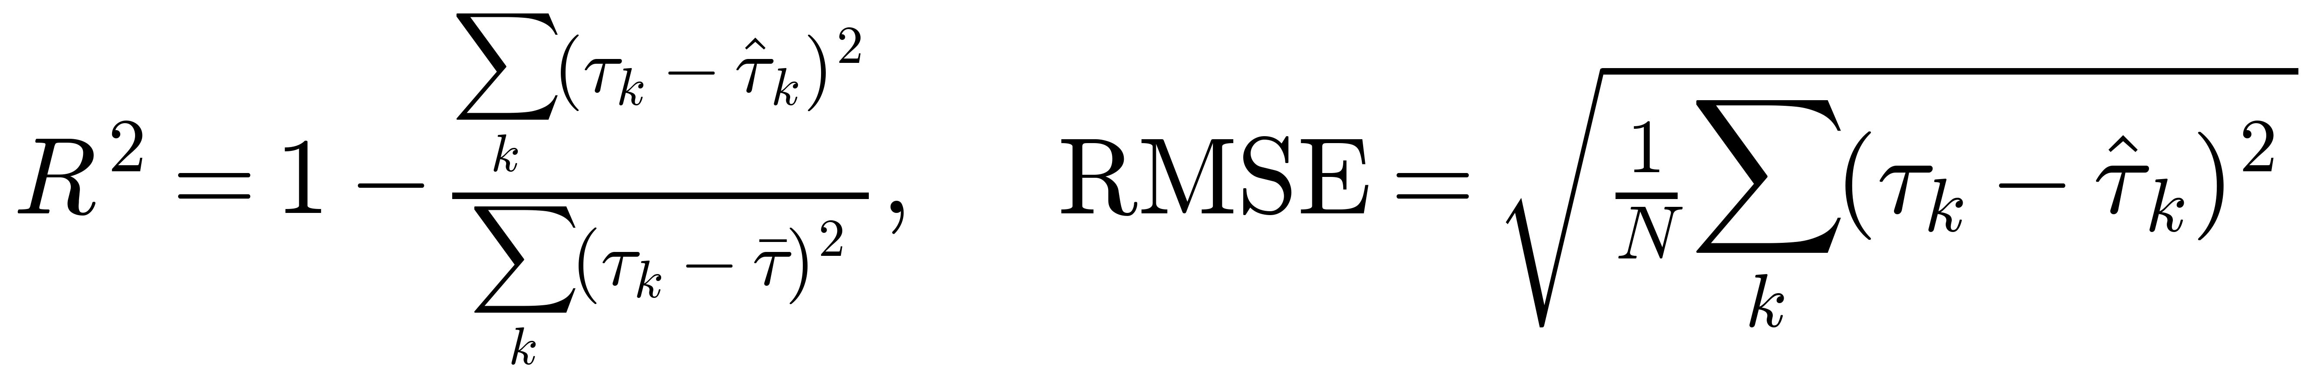
Equation 7. Goodness-of-fit metrics used throughout the program.
Every numerical claim in this report is receipted in the project's claims register with source, page, and verification status. Two provenance incidents are disclosed deliberately. An early parameter file mis-read a column of Table II; re-derivation against the paper caught it, and the correction is on record under version control. Separately, a claimed benchmark (“Rasuli reports R² = 0.942”) circulating in early drafts could not be located in [1], the paper reports payload means and standard deviations (e.g., 8,402 kg estimated vs 8,420 kg actual, σ = 104 kg, swing regime), not a validation R², and the claim was struck. One units trap is recorded for reproducibility: the joint dialog accepts viscous damping in N·m/(deg/s), so 3,800 N·m·s/rad enters as 66.3225; the parameter file performs the conversion in exactly one place.

5. Results

5.1 Excitation and forward validation
Figure 2 shows the excitation trajectories. Under sensed accelerations, the saddle equation reproduces the oracle with R² = 1.000000 and RMSE = 0 N·m; residuals sit at the 10⁻¹³ level against a 2.4–2.9 MN·m signal, the floating-point floor (Figure 3). The crowd equation, validated for the first time in the program, attains the same: R² = 1.000000, RMSE = 0 N (Figure 4). Agreement eleven orders of magnitude below signal scale between two independently constructed computations certifies the algebra, the geometry, and the parameter bookkeeping simultaneously. The residual panels of Figures 3–4 deserve a forward reading: that channel is the load channel of Equation 1 evaluated at zero load, and its machine-precision floor is the calibration certificate for the subtraction reference that Milestone M2 will populate with a real signal.
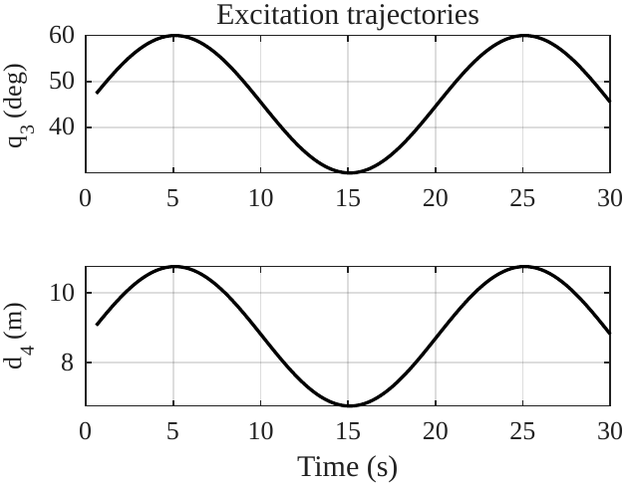
Figure 2. Excitation trajectories: q₃ = 45° ± 15°, d₄ = 8.75 ± 2 m, ω = π/10 rad/s (20 s period).
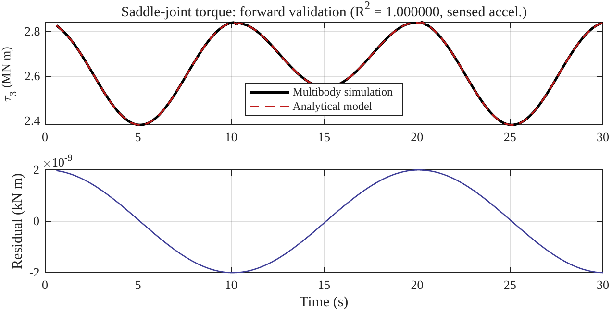
Figure 3. Saddle (revolute) equation vs multibody oracle: overlay and residual at the numerical floor.
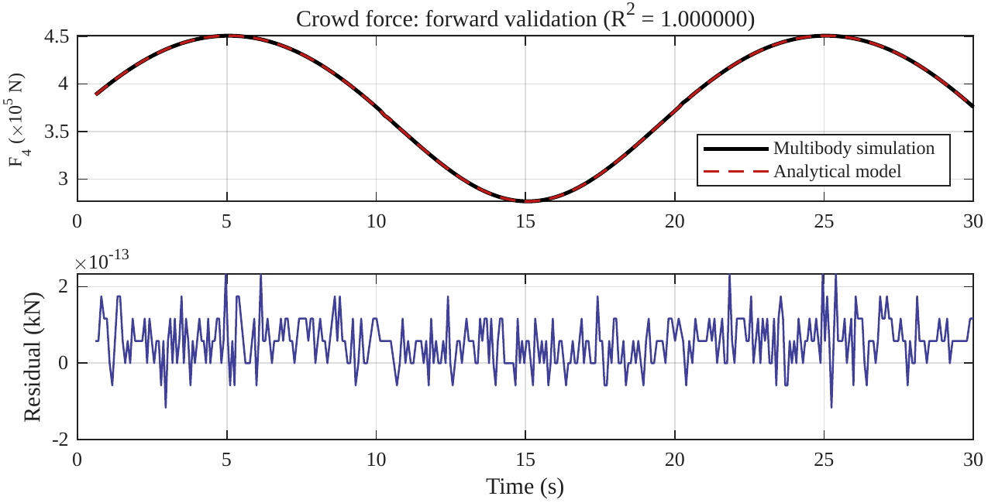
Figure 4. Crowd (prismatic) equation vs multibody oracle: first validation of this equation.

5.2 Blind parameter identification
With parameters withheld, least squares on sensed-acceleration data recovers every value exactly, with confidence intervals collapsed to numerical zero (Table 1. Figure 5). The Coulomb column returns a verified null, f_{c3} = 0.0 ± 0.0, matching its deliberate exclusion from the simulation: the estimator correctly reports the absence of what is genuinely absent.
Parameter | Identified ± 95% CI | Ground truth
M_{d} (kg) | 54,300.0 ± 0.0 | 54,300
c (m) | −1.3200 ± 0.0000 | −1.32
I_{zz} (kg·m²) | 287,900 ± 0 | 287,900
f_{v3} (N·m·s/rad) | 3,800.0 ± 0.0 | 3,800
f_{c3} (N·m) | 0.0 ± 0.0 | 0 (excluded from model)
Table 1. Blind identification under sensed accelerations: exact recovery of all parameters.
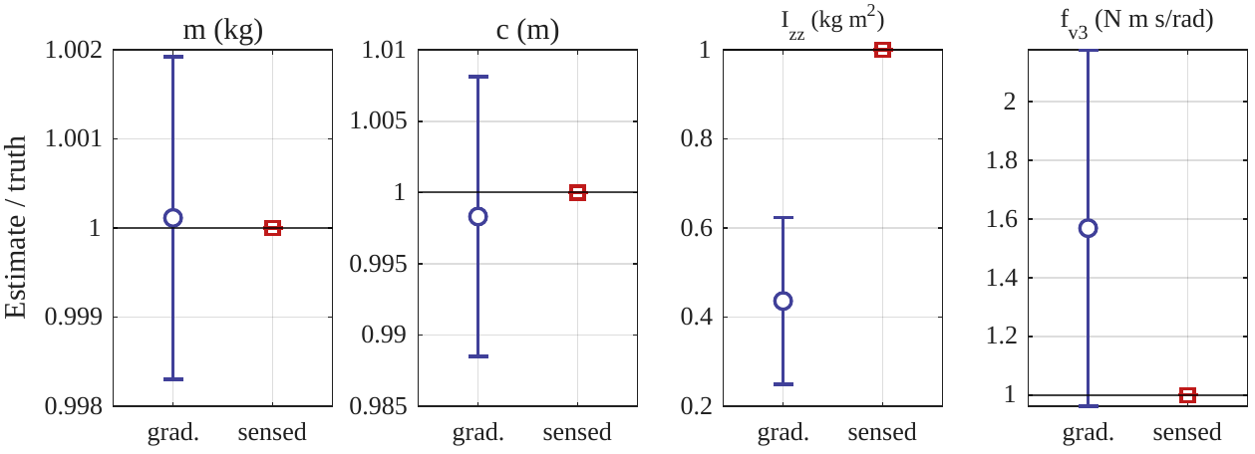
Figure 5. Estimate/truth ratios with 95% CIs: gradient-based (left member of each pair) vs sensed accelerations (right).

5.3 Differentiated vs sensed accelerations
Repeating the identical pipeline with accelerations obtained by numerical differentiation of logged velocities degrades forward validation to NRMSE ≈ 0.79% and biases the identified inertia to 125,804 kg·m², a 56% error, while mass and lever parameters remain tight (Figure 6). The mechanism is structural: differentiation amplifies high-frequency error, and the inertia term is ≈0.4% of total torque at shovel timescales, so differentiation noise lands exactly on the parameter that can least afford it. All validation error previously observed in the program is thereby attributed to numerical differentiation, not to the model. The field-phase consequence is a hard instrumentation requirement: acceleration must be sensed or estimated by an observer (Milestone M3), never numerically differentiated from encoder velocities.
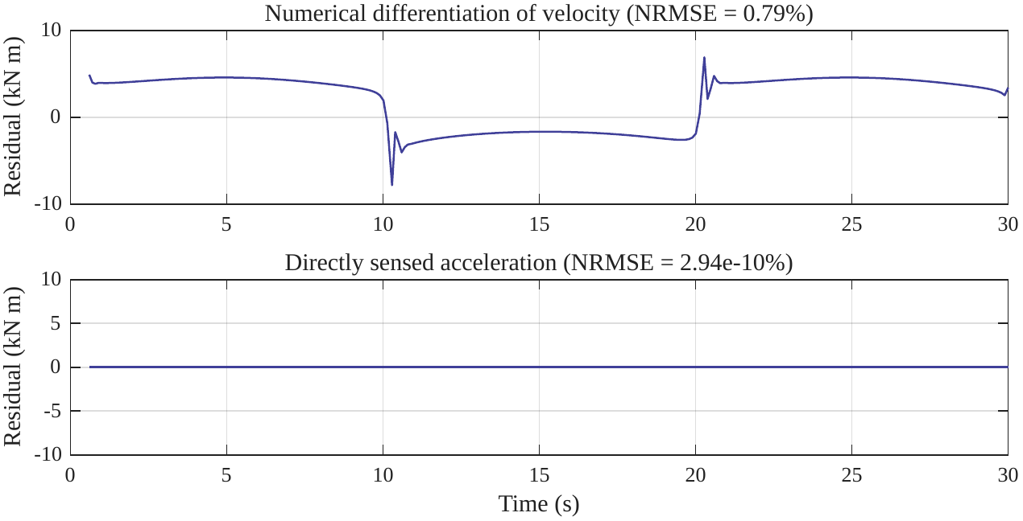
Figure 6. The differentiation study: the gradient pipeline's entire residual is differentiation noise.

5.4 Startup-transient ablation
A controlled ablation removed the 0.5 s trim of Section 3.3 while one equation ran on sensed accelerations and the other on the gradient fallback. The crowd equation, fed true accelerations, retained R² = 1.000000 through the startup spike, the transient is genuine rigid-body dynamics, exactly described by the model. The saddle equation on differentiated accelerations collapsed to R² = 0.933 (NRMSE 2.58%), and its identification became uninformative (Î_{zz} = 79,336 ± 143,359; f̂_v3 = −68,447 ± 242,596, intervals larger than their estimates). The ablation separates the effects cleanly: the spike does not break the physics; it breaks numerical differentiation. The trim protects the analysis, not the model. A follow-up single-variable ablation (both equations on sensed accelerations, trim as the only change; archived under experiments/2026-07-15_trim_ablation/) sharpens the point: the untrimmed run recovers every parameter exactly and improves the scaled condition number from 82.2 to 13.4, the large startup accelerations enrich the excitation. At this stage the trim is therefore conservative hygiene for later noisy or differentiated data, not a Stage-1 necessity.
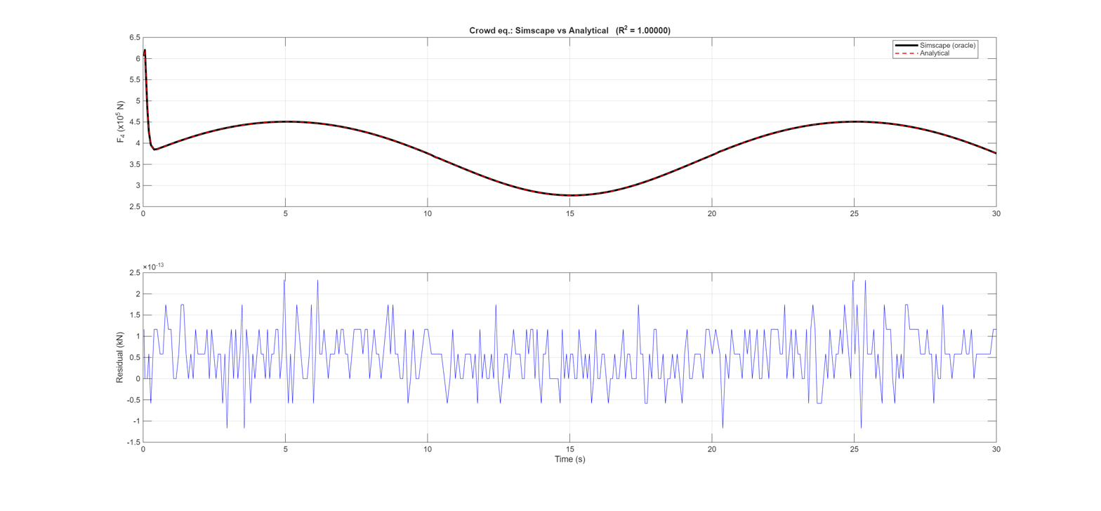
Figure 7. Crowd (prismatic) equation, untrimmed run: multibody oracle versus analytical model, with the residual panel below.
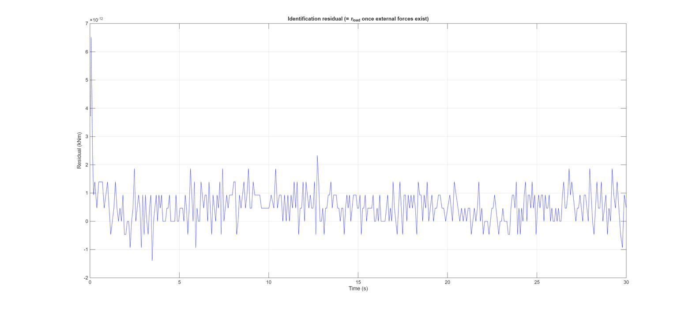
Figure 8. Identification residual for the untrimmed run: the τ_{load} channel, empty at Stage 1 and calibrated for the load estimate that Milestone M2 will populate.
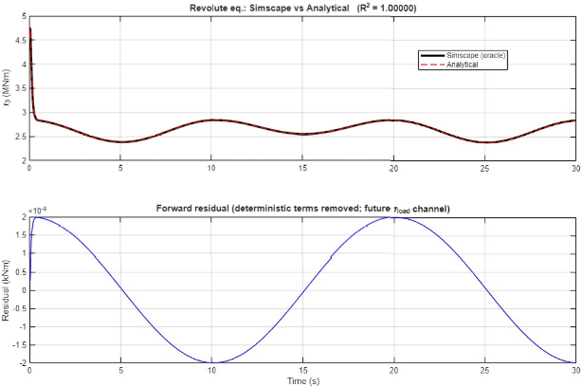
Figure 9. Saddle (revolute) equation, untrimmed run: multibody oracle versus analytical model, with the forward residual below.

6. Scope and Outlook

6.1 What has and has not been proven
Machine-precision agreement certifies mathematical correctness: the derived equations are term-for-term identical to an independent multibody solution under the stated assumptions. It does not certify field accuracy, the simulation is noise-free, rigid, planar, and friction-simplified, and the zero-width confidence intervals are a simulation-only phenomenon that real data will reopen. The bounded claim answers the promise of Section 1: the subtraction reference of Equation 1 is now exact by construction, so any future residual is attributable to what the model deliberately omits, load, condition, noise, rather than to modelling error. Stage 1 built and proved the instrument; it has not yet pointed it at the target. Table 2 states every simplification and its removal milestone; the boundary of every claim in this report is that table.
# | Assumption (Stage 1) | Reality | Removed at
A1 | 2 DOF only (saddle + crowd) | Swing, hoist rope, boom compliance | M5–M6
A2 | Perfectly rigid bodies | Handle flex, boom modes, rope stretch | M6 partly; residue → M9
A3 | Planar mechanism, gravity tilted in-plane | 3-D machine; swing couples out-of-plane | M6
A4 | Viscous friction only, constant | Coulomb + Stribeck, temperature-dependent | Coulomb pre-M4; drift → M9
A5 | Joint torque directly measurable | Only motor current; K = K′Φ(i_{f}), gearbox η | M5
A6 | Noise-free signals; sensed accelerations | 30 Hz sampled, quantized, noisy; no accelerometer | M4 noise; M3 observer
A7 | Parameters constant and exact | Wear and temperature cause drift | Drift IS the health signal, M9
A8 | No external forces in validation | The machine digs | M2 recovery; M7 structure
A9 | Smooth sinusoidal excitation | Jerky, operator-dependent cycles, impacts | M4/M8 segmentation
A10 | Slide passes through the pivot (e = 0) | Trunnion axis vs guide bore likely eccentric; [1] assumes a₃ = 0 (o₂ ≡ o₃) and identifies under it, inherited here; detection: sin q₃ residual signature | e-model at M6/M8
Table 2. Assumptions ledger: each simplification and the milestone that removes it.

6.2 Outlook: from validated model to health monitor
The program proceeds through nine milestones (Figure 10). The immediate next step, M2, injects a known time-varying external force at the dipper in simulation, unknown to the analytical model, and requires the residual to recover it within 2–3% NRMSE: the first demonstration that the cleaned channel carries load information. M3 replaces the acceleration requirement with a generalized-momentum observer, exploiting the structural properties noted in Section 2.2. M4 adds measurement noise under the ±5–25% protocol of [4]; M5 builds the motor-current-to-torque map through the drive and gearbox; M6–M7 extend to four degrees of freedom with digging-force structure informed by [2, 3]. M8 is the reality gate, validation on CMPDI machine data against weighbridge ground truth, for which the 18-item data-requirements specification is already with the sponsor; the data pipeline runs concurrently with the simulation milestones so no external delay stalls the program. M9 delivers the health layer: parameter drift tracked by recursive estimation and a physics-informed learner for the residual that rigid-body physics cannot express, the diagnostic product for the CMPDI context that Section 1 promised.
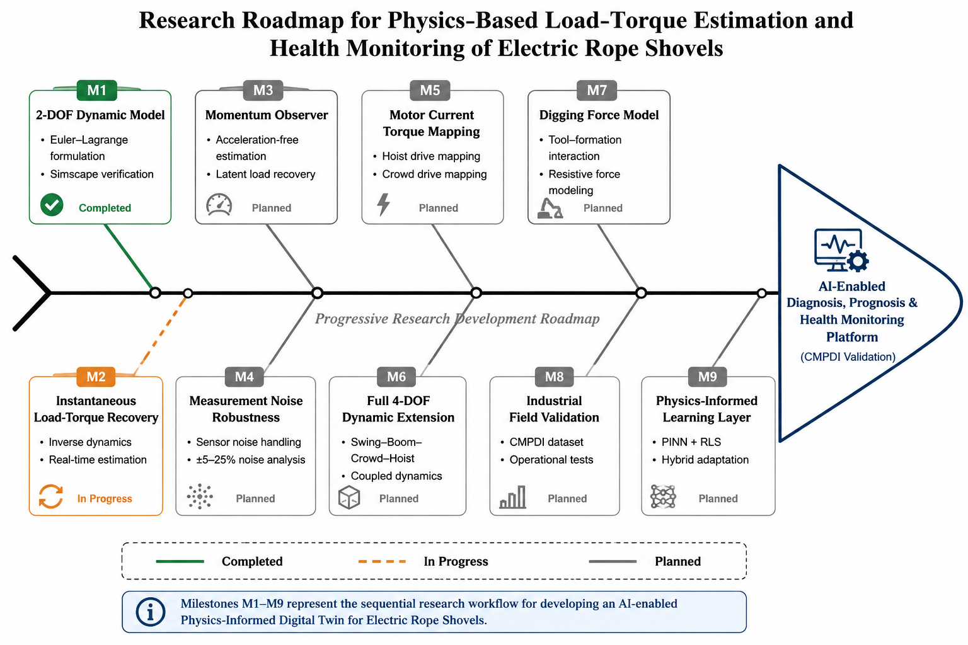
Figure 10. Milestone fishbone: M1 complete, M2 in progress, reality gate at M8.

References
[1] A. Rasuli, S. Tafazoli and W. G. Dunford, “Dynamic modeling, parameter identification, and payload estimation of mining cable shovels,” IEEE Transactions on Industry Applications, vol. 50, no. 3, pp. 2127–2135, 2014.
[2] A. R. Rasuli, “Dynamic modeling, parameter identification, payload estimation, and non-contact arm geometry sensing of the mining cable shovel,” Ph.D. thesis, University of British Columbia, Vancouver, 2012. Open access: UBC cIRcle, item 1.0073407.
[3] M. W. Spong, S. Hutchinson and M. Vidyasagar, Robot Modeling and Control. Hoboken, NJ: Wiley, 2006 (rigid-body kinetic-energy decomposition).
[4] T. Fu et al., “Novel hybrid physics-informed deep neural network for dynamic load prediction of electric cable shovel,” Chinese Journal of Mechanical Engineering, vol. 35, 2022. doi: 10.1186/s10033-022-00817-x.
[5] S. Tafazoli, P. D. Lawrence and S. E. Salcudean, “Identification of inertial and friction parameters for excavator arms,” IEEE Transactions on Robotics and Automation, vol. 15, no. 5, 1999.
[6] S. Frimpong and Y. Hu, “Intelligent cable shovel excavation modeling and simulation,” International Journal of Geomechanics (ASCE), vol. 8, no. 2, pp. 2–10, 2008.
[7] S. Frimpong, Y. Hu and K. Awuah-Offei, “Mechanics of cable shovel-formation interactions in surface mining excavations,” Journal of Terramechanics, vol. 42, no. 1, pp. 15–33, 2005. doi: 10.1016/j.jterra.2004.06.002.

Appendix A, Full Derivation Steps
Setup. The dipper–handle assembly (mass M_{d}, moment of inertia I_{zz} about the spin-parallel axis through its COG) rotates about the saddle pivot by q₃ while translating along the handle by d₄. The COG lies on the slide axis at lever arm r = d₄ + c (c = −1.32 m). In the plane of motion, with gravity in-plane:
Step 1, velocity of the COG. Differentiating position in polar form gives radial rate ṙ = ḋ₄ and transverse rate r q̇₃, so
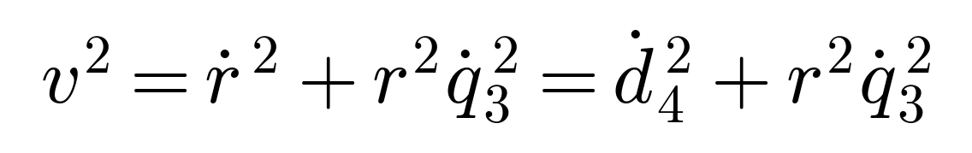
Step 2, kinetic energy. By König's theorem [3], translation of the COG plus rotation about it (the q̇₃² term with I_{zz} is the origin, together with the M_{d} r² term, of the parallel-axis inertia):
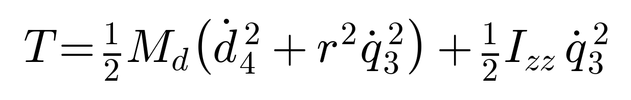
Step 3, potential energy and the Lagrangian. The COG height above the pivot is r sin q₃:
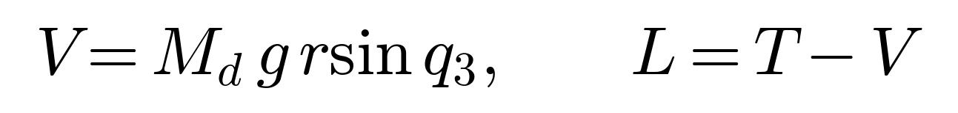
Step 4, saddle equation, momentum branch. Differentiate L with respect to q̇₃ and then time; the product rule on r²(t) is the origin of the factor 2 in the Coriolis term:
Step 5, saddle equation, configuration branch:
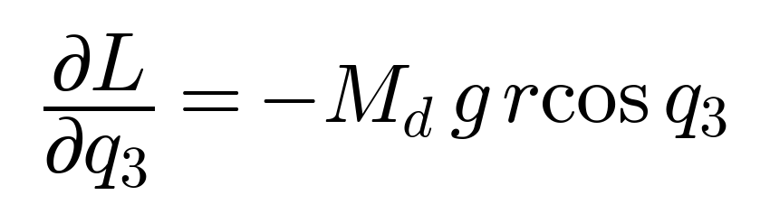
Step 6, assemble Equation 2 for q₃ and append the dissipative (viscous) generalized force, which the conservative Lagrangian cannot produce (formally, a Rayleigh dissipation term):
Step 7, crowd equation, momentum branch:
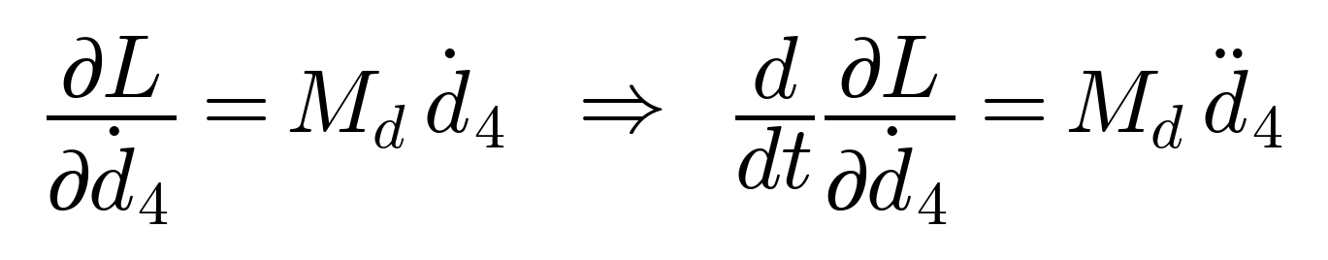
Step 8, crowd equation, configuration branch. Both the centrifugal and gravity dependences enter through r and the height term:
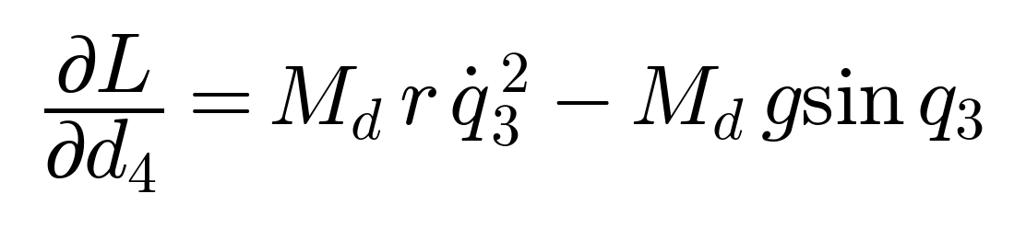
Step 9, assemble and append viscous dissipation. Note the sign of the centrifugal term: rotation relieves the crowd drive.
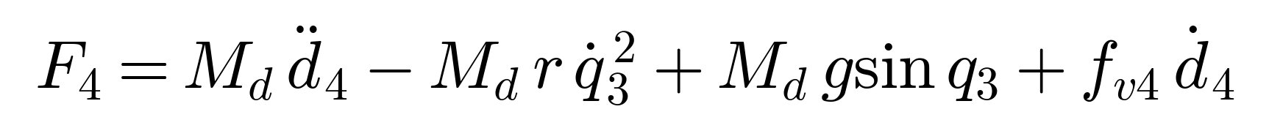
The two boxed results are Equations 3 and 4 of the main text, and the exact algebra implemented term-for-term in the analysis script.

Appendix B, Supplementary Evidence

B.1 Design-decision ledger
Every consequential Stage-1 choice, the alternative rejected, and the deciding reason. Rows citing an incident are choices forced by a documented failure in the debug history.
Choice made | Alternative rejected | Deciding reason
2-DOF subsystem | Full machine / 1-DOF | Smallest system containing every term type; 1-DOF has no telescoping radius
Simscape referee | Hand-coded ODE | Independent equation assembly → non-circular validation
Tilted gravity, planar | 3-D frame stacks | Fewer failure points (carousel incident); planar-valid; revisited at M6
COG on slide axis | Perpendicular offset | One clean lever scalar; one-change-at-a-time discipline
Motion-prescribed, torque-sensed | Torque-driven + controller | Matches the field inference; no controller contamination
Viscous now, Coulomb later | Both now | sgn(q̇) discontinuity vs variable-step solver; null return is a negative control
Solver time base law | Uniform reconstructed clock | Incident: linspace misalignment corrupted every derivative
Sensed accelerations | Differentiated velocities | 56% I_{zz} bias vs exact recovery (Section 5.3); also a field finding
Single-tone sines | Chirp / multisine | Analytic debuggability (frequency-doubling diagnostic); multisine is the field upgrade
Trim t > 0.5 s (10τ) | Keep all samples | Startup transient is an initial-condition artifact (Section 3.3, Section 5.4)
Slide axis through pivot (e = 0) | Explicit-e model (gravity M_{d} g(r cos q₃ − e sin q₃); extra regressor column) | Shared with source: [1] states a₃ = 0 with o₂ ≡ o₃ coincident; identified parameters are those of the e = 0 model. sin q₃-shaped residual will flag a real e at M8 (Section 2.3)
OLS batch | Recursive LS | All data at once; drift tracking is M9's job by design
Regressor regrouping | Nonlinear least squares | Convex, unique, no initial guess (Tafazoli [5])

B.2 Full parameter table
Complete Stage-1 parameter set with provenance and model status. Every value traces to Rasuli et al. [1], Table II (dynamic-identification case), receipted in claims.md.
Parameter | Symbol | Value | Unit | Status in Stage-1 model
Dipper + handle mass | M_{d} | 54,300 | kg | In model
COG offset of assembly | L_{COG_Offset} | 2.82 | m | In model (via c)
Derived lever constant (pivot–COG) | c | −1.32 | m | Derived: transform 1.5 − L; r = d₄ + c
Moment of inertia (COG, spin-parallel axis) | I_{zz} | 287,900 | kg·m² | In model
Viscous friction, saddle | f_{v3} | 3,800 | N·m·s/rad | In model (dialog entry: 66.3225 N·m/(deg/s))
Viscous friction, crowd | f_{v4} | 1,473 | N·s/m | In model
Coulomb friction, saddle | f_{c3} | 340 | N·m | On record; deliberately excluded (Section 2.3)
Coulomb friction, crowd | f_{c4} | 480 | N | On record; deliberately excluded (Section 2.3)
Gravitational acceleration | g | 9.80665 | m/s² | In model (in-plane, Section 3.1)
Saddle excitation | q₃ | 45 ± 15, ω = π/10 | deg, rad/s | Experiment design (Section 4.2)
Crowd excitation | d₄ | 8.75 ± 2, ω = π/10 | m, rad/s | Experiment design (Section 4.2)
Table B.1, Full parameter set: values, provenance, and Stage-1 model status.

B.3 Provenance and reproducibility
All artifacts are version-controlled in a private repository (github.com/sonu037/shovel_dynamics). The frozen evidence for this report is experiments/2026-07-07_stage1_final/: stage1_results.mat (complete run record, signals, estimates, covariances, condition numbers) plus five vector figures regenerable by scripts/make_stage1_figures.m. The model is model/ShovelSimulator.slx with its CHANGELOG; parameters live solely in scripts/shovel_params.m; the analysis is scripts/validate_and_identify.m, whose header documents nine audited fixes (G1–G9). Numerical claims are receipted in claims.md; the day-by-day narrative, including all defect investigations of Section 3.2 and both provenance incidents of Section 4.3, is research_log.md. Any figure or number in this report can be regenerated from the repository at the commit tagged for this release.

