Software Testing Assignment

**Module–1(Fundamental)**

1. **What is software testing?**

**Ans**.) It is activity where we check whether the actual requirement is equal to the expected requirement.

2) It checks the correctness,completeness and quality of the software

**2**. **What is SDLC?**

**Ans**.Software Development Life Cycle is a process used by software industry to design, develop and test software.

Phases of SDLC

1. **Requirements**
2. **Analysis**
3. **Design**
4. **Implementation**
5. **Testing**
6. **Maintenance**

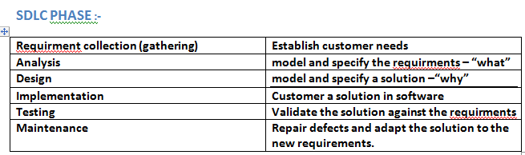

**3.What is SRS?**

**Ans.** Software Requirement specificationin that document they will document every requirement from the customer.

**4**.**What is agile methodology?**

**Ans.** It is combination iteractive and increment model.

* It is divides the software into small incremental builds are provided in iterations that meansthe big projects are divided into small chunks.
* Each iteration last about one to three weeks.
* Each iteration involves all the team members to working simultameously analysis, coding, unit testing and acceptance testing.

**5**.**What is oops?**

**Ans**. Identifying objects and assigning responsibilities to these objects.

Objects communicate to other objects by sending message

An object is like a black box

The internal details are hidden.

**6.Write Basic Concepts of oops**

**Ans. 1) Class**

**2) Object**

**3) Encapsulation**

**4) Inheritance**

**5) Polymorphism**

**7. What is class?**

**Ans.**Class is collection of Data and Function

**8.What is object?**

**Ans.**Object gives permission to access the functionality of class

**9.What is encapsulation?**

**Ans.**Wrapping of Data

**10.What is inheritance?**

**Ans.** Creating a class from an existing class

**11.What is polymorphism?**

**Ans.** One name multiple from

**1)Over ridding**

**2)Over loading**

**12. Write SDLC phases with basic introduction**

**Ans.**Phases of SDLC

1. **Requirements**
2. **Analysis**
3. **Design**
4. **Implementation**
5. **Testing**
6. **Maintenance**

**1.Requirement**

Collect the requirement from the customer and once they get the requirement they prepare some kind of document that is called SRS document (Software Requirement Specification)

2.**Analysis**

Ideally this document states in a clear and prease fashion what is to be built.

3.**Design**

Based on the requirement document the designer will prepare the design document.

4.**Implementation**

Implementation in the sense of development(coding)

5.**Testing**

Tester will test the software.

6.**Maintenance**

Customer start using the software so that is a maintenance phase. Repair defects and adapt the solution to the new requirement.

1) **Adaptive maintenance**

Adapting the existing solution of the new platforms

2) **Corrective maintenance**

Identifying and repairing defect

3) **Perfective maintenance**

Implementing the new requirements

**13**.**Write agile manifesto principles**

**Ans. The 12 agile principles**

### 1)  Satisfy Customers Through Early & Continuous Delivery

### 2)**Welcome Changing Requirements Even Late in the Project**

### 3)**Deliver Value Frequently**

### 4)**Break the Silos of Your Project**

### **5)Build Projects Around Motivated Individuals**

### 6)**The Most Effective Way of Communication is Face-to-face**

### 7)**Working Software is the Primary Measure of Progress**

### 8)**Maintain a Sustainable Working Pace**

### 9)**Continuous Excellence Enhances Agility**

### 10)**Simplicity is Essential**

### 11)**Self-organizing Teams Generate Most Value**

### 12)**Regularly Reflect and Adjust Your Way of Work to Boost Effectiveness**

**14. Explain working methodology of agile model and also write pros and cons.**

**Ans.** It is combination iteractive and increment model.

* It is divides the software into small incremental builds are provided in iterations that means the big projects are divided into small chunks.
* Each iteration last about one to three weeks.
* Each iteration involves all the team members to working simultameously analysis, coding, unit testing and acceptance testing.
* At the end of the iteration the working product is displayed to the customer or the important stake holder and it is released in the market
* After the release we check for the feedback of the deployed software
* It any enhancement is needed in the projects then it’s re-released

Advantage.

* Frequent delivery
* Face to face communication with the customer
* Less time
* Adaptability

**Disadvantage.**

* Less documentation
* Maintenance problem

**15. Explain Phases of the waterfall model**

**Ans. 1) Unit testing** Unit tests designed in module design phase are executed on the code during this validation phase unit testing is the testing at code level and helps eliminate bags of an early stage, though all defects cannot be uncovered by unit testing.

**2)Integration testing**

Testing is associated with the architectural design phase. Integration tests are performed to test the coexistence and communication of the internal modules within the system

**3) System testing**

System testing is directly associated with the system design phase. System tests check the entire system functionality and the communication of the system under development with external system. Most of the software and hardware compatibility issues can be uncovered during system test executing.

**4) Acceptance testing**

Acceptance testing is associated with the business requirement analysis phase and involves testing the product in user environment Acceptance testing the compatibility issue with the other system available in the user environment. It also discovered the non-functional issue as load and performance defects in the actual user environment.

**16.Write phases of spiral mode**

**Ans.**

1. **Determine objectives and find alternate solutions**

 This phase includes requirement gathering and analysis. Based on the requirements, objectives are defined and different alternate solutions are proposed.

1. **Risk Analysis and resolving**

In this quadrant, all the proposed solutions are analyzed and any potential risk is identified, analyzed, and resolved.

1. **Develop and test**

 This phase includes the actual implementation of the different features. All the implemented features are then verified with thorough testing.

1. **Review and planning of the next phase**

In this phase,the software is evaluated by the customer. It also includes risk identification and monitoring like cost overrun or schedule slippage and after that planning of the next phase is started.

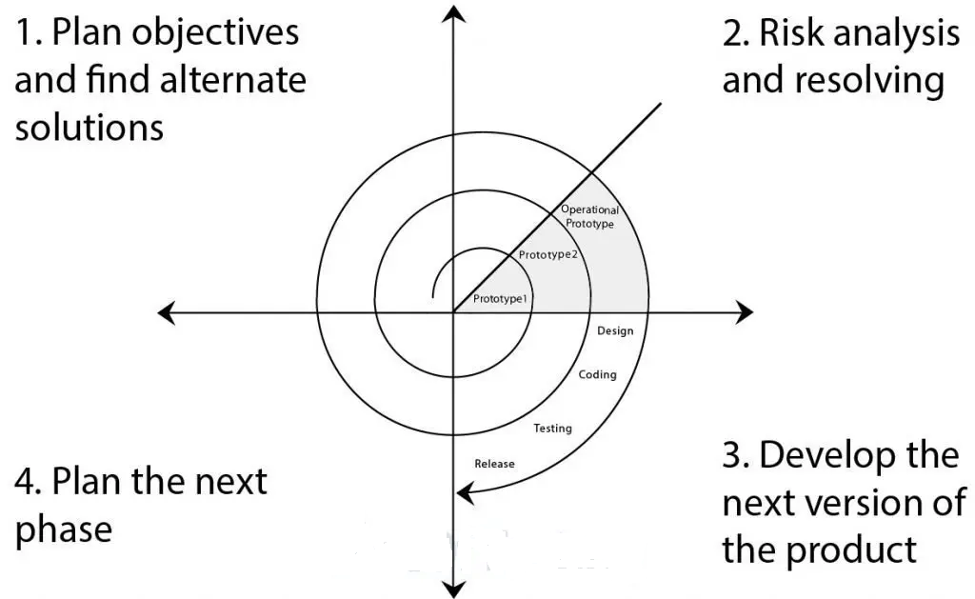

**17.Draw Usecase on Online book shopping**

**Ans.**

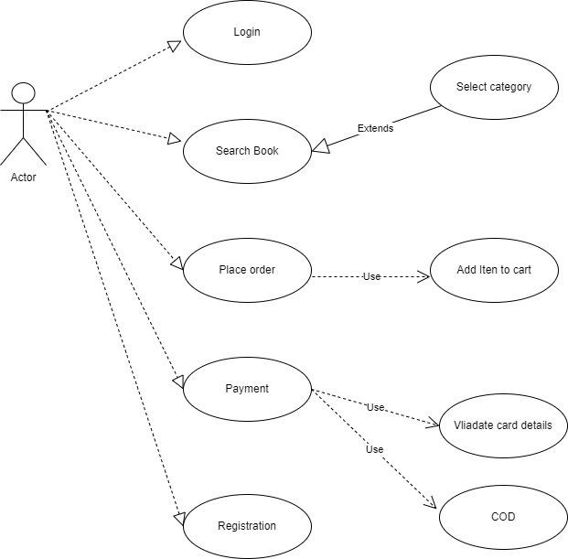

**18. Draw Usecase on online bill payment system (paytm)**

**Ans.**

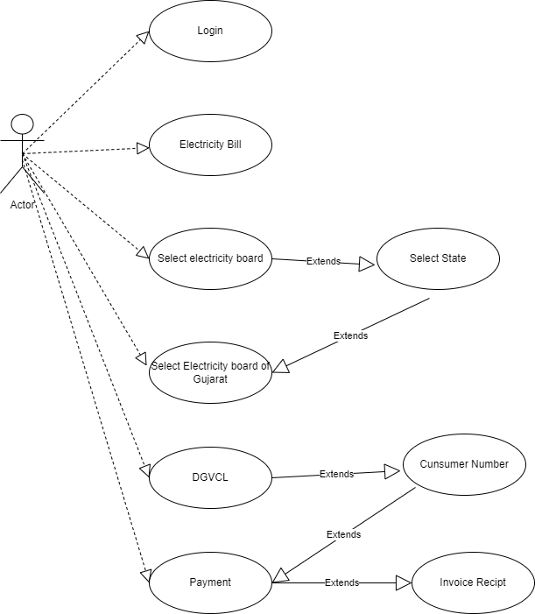

**19. Draw usecase on Online shopping product using COD**.

**Ans.**

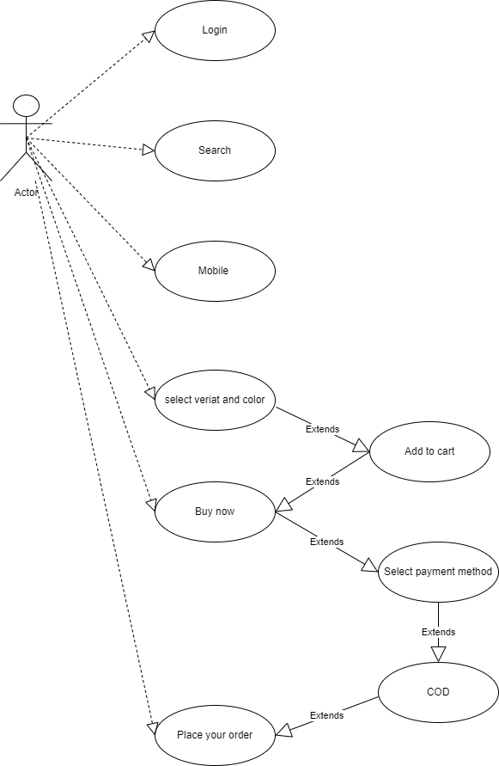

**20. Draw usecase on Online shopping product using payment gateway.**

**Ans.**

