POST /product - Add product to the MongoDB database

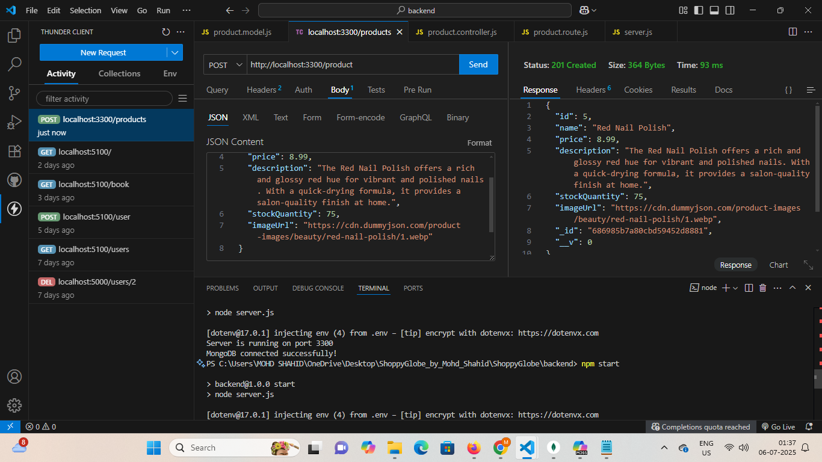

GET /products - Fetch a list of products from MongoDB database

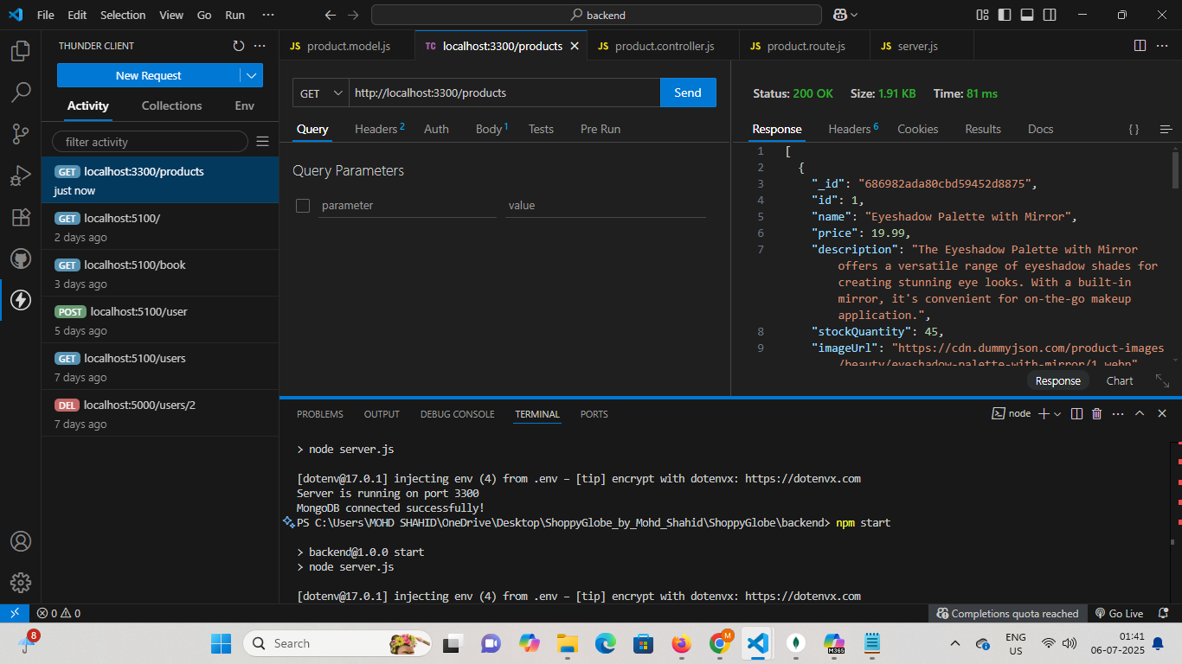

GET /products/:id - Fetch details of a single product by its ID

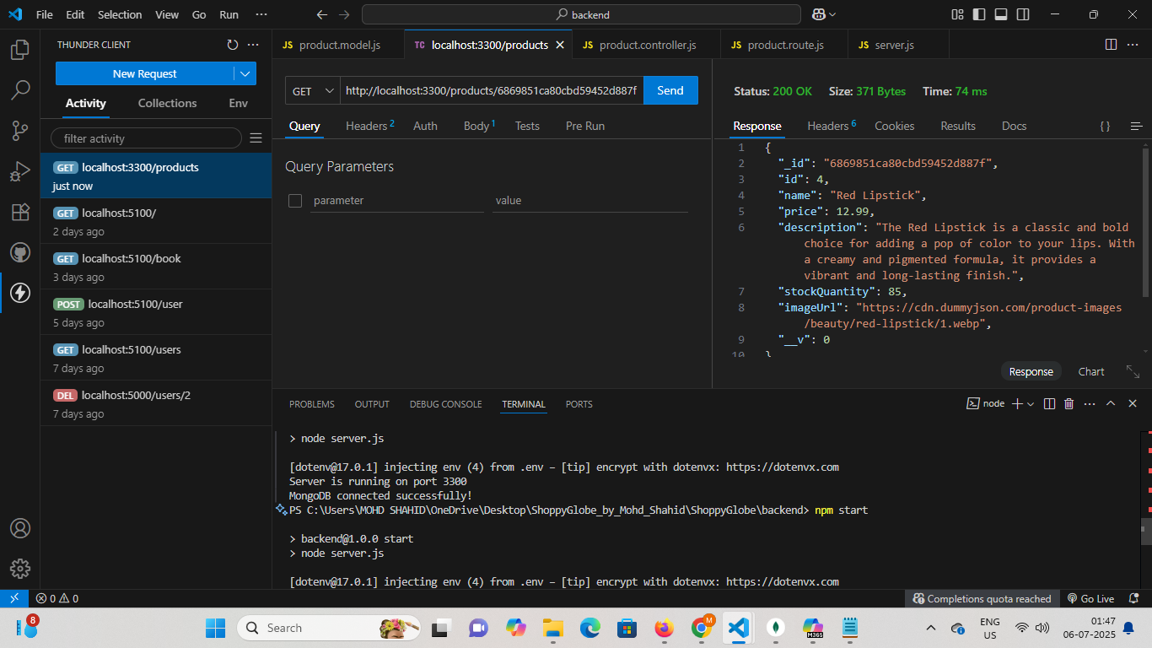

POST /register - Register a new user

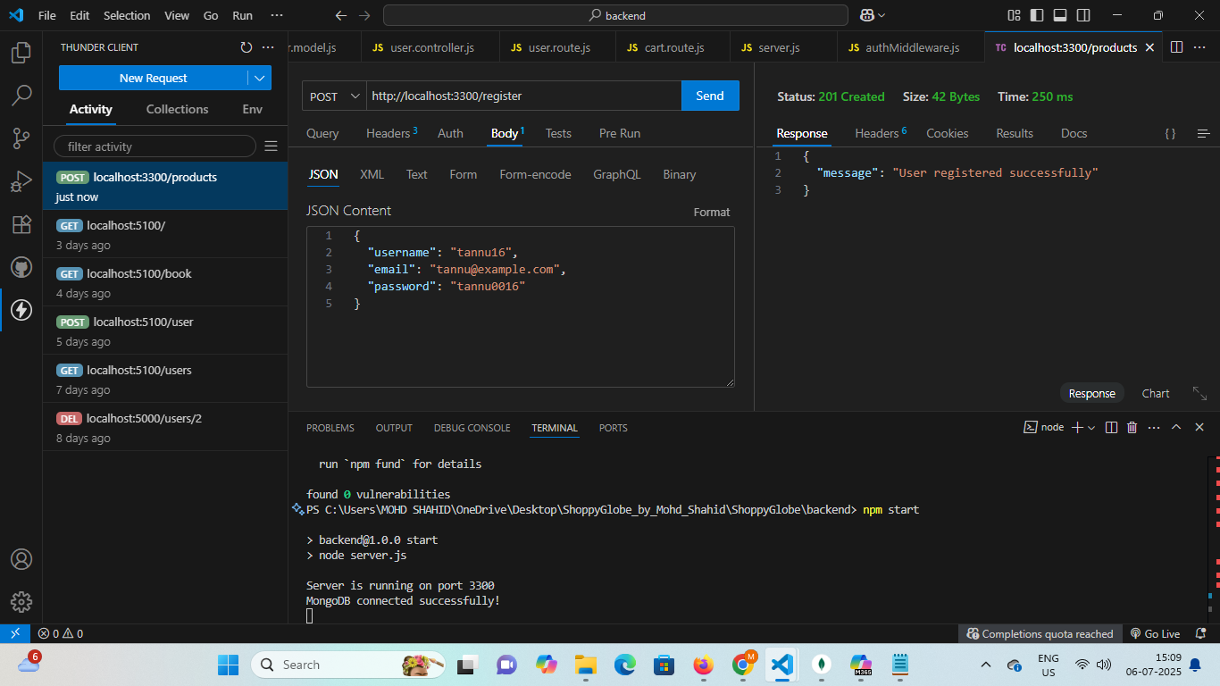

POST /login - Authenticate user and return a JWT token

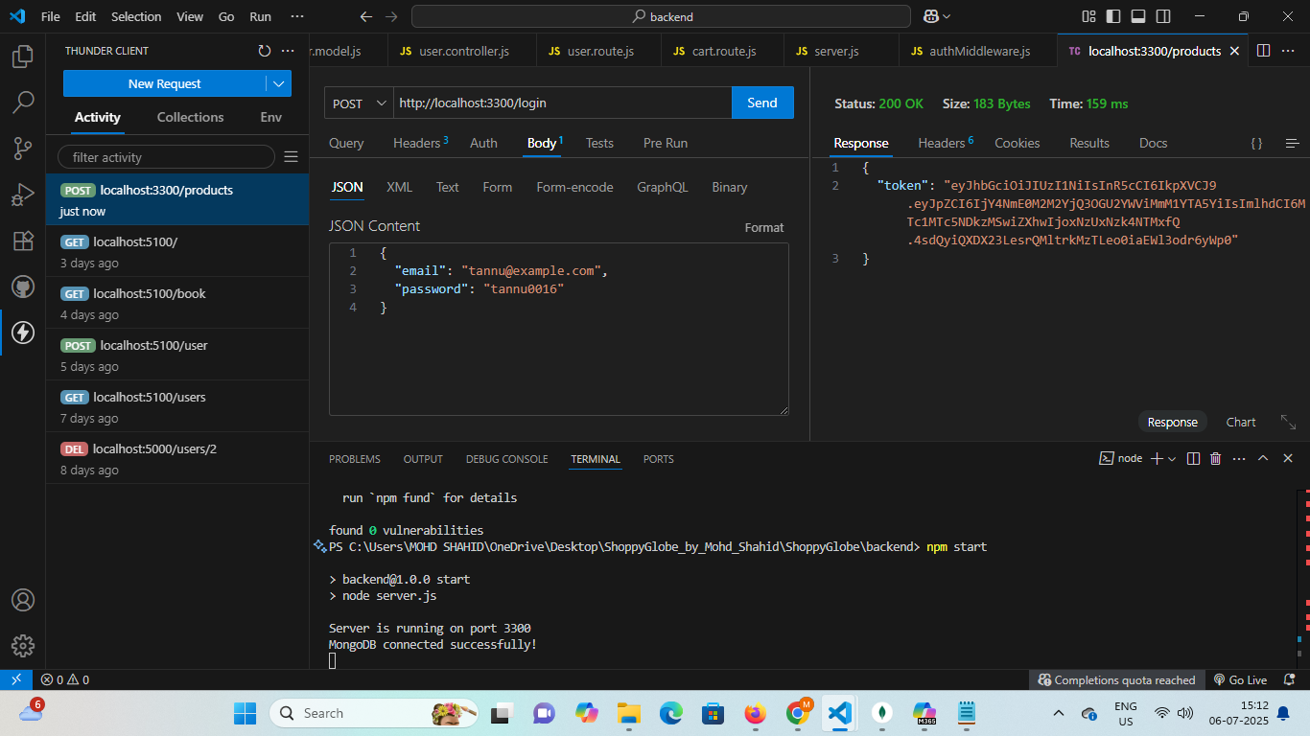

POST /cart - Add item to the shopping cart

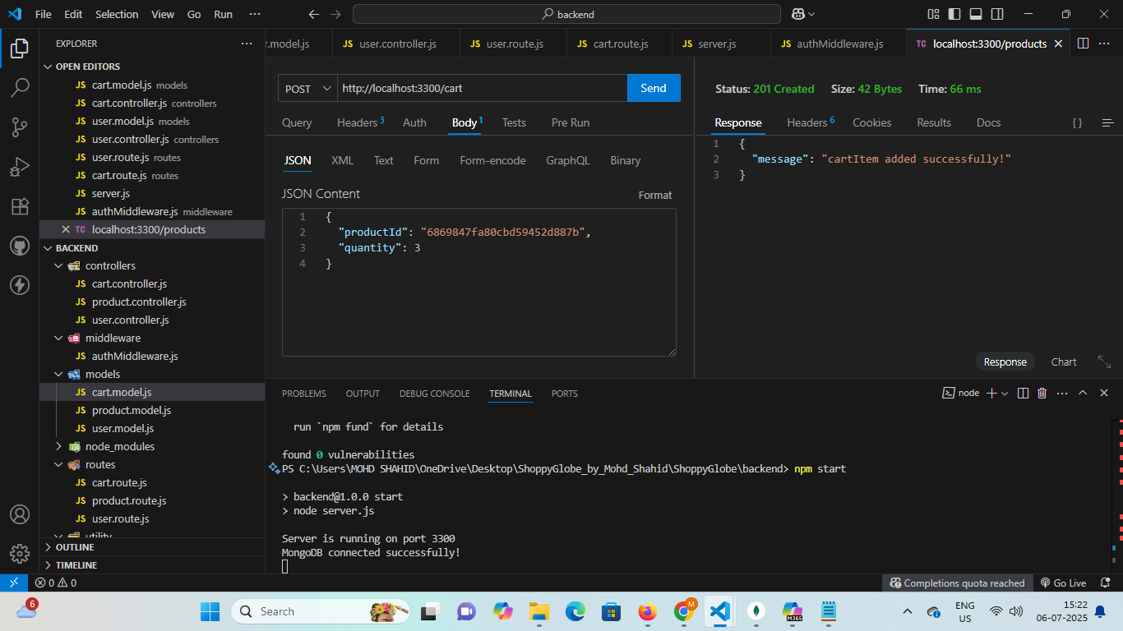

GET /cart - Fetch item in the cart

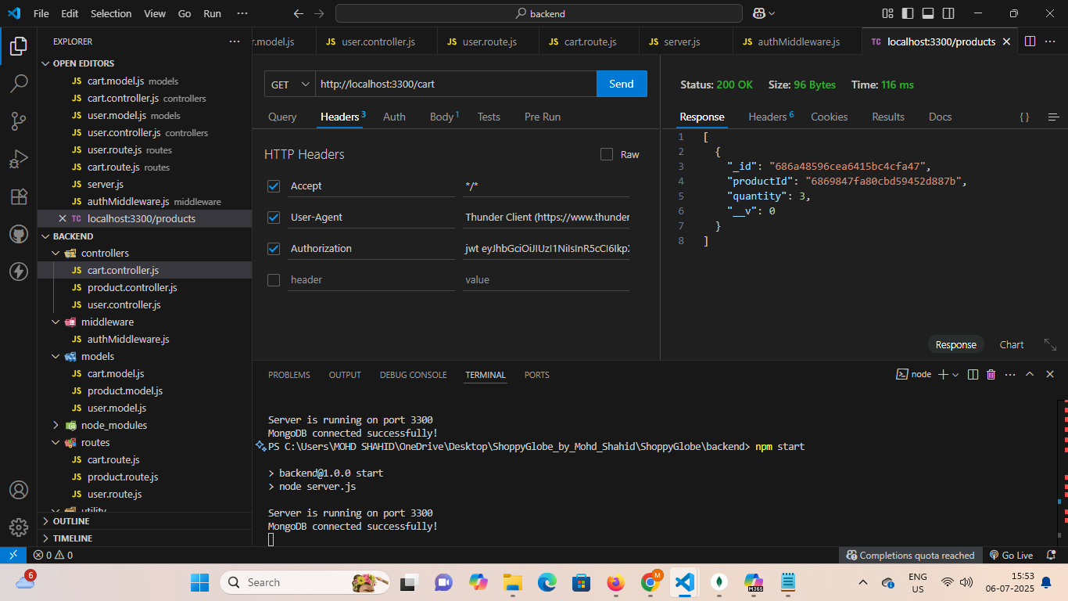

PUT /cart/:id – Update quantity of the cart item

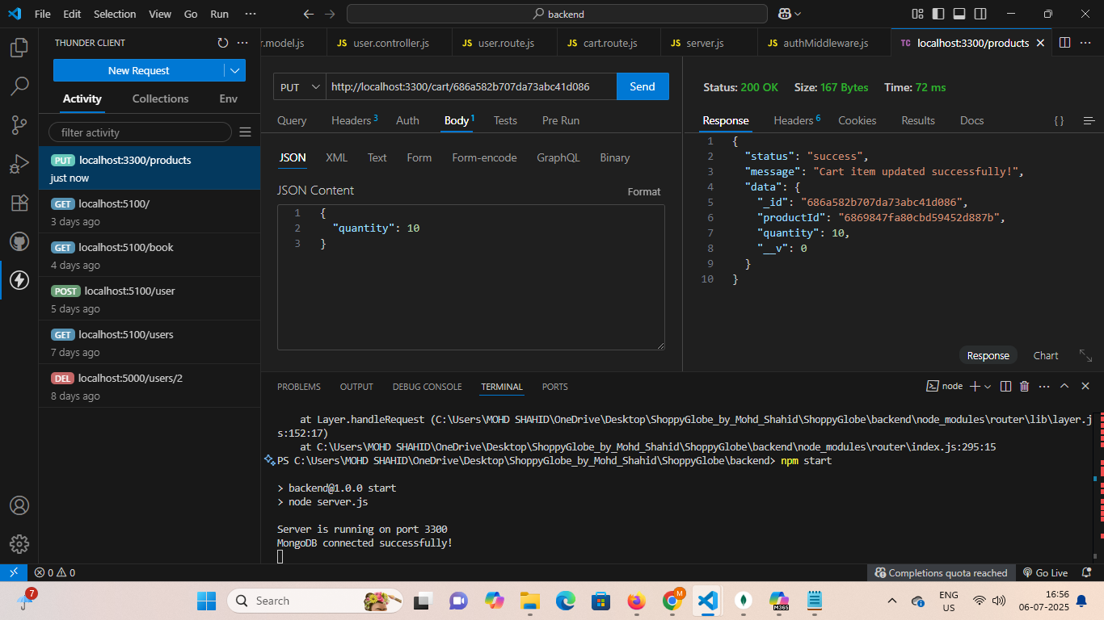

DELETE /cart/:productId – Delete cart item by the product id

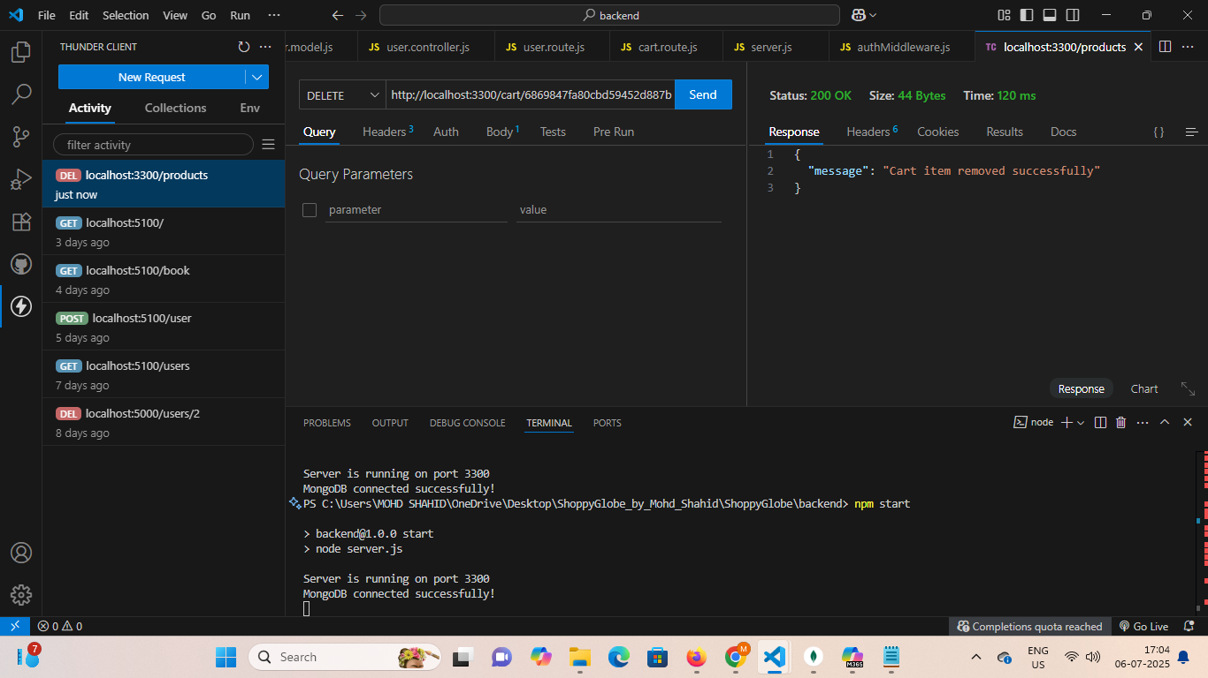

Error handling for all invalid routes

