Product Codes Description in ERP
Product Names | Short Forms
Stand up pouches  Flat Bottom Pouches  Central seal gusset  Brown Paper Bio Degradable bags  Energy bags  Jerky Bags  Mailler bags  Plastic scoops  Sealer machine  Spout pouch sup center  Spout pouch sup corner  Stand up juice pouch with zipper and handle/Ultra Clear Stand up pouches with zipper and euro hole  Ultra Clear Three Side Seal with zipper and euro hole  Storezo  Three side seal  Vaccum Sup | SUP  FBP  CSG  BIO  ENG  JP  MB  SCP  SM  SP (Center CEN code will be mentioned at the end of product code)  SP (Corner COR code will be mentioned at the end of product code)  USUP  UTSS  SRB  TSS  SVP
Zipper Names | Short Forms
With Zipper  No Zipper  Tear off Zipper  Tin Tie  With Welcro Zipper | ZZ  NZ  TZ (Japanese and pocket zipper are know as Tear off Zipper)  TT (Sizes will be mentioned at the end of product code)  WZ
Valve | Short Forms
No valve  With Valve | NV  WV
Spout Names | Short Forms
Spout 22 mm  Spout 10 mm  No Spout | SP (After that colour short forms then 22M)  SP (After that colour short forms then 10M)  There will be no any specification of no spout in the product code
Accessories | Short Forms
Euro Hole  Round Corner  Die Cut  No Accessories | EU  RC  DC  There will be no any specification of no accessories in the product code
Make of Pouch | Short Forms
Normal  Paper  Oxo Bio degradable  Retort  Spout  Vaccum | PL  PP  OX  RT  SP  VC
Colour Names | Short Forms
Matt black /matt black  Red / Red  Clear Shine White  Green oval Window  Jutte look / Jutte Look  Brown Paper full Rectangle window  Brown Kraft Paper  Clear / Clear  Cristal Clear | MKK  SRR  CSW  SGO  JTL  KPR  BKP  SCC  CCC
Example of Stock product codes | Decsription
SUP150ZZNVPPCKPR | Stand up pouches 150 gm With zipper And No valve Make of pouch : paper, Colour : Clear Kraft paper
MB482 | Mailler bag 482 X 609 + 50 mm
TSS3GZZNVPLSGEU | Three side seal bag 3 Gm With zipper and no valve Make of pouch : plastic, Colour : Shine green, With Euro Hole
SP500PLC22CEN | Spout Pouch 500 Ml Center spout 22 mm
SP200PLC10COR | Spout Pouch 200 Ml Corner spout 10 mm
SCP25MLPLBL | Scoop 25 ML Make of pouch : Plastic, Colour : blue
Example of Custom Product Codes | Description
CUST1KGZZWVPLBOC | 1 KG Bello Café With Zipper and valve
LBLCCS | Chocolate Coated Sultanas Label
LBL150BBMC | 150 gm Blessed Breus Mountain Chai
CUST3GBB | 3 GM Bikini Bum

CUST Refers to Custom Products and LBL refers to Label. And in the above example CUST1KGZZWVPLBOC = Custom Product 1 Kg With Zipper and Valve make of pouch : Normal (Plastic) Bello Café With Zipper and Valve.

Steps to add Stock Product Codes in Swiss ERP

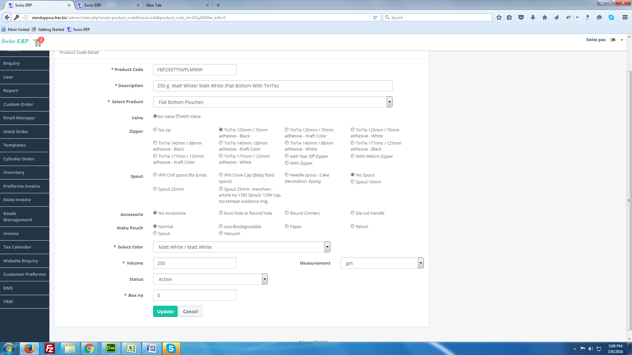
Steps to add Custom Product Codes in Swiss ERP

